National Association of Benefits and Insurance Professionals
Northern Nevada Chapter

Board of Directors Meeting Minutes
September 2nd, 2025 11:01 AM - 12:15 PM
4600 Kietzke Lane, Building G-160, Reno, NV
Via Zoom – Meeting ID = us02web.zoom.us/j/84698950624

Attendance Report: Aliana Rushing, Joy Gardner, Gina Espinal-Aguerre, Don Goldmann, Merre Gregory, Chanté Padilla, Breeze Yerves, Mary Lou Urrutia

Virtual Attendance: Dave Sherrill, Georgana Cepeda, Jay Eldridge, Ross Pendergraft, Julie Ann Evans, George, Beach, Ashley Kapostins

Absent: Molly Moreno, Adrienne Saintil, Merre Gregory and Doug Boulton

Guests: none

- Meeting called to order by President Aliana Rushing at 11:01 AM.

- Roll Call of attendees was taken by sight for those attending in person and on Zoom by Secretary, Chanté Padilla. Quorum confirmed. Connectivity confirmed.

- Review of the August 2025 board minutes by Secretary, Chanté Padilla.

  - A motion to approve the board minutes was made by Joy Gardner and seconded by Julie Ann Evans. Unanimously approved.

- President’s report by Aliana Rushing. Written report submitted and entered into the addendum with brief discussion.

  - Brief discussion indicating Anthem will no longer provide the State of NV monthly free CE credit.

    - Aliana mentions if anyone wishes to host CE class to connect with Julie Ann Evans.

    - Aliana sets the goal of the N. Nevada chapter hosting 5 CE classes.

      - Donald Goldmann commits to host CE.

      - Aliana Rushing commits to host CE.

      - Jay Eldrigdge commits to host CE.

      - Dan Huffily commits to host CE.
  - Brief update on Region 8 trip indicating Pat Burns wants to put together a committee with speakers who live in Region 8, to rely less on national speakers but the importance of more local speakers. Also flying from within the Region would be useful.

    - All chapters of Region 8 will have a calendar of events.

    - Region 8 speakers would be rated probably using google docs.

  - Brief discussion about who has not registered for the Gala. Verifying if all who’ve committed have registered.

- Secretary report by Chanté Padilla.

  - With the approval of the last board meeting minutes, the leadership minutes and the strategic planning minutes, there was nothing else to report.

  - Chante reminds the board to upload reports to Google Docs.

- VP of Finance’s report by Joy Gardner. Financial statements submitted and added into the addendum. BOD had brief discussions.

  - Motion to approve July Financial reports made by Julie Ann Evans and seconded by Don Goldmann. Unanimously approved.

  - Motion to approve August Financial report made by Aliana Rushing seconded by Julie Ann Evans. Unanimously approved.

  - Past due accounts: Prominence past due since 2020.

  - QuickBooks and Umqua are now connecting. However there has been another name change. Joy as administrator will be able to continue to navigate this change.

- Committee Reports

  - Vice President’s report by Georgana Capeda. Written report submitted and entered into the addendum with brief discussion.

    - We are up to date and in good order, very little to be done for 2026 EXPO.

    - Next meeting will be after the GALA.

    - Will send out flyer for EXPO for final approval.

    - Next meeting will be October 11th for EXPO

  - Director of Program’s report by Aliana Rushing. Written report submitted and entered into the addendum with brief discussion.

    - 45 registered for GALA

    - The President and the Master of Ceremonies need to connect to finalize decisions.

    - REGION 8 meeting discussion ideas:

      - Recouping programs for large events to connect people together.

      - Many Regions are struggling on hosing monthly meetings.

      - Suggested spreading out meetings, and events in lieu of monthly meetings.

      - Many Chapters in Region 8 that have switched to quarterly meetings are more successful with higher attendance rates.

      - Suggested 3 large events per year due to October meetings typically having low attendance for luncheons

    - The president mentioned HOT TOPICS and shared ideas to consider to go “dark” during AEP for 2026.

      - Don Goldmann suggested the need to verify with the Chair of Awards on whether or not this would negatively impact our chances for awards. Can this affect points for awards?

      - Ross has indicated the maximum min # of monthly meeting for awards is 12 however the update has not been released for 2026 award critics for Pacesetter.

        - 10 points per meeting per month

    - Don suggests other types of meetings that could be held during the busy months in lieu of canceling the meetings.

    - Don suggests not lowering ourselves as other chapters may be accustomed to.

    - Joy mentions the training and work put into this chapter in support of keeping things as is and keeping the value and quality of our chapter to high standards. We really do a lot. The experience this chapter holds has high value.

    - Aliana discusses a need for an events planning chair. Future board members may want to consider assisting the events planning chair. It may be good to delegate more responsibility. Example: Food, Dates, Contract and negotiations, floor planning etc.

      - Breezy expresses desire to hold the event planning chair as this is something she’s done prior and is right up her alley.

    - A brief discussion was held on the potential to combine Board of Directors meetings with NABIP luncheons beginning in 2026.

    - First combined meeting is scheduled for January 14th, 2026. However, this will likely be changed.

    - The monthly board meeting will also need to be adjusted.

    - A brief discussion was held on the idea of making the NABIP March luncheon a Group Panel format.

    - It was noted that panelist approval requests will need to be submitted by January, at least 60 days in advance.

    - The Board expressed interest in leveraging newly appointed Employer Benefits Chair Breeze’s expertise in connecting with groups and event planning.

    - Brief discussion on which group carriers would be ideal to invite to participate on the group panel.

      - BOD suggested United Health Care, Anthem, Prominence and HomeTown Health

    - A brief discussion was held without resolution about making the April luncheon a membership appreciation event.

    - There will be no May luncheon due to having the Expo that month.

    - Brief discussion instructing Merre Gregory to start planning to head a CE approved class on AHIP training.

  - VP of Professional Development’s report by Julie Ann Evans - written report and entered into these minutes.

    - Chapter Leadership Training:

      - Joined the NABIP Leadership Training session offered virtually on August 28, 2025

    - NABIP SN - August Monthly Luncheon:

      - NABIP SNs August 12th luncheon was a CE approved event, having Calvin Bagley, Nuvo Health, present the same CE class he did for NABIP NN at our Expo on May 21st

      - There was a total of 29 CEs processed on August 13th

      - There is a $1.25 fee per CE completion, so we should see an invoice from Sircon for $36.25

      - As NABIP NN already covered the $40.00 filing fee, the total cost to be billed to NABIP SN is $36.25 and this was communicated to NABIP SN, as well as to Joy Gardner, VP of Finance for NABIP NN

    - NABIP NN - August Monthly Luncheon:

      - This was a CE approved event, presented by Paul Roberts, Word & Brown, on August 13th, the title being “Sizzling Hot Group Compliance Topics 2025”

      - There was a total of 22 CEs processed on August 13th

      - There is a $1.25 fee per CE completion, so we should see an invoice from Sircon for $27.50

      - The total CE cost is $67.50 ($40.00 filing fee, plus $27.50 completion fee)

    - NABIP NV - August CE Class:

      - The August 15th CE class was managed through NABIP NNs Sircon account.

      - There was a total of 16 CEs processed on August 15th

      - There is a $1.25 fee per CE completion, so we should see an invoice from Sircon for $20.00

      - The total CE cost is $60.00 ($40.00 filing fee, plus $20.00 completion fee)

    - NABIP NV - October CE Class:

      - This CE class is being managed through NABIP NNs Sircon account. The course title is “The Silver Tsunami” - An Overview of Long-Term Care Insurance, presented by Don Quante, Simplicity Asset Based LTC

      - The course material was submitted on August 25th

      - There is a $40.00 filing fee, so we should see an invoice from Sircon for $40.00

    - NABIP NV - Monthly Professional Development Meeting:

      - Typically, on the 4th Friday of each month there is a virtual meeting held for those who are involved with planning luncheons, events, CE classes, etc. for both local chapters and the state chapter

      - The next meeting will be held on September 26th at 2:00 PM, and all are welcome to attend the meeting

  - Vice President of Media and Communication’s report by Donald Goldmann - Written report submitted and entered into these minutes.

    - The August newsletter was well received, and the addition of the new President’s Column was mentioned by a number of the members at the August luncheon.

    - While the goal is to have the draft of the newsletter each month to Ashley at Kapsher, at least by the next to last week of the next month’s issue, it was agreed not to work on that calendar deadline this month in order to delay submission of the draft until after pictures from the Gala can be included. It is expected that the September draft will be completed by Monday, September 8th.

    - I would like to have a short discussion about whether the annual budget can afford to purchase a broker’s list to also send the newsletter to non-members as well as covering the cost of distribution.

    - Aliana mentions Photo Booth contact verified photo booth pics will be available for the newsletter also.
  - Vice President of Membership’s report by Gina Aguerre. Written report submitted and entered into these minutes.

    - We are at 102 members.

    - This month we will work on calling members that have quit this last year.
    - On August 12th I attended (via zoom) the National Membership Chair Training, as we prepare for the year to come.
    - One thing that stood out are the Social Media blitzes chapters host (hmmm maybe we can do one) and a popular recruitment one was to hold a March Maddess Membership Call-a-thon – The board reaches out to all non-members in the area and try and recruit, I like it!
  - Vice President of Awards’ report by Ross Pendergraft. Written report submitted and entered into these minutes.

    - We are still waiting for all the new 2026 NABIP Awards to be posted on the website.
    - Our last Facebook post was August 14, 2023. Also, not seeing anything posted recently on X or LinkedIn. We need to develop a plan to post on these social media sites.

    - Reminding everyone to complete their NABIP Leadership Training. This will help with your position. Be sure to sign-in before watching the video: https://videos.nabip.org/

    - The New Member Orientation will continue every 4th Thursday at 9:00am PST on Zoom. Need to make sure we keep blasting this out in our newsletter each month

      - Zoom meeting ID 826 3420 3381, Passcode “Membership”

      - http://welcometonabip.org

  - Vice President of Legislative Affairs’ report by Mary Lou Urrutia. Written report submitted and entered into the addendum.

  - Medicare Chair’s and VP of Medicare Chair’s report by Merre Gregory Lou and Doug Boulton. Written report submitted and entered into the addendum.

  - Employer Benefits Chair’s report by Breeze Yerves. No report, brief discussion.

    - Brief discussion of hope to send out surveys to group contacts verifying what they are hoping to hear in the Carrier Group Panel in March. The surveys would ask, “What would they view as beneficial and what questions do you want carriers to ask?”

    - Aliana asks Dave if he can create a survey for Breeze to send out.

    - Ashley verifies this is possible and they will connect.

    - Brief discussion that this would be good to send to the Nevada Health Link panel also.

  - LPRT Chair’s report by Joy Gardner. No report.

  - Incoming DEIB Chair’s report by Adrienne Saintil. No report, absent.

  - Incoming NABIP Foundation chair’s report by George Beach. No report brief discussion.

    - George indicates he will be working with Amanda Burton who is on the Foundation Board.

    - Julie Ann Evans offers additional assistance as she also is on the board.

    - Aliana mentions Pat Burns is also on the board and has offered our chapter assistance.

  - Incoming Director of NABIP PAC’s report by Jay Eldrige. Written report submitted and entered into addendum.

    - Brief Discussion that he completed leadership training.

  - Immediate Past President’s report by Molly Moreno. No report, absent. BOD has a brief discussion.

    - Brief Discussion as Molly has not been a member since May 31st, 2025.

      - Don suggests that we need to verify bi laws.

      - Aliana asks Gina to connect with Molly about past due membership fees as she has a seat on the committee currently.

      - Gina will reach out to Rosi Gonzalez with Aetna in regards to Christmas party sponsorship.

- A motion was by Don Goldman and seconded by Mary Lou Urrutia. to accept all reports in toto. Unanimously approved.

- Old Business - None

- New Business - None

- A motion to adjourn meeting by Julie Anne Evans, seconded by Mary Lou Urrutia. Unanimously approved.

- President Aliana Rushing adjourned the meeting at 12:15 pm.

- Submitted by Chanté Padilla NABIP NN Secretary.
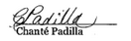

Next Monthly Board Meeting: October 7th, 2025, 11:00 AM - 12:30 PM. 4600 Kietzke Lane, Building G 16, Reno, NV.

Addendum

Report from the President - Aliana Rushing
PG 1 of 1
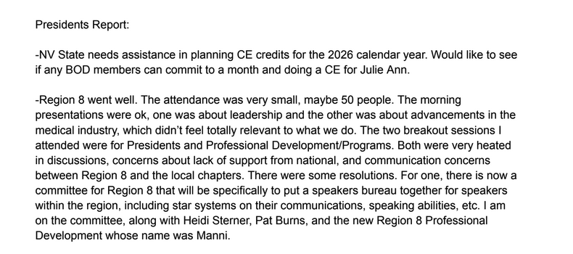

Treasurer’s Report from VP of Finance - Joy Gardner
Pg 1 of 1
NABIP-NORTHERN NEVADA Treasurer’s Report
Month end 8/31/2025

Partnerships 2025: All Paid
Diamond-$8,500 Anthem
Gold-$4,000 Hometown Health, United Healthcare
Silver-$2,500 Aetna, Word & Brown
Bronze-

Umpqua Bank Balance: 8/31/25
Checking $71,339.39
Savings $ 200.40
See attached bank statement

Budget vs Actual: Attached

Luncheon: 8/13/2025
Attendance: 30 (14 attendees, 13 Ambassadors, 1 speaker, 2 Sponsors)
No Shows: 3 ( 1 Ambassadors, 2 Member)
Walk Ins: 0
Income: $631.00 + $490 (Ambassadors) + $525 (Sponsors) = $1,646.00
Cost: $1,188.95
Raffle Income: $260.00

Additional Information:

All Annual Partnerships have been paid.

Prominence Health Plans owe us $375 from 2020. I verified we have not received the funds and requested payment. Have not received it as of 8/31/25.

Both the Checking and Savings accounts balance.

I now have QuickBooks and Umpqua Bank talking to each other. Umpqua Bank’s name has changed to Columbia Bank. I will probably need to make some adjustments to the coordination between the new bank and QuickBooks. The name changed today September 1, 2025, so I will work on that next week.

Atlantis was not paid for the luncheon in August because I never got an invoice. I requested it today when I discovered they had not been paid.

Respectfully submitted:

Joy K Gardner

Umpqua July 2025 Statement
Pg 1 of 3
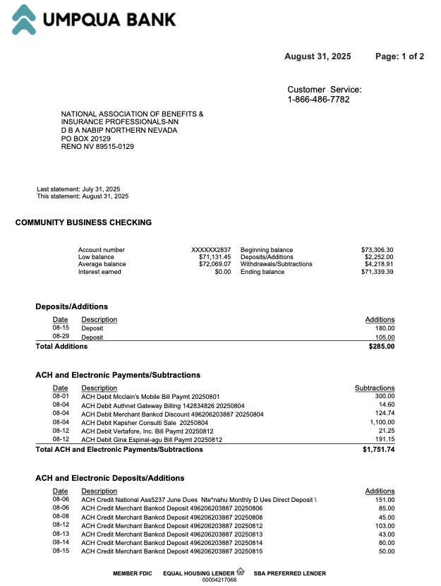
Umpqua July 2025 Statement
Pg 2 of 3
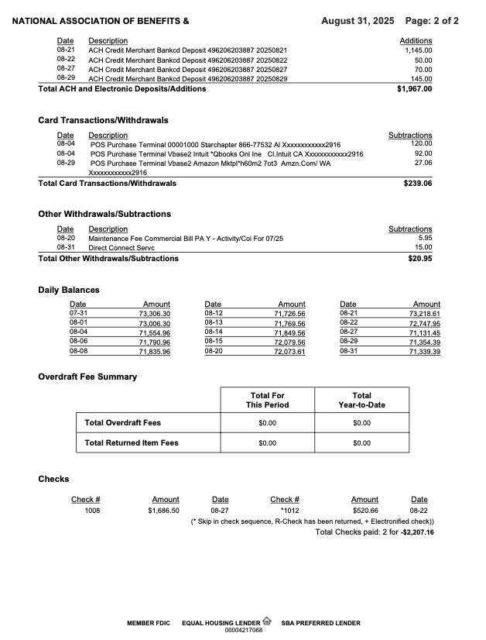
Reconciliation of Check and Savings Accounts
PG 1 of 1
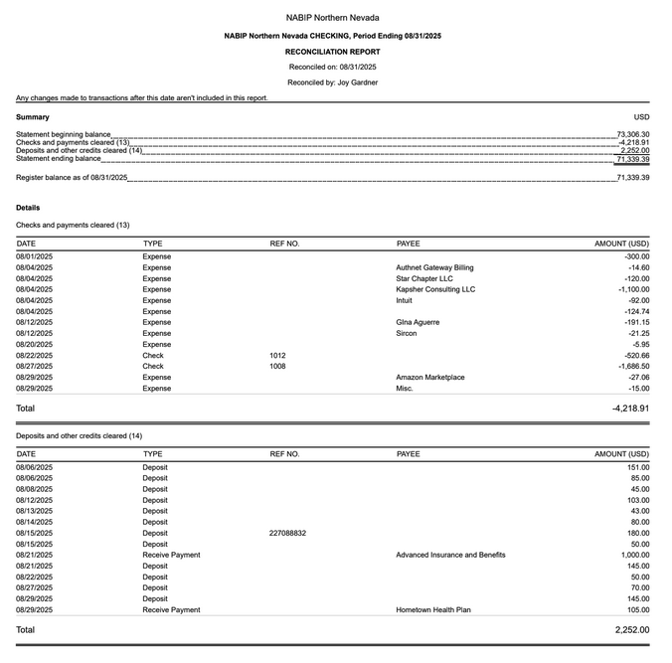

NABIP NN Budget vs Actual January 2025- August 2025 Profit and Loss
Pg 1 of 2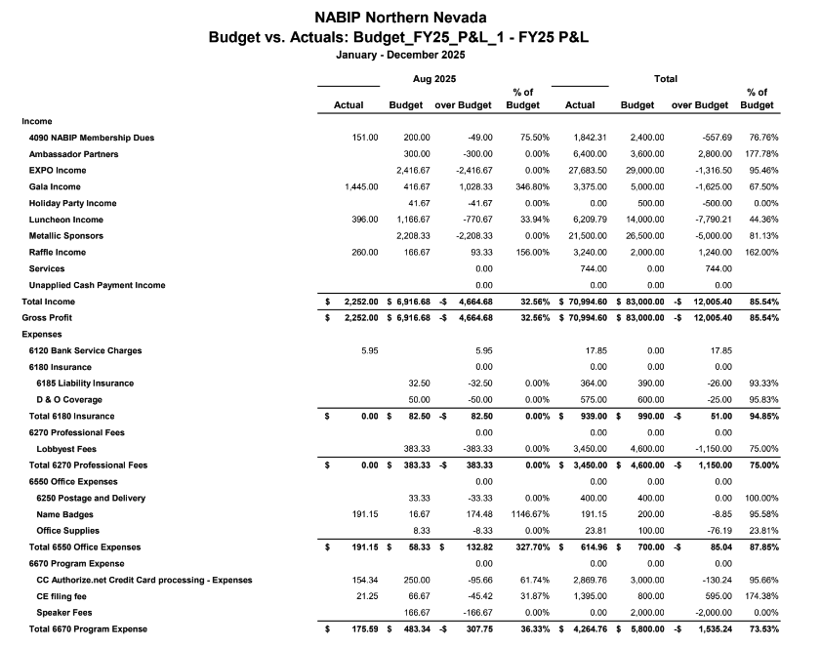

NABIP NN Budget vs Actual January 2025- August 2025 Profit and Loss
Pg 2 of 2
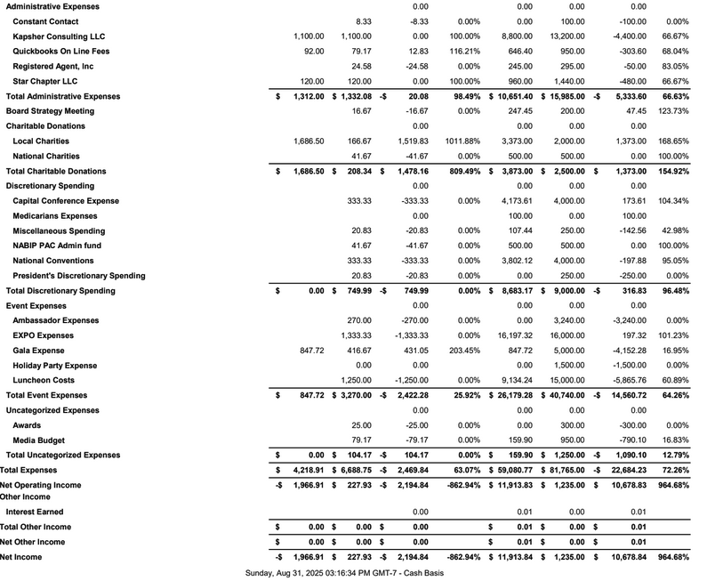

NABIP NN Profit and Loss by Month. January 2025- August 2025
Pg 1 of 2

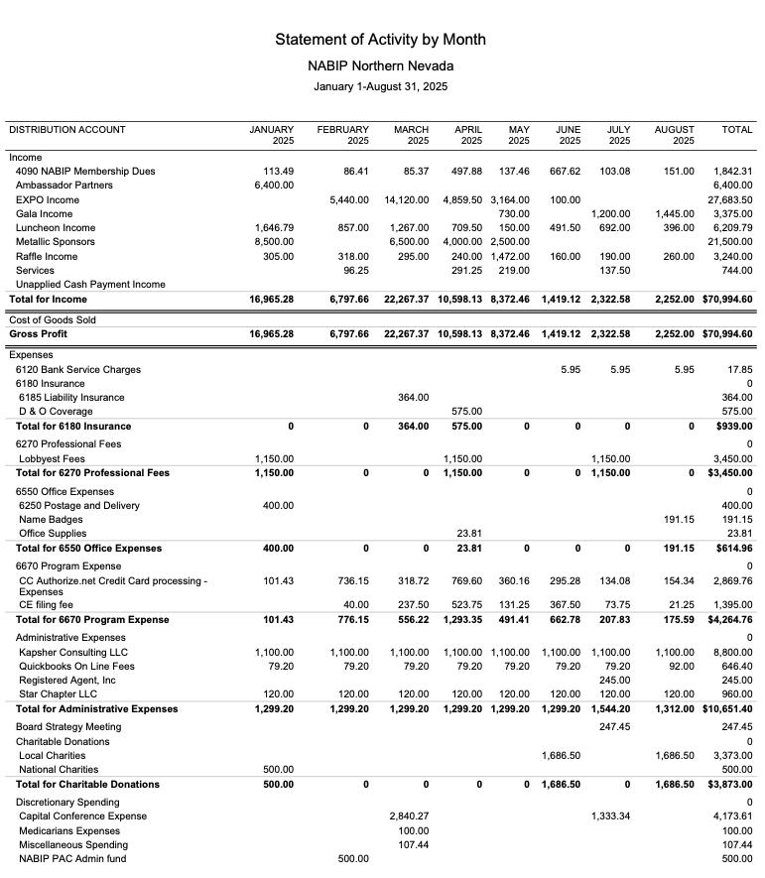

NABIP NN Profit and Loss by Month. January 2025- August 2025
Pg 2 of 2

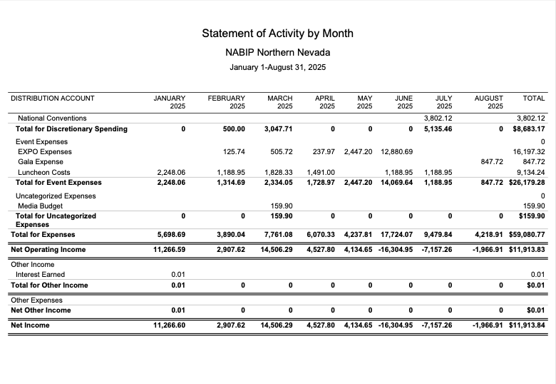

Report from the VP - Georgana Cepeda
PG 1 of 2

National Association of Benefits and Insurance Professionals
Northern Nevada Chapter – Board of Directors Meeting
2026 EXPO REPORT
Expo Date: April 29, 2026
Theme: Country
Theme/Slogans:
- Saddlin Up for Success
Proposed Speaker Line-Up:
Principal Owner of Medicare Answers Now, and Chalen Jackson, Compliance Officer at McNerney Management Group. RE: Medicare Initiatives (Julieann to contact him)
David C. Smith has been an active member of NABIP for 20 years, serving in leadership positions at the local, state, and national levels. During that time, he has invested heavily in improving professional development and our association's ability to deliver the best to its members. In his work life, David is Senior Vice President of eBen, a regional benefits consulting firm and agency, working with over 100 coworkers and associates to change the relationship with our clients by raising their expectations and building lasting partnerships. (Julieann to see if he is available and hot topics)
Master of Ceremony:
Notes/text messages (Per Merre)
Yes, she is available. $3000, covers everything. That would include one night at the Atlantis, I’m sure there is someone we can talk to get a good price for one night. Also includes her flight and all day MC. I would be willing to sponsor her and pay for her plane ticket. Let me know if I can do anything to help you.
Hey Merre. Does this include her doing a keynote session? Could you find out what her cost is for keynote only?
We had an idea at the last meeting about having Paul Roberts MC the whole event which seemed really fun but we weren’t able to bounce the idea off you yet.

Report from the VP - Georgana Cepeda
PG 1 of 1
Yes, the cost includes her whole day. She will start the meeting with something to tie our event together, then MC thru the day, do something interesting/funny for Lunch as well as cocktail hour, wrapping up the day. The cost without her MCi-ng would be $2500, so I don’t think it would. make since to not have her do it all. However, she and Paul could work together to MC and bounce off of each other?
Please look at Merre’s videos she has sent on MC and help decide.
Aliana to do list:
Getting Panel together
Vendor Hall
Break Room
Misc.
Table Decor
Raffles/Games
Best Cowboy Outfits
Order wipes for Lunch Menu (BBQ)
Meetings resume after Gala
Thank you,
Georgana Cepeda
VP, NABIP Northern Nevada Chapter

Report from the Director of Programs - Aliana Rushing
PG 1 of 1
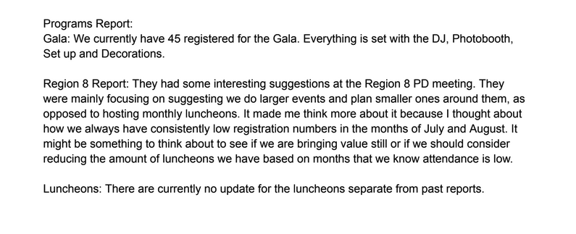

Report from the Vice President of Legislative Affairs - Mary Lou Urrutia
PG 1 of 7
ACA Marketplace Rule Litigation: Temporary Stay
Last week, a federal district court in Maryland issued a temporary nationwide stay blocking key parts of the Trump administration's new marketplace rule that were scheduled for implementation on August 25.
The stayed provisions include the $5 premium surcharge, stricter requirements for verifying eligibility during special enrollment periods, additional income verification measures, the mandate to file and reconcile taxes, the policy on unpaid premiums, and revisions to the de minimis range used in actuarial value calculations. Two aspects of the rule remain in effect for now: the methodology for calculating the premium adjustment percentage and an automatic 60-day extension for resolving data-matching issues.
NABIP is closely monitoring these developments and is providing members with related education on the impact of this rule and the One Big Beautiful Bill Act on consumers and agents ahead of this year's Open Enrollment Period.
House Lawmakers Introduce Bipartisan BENES 2.0 Act Ahead of Social Security's 90th Anniversary to Protect Seniors from Medicare Penalties
August 14, 2025
Press Release
Washington, D.C. -Today, Representatives Gus Bilirakis (R-FL), Raul Ruiz M.D. (D-CA), Dwight Evans (D- PA), and Brad Schneider (D-IL) announced the introduction of the BENES 2.0 Act, aimed at protecting Americans approaching Medicare eligibility from costly and confusing enrollment penalties. The bill's rollout occurs at the same time as the 90th anniversary of Social Security, reinforcing the lawmakers' commitment to improving access and understanding for critical retirement-era benefits. Complex Medicare enrollment rules and insufficient notification are causing tens of thousands of older adults and individuals with disabilities to face lifetime fines, gaps in coverage, and unexpected health care costs. With fewer individuals automatically enrolled in Medicare-and approximately 10,000 Baby Boomers aging into eligibility every day-many are required to navigate active enrollment. Missing the initial window can result in permanent penalties. In 2020, about 776,000 Medicare beneficiaries were paying a Late Enrollment Penalty, which averaged nearly a 27% increase in their monthly premium. The BENES 2.0 Act directs the federal government to include critical Medicare eligibility and enrollment information in Social Security statements sent to individuals as they near Medicare eligibility-typically between ages 60 and 65-giving advanced notice and reducing confusion. This measure fills a longstanding gap in outreach and education.
"I've heard from many constituents who were confused by their Medicare options and ended up paying significant penalties due to simple misunderstandings about how the program works. We addressed some of those challenges with the original BENES Act, which is now law. BENES 2 builds on that progress by ensuring every American receives a clear, written explanation of their eligibility before they have to choose a plan. This will empower seniors to make better-informed decisions about their health care. I'm

Report from the Vice President of Legislative Affairs - Mary Lou Urrutia
PG 2 of 7

proud to be part of this bipartisan effort to simplify Medicare and make it more accessible and user- friendly for older Americans," said Congressman Bilirakis.
"Too many hardworking Americans are blindsided by lifetime Medicare penalties because they didn't know when or how to enroll. The BENES 2.0 Act is a commonsense, bipartisan fix that empowers people with advance information, helping protect their health and their finances," said Congressman Ruiz. "As we honor Social Security's 90th anniversary, let's recommit to strengthening-not complicating- pathways to health coverage."
"Medicare is an earned benefit, and we should make sure it's easier for people who qualify to enroll in that earned benefit! I'm proud to co-lead this bipartisan bill that could help hundreds of thousands of Americans to avoid costly penalties and receive crucial health care." - Congressman Dwight Evans
"Our Medicare system exists to ensure our seniors have access to quality, affordable health care, but for too many older Americans the enrollment process can be a source of stress, confusion, and even lifelong financial penalties. The BENES Act - which I coauthored and is now law - made commonsense updates to improve education, fix the fragmented enrollment periods, and make sure fewer seniors fall through the cracks. I am proud to again join my colleagues in introducing BENES 2.0 to proactively provide seniors with better information about enrollment as they near Medicare eligibility." - Congressman Schneider
The bill is backed by over 85 national and state organizations, including AARP, AFL-CIO, Medicare Rights Center, BlueCross BlueShield Association, Better Medicare Alliance, CVS Health, and The Arc of the United States. A district court in Texas has ruled against the Department of Health and Human Services, deciding to vacate several provisions imposed last year impacting how Medicare Advantage (MA) plans market products.
The Centers for Medicare & Medicaid Services (CMS) finalized a rule in April 2024 that fixed broker and agent compensation and raised the pay cap for new enrollments. It also eliminated certain contracts between MA plans and third-party marketing organizations as well as volume-based bonuses.
A judge paused enforcement of the provisions last summer. Yesterday (PDF), the court said the rule exceeded statutory authority and violated the Administrative Procedures Act, siding with Americans for Beneficiary Choice and broker groups to vacate the provisions.
However, the court did uphold a provision requiring banning third-party marketing firms from distributing personal beneficiary data-such as names, addresses and phone numbers-to other marketing organizations without consent.
This provision was supported by Sen. Ron Wyden, citing investigations by the Senate Finance
Committee.
The CMS regulates compensation MA plans can pay agents, brokers and third-party marketing firms. Under the Biden administration, the agency tried capping payments to third-party firms. Industry

Report from the Vice President of Legislative Affairs - Mary Lou Urrutia
PG 3 of 7
stakeholders later told the feds its changes could cause agents and brokers to leave their field.
RELATED
Court pauses CMS broker compensation rule for Medicare Advantage plans
In the decision, the judge cited the overturning of the Chevron deference doctrine, a consequential Supreme Court decision last summer that limits the power of federal agencies to interpret and enforce regulations. In this situation, the CMS can only regulate how compensation is used, not "engage in ratemaking," the judge determined.
"The decision gives some level of certainty to the broker community as to how it can structure operations and upstream and downstream arrangements moving forward," said Helaine Fingold, a regulatory
attorney at Epstein Becker Green, in a statement to Fierce Healthcare. "CMS will be issuing its 2027 MA- PD proposed rule in the next several months and may again propose changes to how they regulate administrative payments."
The final rule also had implications for health equity, quality bonus payments, supplemental benefits and biosimilars.
Independent BROKERS TIME Act of 2025 to Protect Seniors' Access to Licensed Insurance Professionals
(Washington, D.C.) - The National Association of Benefits and Insurance Professionals (NABIP) applauds Senators Mike Rounds (R-SD) and Catherine Cortez Masto (D-NV) for introducing the Independent Broker Relief and Oversight of Knowingly Egregious and Repetitive Sales Tactics in Medicare Enrollment Act of 2025, or the Independent BROKERS TIME Act of 2025 (S. 2625).
This bipartisan bill directs the secretary of Health and Human Services (HHS) to issue rules updating the regulation of independent agents, brokers, and third-party marketing organizations (TPMOs) under Medicare Parts C and D. It addresses urgent concerns facing seniors and the licensed professionals who serve them, including:
Clarifying the definition of TPMOs to ensure independent agents and brokers are properly distinguished from large, unregulated marketing entities such as offshore call centers and private equity-financed lead generators.
Establishing stronger oversight of predatory call centers, including creating monetary rewards for whistleblowers who provide information on fraudulent or misleading Medicare marketing scams.
• Creating a standardized registration process for independent agents and brokers across carriers to reduce redundant and inconsistent compliance requirements.
Nullifying the 48-hour waiting period requirement for independent agents and brokers, which has unnecessarily delayed seniors' ability to meet with a trusted professional to review Medicare options.
·
Directing the inspector general of HHS to review and report on predatory call centers and their harmful impact on Medicare beneficiaries.
i
Report from the Vice President of Legislative Affairs - Mary Lou Urrutia
PG 4 of 7
Small Group
Small group has seen an increase in costs, in medical and pharmacy trends and in premiums.
Key legislative and regulatory updates
Timely claim processing (AB 52): Legislation passed during the 2025 session has set new, stricter
deadlines for insurers to process and pay claims. The new rules require insurers to process
electronic claims within 21 days and paper claims within 30 days.
Essential health benefits (EHB) input: In February 2025, the Division of Insurance sought public input
on potential revisions to Nevada's EHB plan, which sets the required coverage for small group and
individual plans.
Small group plan changes: A court case finalized in April 2024 rescinded eligibility for certain
Association Health Plans, specifically for sole proprietors and businesses consisting of a single
married couple.
Public employee benefits
Premium increases: In April 2024, the Public Employees' Benefits Program (PEBP) approved
significant rate hikes for state employees and retirees to cover rising medical and pharmacy costs.
To mitigate a portion of the increase, the board voted to use a reserve fund.
Financial trends: PEBP officials noted high increases in medical and pharmacy claim costs in
presentations made in early 2025. Medical claims were projected to trend higher than in the previous
year.
HRA cap: Effective May 30, 2025, a cap of $8,000 was enforced on Health Reimbursement
Arrangement (HRA) balances for PEBP participants.
Below is the average increase this year for small group plans in our area put out by Hometown Health at their
Broker Summit at Edgewood.

Report from the Vice President of Legislative Affairs - Mary Lou Urrutia
PG 5 of 7
Hometown Health Rates
Small Group
Product
Average Rate Change
Rates
HMO
6.5%
HMO - Rating Areas 2 & 3
EPO
12.2%
PPO
10.2%
EPO - Rating Areas 1, 2, 3, & 4
(except White Pine & Elko)
PPO - Rating Areas 1, 2, 3, & 4
(except White Pine & Elko)
Competitive Landscape - Increase by Carrier
Carrier
Product
Average Increase
Anthem
HMO
21.74%
Anthem

Report from the Vice President of Legislative Affairs - Mary Lou Urrutia
PG 6 of 7
PPO
21.48%
Prominence
HMO
12.94%
Prominence
PPO
17.66%
United
PPO
10.3%
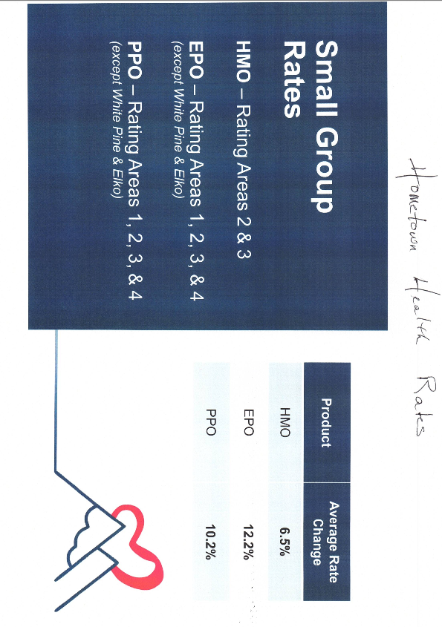
Report from the Vice President of Legislative Affairs - Mary Lou Urrutia
PG 7 of 7
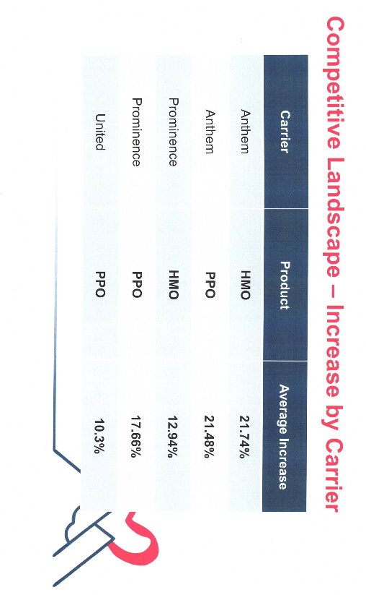

Report from the Medicare Chair- Merre Gregory
Pg 1 of 4
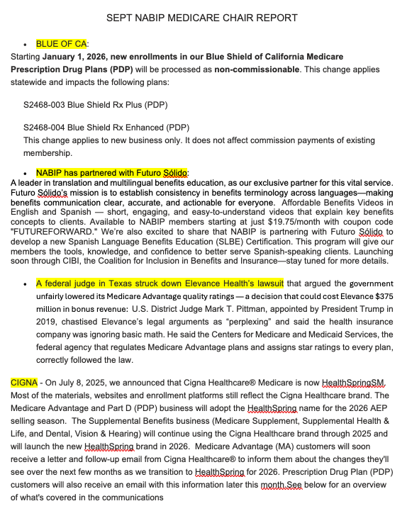

Report from the Medicare Chair- Merre Gregory
Pg 2 of 4
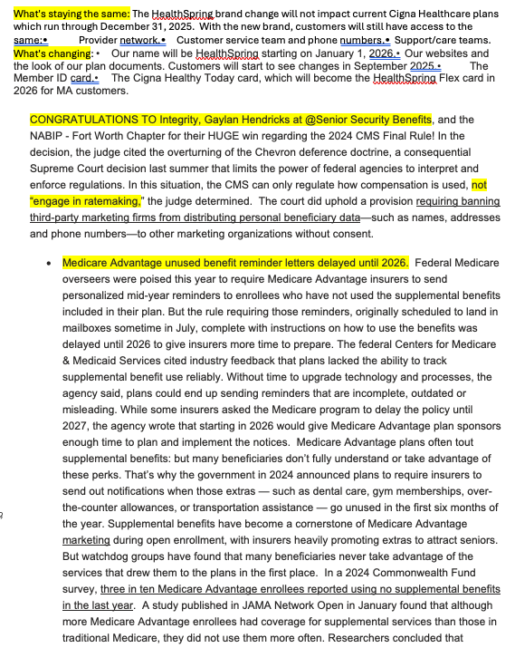

Report from the Medicare Chair- Merre Gregory
Pg 3 of 4
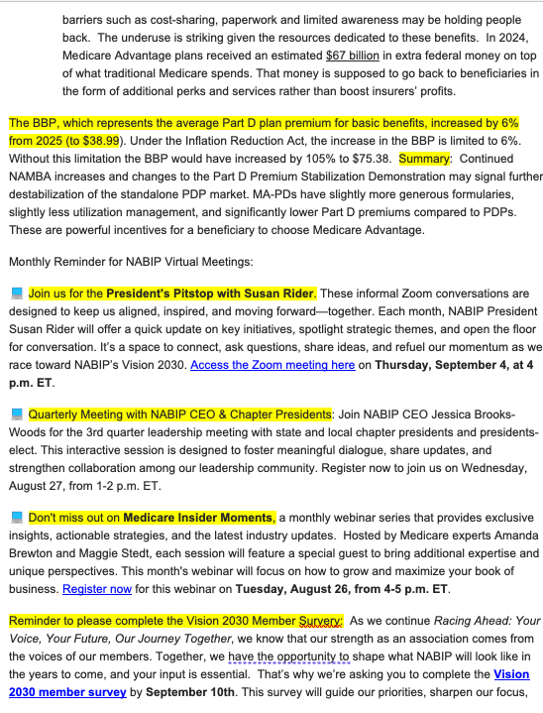

Report from the Medicare Chair- Merre Gregory
Pg 4 of 4
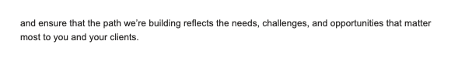

Report from the Director of NABIP Pac - Jay Eldridge
Pg 1 of 1
