National Association of Benefits and Insurance Professionals
Northern Nevada Chapter

Board of Directors Meeting Minutes
February 11th, 2026, 9:32 AM - 10:51 AM
Via Zoom – Meeting ID = us02web.zoom.us/j/84698950624

Attendance Report: Aliana Rushing, Don Goldmann, Merre Gregory, Chanté Padilla, Mary Lou Urrutia, Georgana Cepeda, Joy Gardner, Gina Espinal-Aguerre, Breezé Yerves

Virtual Attendance: Dave Sherrill, Ross Pendergraft, Ashley Kapostins, Jay Eldridge

Absent: Molly Moreno, Adrienne Saintil,

Guests: none

- Meeting called to order by President Aliana Rushing at 9:32 AM.

- Roll Call of attendees was taken by sight for those attending in person and on Zoom by Secretary, Chanté Padilla. Quorum confirmed. Connectivity confirmed.

- Review of the November 2025 & December 2025 board minutes by Secretary, Chanté Padilla.

  - A motion to approve the board minutes was made by Donald Goldman and seconded by Joy Gardner. Unanimously approved.

- President’s report by Aliana Rushing. Verbal report entered into the minutes with brief discussion.

  - Brief discussion regarding NABIP National Conference trip and budget.

    - The allocated budget for the National Conference is $4,000.

    - Reminder to plan ahead and schedule events appropriately as the city may be shut down.

    - A Motion to approve up to 3 board members to attend National Convention and be reimbursed $1300 per traveler made by Chante Padilla, seconded Mary Lou Urrutia. Unanimously approved.

- Secretary report by Chanté Padilla.

  - With the approval of the January 2026 minutes there was nothing else to report.

- VP of Finance’s report by Joy Gardner. Financial statements submitted and added into the addendum.

  - Financial statements submitted and added into the addendum. BOD had brief discussions.

  - Motion to approve December 2026 and January 2026 financial report made by Gina Espinal-Aguerre seconded by Chante Padilla. Unanimously approved.

  - Brief discussion regarding the cost structure of the monthly luncheons.

    - It was noted that a minimum of 50 paid attendees is required to support hosting a panel of three speakers.

    - Brief discussion on strategies to enhance the appeal of NABIP luncheons and better position them as a high-value offering, including current efforts underway to improve engagement and attendance.

    - Reminder to review the existing call list and proactively reach out to contacts.

    - Suggestion that panelists and carrier representatives also distribute event invitations to their respective networks to increase attendance.

    - Suggestion to distribute a mailer to current and former members to gather feedback on topics and programming they would like NABIP to present.

    - Suggestion to invite an HTH representative in August to provide an overview and discussion regarding Kaiser.

    - Suggestion to host a pharmacy benefit manager to present on the impact of GLP-1 medications on benefit plans.

    - Recommendation to prioritize efforts to secure additional Annual Sponsorships.

    - Recommendation to reconnect with inactive group members. Gina Espinal-Aguerre and Breezé Yerves will collaborate on this initiative.

    - Aliana Rushing moved to appoint Chante Padilla as Marketing Chair; the motion was seconded by Joy Gardner and approved unanimously.

- Committee Reports

  - Vice President’s report by Georgana Cepeda. Written report submitted and entered into the addendum with brief discussion.

    - Expo meetings are on time and on schedule

  - Director of Program’s report by Aliana Rushing. Verbal report entered into the minutes with brief discussion.

    - Will explore inviting a Pharmacy Benefit Manager to serve as a guest speaker at a future luncheon.

  - VP of Professional Development’s report by Julie Ann Evans. Written report submitted and entered into the addendum.

    - Quick update: EXPO Speaker David Smith has been CE approved.

  - Vice President of Media and Communication’s report by Donald Goldmann. Written report submitted and entered into the addendum.

    - Reviewed report.

  - Vice President of Membership’s report by Gina Espinal-Aguerre and Breeze Yerves. Written report submitted and entered into the minutes with brief discussion.

    - We are 100 members.

    - Confirmed March 31st is the date to register membership numbers.

  - Vice President of Awards’ report by Ross Pendergraft. Brief discussion and written report submitted and entered into the addendum.

    - Updated email address use rosswmp@gmail.com only.

    - Intends to submit a DSA award.

    - The New Member Orientation will continue every 4th Thursday at 9:00am PST on Zoom. Need to make sure we keep blasting this out in our newsletter each month

    - Zoom meeting ID 826 3420 3381, Passcode “Membership”

    - http://welcometonabip.org

  - Vice President of Legislative Affairs’ report by Mary Lou Urrutia. Written report submitted and entered into the addendum with brief discussion.

    - Reviewed select details from the submitted report.

    - Brief discussion regarding Affordable Care Act (ACA) updates and related developments.

      - Ongoing investigations are being conducted to determine what constitutes fraudulent activity and what does not.

    - Introduction of a new group health carrier in Southern Nevada: Angle Health.

      - Suggestion to invite Angle Health to participate in the upcoming EXPO.

      - Notification that an Angle Health webinar will be hosted by Word & Brown.

  - Employer Benefits Chair’s report by Breeze Yerves. No report, brief update.

    - Currently engaging with two prospective new NABIP members.

  - Medicare Chair’s and VP of Medicare Chair’s report by Merre Gregory. Written report submitted and entered into the addendum with brief discussion.

    - Reviewed select details from the submitted report.

      - According to the latest release from the Chamber of Commerce, Kaiser and Renown Health have finalized their joint venture planning and the agreement has been completed.

      - Anticipated reduction in pricing for GLP-1 medications.

      - Trump RX is currently structured as a coupon-only program that utilizes designated pharmacies; however, it remains a work in progress.

  - LPRT Chair’s report by Joy Gardner. No report.

    - Reminder that a presentation will be delivered at the March Luncheon outlining the LPRT position, including its purpose, goals, and responsibilities.

  - DEIB Chair’s report by Adrienne Saintil. Absent, no report.

  - NABIP Foundation chair’s report by Julie Ann Evans. Written report with brief discussion and presentation.

    - A NABIP Foundation presentation was provided to Board members by Julie Ann Evans.

      - Discussion included how the Foundation is funded, supported, and the ongoing efforts behind its initiatives.

  - Director of NABIP PAC’s report by Jay Eldridge. No report, brief discussion.

    - Confirmed will give an update on NABIP PAC during the February Luncheon.

  - Past President’s report by Molly Moreno. No report, absent.

- A motion was made by Aliana Rushing and seconded by Gina Espinal-Aguerre to accept all reports in toto. Unanimously approved.

- Old Business -

  - Nominations Committee Discussion.

- New Business:

  - Board meetings will be held on the second Wednesday of each month at 9:30 a.m.

- A motion to adjourn meeting by Mary Lou Urrutia, seconded by Gina Espinal-Aguerre. Unanimously approved.

- President Aliana Rushing adjourned the meeting at 10:51 am.

- Submitted by Chanté Padilla NABIP NN Secretary.
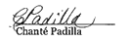
Next Monthly Board Meeting: Wednesday, March 11th, 2026, 9:30 AM - 11:00 PM. https://us06web.zoom.us/j/85852438497?pwd=GhSaLjW8LD03ZBoa4fAgz12XNh7cGe.1
Meeting ID: 858 5243 8497 Passcode: 881981

Addendum

Treasurer’s Report from VP of Finance - Joy Gardner
Pg 1 of 1

NABIP-NORTHERN NEVADA Treasurer’s Report
Month end 1/31/2026

Partnerships 2025: All Paid
Diamond-$8,500 Anthem
Gold-$4,000 Hometown Health, United Healthcare
Silver-$2,500 Aetna, Word & Brown

Partnerships 2026:
Diamond-$8,500
Platinum-$5,500-Anthem Paid
Gold-$4,000 Hometown Health invoiced, United Healthcare working on
Silver-$2,000 Aetna & Word & Brown working on

Umpqua Bank Balance: 1/31/2026
Checking $71,307.56
Savings $ 200.40
See attached bank statement

Budget vs Actual: Attached

Luncheon: 1/21/2026
Attendance: 36 (20 attendees, 10 Ambassadors, 4 speakers, 2 Sponsors)
No Shows: ( 1 Ambassadors, 1 Member)
Walk Ins: 0
Income: $766.00 + $420 (Ambassadors) + $175 (Sponsors) = $1,361.00
Cost: $1,8,25.38
Raffle Income: $150.00

Additional Information:

I have been speaking with Carriers about the Annual Partnerships.

Prominence Health Plans owe us $375 from 2020. I verified we have not received the funds and requested payment. Have not received it as of 1/31/2026

Both the Checking and Savings accounts balance.

I am caught up with the invoicing for the EXPO.

Respectfully submitted:

Joy K Gardner
Columbia Statement January 2026
Pg 1 of 3
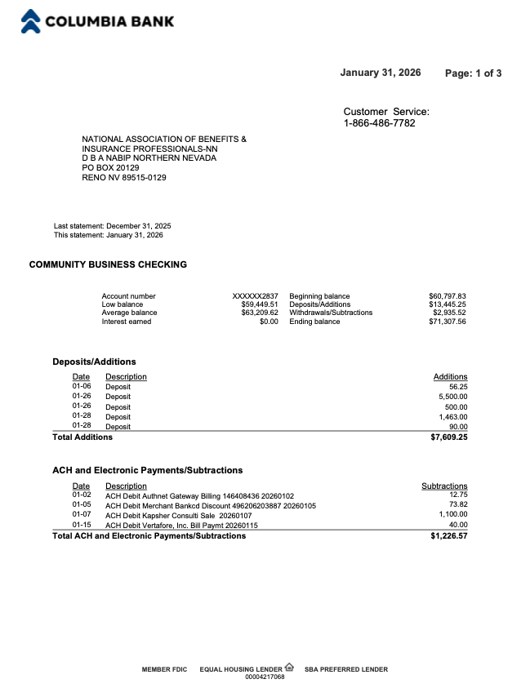

Columbia Statement January 2026
Pg 2 of 3
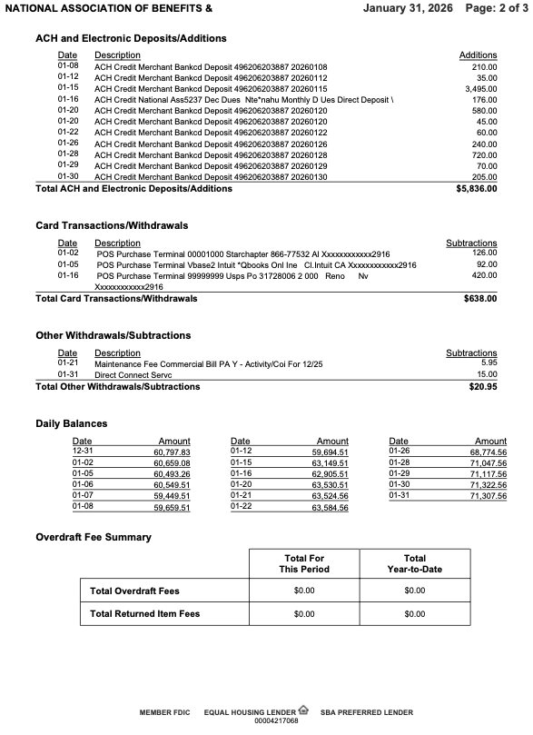

Columbia Statement January 2026
Pg 3 of 3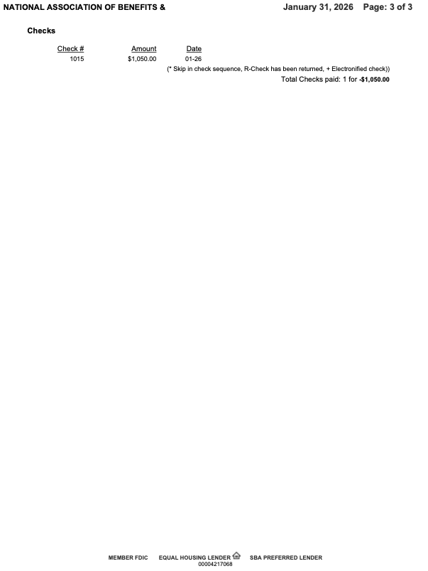

Reconciliation of Check and Savings Accounts
PG 1 of 1
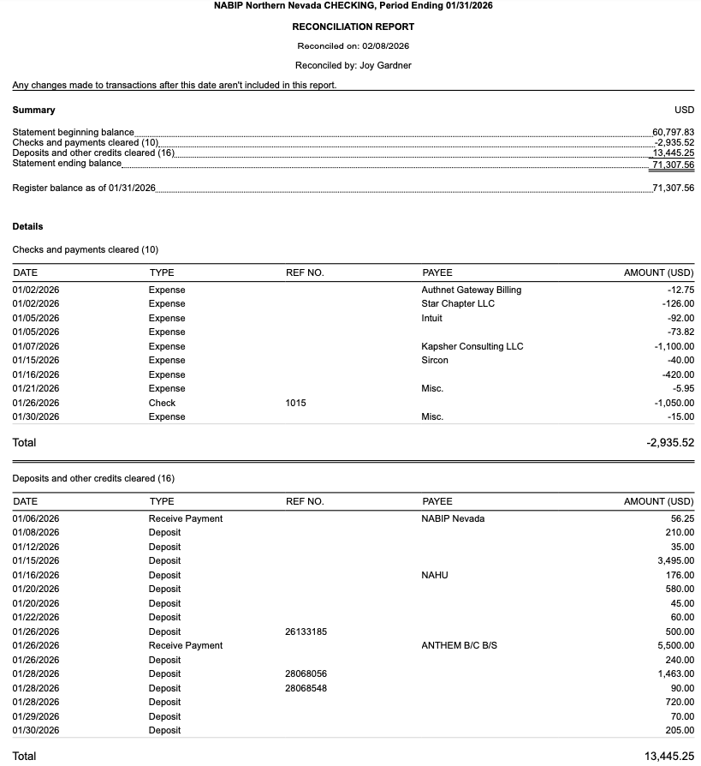

NABIP NN Budget vs Actual January – December 2026 Profit and Loss
Pg 1 of 1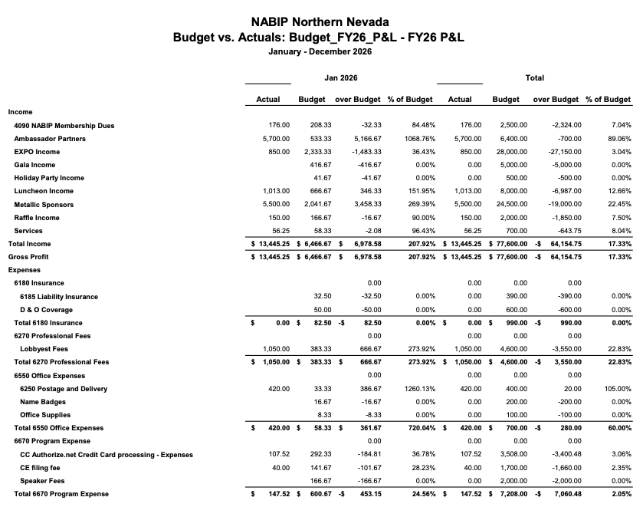

NABIP NN Budget vs Actual January – December 2026 Profit and Loss
Pg 2 of 2
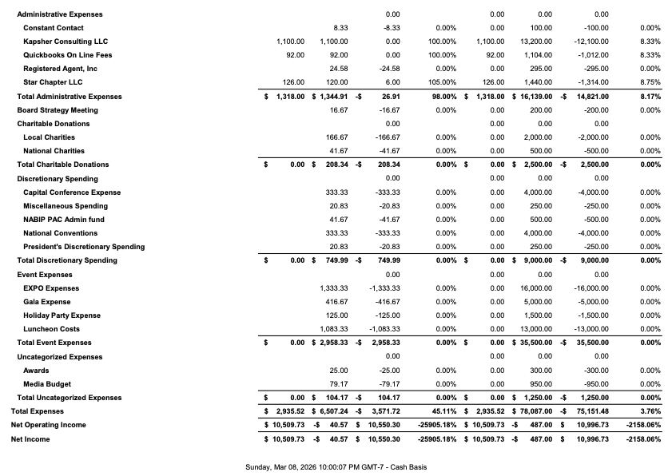

NABIP NN Profit and Loss by Month. January 2026
Pg 1 of 1
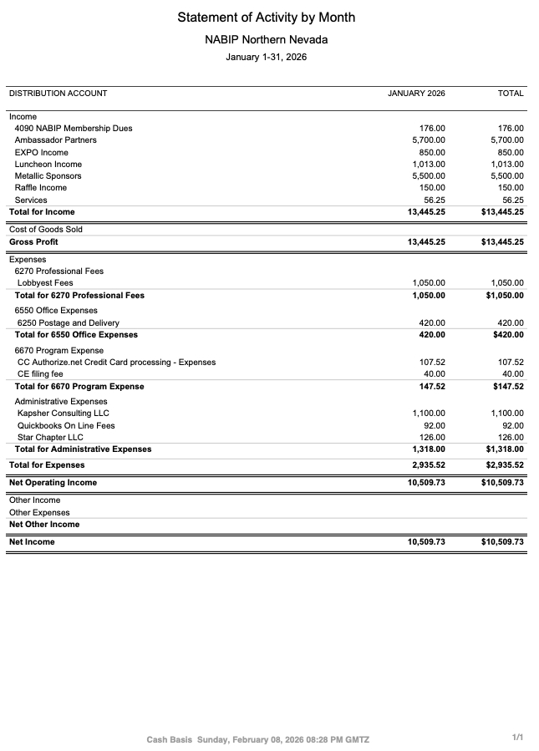
Report from the VP - Georgana Cepeda
PG 1 of 1

National Association of Benefits and Insurance Professionals
Northern Nevada Chapter – Board of Directors Meeting
2026 EXPO REPORT FEBRUARY 2025
Expo Date: April 29, 2026
Theme: Country
Theme/Slogans:
- Saddlin Up for Success
Committee Update
The first Expo Committee meeting was held on January 8, 2026.
Last Expo Committee meeting was held February 5, 2026.
Follow-Up Items
Gavi & Kaiser Speakers
Gina (Gavi): Yes, they are coming, just waiting for Speaker Confirmation.
Kaiser (via CJ Bawden / Hometown Health): We received the following update:
“We will pass the information along. We are currently waiting for regulatory approval, so we will not be able to commit until that has been completed.”
Julie Ann will keep us up to date.
Panel Participation
Aliana is reaching out to Joel Lewis, John Hiatt (undecided), and Tom Holland to assess their availability to participate on the panel.
Speaker / Video Participation
Ned Gaines, Insurance Commissioner will speak at Expo
Vendor Packets
Fillable forms are now available for vendor packets.
Action Item: Please begin distributing vendor packets.

Report from the VP of Professional Development - Julie Ann Evans
PG 1 of 1

NABIP NN - NABIP Foundation Report 02/11/2026

The NABIP Foundation helps consumers and communities’ access and afford high-quality healthcare through education programs, targeted contributions and user-friendly tools.

It was founded in 1980 and is a 501(c) (3) organization with the primary goal being to educate the public on healthcare and healthcare financing through private and public programs and provider initiatives.

The brochures, videos and other materials address a range of important health issues ranging from mental health to the importance of medication adherence, and so much more. There are resources for Medicare beneficiaries as well as public programs like Medicaid, with continued work on opportunities to promote private healthcare financing through health insurance.

Supporting the NABIP Foundation is accomplished by contributions and grants from individuals, companies and foundations. The attached flyer provides information on the various levels of contributions for both individual level donors and corporate level donors.

Please consider contributing to the NABIP Foundation!

Report from the VP of Media & Communications - Donald Goldmann
PG 1 of 1
Media – February 2026

The February newsletter will go out as planned just before the February membership luncheon meeting. It will contain a story about an Operation Shout article, announcement of the chapter’s two new annual charities and an announcement about the chapter being open for nominations for officers to serve on the 2026-27 board of directors.

I authored a letter to the editor, and I will get a copy of it to Ross for awards. I also remember that I did two such letters to the local newspaper in the fall and I will get Ross copies of those as well.

Report from the VP of Awards - Ross Pendergraft
PG 1 of 1

NABIP-NN Awards Report for February 11, 2026

- Awards – Items needing attention:

  - Board Meeting Minutes 2025-2026 – Posted on the Website

    - Last one posted is October 2025

- Legislative Chair, Mary Lou Urrutia, attending Capitol Conference – 75 points

- President-Elect, Georgana Cepeda, at NABIP Leadership training Capitol Conference – 150 points

- Submit for DSA – Working on this right now

- REPEAT: Even though this has been eliminated from Pacesetter Awards, I still strongly recommend you complete the NABIP Leadership Training. This will help with your position. Be sure to sign-in before watching the video: https://videos.nabip.org/

- REPEAT: The New Member Orientation will continue every 4th Thursday at 9:00am PST on Zoom. Need to make sure we keep blasting this out in our newsletter each month

  - Zoom meeting ID 826 3420 3381, Passcode “Membership”

  - http://welcometonabip.org

Respectfully submitted,
Ross Pendergraft
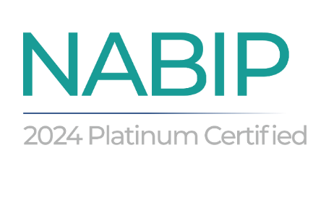

Report from the Vice President of Legislative Affairs - Mary Lou Urrutia
Pg 1 of 3

Legislative report – February 2026
PBM transparency mandates come to life in $1.2T House spending package
President Donald Trump today signed the Consolidated Appropriations Act 2026 bill — a $1.2 trillion spending package that includes major employer pharmacy benefit manager and Medicare PBM provisions.
The employer PBM provisions: One employer PBM transparency provision in the CAA 2026 package calls for PBMs to send employer health plan fiduciaries detailed prescription benefits operations data. The fiduciaries are supposed to use the data to verify that compensation levels for PBMs and other pharmacy benefits players are reasonable.
Another provision calls for the PBMs and other pharmacy benefit players to pass all rebates and other discounts on to employer plans and plan participants.
The employer PBM transparency provision does not classify the PBMs themselves as employer plan fiduciaries.
A Medicare PBM provision calls for PBMs serving Medicare Part D prescription drug plans to send them detailed information.
CMS announced round 3 for Medicare Drug price negotiations for 2028 - 15 drugs
The drugs selected for the third round are: Trulicity, Biktarvy, Orencia, Cosentyx, Erleada, Kisqali, Entyvio, Verzenio, Botox, Lenvima, Xolair, Rexulti, Xeljanz, Anoro Ellipta, and Cimzia. One drug, Tradjenta, will be renegotiated.
2027 list round 2 are: Ozempic/Rybelsus/Wegovy, Trelegy Ellipta, Xtandi, Pomalyst, Ibrance, Ofev, Linzess, Calquence, Austedo/Austedo XR, Breo Ellipta, Tradjenta, Xifaxan, Vraylar, Janumet/Janumet XR, Otezla.
CMS says Medicare Advantage overpayment recoveries ‘will begin soon’
CMS plans to continue its Medicare Advantage audits and overpayment recoveries, according to a Jan. 27 memo. While federal estimates point to $17 billion in overpayments each year, the last major risk-adjustment data-validation recovery took place in payment year 2007. From payment years 2011 to 2013, CMS identified overpayment rates between 5% and 8%.

Report from the Vice President of Legislative Affairs - Mary Lou Urrutia
Pg 2 of 3
In May, CMS said it hoped to tackle its backlog from previous audits and wrap up audits that ran from 2018 to 2024. The agency planned an “aggressive” MA audit expansion by hiring more medical coders, but, as of September, progress was unclear. Now, CMS confirmed it is prioritizing those recoveries and unfinished audits. MedPAC estimated MA payments would reach $76 billion more than what fee-for-service spending would have been in 2026. This figure reflects the additional costs associated with MA plans, which are government funded but private in nature. The overpayments are attributed to factors such as coding intensity and favorable selection, where MA plans may increase the number or diagnoses for patients to make them appear sicker or more high risk, leading to inflated reimbursements for the federal government.
MedPac – Medicare Payment Advisory Commission 2 reports each year – March and June.
March Report: Focuses on Medicare payment policy recommendations.
June Report: Analyzes broader issues, such as beneficiary access to care and healthcare spending trends.
Tab-N-MA_Status-Jan-2026.pdf
How systems are preparing to care for a spike in uninsured patients
Clinical leaders across the country are well aware of the challenges individuals face when they are uninsured: delays in care and worsening health conditions, which ultimately lead to more complex and costly treatment.
The prospect of a widening pool of uninsured is increasingly an imminent reality. Millions of people are projected to lose insurance coverage in the coming years following the expiration of enhanced ACA tax credits and upcoming cuts to Medicaid under the One Big Beautiful Bill Act. Nearly 15 million people could become uninsured over the next decade: 5 million without an extension of the subsidies, and another 10 million under OBBBA’s Medicare and Medicaid provisions, according to estimates from the Urban Institute and Congressional Budget Office.
Community health centers provide primary care services and receive federal funding through grants and enhanced reimbursement from Medicare and Medicaid. This funding structure allows them to offer discounted care on a sliding scale, or in some cases, at no cost to patients based on income.
Strengthening ties with community organizations isn’t just about expanding access to medical care; it’s about connecting patients to resources that help meet basic needs so they’re in a position to stay on top of their care in the first place, leaders said.
“It’s hard to talk to people about advanced care when they’re hungry or homeless, or their basic needs have not been met in a way that they would really care too much about prevention because their fundamental needs have not yet been addressed,” Ms. Cooper said.
Report from the Vice President of Legislative Affairs - Mary Lou Urrutia
Pg 3 of 3

With more patients at risk of losing coverage, leaders say this moment has reiterated a longstanding but increasingly urgent commitment to address the social factors that affect a person’s health. When patients must pay out of pocket for care, it often means pulling from limited budgets meant for food, housing or education. Recognizing that, health systems are leaning more heavily into partnerships and programs that help fill these gaps. Forging new partnerships with food pantries and pharmacies to help ensure patients can afford medications and don’t go without necessities.
Health systems’ roles are expanding beyond care delivery, with some moving further upstream to prevent coverage loss and ensure patients can access care without disruption.

In many ways, the strategies health systems are leaning on today mirror those from more than 15 years ago, before the Affordable Care Act significantly expanded coverage. At that time, many hospitals relied on local partnerships and free clinics to help patients access basic care.
While today’s healthcare landscape has a more structured safety-net infrastructure, many of the same tactics are resurfacing. Only this time, healthcare providers are operating under even greater financial and access pressures, requiring health systems to approach this work with more strategy and intention.

New Carrier added to Word & Brown – Angle Health - Headquartered in San Francisco, CA
Angle Health is an AI-enabled, full-stack health platform that brings together the roles of carrier, third-party administrator, and managing general underwriter into one connected experience.
‍
Instead of relying on disconnected vendors and legacy processes, we offer a single health plan experience designed to support quoting, onboarding, administration, and member engagement in one place.
Available in Southern Nevada – W & B will be hosting an Angle Health Webinar on February 23rd at 3pm

Report from the Medicare Chair - Merre Gregory
Pg 1 of 1

NABIP Medicare report January 2025
Carson Tahoe Hospital and some affiliated Provider Groups are dropping all advantage plans other than Prominence and Senior Care Plus. They started last year by announcing they are dropping UHC. The next company announced was Aetna as of April 1, 2025. Humana will be dropped as of May 1, 2025. This will create a SEP’s for service area reduction. Aetna clients will have through May 31, 2025, to make a change and Humana clients will have an SEP through June 30, 2025. Looks like this could be the wave of the future as it was the same issue for many CA Bay Area plans as well.
Medicare Advantage beneficiaries in Nevada saw their supplemental benefits reduced or cost-sharing increase by over $90 each month in 2025, according to estimates from Berkeley Research Group.
The research firm estimated MA beneficiaries would see their benefits reduced or cost sharing increased by $33 per month on average. Insurers are likely to cut back on benefits because CMS' proposed benchmark payment rates do not offset rising medical costs, according to BRG's report.
The potential impacts vary by state, because of different effects of risk-model changes and star ratings bonuses in each state, according to the report. In Texas, MA beneficiaries could see their benefits reduced by $78 each month, while beneficiaries in Delaware could see their benefits increased by $39 each month.
Here are the 10 states slated to see the largest decreases in benefits, according to BRG:
1. Nevada: $90+
2. Texas: $78
3. Kansas: $67
4. Nebraska: $61
5. California: $57
6. Indiana: $56
7. Oklahoma: $49
8. Illinois: $44
9. Virginia: $44
10. Georgia: $43

