National Association of Benefits and Insurance Professionals
Northern Nevada Chapter

Board of Directors Meeting Minutes
March 11th, 2026, 9:37 AM - 10:53 AM
Via Zoom – Meeting ID = us02web.zoom.us/j/84698950624

Attendance Report: Aliana Rushing, Merre Gregory, Chanté Padilla, Mary Lou Urrutia, Georgana Cepeda, Joy Gardner, Gina Espinal-Aguerre

Virtual Attendance: Dave Sherrill, Ross Pendergraft, Ashley Kapostins, Julie Ann Evans, Breezé Yerves

Absent: Molly Moreno, Adrienne Saintil, Don Goldmann, Jay Eldridge

Guests: none

- Meeting called to order by President Aliana Rushing at 9:37 AM.

- Roll Call of attendees was taken by sight for those attending in person and on Zoom by Secretary, Chanté Padilla. Quorum confirmed. Connectivity confirmed.

- Review of the February 2026 board minutes by Secretary, Chanté Padilla.

  - A motion to approve the board minutes was made by Aliana Rushing and seconded by Julie Ann Evans with edits to the February budget. Unanimously approved.

- President’s report by Aliana Rushing. Verbal report entered into the minutes with brief discussion.

  - Brief update on CapCon trip and shared exceptional experience.

- Secretary report by Chanté Padilla.

  - With the approval of the February 2026 minutes there was nothing else to report.

- VP of Finance’s report by Joy Gardner. Financial statements submitted and added into the addendum.

  - A discussion was held and members engaged in brainstorming regarding the need to secure additional partnerships. The following points were identified:

    - Strategies to secure Half-Year Under 64 sponsorships

    - Review and comparison of sponsorships secured this year versus the prior year

    - Strategies to increase interest and overall attendance at the EXPO.

    - Consideration of whether conducting meetings via Zoom may be more cost-effective in lieu of hosting a luncheon.

    - Consideration of the potential value of increasing the luncheon registration fee.

    - Update regarding pending sponsorships from UHC and Word & Brown.

    - Discussion on encouraging plan networks to participate as sponsors.

  - A motion to approve the February 2026 Financial Report, with the Budget Statement included, was made by Julie Ann Evans and seconded by Gina Espinal-Aguerre. The motion was unanimously approved.

- Committee Reports

  - Vice President’s report by Georgana Cepeda. Written report submitted and entered into the addendum with brief discussion.

    - Brief Expo update:

      - Speakers secured- big thanks to Julie Ann Evans.

      - The next in person Expo meeting will be March 12th, 2026.

  - Director of Program’s report by Aliana Rushing. No report, had a brief discussion.

    - The June Luncheon planning is a priority and shared intention to secure speakers.

    - The July Luncheon's confirmed speaker is Donald Goldmann.

    - The August Luncheon will include the final rule update.

    - The October Luncheon will have an IFP broker panel and will include:

      - “The Fall Out”

      - Effects of high premiums.

      - Agent “must know”

      - Confirmed panelist: .

        - Gina Espinal-Aguerre

        - Se’Leah Schultz

        - Jackie Peterson

        - Julie Ann Evans

    - Suggestion to secure a CE class with all things AI.

    - Confirmed LPRT presentation by Joy Gardner at Luncheon scheduled for today.

  - VP of Professional Development’s report by Julie Ann Evans. Written report submitted and entered into the addendum.

    - Brief discussion regarding the need for Joy to place proper CE credit entities in the financial reports.

    - All 4 CE’s submitted & approved.

      - Once the agenda is finalized the schedule will be provided to the speakers.

    - Confirmation of who needs to be billed for Paul Roberts CE.

  - Vice President of Media and Communication’s report by Donald Goldmann. Absent. Written report submitted and entered into the minutes.

    - Confirmed the March Newsletter has been sent out.

  - Vice President of Membership’s report by Gina Espinal-Aguerre and Breeze Yerves. Written report submitted and entered into the minutes with brief discussion.

    - We are 101 members.

    - Confirmed March 31st is the date to register membership numbers.

    - Confirmed a new member has been secured.

  - Vice President of Awards’ report by Ross Pendergraft. Written report submitted and entered into the addendum with brief discussion.

    - February minutes need to be posted.

    - The March minutes need to be posted online before April 2nd.

    - Updated email address use rosswmp@gmail.com only.

    - Intends to submit a DSA award.

    - The New Member Orientation will continue every 4th Thursday at 9:00am PST on Zoom. Need to make sure we keep blasting this out in our newsletter each month

    - Zoom meeting ID 826 3420 3381, Passcode “Membership”

    - http://welcometonabip.org

  - Vice President of Legislative Affairs’ report by Mary Lou Urrutia. Written report submitted and entered into the addendum with brief discussion.

    - Reviewed select details from the submitted report.

  - Employer Benefits Chair’s report by Breeze Yerves. No report.

    - Brief update indicating A&H Membership is now up to date.

    - Continued effort helping secure attendees for the Luncheon.

  - Medicare Chair’s and VP of Medicare Chair’s report by Merre Gregory. Written report submitted and entered into the addendum with brief discussion.

    - Reviewed select details from the submitted report.

    - Strong emphasis on the benefits of NABIP members attending CapCon.

    - Brief update new Medicare numbers will be sent out to Medicare recipients due to arising issues with Medicare numbers.

      - Many carriers may charge back; reminds agents they need to be watching their commission statements.

      - Should reach out to clients indicating Medicare cards may be coming and what should clients do.

      - Confirmed that Merre will confirm whether or not we can confirm which states will be affected.

  - LPRT Chair’s report by Joy Gardner. No report.

    - Confirmed Luncheon presentation will be held today at the NABIP Luncheon.

  - DEIB Chair’s report by Adrienne Saintil. Absent, no report.

  - NABIP Foundation chair’s report by Julie Ann Evans. No report.

  - Director of NABIP PAC’s report by Jay Eldridge. Absent, no report

  - Past President’s report by Molly Moreno. Absent, no report.

- A motion was made by Julie Ann Evans and seconded by Mary Lou Urrutia to accept all reports in toto. Unanimously approved.

- Old Business: None.

- New Business:

  - Power Point Presentation by the Vice President of Awards. “Working with the Media” Media relations 101.

  - Confirmed presentation will be available on the NABIP website under Media Relations.

  - Presented the following:

    - NABIP Value of Media Relations.

    - NABIP Media Relations Overview.

    - NABIP Media Relations Chair and Roles.

    - NABIP Media Relations Journalist.

    - NABIP Media Relations Tools.

    - NABIP Media Relations Guidebook.

    - NABIP Media Relations Toll on the web.

    - NABIP Media Nuts and Bolts of Media Relations Know Your Local Media.

      - Expressed how the board can be helpful.

    - Distinction between Print and Broadcast Media.

    - Building Relationships with the Media.

      - Strong emphasis on the benefits and value of building these relationships.

      - Suggest getting reports and journalists to come to NABIP EXPO.

      - Make 1st contact.

    - Content Message Management.
    - When & How to Use the Tools.

      - Benefits of responding to the Editor regarding an article.

    - Opportunities for Visibility.

    - Speakers Bureau.

      - Media Militia.

    - How to be a season NABIP spokesperson.

    - Encouragement to not speak out of line.

    - Social Media.

    - Share valuable social media posts.

    - Tag the Social Media Accounts to link the account to the appropriate NV NABIP account.

    - Check out the different Health Industry Heavyweights.

    - Media Relations Award.

    - Updated board on the SVP of Public Relations contact person.

- A motion to adjourn meeting by Aliana Rushing, seconded by Gina Espinal-Aguerre. Unanimously approved.

- President Aliana Rushing adjourned the meeting at 10:53 am.

- Submitted by Chanté Padilla NABIP NN Secretary.
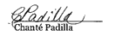

Next Monthly Board Meeting: Wednesday, April 8th, 2026, 9:30 AM - 11:00 PM. https://us06web.zoom.us/j/85852438497?pwd=GhSaLjW8LD03ZBoa4fAgz12XNh7cGe.1
Meeting ID: 858 5243 8497 Passcode: 881981

Addendum

Treasurer’s Report from VP of Finance - Joy Gardner
Pg 1 of 1

NABIP-NORTHERN NEVADA Treasurer’s Report
Month end 2/28/2026

Partnerships 2026:
Diamond-$8,500
Platinum-$5,500-Anthem Paid
Gold-$4,000 Hometown Health Paid, United Healthcare Invoiced
Silver-$2,000 Aetna & Word & Brown Invoiced

Umpqua Bank Balance: 2/28/2026
Checking $73,042.51
Savings $200.40
See attached bank statement

Budget vs Actual: Attached

Luncheon: 2/11/2026
Attendance: 46 (28 attendees, 12 Ambassadors, 4 speakers, 2 Sponsors)
No Shows: ( 0 Ambassadors, 3 Members)
Walk Ins: 6
Income: $1,154.00 + $420 (Ambassadors) + $245 (Sponsors) = $1,819.00
Cost: $2,116.90
Raffle Income: $260.00

Additional Information:

We need more partnerships or we need to eliminate some spending for this year.

Prominence Health Plans owe us $375 from 2020. I verified we have not received the funds and requested payment. Have not received it as of 2/28/2026

Both the Checking and Savings accounts balance.

Star Chapter rates are going up April 1, 2026, to $147.00. I will adjust the budget accordingly.

Respectfully submitted:

Joy K Gardner

Columbia Statement February 2026
Pg 1 of 2
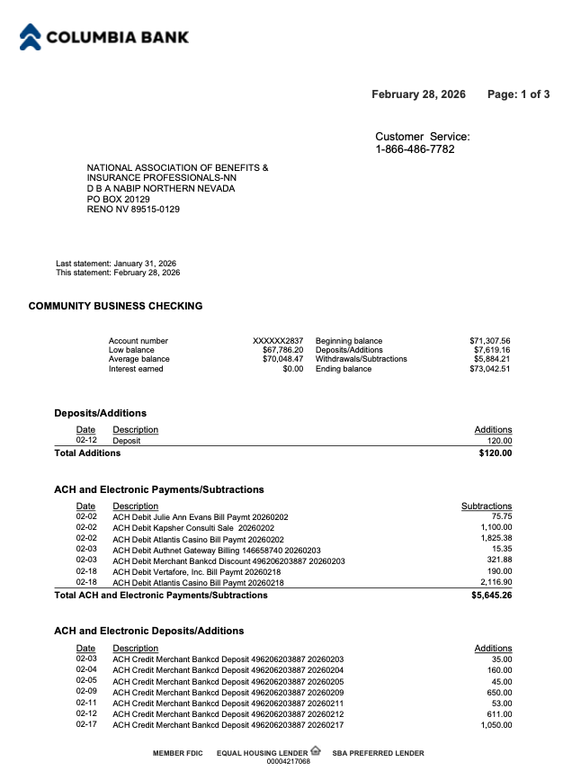

Columbia Statement February 2026
Pg 2 of 2
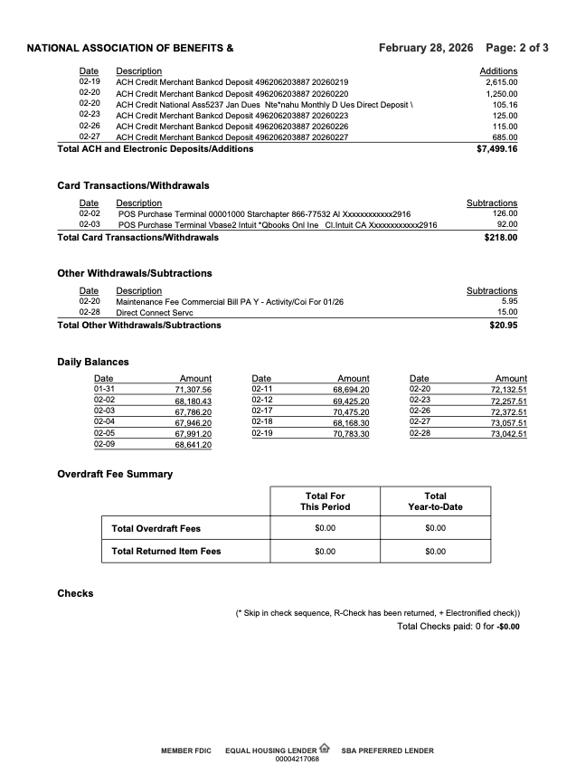

Reconciliation of Check and Savings Accounts
PG 1 of 1
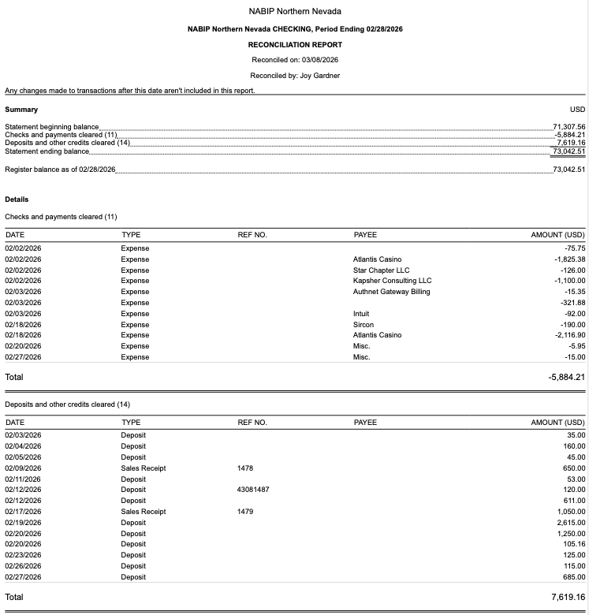
﻿

﻿

NABIP NN Budget vs Actual February 2026 Profit and Loss
Pg 1 of 2

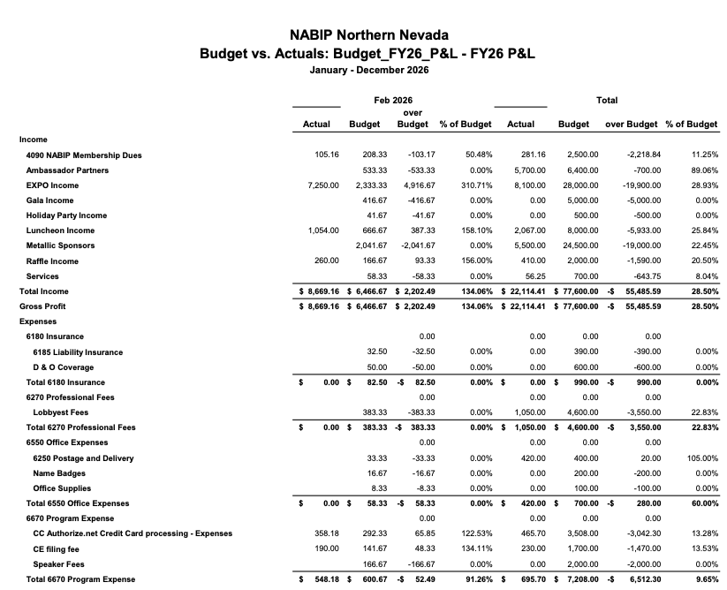

NABIP NN Budget vs Actual February 2026 Profit and Loss
Pg 2 of 2

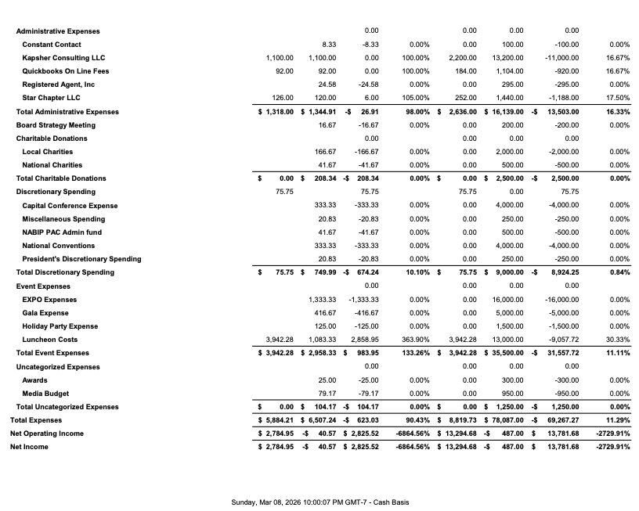

NABIP NN Profit and Loss by Month. February 2026
Pg 1 of 1
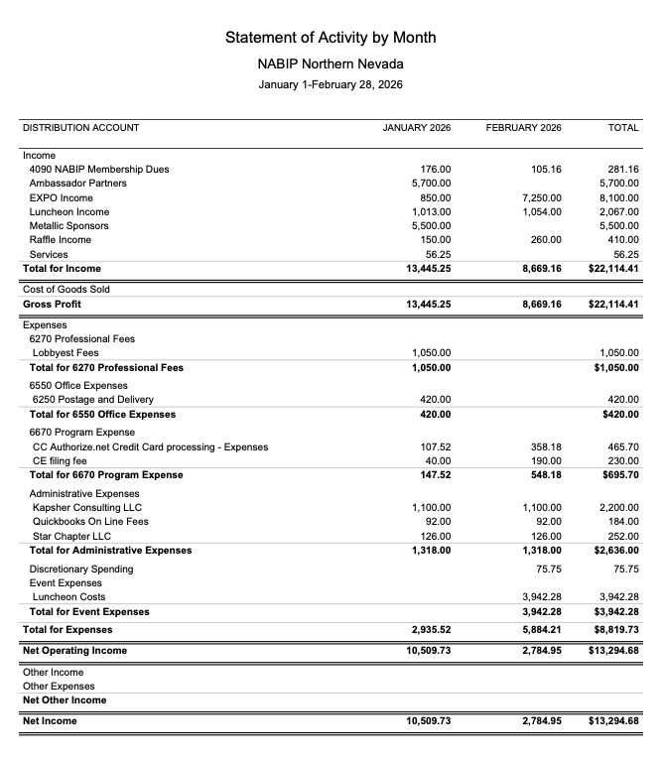

Report from the VP - Georgana Cepeda
PG 1 of 4

National Association of Benefits and Insurance Professionals
Northern Nevada Chapter – Board of Directors Meeting
2026 EXPO REPORT MARCH 2026
Expo Date: April 29, 2026
Theme: Country
Theme/Slogans:
● Saddlin Up for Success
Committee Update
The first Expo Committee meeting was held on January 8, 2026.
Last Expo Committee meeting was held March 5, 2026.

Here is a 1-Page Board Snapshot version. This format is typically what boards prefer because it highlights status, risks, and key decisions quickly.

NABIP Northern Nevada

2026 Expo – Board Snapshot
Board of Directors Report | March 2026
Expo Date: April 29, 2026
Location: Atlantis Resort
Theme: Country
Theme Slogan: “Saddlin’ Up for Success”

Report from the VP - Georgana Cepeda
PG 2 of 4

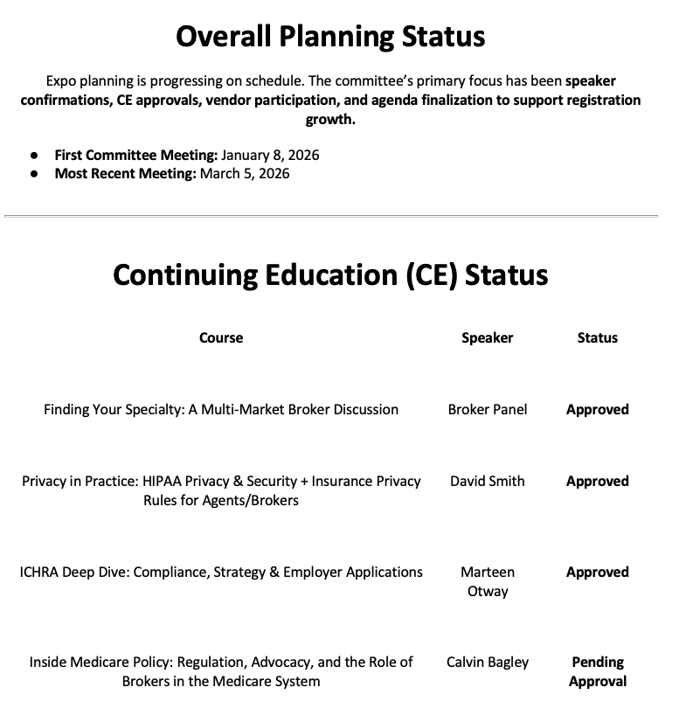

Report from the VP - Georgana Cepeda
PG 3 of 4

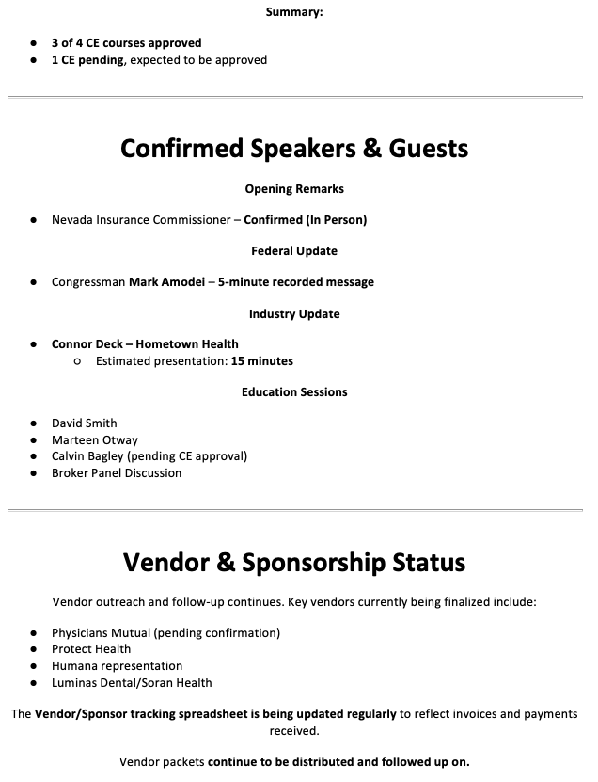

Report from the VP - Georgana Cepeda
PG 4 of 4
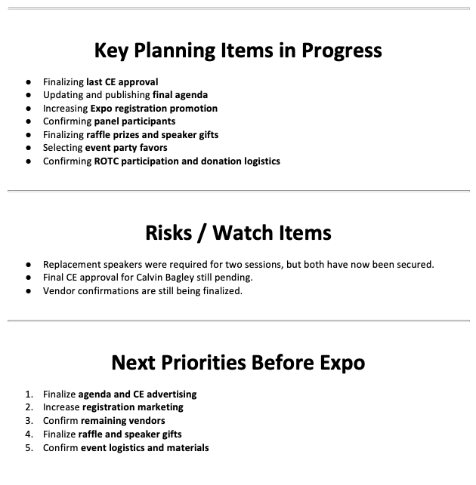

Report from the VP of Professional Development - Julie Ann Evans
PG 1 of 2

NABIP NN - Professional Development Board Meeting Notes 03/11/2026

1. NABIP NN - February Monthly Luncheon:

a. This was a CE approved event.

b. There was a total of 37 CEs processed on February 17th.

c. There is a $1.25 fee per CE processed, so we should see an invoice from Sircon for $46.25.

2. NABIP NV - February CE Class:

a. There was a total of 51 CEs processed on February 18th.

b. There is a $1.25 fee per CE processed, so NABIP NN should see an invoice from Sircon for $63.75.

3. NABIP NV - April CE Class:

a. The course material was submitted on February 17th and approved on February 18th, and the course offering was created on March 10th.

b. There is a $40.00 filing fee, so we should see an invoice from Sircon for $40.00.

4. NABIP NN - Annual Expo:

a. A total of four CEs have been submitted and approved for this event.

i. As two of the classes will be a breakout session, there will be three CEs available for those who attend the entire day.

b. At the last hour two of the committed speakers backed out, thankfully we were able to quickly secure replacement speakers.

c. The course material for the broker panel was submitted on March 5th and approved on March 6th, and the course offering was created on March 10th.

Report from the VP of Professional Development - Julie Ann Evans
PG 2 of 2

d. The course material for Marteen Otway was submitted on March 5th and approved on March 6th, and the course offering was created on March 10th.

e. The course material Calvin Bagley was submitted on March 6th and approved on March 9th, and the course offering was created on March 10th.

f. There is a $40.00 filing fee per class, so we should see an invoice from Sircon for $120.00.

g. All the information needed to properly advertise the event (i.e. course title, course ID, course type, course objective/description, speaker bios, and headshots) was sent to Kapsher on March 9th.

5. NABIP NV - September CE Class:

a. The course material was submitted on February 17th and approved on February 18th, and the course offering was created on March 10th.

b. There is a $40.00 filing fee, so we should see an invoice from Sircon for $40.00.

6. NABIP Region 8 Professional Development Meeting:

a. I attended this virtual meeting, which was held on February 27th.

b. Topics discussed included reviewing the joint Google document where all the Region 8 chapters can share ideas on topics and speakers, and how to increase attendance at local monthly luncheons and events.

7. NABIP NV - Monthly Professional Development Meeting:

a. Typically, on the 4th Friday of each month there is a virtual meeting held for those who are involved with planning luncheons, events, CE classes, etc. for both local chapters and the state chapter.

b. The next meeting will be held on March 27th at 2:00 PM, and all are welcome to attend the meeting.

Report from the VP of Awards - Ross Pendergraft
PG 1 of 1

NABIP-NN Awards Report for March 11, 2026
1. Awards – Items needing attention:

a. Board Meeting Minutes 2025-2026 – Posted on the Website

· Last one posted is January 2026

· I will need the March 11, 2026, Minutes by April 2, 2026

2. Legislative Chair, Mary Lou Urrutia, attended Capitol Conference – 75 points

3. President-Elect, Georgana Cepeda, at NABIP Leadership training Capitol Conference – 150 points

4. Submit for DSA – Working on this right now

5. REPEAT: Even though this has been eliminated from Pacesetter Awards, I still strongly recommend you complete the NABIP Leadership Training. This will help with your position. Be sure to sign-in before watching the video: https://videos.nabip.org/

6. REPEAT: The New Member Orientation will continue every 4th Thursday at 9:00am PST on Zoom. Need to make sure we keep blasting this out in our newsletter each month

a. Zoom meeting ID 826 3420 3381, Passcode “Membership”

b. http://welcometonabip.org

Respectfully submitted,
Ross Pendergraft
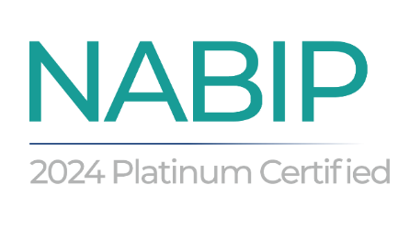

Report from the Vice President of Legislative Affairs - Mary Lou Urrutia
Pg 1 of 2

Legislative Report for March

As of March 10, 2026, Congress is primarily focused on Affordable Care Act (ACA) subsidy extensions, Pharmacy Benefit Manager (PBM) reforms, and telehealth flexibilities. While a major health package was signed into law in February 2026, significant legislative tension remains over long-term affordability and Medicaid oversight.
Recent Legislative Actions (February 2026)
In early February 2026, President Trump signed a budget package that included several critical healthcare provisions:
- Medicare Telehealth Extension: Extended key telehealth waivers through December 31, 2027, preserving access to non-behavioral health services in the home and audio-only visits.
- Hospital at Home Program: Extended this program through September 30, 2030.
- PBM Reforms: Included measures to increase transparency, curb certain Medicare drug rebate practices, and strengthen enforcement against anti-competitive behavior.
- Public Health Programs: Granted one-year extensions (through 2026) for the Community Health Center Fund, National Health Service Corps, and Special Diabetes Programs.
Ongoing Sticking Points and Investigations
- ACA Premium Tax Credits: Enhanced subsidies expired on December 31, 2025, leading to significant premium increases for millions of Americans. Although the House passed an extension in January 2026—defying GOP leadership through a discharge petition, the measure remains stalled in the Senate as of March 2026.
- Medicaid Fraud Investigation: On March 3, 2026, Republican leaders of the House Energy and Commerce Committee expanded their investigation into alleged fraud within the Medicaid program, sending inquiry letters to 10 states.
- Cybersecurity: Following recent health-related cyberattacks, Congress is currently drafting a new legislative response to bolster healthcare system security.

Report from the Vice President of Legislative Affairs - Mary Lou Urrutia
Pg 2 of 2

The "Great Healthcare Plan" Proposal
The Trump Administration has called on Congress to codify its "Great Healthcare Plan," which proposes:
- Direct Payments: Ending traditional subsidy payments to insurance companies and instead sending funds directly to eligible Americans to purchase private plans.
- Cost-Sharing Reductions: Funding a program intended to reduce premiums by over 10%.
- Transparency: Requiring "plain English" insurance standards and publicizing pricing for any provider accepting public insurance.
Current Activity (Week of March 10, 2026)
The U.S. Senate is the only chamber in session this week; however, no major healthcare legislation is scheduled for floor consideration. Activity is concentrated at the committee level, focusing on:
- Healthcare AI & Data: The Senate HELP Committee recently held hearings on the role of artificial intelligence and interoperability in patient outcomes.
- Nutrition Training: A new initiative was announced by HHS and the Department of Education to expand nutrition education in medical schools starting in fall 2026.

Report from the Medicare Chair - Merre Gregory
Pg 1 of 1

NABIP February 2026 Medicare Chair Report

NABIP February 2026 Medicare Chair Report – Capitol Conference
Our group had a great experience attending the Capitol Conference in Washington, DC. With Aliana serving as our helm leader, along with Georgana, Ross, and myself, it was a productive and inspiring event. We heard from many excellent speakers and had meaningful conversations about the future of Medicare and the role of agents and brokers.
I highly recommend that anyone who has not yet attended a Capitol Conference consider going in the future. It is a valuable opportunity to connect with fellow members, hear from policy leaders, and advocate for the issues that matter most to our profession and our clients.
One highlight of the trip was meeting with the legislative assistant for Congressman Mark Amodei. I was very impressed with how willing he was to listen to our conversation points and engage in discussion. Aliana did a fantastic job starting the conversation and presenting our concerns with clear and expressive insight, which really drew him into the discussion.
That meeting made me feel hopeful that our efforts are making an impact and that our voices are being heard on Capitol Hill. I’m looking forward to continuing this work and encouraging even more NABIP members to get involved in future advocacy opportunities.
The weather was extreme and unfortunately Mary Lou was not able to be in attendance, she was missed very much!

