National Association of Benefits and Insurance Professionals
Northern Nevada Chapter

Board of Directors Meeting Minutes
April 8th, 2026, 9:39 AM - 10:53 AM
Via Zoom – Meeting ID = us02web.zoom.us/j/84698950624

Attendance Report: Aliana Rushing, Merre Gregory, Chanté Padilla, Mary Lou Urrutia, Georgana Cepeda, Joy Gardner, Breezé Yerves

Virtual Attendance: Dave Sherrill

Absent: Molly Moreno, Adrienne Saintil, Don Goldmann, Jay Eldridge, Gina Espinal-Aguerre,
Ashley Kapostins, Ross Pendergraft

Guests: none

- Meeting called to order by President Aliana Rushing at 9:39 AM.

- Roll Call of attendees was taken by sight for those attending in person and on Zoom by President, Aliana Rushing. Quorum confirmed. Connectivity confirmed.

- Review of the March 2026 board minutes by Secretary, Chanté Padilla.

  - A motion to approve the board minutes was made by Chanté Padilla and seconded by Julie Ann Evans . Unanimously approved.

- President’s report by Aliana Rushing. Written report entered into the minutes with brief discussion.

  - Brief discussion of attendance to the National Convention-cost and travel.

    - Delegation to the national convention was debated and, given cost constraints, the board moved to split the available $4,000 budget between two attendees at $2,000 each and coordinate shared lodging and travel to reduce per-person cost. Discussions then turned to final Expo logistics including registration counts, vendor/table registration complexity, media and communications work, legislative and benefits updates.

    - Georgana will run the updated convention cost numbers with Mary Lou so the board can confirm affordability for two delegates.

    - Mary Lou will coordinate flight and lodging bookings with the delegates who attend so they can share travel arrangements.

    - The committee will meet immediately after this meeting to address remaining expo logistics

  - Brief discussion of NN NABIP Gala planning.

    - Ashley will start working on the gala flyer using the “Night Under the Starts” theme.

    - Aliana Rushing will ask Eloisa to prepare a cost estimate for the Gala to inform sponsorship and ticket pricing decisions.

  - The president will confirm with Don whether he will prepare proposed bylaw edits to make positions voting roles and will work with him to assemble the annual membership meeting agenda.

- Secretary report by Chanté Padilla.

  - With the approval of the March 2026 minutes there was nothing else to report.

- VP of Finance’s report by Joy Gardner. Written report received and added into the addendum.

- Committee Reports

  - Vice President’s report by Georgana Cepeda. Written report submitted and entered into the addendum.

    - In lieu of Luncheon, members are invited to stay for lunch to assist with EXPO

  - Director of Program’s report by Aliana Rushing. Written report submitted and entered into the minutes.

    - April luncheon was cancelled due to low attendance. The Program, PD and Medicare committee heads worked together to create a program on May 20th that should not counter our June program since they are different topics.

    - All programs for May, June and July have been finalized with enough time for CE Processing.

    - August Luncheon - It is my goal to have a PBM come in to discuss GLP-1s. I have reached out to one recommended by Heidi Sterner and did not hear back. I am hoping someone on the board can assist me if anyone else has contacts at PBM’s. The CE submission deadline for this would be early June so I’d like to finalize that asap.

    - September Gala - I would like to form a committee for the Gala to create a flyer and a theme. I am hoping this can be done before the expo so that we can advertise it appropriately at the expo and also need to discuss if we want to have sponsors again for it. My thoughts are to ask W&B, Aetna Medicare, and Health Spring for the sponsorships.

    - October Luncheon - the October luncheon will be a broker panel to discuss the fall out of the NV health link changes, and how it played out for those who had to go uninsured, underinsured, or a difficult time managing their Medicaid. Three panelists are confirmed. Julie Ann and Aliana Rushing will be working together to create questions and submit the CEs prior to the deadline.

    - November - DARK

    - December - Christmas Party venue is booked.

  - VP of Professional Development’s report by Julie Ann Evans. Written report submitted and entered into the addendum.

  - Vice President of Media and Communication’s report by Donald Goldmann. Absent. Written report submitted and entered into the addendum.

  - Vice President of Membership’s report by Gina Espinal-Aguerre and Breeze Yerves. Absent, no report.

  - Vice President of Awards’ report by Ross Pendergraft. Absent, no report.

  - Vice President of Legislative Affairs’ report by Mary Lou Urrutia. Written report submitted and entered into the addendum with brief discussion.

    - Reviewed select details from the submitted report.

  - Employer Benefits Chair’s report by Breeze Yerves. No report.

    - Breeze will continue to clean up the A&H membership list by adding current members and removing departed individuals

  - Medicare Chair’s and VP of Medicare Chair’s report by Merre Gregory. Written report submitted and entered into the addendum with brief discussion.

    - Reviewed select details from the submitted report.

    - Strong emphasis on the benefits of NABIP members attending CapCon.

    - Brief update new Medicare numbers will be sent out to Medicare recipients due to arising issues with Medicare numbers.

      - Many carriers may charge back, and agents need to be watching their commission statements.

      - Should reach out to clients indicating Medicare cards may be coming and what should clients do.

      - Confirmed that Merre will confirm which states will be affected by new Medicare cards.

  - LPRT Chair’s report by Joy Gardner. No report.

  - DEIB Chair’s report by Adrienne Saintil. Absent, no report.

  - NABIP Foundation chair’s report by Julie Ann Evans. No report.

  - Director of NABIP PAC’s report by Jay Eldridge. Absent, no report

  - Past President’s report by Molly Moreno. Absent, no report.

- A motion was made by Julie Ann Evans and seconded by Mary Lou Urrutia to accept all reports in toto. Unanimously approved.

- Old Business: None.

- New Business: None.

- A motion to adjourn meeting by Aliana Rushing, seconded by Gina Espinal-Aguerre. Unanimously approved.

- President Aliana Rushing adjourned the meeting at 10:53 am.

- Submitted by Chanté Padilla NABIP NN Secretary.
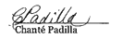

Next Monthly Board Meeting: Wednesday, May 13th, 2026, 9:30 AM - 11:00 PM. https://us06web.zoom.us/j/85852438497?pwd=GhSaLjW8LD03ZBoa4fAgz12XNh7cGe.1
Meeting ID: 858 5243 8497 Passcode: 881981

Addendum

Treasurer’s Report from VP of Finance - Joy Gardner
Pg 1 of 1

NABIP-NORTHERN NEVADA Treasurer’s Report
Month end 3/31/2026

Partnerships 2026:
Diamond-$8,500
Platinum-$5,500-Anthem Paid
Gold-$4,000 Hometown Health Paid, United Healthcare Invoiced
Silver-$2,000 Aetna & Word & Brown Invoiced

Umpqua Bank Balance: 3/31/2026
Checking $79,803.67
Savings $200.43
See attached bank statement

Budget vs Actual: Attached

Luncheon: 3/11/2026
Attendance: 47 (32 attendees, 9 Ambassadors, 3 speakers, 3 Sponsors)
No Shows: (3 Ambassadors 2 Members, 1 Speaker)
Walk Ins: 2
Income: $1,266.50 + $420 (Ambassadors) + $245 (Sponsors) = $1,931.50
Cost: $1,906.35
Raffle Income: $260.00

Additional Information:

We need more partnerships or we need to eliminate some spending for this year.

Prominence Health Plans owe us $375 from 2020. I verified we have not received the funds and requested payment. Have not received it as of 4/10/2026

Both the Checking and Savings accounts balance.

Star Chapter rates are going up April 1, 2026, to $147.00. I will adjust budget accordingly.

All but one vendor has paid for the EXPO.

Respectfully submitted:

Joy K Gardner

Columbia Statement March 2026
Pg 1 of 3
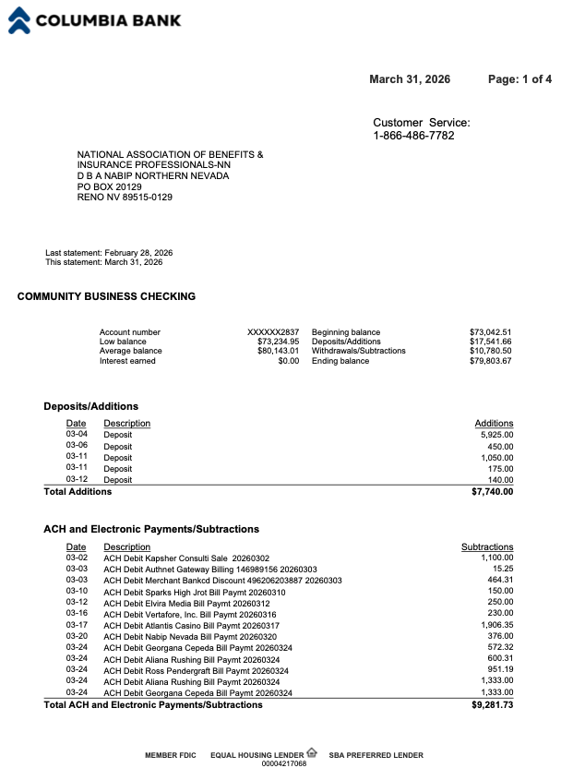

Columbia Statement March 2026
Pg 2 of 3
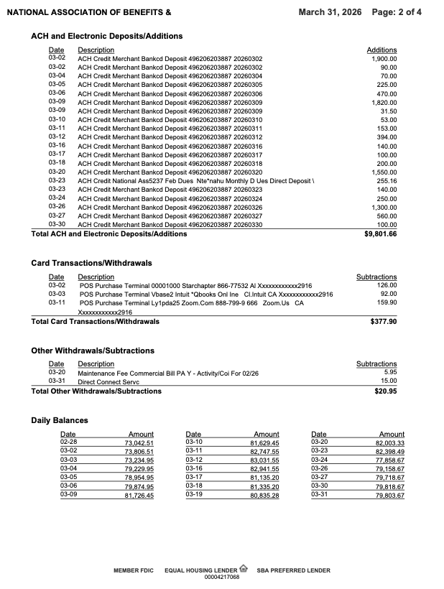

Columbia Statement March 2026
Pg 2 of 3
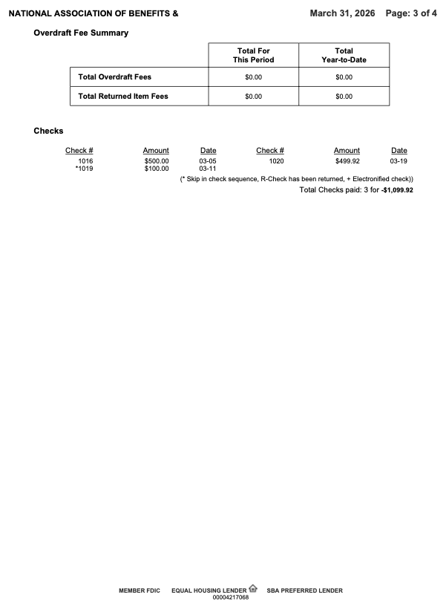
Reconciliation of Check and Savings Accounts
PG 1 of 2
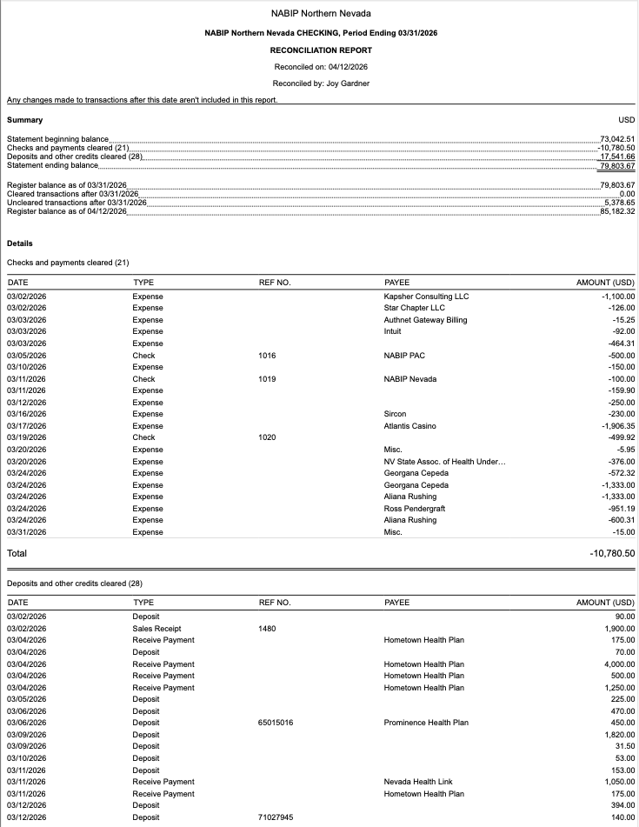
﻿Reconciliation of Check and Savings Accounts
PG 2 of 2

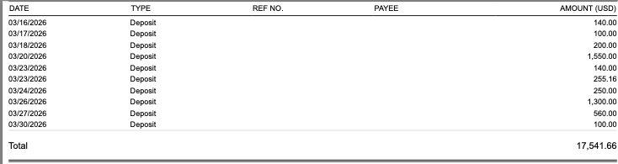

﻿

NABIP NN Budget vs Actual March 2026 Profit and Loss
Pg 1 of 2

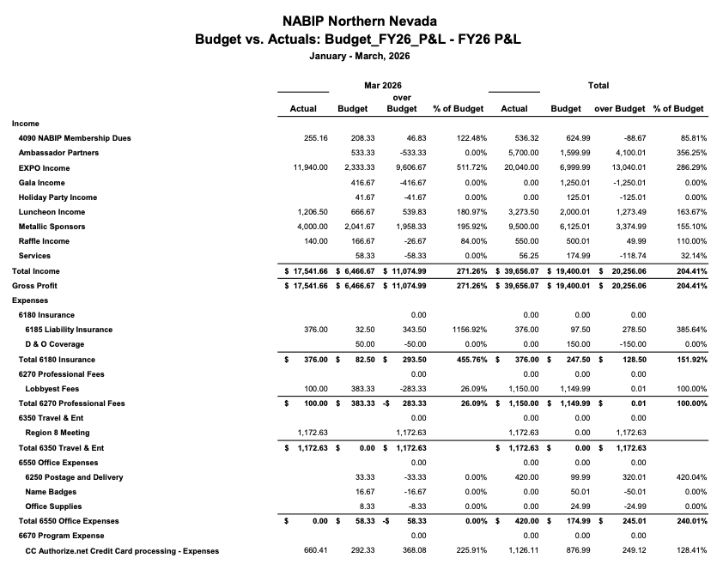

NABIP NN Budget vs Actual March 2026 Profit and Loss
Pg 2 of 2

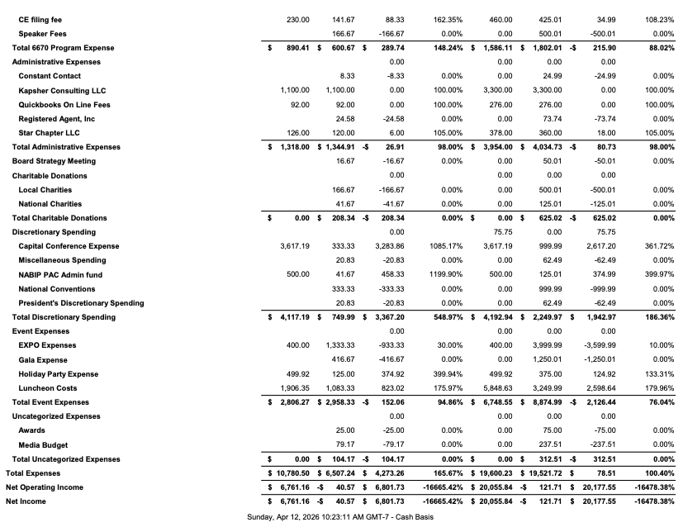

NABIP NN Profit and Loss by Month. March 2026
Pg 1 of 2
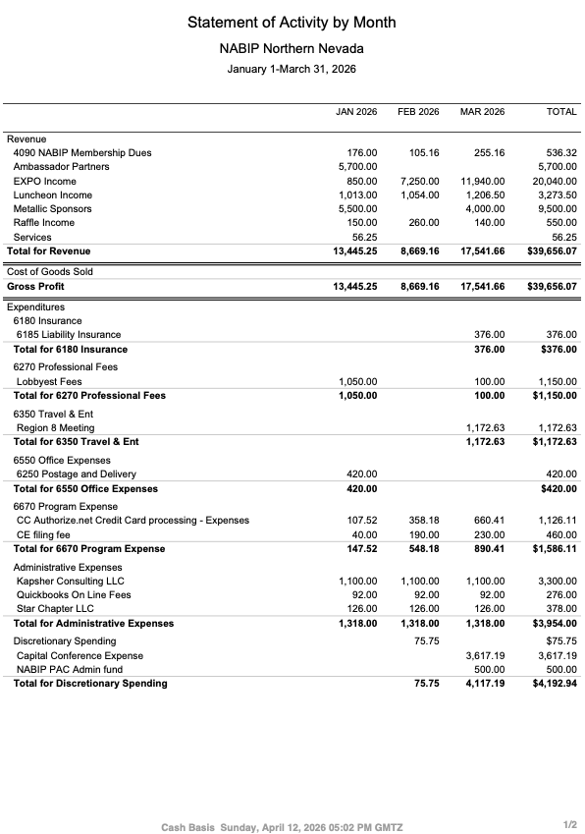
NABIP NN Profit and Loss by Month. March 2026
Pg 2 of 2
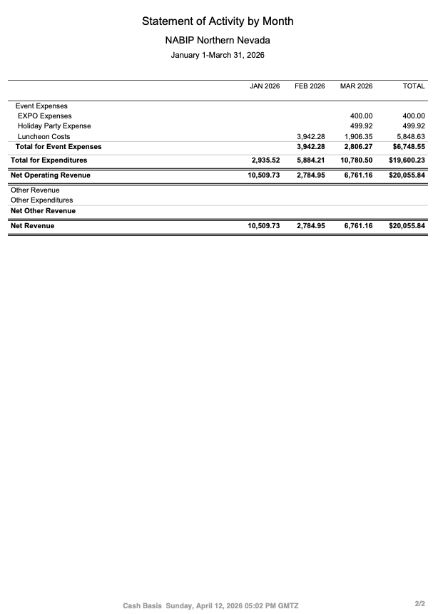
Report from the VP - Georgana Cepeda
PG 1 of 2

National Association of Benefits and Insurance Professionals (NABIP)
Northern Nevada Chapter – VP Board of Directors Report
2026 Expo Update | April 2026

Expo Overview
- Event Date: April 29, 2026
- Location: Atlantis Resort & Casino, Reno
- Theme: Country
- Theme Slogan: “Saddlin’ Up for Success”

Planning Timeline
- First Committee Meeting: January 8, 2026
- Most Recent Meeting: April 2, 2026
Expo planning remains on schedule, with strong progress across all key areas. Current efforts are focused on vendor acquisition, attendee registration, and final event logistics.

Program & Speakers
All speakers and Continuing Education (CE) courses have been approved and confirmed.
Opening Remarks
- Congressman Mark Amodei – 5-minute recorded message
- Nevada Insurance Commissioner – Confirmed (In-Person)
- Connor Deck, Hometown Health
  - Estimated presentation: 15 minutes
Education Sessions
- David Smith
- Marteen Otway
- Calvin Bagley
Report from the VP - Georgana Cepeda
PG 2 of 2
- Broker Panel Discussion

Vendor & Sponsor Status
- Ongoing vendor outreach and follow-up
- Vendor/Sponsor tracking spreadsheet is actively maintained and current as of April 2, 2026
- Vendor packets continue to be distributed and followed up on consistently

Key Planning Items in Progress
- Expanding Expo registration marketing and promotion efforts
- Finalizing raffle prizes and speaker appreciation gifts
- Donation logistics

Pre-Event Priorities
- Increase attendee registration and marketing outreach
- Confirm remaining vendors and sponsors
- Finalize raffle prizes and speaker gifts
- Confirm all event-day logistics and operations

Summary
The 2026 NABIP Northern Nevada Expo is well-positioned for success, with strong momentum in planning, confirmed speakers, and ongoing vendor engagement. Final efforts are centered on maximizing attendance, securing remaining vendors, and ensuring a seamless event experience.

Report from the VP of Professional Development - Julie Ann Evans
PG 1 of 2

NABIP NN - Professional Development Board Meeting Notes 04/08/2026

1. NABIP NN - March Monthly Luncheon:

a. This was a CE approved event.

b. There was a total of 31 CEs processed on March 11th.

c. There is a $1.25 fee per CE processed, so we should see an invoice from Sircon for $38.75.

2. NABIP NV - March CE Class:

a. There was a total of 20 CEs processed on March 20th.

b. There is a $1.25 fee per CE processed, so NABIP NN should see an invoice from Sircon for $25.00.

3. NABIP SN - April Monthly Luncheon:

a. This will be a CE approved event where they will be doing the “Group Carrier Panel” that NABIP NN did on March 11th.

b. A new course offering was created on March 12th.

c. The sign in sheet was created and sent to Heidi Sterner on
March 23rd.

4. NABIP NN - May Monthly Luncheon:

a. This will be a CE approved event.

b. The course material was submitted on March 27th and approved on March 30th, and the course offering was completed on March 31st.

c. There is a $40.00 filing fee, so we should see an invoice from Sircon for $40.00.

2. NABIP NN - June Monthly Luncheon:

a. This will be a CE approved event.
Report from the VP of Professional Development - Julie Ann Evans
PG 2 of 2

b. The course material was submitted on March 13th and approved on March 17th, and the course offering was created on March 17th.

c. There is a $40.00 filing fee, so we should see an invoice from Sircon for $40.00.

3. NABIP NN - July Monthly Luncheon:

a. This will be a CE approved event.

b. The course material was submitted on March 27th and approved on March 31st, and the course offering was created on March 31st.

c. There is a $40.00 filing fee, so we should see an invoice from Sircon for $40.00.

4. NABIP NV - July CE Class:

a. The course material was submitted on March 27th and approved on March 31st, and the course offering was created on March 31st.

b. There is a $40.00 filing fee, so NABIP NN should see an invoice from Sircon for $40.00.

5. NABIP Region 8 Professional Development Meeting:

a. The Region 8 Professional Development meeting scheduled for March 27th was canceled due to the Chair being ill.

6. NABIP NV - Monthly Professional Development Meeting:

a. Typically, on the 4th Friday of each month there is a virtual meeting held for those who are involved with planning luncheons, events, CE classes, etc. for both local chapters and the state chapter.

b. The next meeting will be held on April 24th at 2:00 PM, and all are welcome to attend the meeting.

Report from the VP of Media & Communications - Donald Goldmann
PG 1 of 1
Media Report for April

The April newsletter went out on time without any problems.

After discussions with Georgana and Aliana, we came up with the idea for enhancing publicity for the Expo by doing "single focus expo flyers" in which there will be a unique header for a different speaker and/or topic for each different mailer.

Hopefully, each flyer will have an attention-grabbing headline with a short comment, followed by a copy of the entire flyer with the agenda. Kapsher will add any creative visuals that they feel will improve the final version for emailing out.

We will aim for a different single focus version for each Monday, Wednesday and Friday over the next few weeks leading up to the Expo.

A draft sample of the first version is below:

Report from the Vice President of Legislative Affairs - Mary Lou Urrutia
Pg 1 of 2

April 2026 – Legislative Report
The “biggest item happening is the release of the Medicare Advantage (MA) and Part D Final Rule, which I know Merre will be giving a thorough report. I have decided to educate on how NABIP stands on proposed and passed legislation affecting Medicare, group & individual plans (ACA).
The first item attached is the 2025 End-of-Year Impact Report (Q3-Q4) sent by our president Susan Rider.

I have attached letters written by Michael Andel, Senior Vice President of Governmental Affairs, NABIP stating how NABIP stands.

Proposed regulation by the Department of Labor about - Improving Transparency Into
Pharmacy Benefit Manager Fee Disclosure

Report sent out by CMS titled - HEALTH INSURANCE EXCHANGES 2026 OPEN ENROLLMENT REPORT.

The first item attached is the 2025 End-of-Year Impact Report (Q3-Q4) sent by our president Susan Rider.
There is a lot of information, read all or read what interests you!

Report from the Vice President of Legislative Affairs - Mary Lou Urrutia
Pg 2 of 2

Please refer to the hyper-link(s) below for comprehensive and up-to-date information regarding Northern Nevada NABIP and developments within the insurance industry. The material provided is highly informative and offers valuable context, key insights, and relevant updates that will enhance understanding of the topic at hand.

2026 Comment - 2027 NBPP - Patient Protection and Affordable Care Act; HHS Notice of Benefit and Payment Parameters for 2027 and Basic Health Program

HEALTH INSURANCE EXCHANGES 2026 OPEN ENROLLMENT REPORT - CMS Report: 2026 Marketplace Open Enrollment

nabip_quarterlyimpactreport_2025_q3-q4_digital_final2.pdf - Our 2025 End-of-Year Impact Report

nabip-comment-letter_january-26-2026_cms-4208-p.pdf CMS-4212-P - Medicare Program; Contract Year 2027 Policy and Technical Changes to the Medicare Advantage and Part D Programs

https://www.federalregister.gov/documents/2026/01/30/2026-01907/improving-transparency-into-pharmacy-benefit-manager-fee-disclosure - Improving Transparency into Pharmacy Benefit Manager Fee Disclosure

Report from the Medicare Chair - Merre Gregory
Pg 1 of 4
NABIP Medicare Chair Report March 2026
Summary of CMS Final Rule Updates for Medicare Advantage and Part D (Effective June 1, 2026, for 2027 Coverage)
- The final rule takes effect June 1, 2026, applying to coverage beginning in 2027.
- CMS will not implement the Excellent Health Outcomes for All reward; instead, it continues the historic reward factor for high performance across all enrollees and measures.
- Eleven-star ratings measures (mostly administrative or with little variation) are removed, with the “diabetes care – eye exam” measure retained after feedback. These changes will impact 2027 measurement and 2029-star ratings and are estimated to affect the Medicare Trust Fund by $18.6 billion over ten years.
- A new depression screening and follow-up measure is added to address behavioral health gaps, starting with the 2027 measurement year and reflected in 2029-star ratings.
- The proposed special enrollment period for enrollees whose providers leave their MA network was not finalized but may be considered in future rulemaking.
- Part D changes codified under the Inflation Reduction Act include the elimination of the coverage gap phase, a $2,000 annual out-of-pocket threshold, zero cost-sharing in the catastrophic phase, and a new Manufacturer Discount Program.
- Supplemental benefit debit card guardrails require real-time verification and limit use to the plan year, while plans must publicly post eligibility criteria for special supplemental benefits for the chronically ill. A ban on marketing benefit dollar values was not finalized.
- Cannabis products illegal under state or federal law are not allowed as SSBCI benefits.
- Four health equity requirements are rolled back: no health equity expert or annual analyses on utilization management committees, no mandatory health disparity activities in quality improvement, and no mid-year notices for unused supplemental benefits.
- Account-based plans are exempt from creditable coverage disclosures, and restrictions on agent and broker conversations with beneficiaries are removed.
- CMS will consider comments on risk adjustment modernization (including AI models), C-SNP/D-SNP enrollment trends, and policies for enrollee wellbeing, nutrition, and preventive care for future rulemaking. Over 42,000 comments were received on the proposed rule.

Report from the Medicare Chair - Merre Gregory
Pg 2 of 4

Medicare Advantage insurers will receive a 2.48% boost to payments next year. To understand the impact of the 2.48% payment boost for Medicare Advantage insurers next year, consider the following points: The increase aims to enhance the financial stability of Medicare Advantage plans.
· It may lead to improved benefits and services for enrollees.
· Insurers could use the additional funds to expand coverage options.
· The boost reflects adjustments based on healthcare cost trends.
· Beneficiaries might see changes in premiums or out-of-pocket costs.
· This adjustment is part of ongoing efforts to ensure quality care in Medicare programs.

Summary of CMS Final Rule for Contract Year 2027 Medicare Programs
Key Changes to Medicare Advantage and Part D Star Ratings
On April 2, 2026, CMS issued a final rule updating the Medicare Advantage (MA), Medicare Prescription Drug Benefit (Part D), and Medicare Cost Plan programs for Contract Year 2027. The rule aims to enhance care quality and accessibility by revising MA and Part D Star Ratings and simplifying enrollment procedures.
The Star Ratings system, which helps beneficiaries evaluate plan quality and impacts Quality Bonus Payments, will undergo significant changes. First, CMS will not implement the Excellent Health Outcomes for All reward (formerly the Health Equity Index reward) for 2027 Star Ratings, instead maintaining the historical reward factor. Second, 11 measures related to administrative processes and areas with little performance variation will be removed to reduce administrative burden. A new Part C Depression Screening and Follow-Up measure will be introduced to address behavioral health gaps starting with the 2027 measurement year and 2029 Star Ratings. CMS also finalized a technical clarification regarding contract consolidations.
Overall, these updates refocus Star Ratings on clinical care, outcomes, and patient experience, streamlining the program and eliminating measures that offer minimal distinction between plans.

Implementing Certain Provisions of the Inflation Reduction Act (IRA) of 2022
The IRA of 2022 made major changes to the Medicare Part D prescription drug benefit and directed CMS to implement these changes through 2026 via program instructions. With this program instruction authority expiring, CMS is codifying these changes for 2027 and
Report from the Medicare Chair - Merre Gregory
Pg 3 of 4

beyond, including eliminating the coverage gap phase, establishing a reduced annual out-of-pocket threshold, removing cost sharing for enrollees in the catastrophic phase, and incorporating the Manufacturer Discount Program that replaced the Coverage Gap Discount Program on January 1, 2025. CMS is also codifying additional operational
changes including updates to True Out-Of-Pocket cost calculations, specialty-tier rules, reinsurance payment methodologies, and implementation of the Selected Drug Subsidy.
Summary of IRA Provisions for Medicare Part D
CMS is making permanent several improvements to Medicare Part D, as required by the Inflation Reduction Act of 2022, starting in Contract Year 2027. These changes include:
- Ending the coverage gap phase in Part D plans.
- Lowering the annual out-of-pocket maximum for beneficiaries.
- Eliminating cost sharing for people in the catastrophic phase.
- Replacing the Coverage Gap Discount Program with the Manufacturer Discount Program, effective January 1, 2025.
- Updating operational features such as True Out-Of-Pocket cost calculations, specialty-tier rules, reinsurance payments, and implementing the Selected Drug Subsidy.
Altogether, these reforms are designed to make prescription drug coverage more affordable and accessible for Medicare beneficiaries.

CMS is refining its regulations regarding cannabis products by amending current regulatory language to state more precisely that cannabis products that are illegal under applicable State or Federal law, are not allowable as SSBCI. This clarification aligns MA benefit policies with current federal law while maintaining safeguards.
Revise List of Non-Allowable Special Supplemental Benefits for the Chronically Ill (SSBCI) Provisions Related to Supplemental Benefits Being Finalized from the CY 2026 Proposed Rule
· CMS is finalizing two supplemental benefit policies that were proposed in the CY 2026 rule: (1) strengthening SSBCI administration by clarifying eligibility requirements, and increasing transparency by requiring plans to publicly post their plan-developed SSBCI eligibility criteria; and (2) codifying and clarifying requirements for administering supplemental benefits through debit cards, including that debit cards be electronically linked to plan-covered items and services through a real-time identification mechanism to verify

Report from the Medicare Chair - Merre Gregory
Pg 4 of 4

eligibility of plan-covered benefits (products) at the point of sale; and that debit cards be limited to the specific plan year.
Reducing Regulatory Burden and Costs in Accordance with Executive Order 14192
CMS is finalizing several changes to remove duplicative and burdensome regulatory requirements that have limited beneficiary choice, hindered innovation and increased costs:
· Exempting account-based plans (such as health reimbursement arrangements, flexible spending accounts, and health savings accounts) from creditable coverage disclosure requirements.
· Rescinding the requirement for MA plans to send mid-year notices about unused supplemental benefits.
· Eliminating the requirement for MA quality improvement programs to include activities that reduce health disparities.
· Eliminating health equity requirements for MA Utilization Management Committees, including requiring a health equity expert member, conducting annual health equity analyses, and publicly posting these analyses.
· Waiving the requirement for the Limited Income Newly Eligible Transition program to maintain toll-free customer call centers open from 8 a.m. to 8 p.m. in all regions.
· Removing restrictions on the time and manner by which beneficiaries can have conversations with licensed agents and brokers.
· Requests for Information

