National Association of Benefits and Insurance Professionals - Northern Nevada

Board of Directors Meeting Minutes
March 4, 2025, 11:01 AM – 12:07 PM
4600 Kietzke Lane, Building A-105, Reno, NV
Via Zoom – Meeting ID = us02web.zoom.us/j/84698950624

Attendance Report: Don Goldmann, Mary Lou Urrutia, Joy Gardner and Aliana Rushing

Virtual Attendance by Phone and Computer: Julie Ann Evans, Molly Moreno, Jay Eldridge, Ross Pendergraft, Dave Sherrill, Georgana Cepeda, Ashley Kapostins and Merre Gregory.

Absent: Gina Espinal-Aguerre and Mika Clauson.

Guest: None

- Meeting was called to order by President Molly Moreno at 11:01 AM.

- Roll call of attendees was taken by sight for those attending in person and on Zoom by Secretary, Don Goldmann. Quorum confirmed. Connectivity confirmed.

- Review of the February 2025 board minutes by Secretary, Don Goldmann.

  - A motion to approve the February 2025 board minutes was made by Julie Ann Evans and seconded by Don Goldmann. Unanimously approved.

- Report of the President by Molly Moreno:

  - Not much to report but, commented about the success of Cap Conference.

- Report of the Secretary by Don Goldmann:

  - Don Goldmann made a motion to hold the chapter’s Annual Membership Meeting and Officers Election during the luncheon at the Annual Expo and Summit on May 21, 2025. Seconded by Joy Gardner. Unanimously approved.

  - Don Goldmann announced that organizers of the luncheon agreed to have him moderate the Annual Membership Meeting and Officers Election.

- Report of the Vice President of Finance by Joy Gardner: A number of financial documents have been placed into the Addendum of these minutes.

  - There was a reservation expense charge in this month’s report from the Atlantis for the first night of Stephanie Bergers’ visit for a presentation at the Annual Expo and Medicare Summit.

  - There were two active chapter credit cards with two different numbers due to a misunderstanding with the bank but, that error has been corrected and both Star Chapter and QuickBooks are now using the correct card with the other card cancelled.

  - Both the chapter’s checking and savings accounts balance.

  - Review of partnerships for 2025 shows that Anthem is paid up at the Diamond level for $8,500, United Healthcare is paid up at the Gold level for $4,000, Hometown Health has been invoiced for the Gold level, Word & Brown has been invoiced for the Silver level, while Aetna and Prominence is still considering their renewal for 2025.

  - Alignment will not be renewing its annual sponsorship this year.

  - Prominence Health Plans owe the chapter $375 from 2020. It has been verified that the chapter has not received the funds and requested payment. It has not been received as of 3/1/25.

  - Card Pointe Security check has been done for 2025.

  - Current bank checking account balance, as of 2/28/2025, was $73,599.17 and the savings account’s balance was $200.39, but no statement having been received for the month yet.

  - The February 12,2025, luncheon financials were:

    - Attendance: 30 attendees with 18 NABIP members, 9 Ambassadors, 2 sponsors, 1 speaker, and 3 walk-ins (2 NABIP and 1 sponsor).

    - Income: $792 plus $490 Ambassadors and $525 from sponsorships for a total of $1,807.90 in income.

    - Cost: $1,188.95

    - Raffle Income: $323.00

  - A motion to approve the March financial report was made by Don Goldmann and Ross Pendergraft seconded the motion. Unanimously approved.

- Report of the Vice President by Georgana Cepeda: Verbal report updating the activities that committee members are doing, which has been entered into these minutes.

  - Hometown Health will be sending to the Annual Expo and Medicare Summit a maximum number of guests for $1100 in income.

  - Decorations being worked on.

  - Registrations need to have a marketing pushed very soon.

  - Molly Moreno has got a commitment with the high school ROTC for the opening session and a singer has committed to do the national anthem.

- Committee Reports:

  - Vice President of Legislative Affairs report by Mary Lou Urrutia: In addition to the verbal comment included below, a written report has been included in the Addendum of these minutes.

    - The Capital Conference was very good.

    - Federal funding is being dropped for ACA navigators this year to ten million dollars from a prior budget of 97.7 million dollars.

    - President Trump has announced he wants health insurance to lower the barriers to getting IVF treatments.

    - Empowering patients, through price transparency, is the featured message in a recently released movie on YouTube titled, “It’s Not Personal, It’s Only Health Care”.

  - Vice President of Awards report by Ross Pendergraft: Written report was submitted and has been entered into these minutes.

    - The deadline for Awards submission is April 6th and Ross will be reviewing all outstanding items that are still needed.

    - Board members should be prepared for a phone call if something is needed for the Awards submission.

    - Mika Clauson, Vice President of Media, gave a very thorough educational presentation about the NABIP national and the chapter’s websites at the February monthly membership luncheon meeting.

    - Last year, we earned 3,295 points out of 4,815.

    - Areas to focus on to complete in 2025.

      - New Officer Leadership Training (75 pts)

      - Active Membership Campaign Ongoing 3-6 months

      - Establish or continued New Agent Outreach Program

      - Conduct an overview of NABIP Website at Chapter Meeting

      - 5 Letters to the Editors and 5 Press Releases need to be completed.

    - Reminding everyone to complete their NABIP Leadership Training. This will help with your position. Be sure to sign-in before watching the video: https://videos.nabip.org/

    - The New Member Orientation will continue every 4th Thursday at 9:00 AM PST on Zoom. Need to make sure we keep blasting this out in our newsletter each month as has been done each month this year.

      - Zoom meeting ID 826 3420 3381, Passcode “Membership”
      - http://welcometonabip.org

  - Vice President of Membership report by Gina Espinal-Aguerre: Written report that has been entered into these minutes.

    - Membership is 97 with one member still unaccounted for.

    - Lots of great membership idea at Capital Conference.

    - New membership structures are coming.

      - The agency membership model is making a comeback.

      - There is work being done on creating a local membership at student rates in order to encourage mentorship.

      - There is a proposal being considered for giving newly licensed agents a 50% discount for the first year.

    - Live calling initiatives.

      - Proposal to implement monthly live calls for real-time check-ins regarding membership and attendance at chapter functions.

      - It was suggested that such calls be set up immediately after monthly board meetings.

      - Will be discussed at the next board meeting.

    - National Staff Vice President Bob Tretter will soon be introducing a new system which will allow access to quick reports with the touch of a single button.

  - Vice President of Communications/Media report by Mika Clauson:

    - Mika presented an overview of the NABIP website at the February monthly membership luncheon meeting.

  - Vice President of Professional Development report by Julie Ann Evans: Written report submitted and entered into these minutes.

    - NABIP NN’s April 9th Luncheon:

      - Autumn Blattman, Washoe Regional Coordinator for the State of Nevada Aging and Disability Services Division, will be presenting a CE class titled: “DHHS: Navigating Aging and Disability Services in Nevada”.

      - The CE material was submitted on February 7th and approved on February 18th.

      - The course offering was created on March 3^{rd.}

    - NABIP NN - Expo/Summit - May 21st:

      - The committee is planning to have a total of 5 CEs available at this all-day event, but there will be 7 CEs submitted, along with two break-out sessions.

      - All those presenting a CE class have been provided the filing deadline, which is March 21st.

      - The material for one of the 7 classes, Serena Farrell with Anthem BCBS, was submitted on March 3rd and the committee was notified.

      - There is a $40 filing fee, so the chapter should see an invoice from Sircon for $40.

    - NABIP NV Free CE Series:

      - NABIP NV has 3 Ethics CE classes approved, presented by Paul Roberts with Word & Brown, and managed through NABIP NN’s Sircon account.

        - The second class was held on February 13th and there were 49 participants with the CEs being processed on February 14th.

        - There is a $1.25 fee per completed CE course, so NABIP-NN should see an invoice from Sircon for $61.25.

      - The April 11th CE class, presented by Jeff Kerns with Truluma, is being managed through NABIP-NN’s Sircon account.

        - The course material was submitted on February 26th and approved on March 3rd.

        - The course offering was created on March 3rd.

        - There is a $40 filing fee, so NABIP-NN should see an invoice from Sircon for $40.

    - NABIP SN - March 25th Medicare Summit:

      - This all-day event will offer several CE classes, one of which is being managed through NABIP-NN’s Sircon account.

      - The course material was submitted on February 6th and approved on February 18th.

      - The course offering was created on February 19th.

      - There is a $40 filing fee, so NABIP-NN should see an invoice from Sircon for $40. This information was shared with the NABIP-SN President, Medicare Summit Chair and Treasurer, as well as NABIP-NN’s Treasurer.

    - NABIP-NV Monthly Professional Development Meeting:

      - On the 4th Friday of each month there is a virtual meeting held for those who are involved with planning luncheons, events, CE classes, etc. for both local chapters and the state chapter.

      - The March meeting will be held on March 28th at 2 PM.

      - All are welcome to attend the meeting.

    - NABIP Educational Foundation report:

      - Reminder about needing an appointment for a Champion of the Foundation when the new board starts July 1st.

  - Director of Programs report: Written report submitted and entered into the Addendum of these minutes. Verbal discussion on subjects not included in the written report have been entered into these minutes.

    - Aetna advertisements at luncheons should be pulled until they decide whether they will renew their sponsorship for 2025.

    - The chapter will offer, on behalf of Aetna, a raffle prize of a $25 Starbucks gift card to support the charity raffle at the April luncheon.

    - Discussion was held about not closing registration to the lunch meeting on Sunday, but to make two levels of pricing, so that there is one price for registration prior to the close of Sunday (a sort of “early bird rate”), and an $8 increase after.

      - The board chose to allow the decision on the pricing to be made by Aliana Rushing, as the Programs Director, and Joy Gardner, as the Vice President of Finance.

    - Aliana Rushing will have a discussion with the state board of directors about the overlapping list of Northern chapter members getting too many emails about Southern chapter activities.

  - NABIP-PAC Chairperson report by Ross Pendergraft: A written report is included in the Addendum for these minutes.

    - Ross Pendergraft commented that the Northern chapter gives almost double the amount of donation to the NABIP-PAC than the Southern Chapter.

    - It was noted by Mary Lou Urrutia that Don Goldmann and Mike Dillon were recognized as outstanding NABIP-PAC members at Capital Conference.

  - Medicare Chairperson report by Merre Gregory: Written report submitted and entered into these minutes.

    - The biggest news in Northern Nevada Medicare is that the Carson Tahoe Hospital continued to drop all National Advantage Plans.

      - Prominence promised them 300 new clients and it has topped over 800 so far in OEP.

      - Merre has not been able to get information from Senior Care Plus but is working on getting an update before the end of OEP.

    - Aetna sent out a letter to clients in Northern Nevada that Swift Institute is no longer in Network for Northern Nevada, but that was inadvertently sent, as only Swift Institute in Las Vegas was dropped from Aetna.

    - The board was reminded that NABIP’s 2024-25 President Alycia Riedl is trying to reach out to all NABIP members, and anyone can send her a note or join her First Friday meetings, each month on the first Friday at 1 p.m., ET.

      - The next First Friday meeting is on March 7.

    - An important video was premiered at Capitol Conference titled, Medicare Voices which is a compelling tribute to the invaluable role that Medicare agents and brokers play in the lives of beneficiaries.

      - Through heartfelt testimonials and real-life experiences, the video highlights how agents and brokers provide critical guidance, advocate for their clients, and help them navigate the complexities of Medicare.

      - Merre urged board members to give a thumbs up on YouTube to show our support.

    - While not being a NABIP-PAC leader, but having read a great article in BIP about how important it is to contribute to the NABIP-PAC, Merre urged board member to recognize that as they give to the PAC, they are insuring our broker industry as a voice in DC and, the more voices that are in front of Congress to hear our issues, the better.

      - Merre urged board members to all talk more about PAC.

  - By-Laws and P&P Committee report by Don Goldmann:

    - An agenda has been developed for the annual Membership meeting to elect the 2025-26 Board of Directors.

    - As required at the chapter Bylaws, an email notification was sent to the entire chapter membership.

- A motion was made by Joy Gardner, and seconded by Julie Ann Evans, to accept all reports in toto. Unanimously approved.

- Old Business – The chapter’s late summer gala will have a 40-year anniversary theme.

- President Molly Moreno was called away from the meeting and Don Goldmann was selected by the remaining board members to finish the meeting as the acting President.

- New Business –

  - Day on the Hill will be pushed in the March newsletter and will be brought up at the March luncheon membership meeting with the distribution of a handout on the tables.

  - The state’s Constant Contact will be used to promote the “Day on the Hill.

  - Clarification was provided about “Day on the Hill” allowing only NABIP, NAIFA and Big I members to lobby.

  - Julie Ann Evans promoted that there will be a reception at Red’s Old 395 the night before.

- A motion to adjourn was made by Joy Gardner, and seconded by Jullie Ann Evans. Unanimously approved.

- Acting President, Don Goldmann adjourned the meeting at 12:07 PM.

Submitted by Don Goldmann, NABIP-NN Secretary
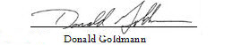

Next Monthly Board Meeting: April 1st, 11:00 AM – 12:30 PM, 4600 Kietzke Lane, Offices of Gina Espinal-Aguerre, Reno, NV
Addendum

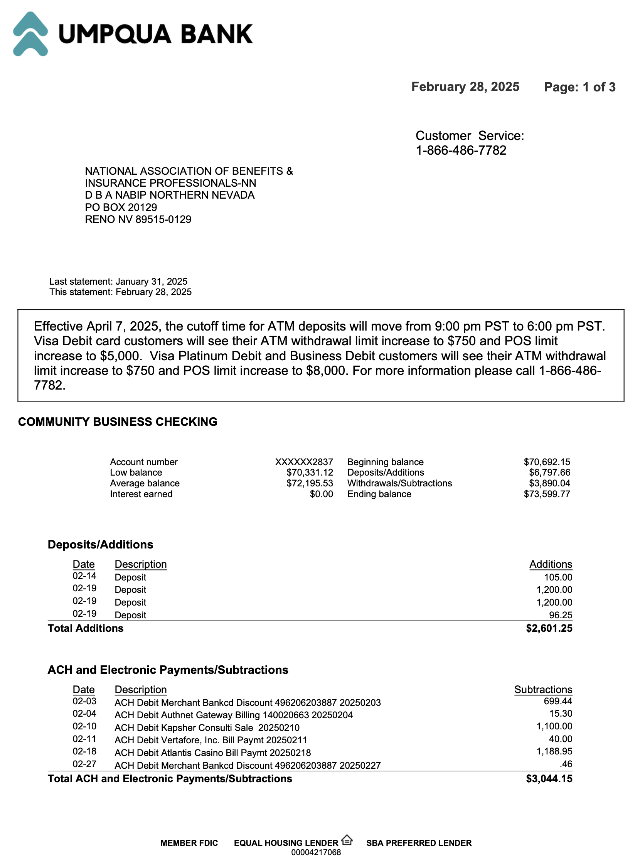
Umpqua February 2025 Statement
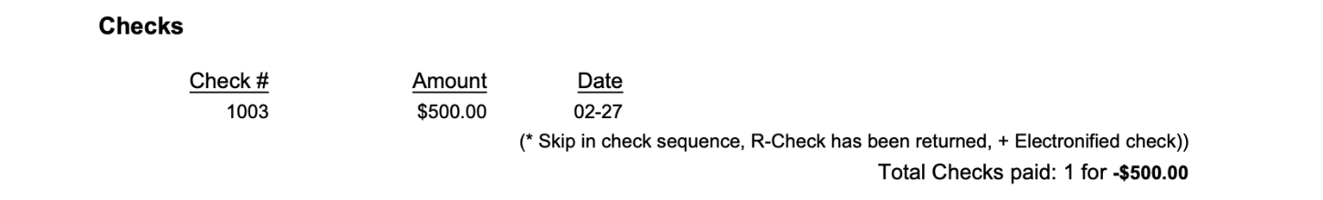
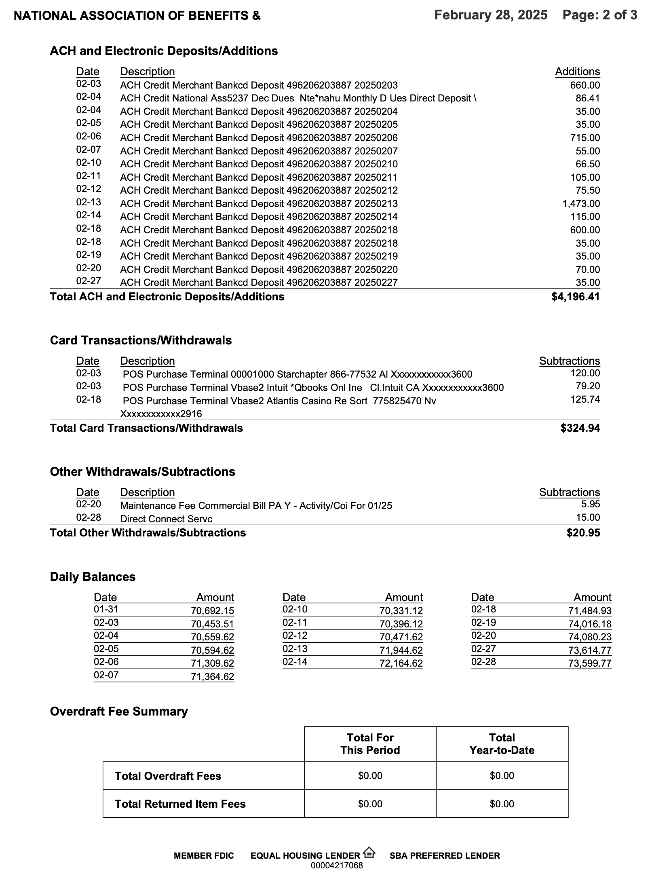

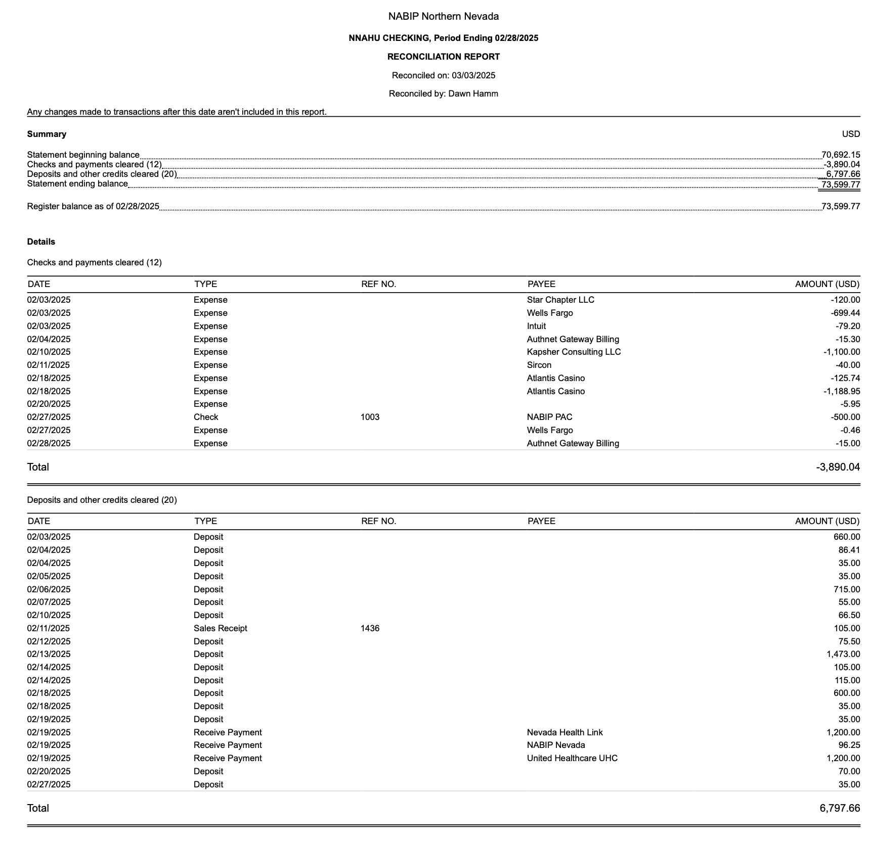
Reconciliation of Checking and Savings Accounts

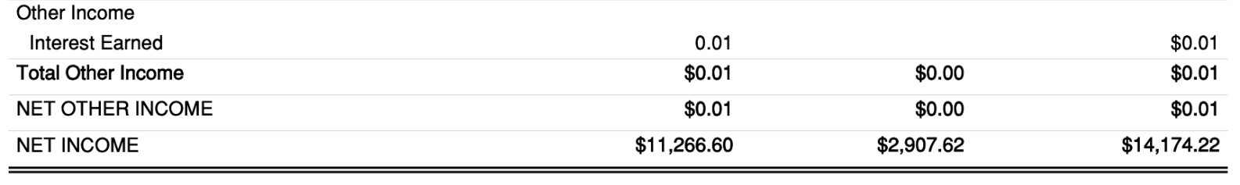
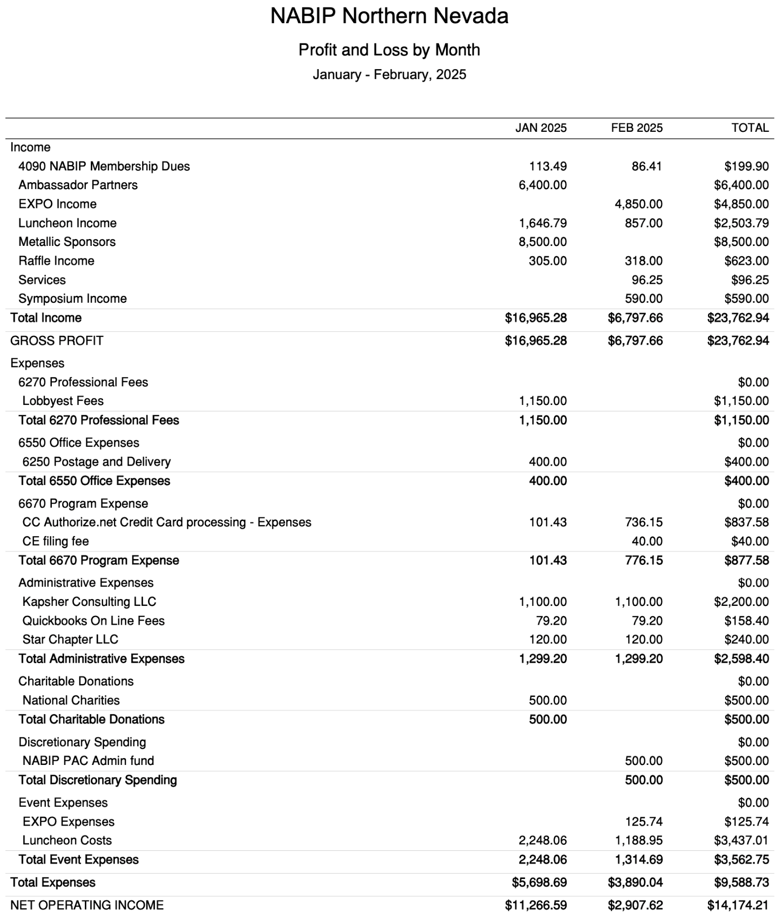
Profit and Loss by Month YTD Through February
Budget vs. Actual January – February 2025
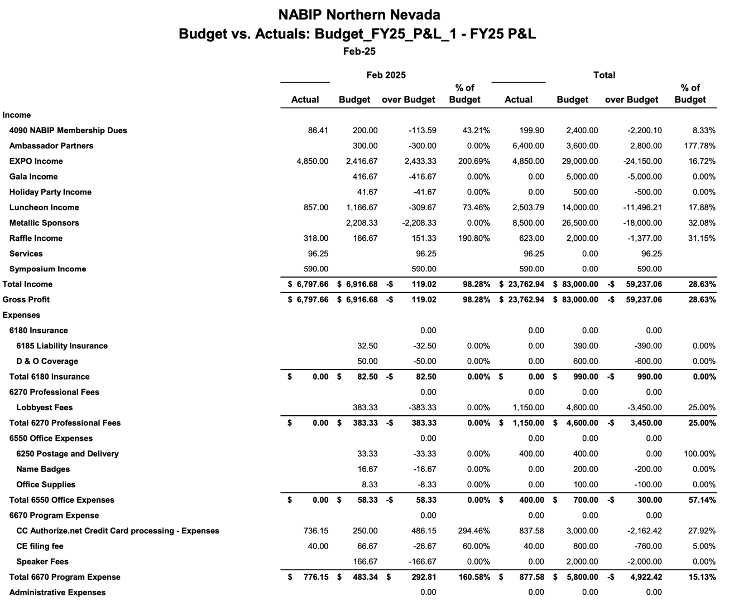
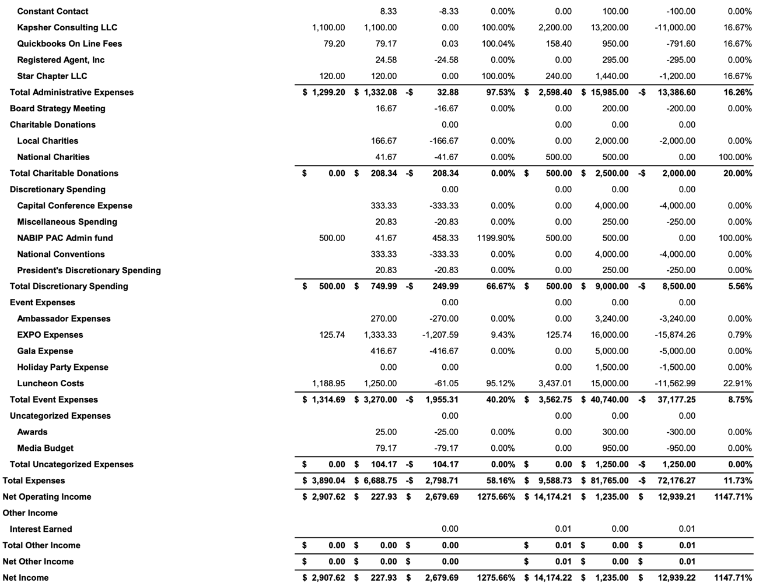
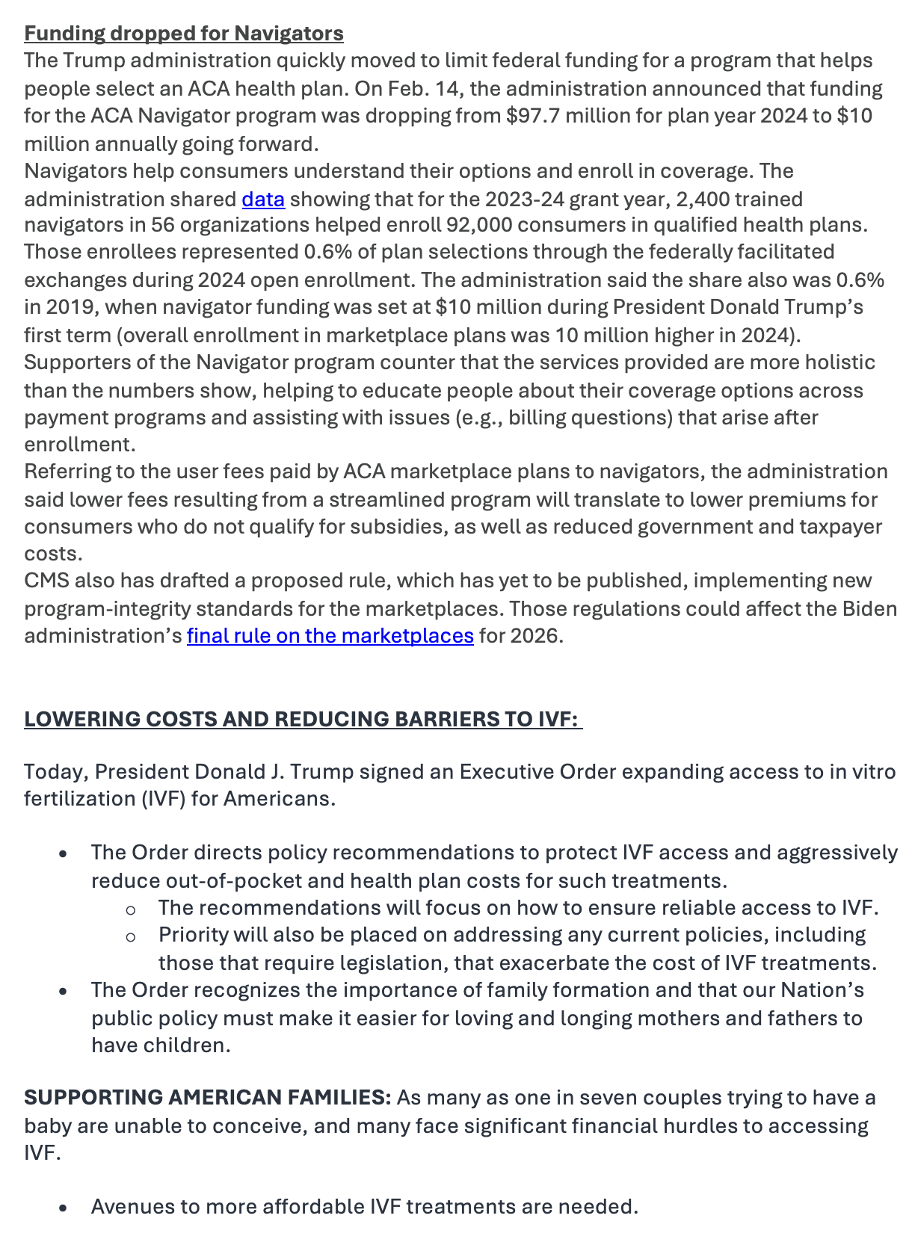
Legislative Report
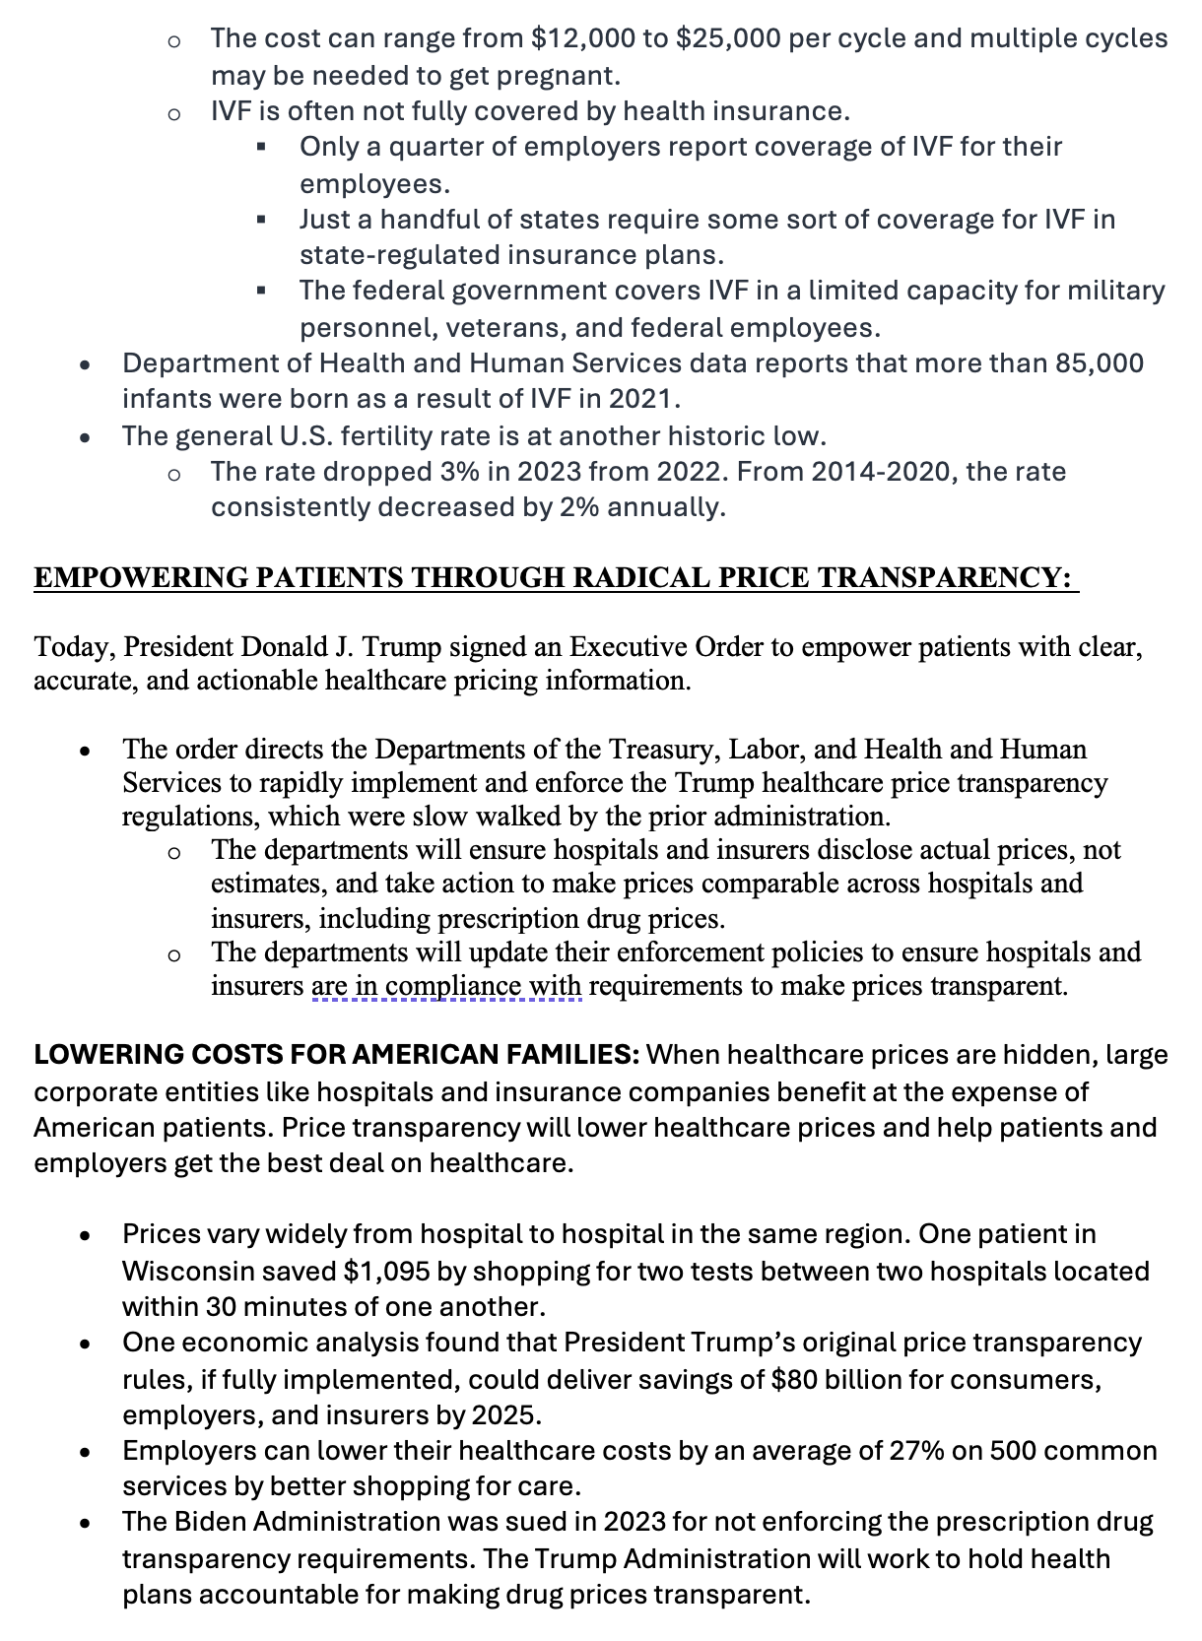
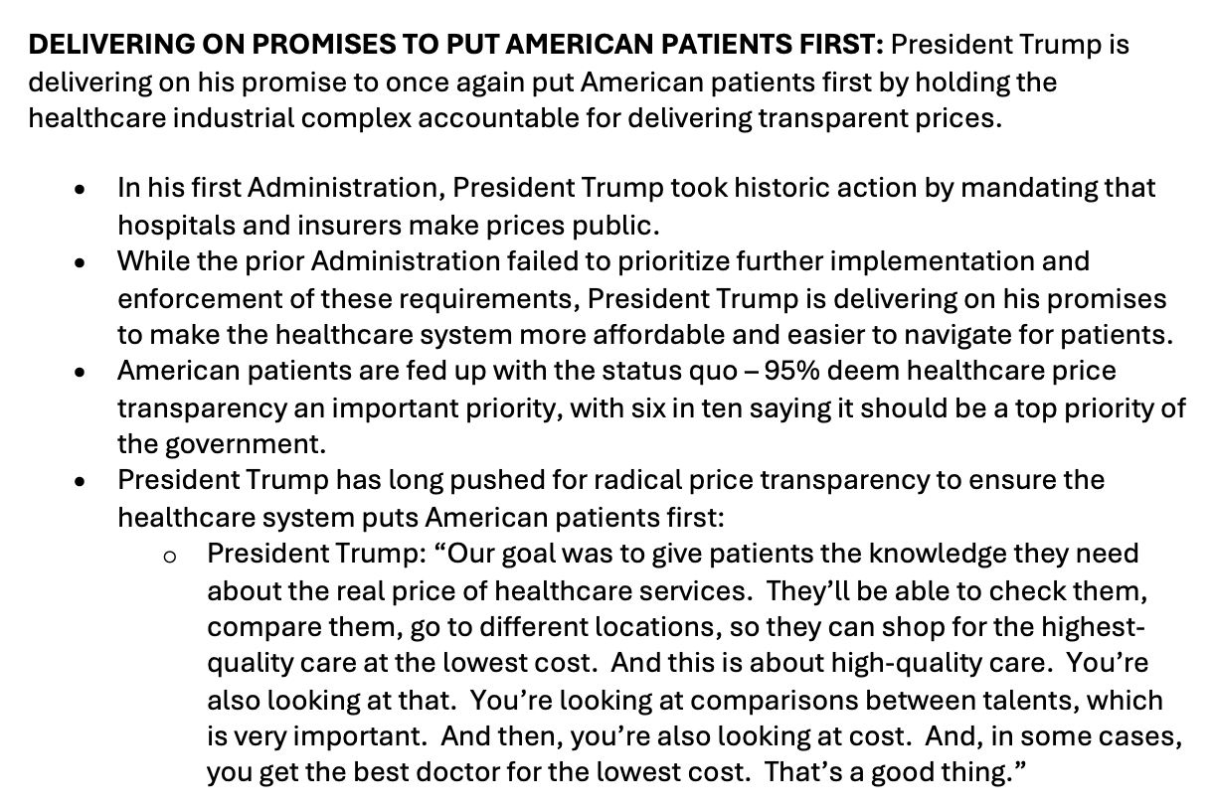

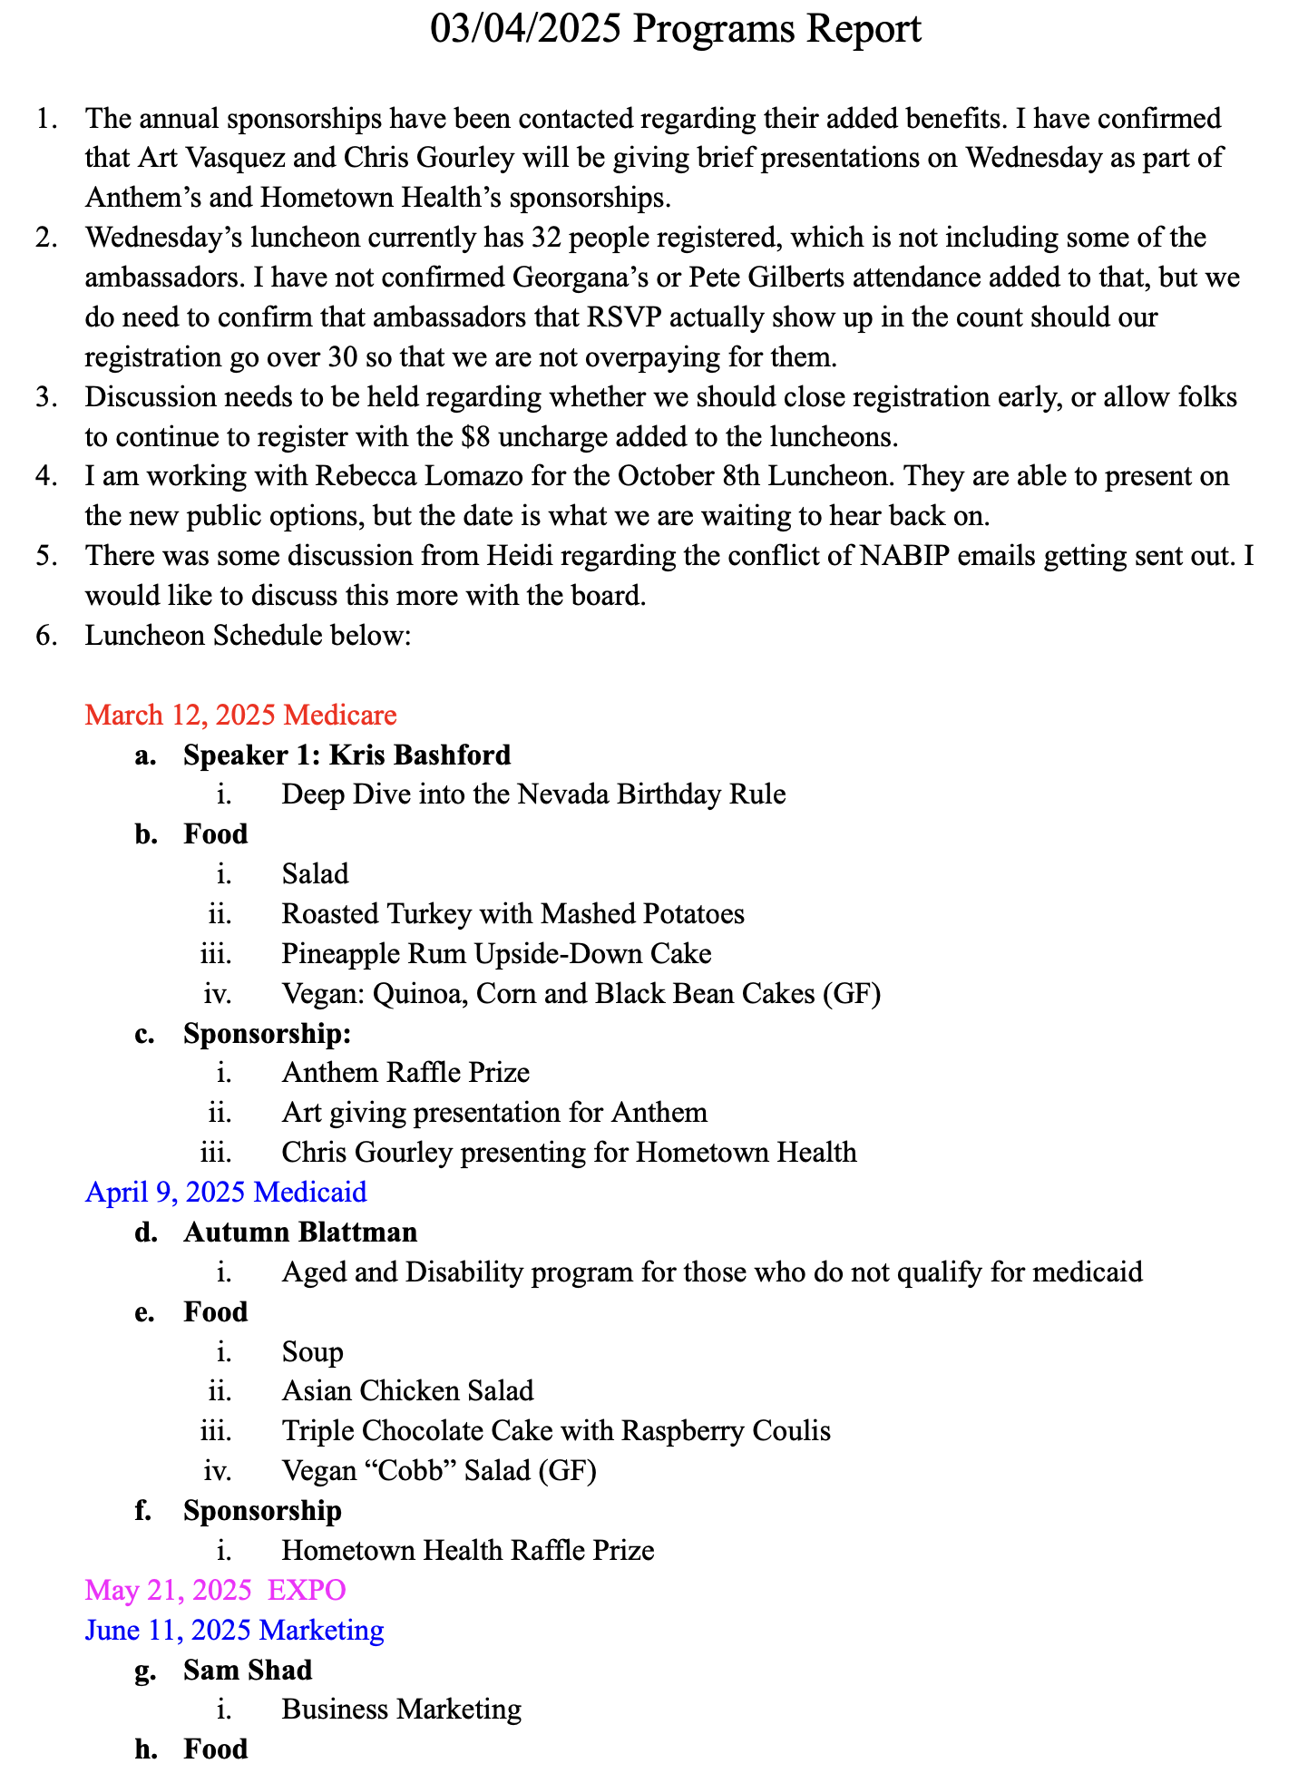
March Programs Report
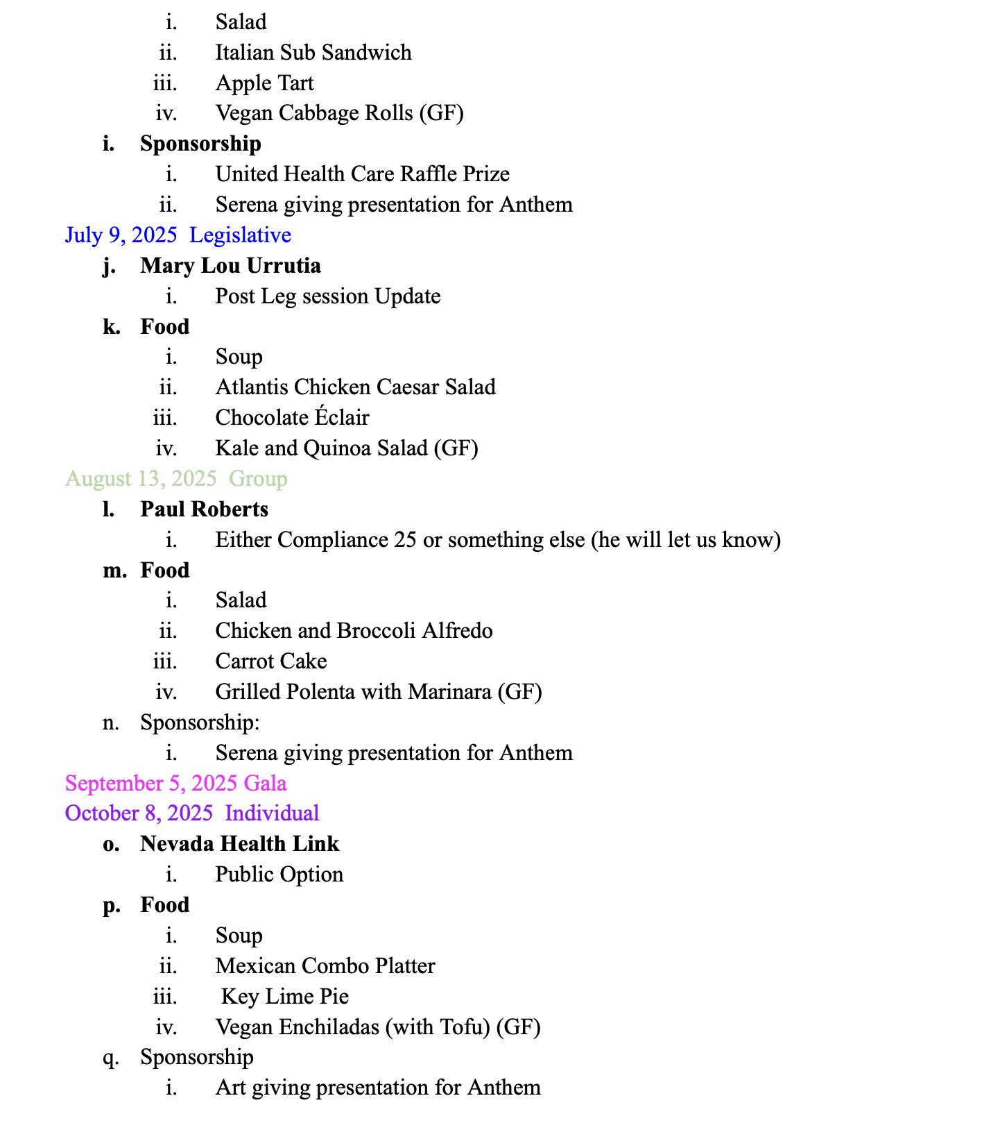

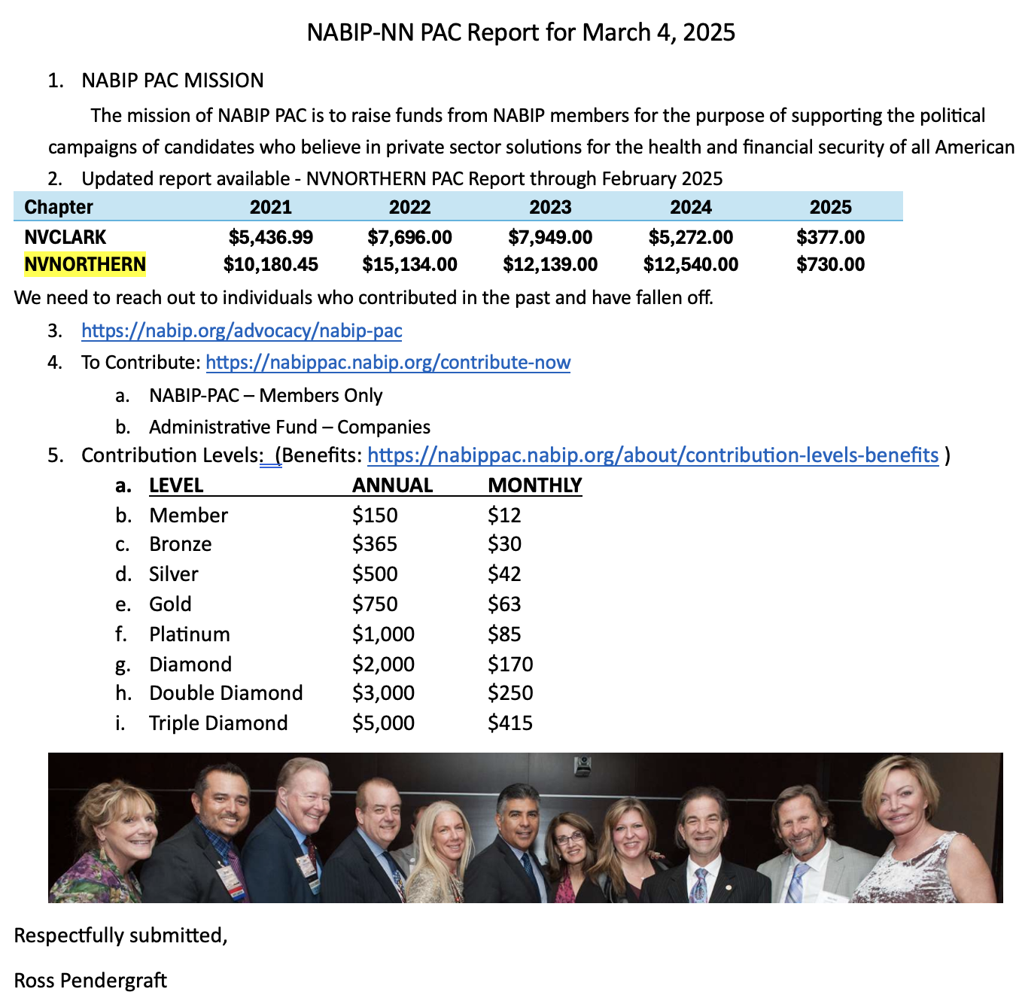
NABIP–PAC Report

