National Association of Benefits and Insurance Professionals - Northern Nevada

Draft Board of Directors Meeting Minutes
April 8, 2025, 11:15 AM – 11:57 PM
4600 Kietzke Lane, Building A-105, Reno, NV
Via Zoom – Meeting ID = us02web.zoom.us/j/84698950624

Attendance Report: Don Goldmann, Joy Gardner, Gina Espinal-Aguerre, and Mary Lou Urrutia

Virtual Attendance by Phone and Computer: Julie Ann Evans, Molly Moreno, Ross Pendergraft, Dave Sherrill, and Merre Gregory.

Absent: Mika Clauson, Alliana Rushing, Georgana Cepeda and Jay Eldridge.

Guest: None

- Meeting was called to order by President Molly Moreno at 11:15 AM.

- Roll call of attendees was taken by sight for those attending in person and on Zoom by Secretary, Don Goldmann. Quorum confirmed. Connectivity confirmed.

- Review of the March 2025 board minutes by Secretary, Don Goldmann.

  - A motion to approve the March 2025 board minutes was made by Molly Moreno and seconded by Don Goldmann. Unanimously approved.

- Report of the President by Molly Moreno:

  - The President expressed appreciation for the work that everyone has done this year.

  - Molly reported that the local high school ROTC marching color guard would open the May Exposition and Medicare Summit, and a $150 donation has been made by the chapter to the unit for its contribution to the chapter’s event.

  - Due to Molly’s leg injury, Aliana Rushing will moderate the April membership luncheon meeting and program.

- Report of the Secretary by Don Goldmann:

  - Don reported that the nomination list for officers for the 2025-26 Board of Directors was printed in the March newsletter, which went to all members last month.

  - Those nominated to elected positions included for President Aliana Rushing, Vice President Georgana Cepeda, Vice President of Finance Joy Gardner, Secretary Chanté Padilla, Vice President of Awards Ross Pendergraft, Vice President of Legislation Mary Lou Urrutia, Vice President of Media & Communications Don Goldmann, Vice President of Membership Gina Aguerre, Vice President of Professional Development Julie Ann Evans and Immediate Past President Molly Moreno, which is an office automatically assumed without being voted upon.

- Report of the Vice President of Finance by Joy Gardner: A number of financial documents have been placed into the Addendum of these minutes.

  - Both the chapter’s checking and savings accounts balance.

  - Review of partnerships for 2025 shows that Anthem is paid up at the Diamond level for $8,500, United Healthcare and Aetna is paid up at the Gold level for $4,000, Hometown Health has been invoiced for the Gold level and Word & Brown has been invoiced for the Silver level.

  - The chapter really needs to step up the activity to get the income for the EXPO up to the budget.

    - This is the chapter’s only fundraiser this year and to have money next year, we need to work on this.

    - More vendors and attendees are needed.

    - We budgeted income at $29,000 and we are at $20,390 as of 3/31/25, plus $830 received in April; therefore $21,220 thru 4/6/25.

  - Prominence Health Plans owe the chapter $375 from 2020. It has been verified that the chapter has not received the funds and requested payment. It has not been received as of 4/1/25.

  - Credit Cards for QuickBooks and Star Chapter have been updated.

  - Current bank checking account balance, as of 3/31/25, was $88,106.05 and the savings account’s balance was $200.39, but no savings account statement has been received for the month yet.

  - The March 12, 2025, luncheon financials were:

    - Attendance: 46 attendees with 31 attendees, 11 Ambassadors, 3 sponsors and 1 speaker, with 1 walk-in and 5 no shows (3 paid and 2 Ambassadors).

    - Income: $1,222 plus $490 Ambassadors and $525 from sponsorships for a total of $2,237 in income.

    - Cost: $1,803.33

    - Raffle Income: $295.00

  - A motion to approve the April financial report was made by Julie Ann Evans and seconded by Don Goldmann. Unanimously approved.

- Report of the Vice President by Georgana Cepeda: Absent with a written report that has been entered into these minutes.

  - Everything for the Expo is coming together beautifully!

  - Molly Moreno has the local high school ROTC committed to open the program.

  - Julie Ann Evans has submitted all CE credits for the speakers and all CEs have been approved.

  - Mary Lou Urrutia is working on creative ideas for decorations.

  - Gina Espinal-Aguerre received and is using the new chapter logo for the party favors.

  - There are only have a few vendor spots left.

  - Georgana is currently in discussions with Optum to secure the After Party location and plan for the After Party event.

  - A final push is needed to drive agent registrations and Georgana asked the board members what has been done to promote attendance, and, how can board members, individually and collectively, encouraging agents to register?

- Committee Reports:

  - Vice President of Legislative Affairs report by Mary Lou Urrutia: Written report submitted and entered into the Addendum of these minutes.

  - Vice President of Awards report by Ross Pendergraft: Written report was submitted and has been entered into these minutes.

    - The deadline for Awards submission was April 5th and that deadline was met.

    - Award submissions were made for the Pacesetter, Media and Website awards with each being in the small local chapter size category based on 98 members.

    - The New Member Orientation will continue every 4th Thursday at 9:00 AM PST on Zoom. Need to make sure we keep blasting this out in our newsletter each month as has been done each month this year.

      - Zoom meeting ID 826 3420 3381, Passcode “Membership”
      - http://welcometonabip.org

  - Vice President of Membership report by Gina Espinal-Aguerre: Written report that has been entered into these minutes.

    - Membership is 98.

    - Have received approval from the national office for a discounted rate for new members recruited at the upcoming May Annual Symposium and Medicare Summit.

    - Work has begun on creating a Membership Committee to start with the new board for 2025-26.

  - Vice President of Communications/Media report by Mika Clauson: absent and no report

  - Vice President of Professional Development report by Julie Ann Evans: Written report submitted and entered into these minutes.

    - NABIP NN - Monthly Luncheons:

      - The March 12th luncheon was a CE approved event.

        - There were 28 CE completions processed on March 14th.
        - There is a $1.25 fee per CE completion, so the chapter should see an invoice from Sircon for $35.00.
        - The total CE cost is $75.00 ($40.00 filing fee, plus $35.00 completion fee)

      - The April 9th luncheon is a CE approved event.

      - The August 13th luncheon is a CE approved event.

        - The course material was submitted on March 30th and approved on April 1st.
        - The course offering was created on April 4th.
        - There is a $40.00 filing fee, so the chapter should see an invoice from Siron for $40.00.

    - NABIP NN - Symposium - May 21st:

      - This all-day event will offer a total of 4 CEs, but material for 6 courses has been submitted, as there will be two break-out sessions.

      - All 6 of the courses have been approved for CEs and the course offerings for all 6 were created on April 4th.

      - There is a $40.00 filing fee per course, so the total cost for filing these courses is $240.00.

    - NABIP NV - Free CE Series:

      - There were 3 Ethics CE classes approved, all presented by Paul Roberts with Word & Brown, and managed through NABIP-NN’s Sircon account.

        - The third class was held on March 13th and there were 47 participants with the CEs processed on March 23rd.
        - There is a $1.25 fee per CE completion, so NABIP-NN should see an invoice from Sircon for $58.75.

      - The April 11th CE class, presented by Jeff Kerns with Truluma, is being managed through NABIP-NN’s Sircon account.

      - The May 16th CE class, presented by Aliana Rushing with Senior Insurance Agency, is being managed through NABIP-NN’s Sircon account.

        - The course material was submitted on March 28th and approved on April 1st.
        - The course offering was created on April 4th.
        - There is a $40.00 filing fee, so NABIP-NN should see an invoice from Sircon for $40.00.

      - The June 13th CE class, presented by Serena Farrell with Anthem BCBS, is being managed through NABIP-NN’s Sircon account.

        - The course material was submitted on March 3rd and approved on March 6th.
        - The course offering was created on April 4th.
        - There is a $40.00 filing fee, so NABIP-NN should see an invoice from Sircon for $40.00.

      - The August 15th CE Class, presented by Stuart Little with Abacus Life, is being managed through NABIP-NN’s Sircon account.

        - The course material was submitted on April 2nd and approved on April 3rd.
        - The course offering was created on April 4th.
        - There is a $40.00 filling fee, so NABIP-NN should see an invoice from Sircon for $40.00.

    - NABIP-SN Medicare Summit - March 25th:

      - This all-day event offered several CE classes, one of which was managed through NABIP- NN’s Sircon account.

      - There were 56 CE completions processed on March 31st.

      - There is a $1.25 fee per CE completion, so NABIP-NN should see an invoice from Sircon for $70.00.

      - The total cost is $110.00 ($40.00 filing fee, plus $70.00 completion fee) and this information was shared with the NABIP-SN President, Medicare Summit Chair and Treasurer, as well as NABIP-NN’s Treasurer.

    - NABIP-NV Monthly Professional Development Meeting:

      - Typically, on the 4th Friday of each month, there is a virtual meeting held for those who are involved with planning luncheons, events, CE classes, etc. for both local chapters and the state chapter.

      - The next meeting will be held on April 25th at 2:00 PM and all are welcome to attend the meeting.

    - An update about the national Education Foundation was provided with an announcement that Aliana Rushing, as next year’s chapter President, has found a candidate to fill the local slot as the “Foundation Champion”.

      - The chapter’s annual donation to the foundation was discussed.

    - A promotion will be given at the April monthly membership luncheon tomorrow about the free statewide virtual CE program, with thanks to Chris Carothers for making the necessary donation to allow the programs to be offered for free.

  - Director of Programs report: Absent with a written report submitted and entered into these minutes.

    - May 21, 2025, EXPO

    - June 11, 2025,

      - Marketing

        - Sam Shad on “Business Marketing”.

      - Food

        - Salad
        - Italian Sub Sandwich
        - Apple Tart
        - Vegan Cabbage Rolls (GF)

      - Sponsorship

        - United Health Care Raffle Prize.
        - Serena giving a presentation for Anthem.

    - July 9, 2025

      - Legislative

        - Mary Lou Urrutia with a “Post Legislative Session Update”.

      - Food

        - Soup
        - Atlantis Chicken Caesar Salad
        - Chocolate Éclair
        - Vegan Kale and Quinoa Salad (GF)

    - August 13, 2025

      - Group

        - Paul Roberts on either, Compliance 25 or something else (to be announced).

      - Food

        - Salad
        - Chicken and Broccoli Alfredo
        - Carrot Cake
        - Vegan Grilled Polenta with Marinara (GF)

      - Sponsorship:

        - Serena giving presentation for Anthem

    - September 5, 2025, Gala

    - October 8, 2025

      - Individual

        - Nevada Health Link on the Public Option.

      - Food

        - Soup
        - Mexican Combo Platter
        - Key Lime Pie
        - Vegan Enchiladas (with Tofu) (GF)

      - Sponsorship

        - Art giving presentation for Anthem

  - NABIP-PAC Chairperson report by Ross Pendergraft: A written report is included in the Addendum for these minutes.

  - Medicare Chairperson report by Merre Gregory: Written report submitted and entered into these minutes.

    - Open Enrollment Period for Medicare is over.

      - There was a lot of movement between plans due to the Carson Tahoe Hospital decision to drop all national Medicare Advantage Plans.
        - Calls were made to Prominence and SCP, without answers, as to their numbers, but hopefully, there will be some numbers to report next month.
      - Per Mary Granger at Prominence, they are working on a Special Enrollment Period for those in the “rural counties” that realized they lost Carson Tahoe Hospital and Mary has indicated that more information will not be available until 4/21.
    - On January 9, 2025, there were several bulletins sent out from FMO’s, as well as carriers, advising of a change to the Disaster/Emergency Special Election Period (SEP) to go into effect April 1, 2025.
      - The change stated that for the Disaster/Emergency SEP to be used, beneficiaries would need to directly call 1-800-Medicare to enroll.
      - Subsequently, agents would no longer be allowed to use the SEP to enroll beneficiaries, and all enrollment applications and plan materials would need to be updated to reflect the change.
      - However, on March 20, 2025, CMS issued a memo announcing the withdrawal of the Disaster/Emergency SEP change slated for April 1, 2025.
      - With this withdrawal, the proposed change will not go into effect on April 1, 2025, and plans will continue to accept applications from agents using the Disaster/Emergency SEP, when appropriate, and agents may continue to use enrollment forms and plan materials that include the Disaster Emergency SEP.
        - This announcement means that agents will continue to be able to enroll beneficiaries using the disaster SEP, if the beneficiary meets the SEP requirements, after April 1, 2025.
        - Carriers will continue to monitor for potential misuse of the disaster SEP code and will issue corrective action, accordingly, and therefore, it is important for sales agents to ensure they are using the disaster SEP code appropriately to avoid any corrective action from carriers.
    - It was a great day at the Nevada State Capital with impressive work by the chapter members in taking our state’s Medicare talking points to the assembly persons.

      - Many assembly persons are very unaware of our points and the bills that they are presented with.

      - This is an amazingly important event for getting our information to them and I would encourage anyone that works in the Medicare field to attend next time.

    - Artificial Intelligence in Medicare Advantage: CMS recently decided not to finalize restrictions on AI use in Medicare Advantage plans, leaving room for future rulemaking on how AI impacts healthcare decisions regarding Prior Authorizations.

      - This was also a bill that was discussed with assembly persons when at the Nevada State Capital Day.
    - Don't miss out on Medicare “Insider Moments”, a monthly webinar series that provides exclusive insights, actionable strategies, the latest industry updates, and hosted by Medicare experts Amanda Brewton and Maggie Stedt.
      - Each session features a special guest, who brings additional expertise and unique perspectives, with this month's webinar focusing on what every agent needs to know about becoming an agency.
      - Register now for the next webinar on Tuesday, April 22, from 4-5 p.m. ET.

  - By-Laws and P&P Committee report by Don Goldmann:
    - Everything is ready for the Annual Membership meeting to be held during the luncheon period at the May Annual Exposition and Medicare Summit event.

- A motion was made by Don Goldmann, and seconded by Molly Moreno, to accept all reports in toto. Unanimously approved.

- Old Business – None.

- New Business – None

- A motion to adjourn was made by Julie Ann Evan and seconded by Gina Espinal-Aguerres. Unanimously approved.

- President, Molly Moreno adjourned the meeting at 11:57 PM.

Submitted by Don Goldmann, NABIP-NN Secretary


Next Monthly Board Meeting: May 6th, 11:00 AM – 12:30 PM, 4600 Kietzke Lane, Offices of Gina Espinal-Aguerre, Reno, NV
Addendum

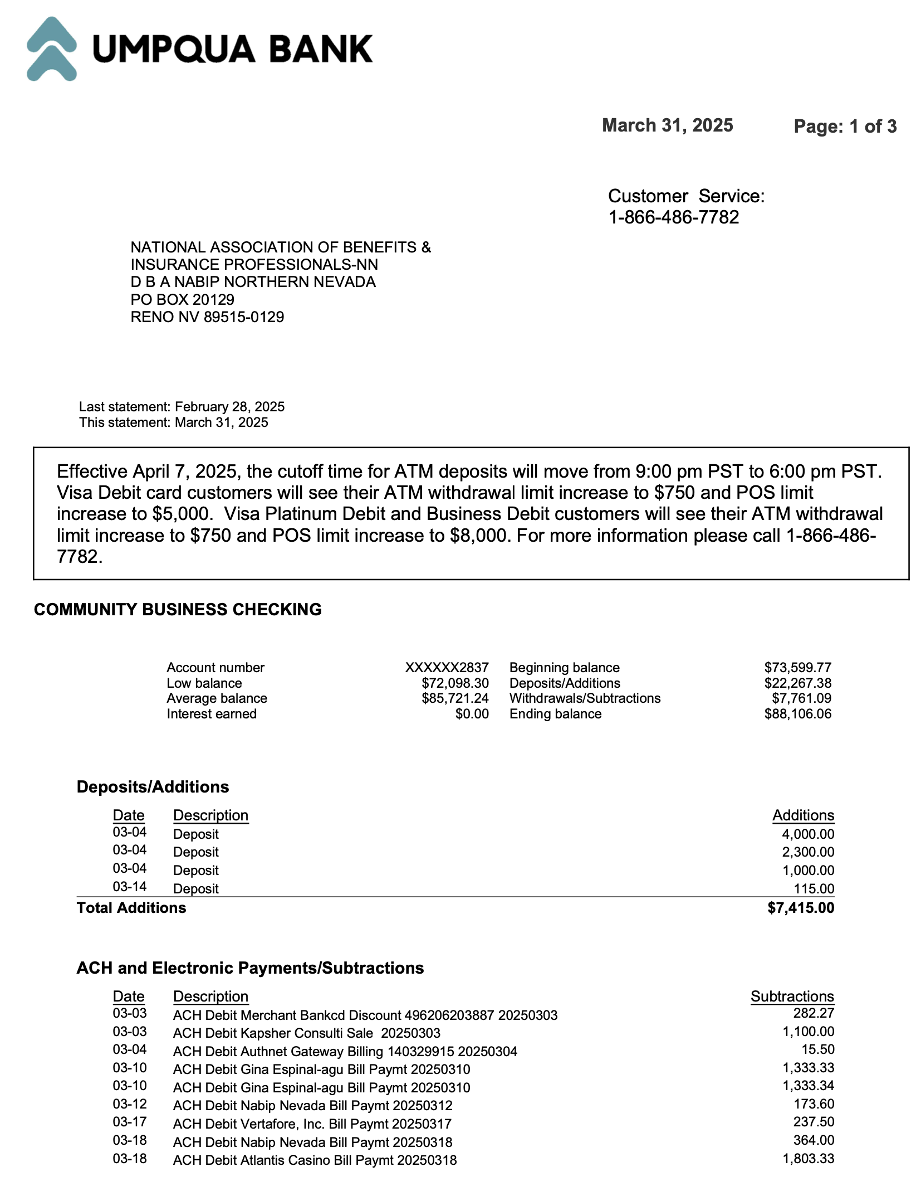
Umpqua March 2025 Statement
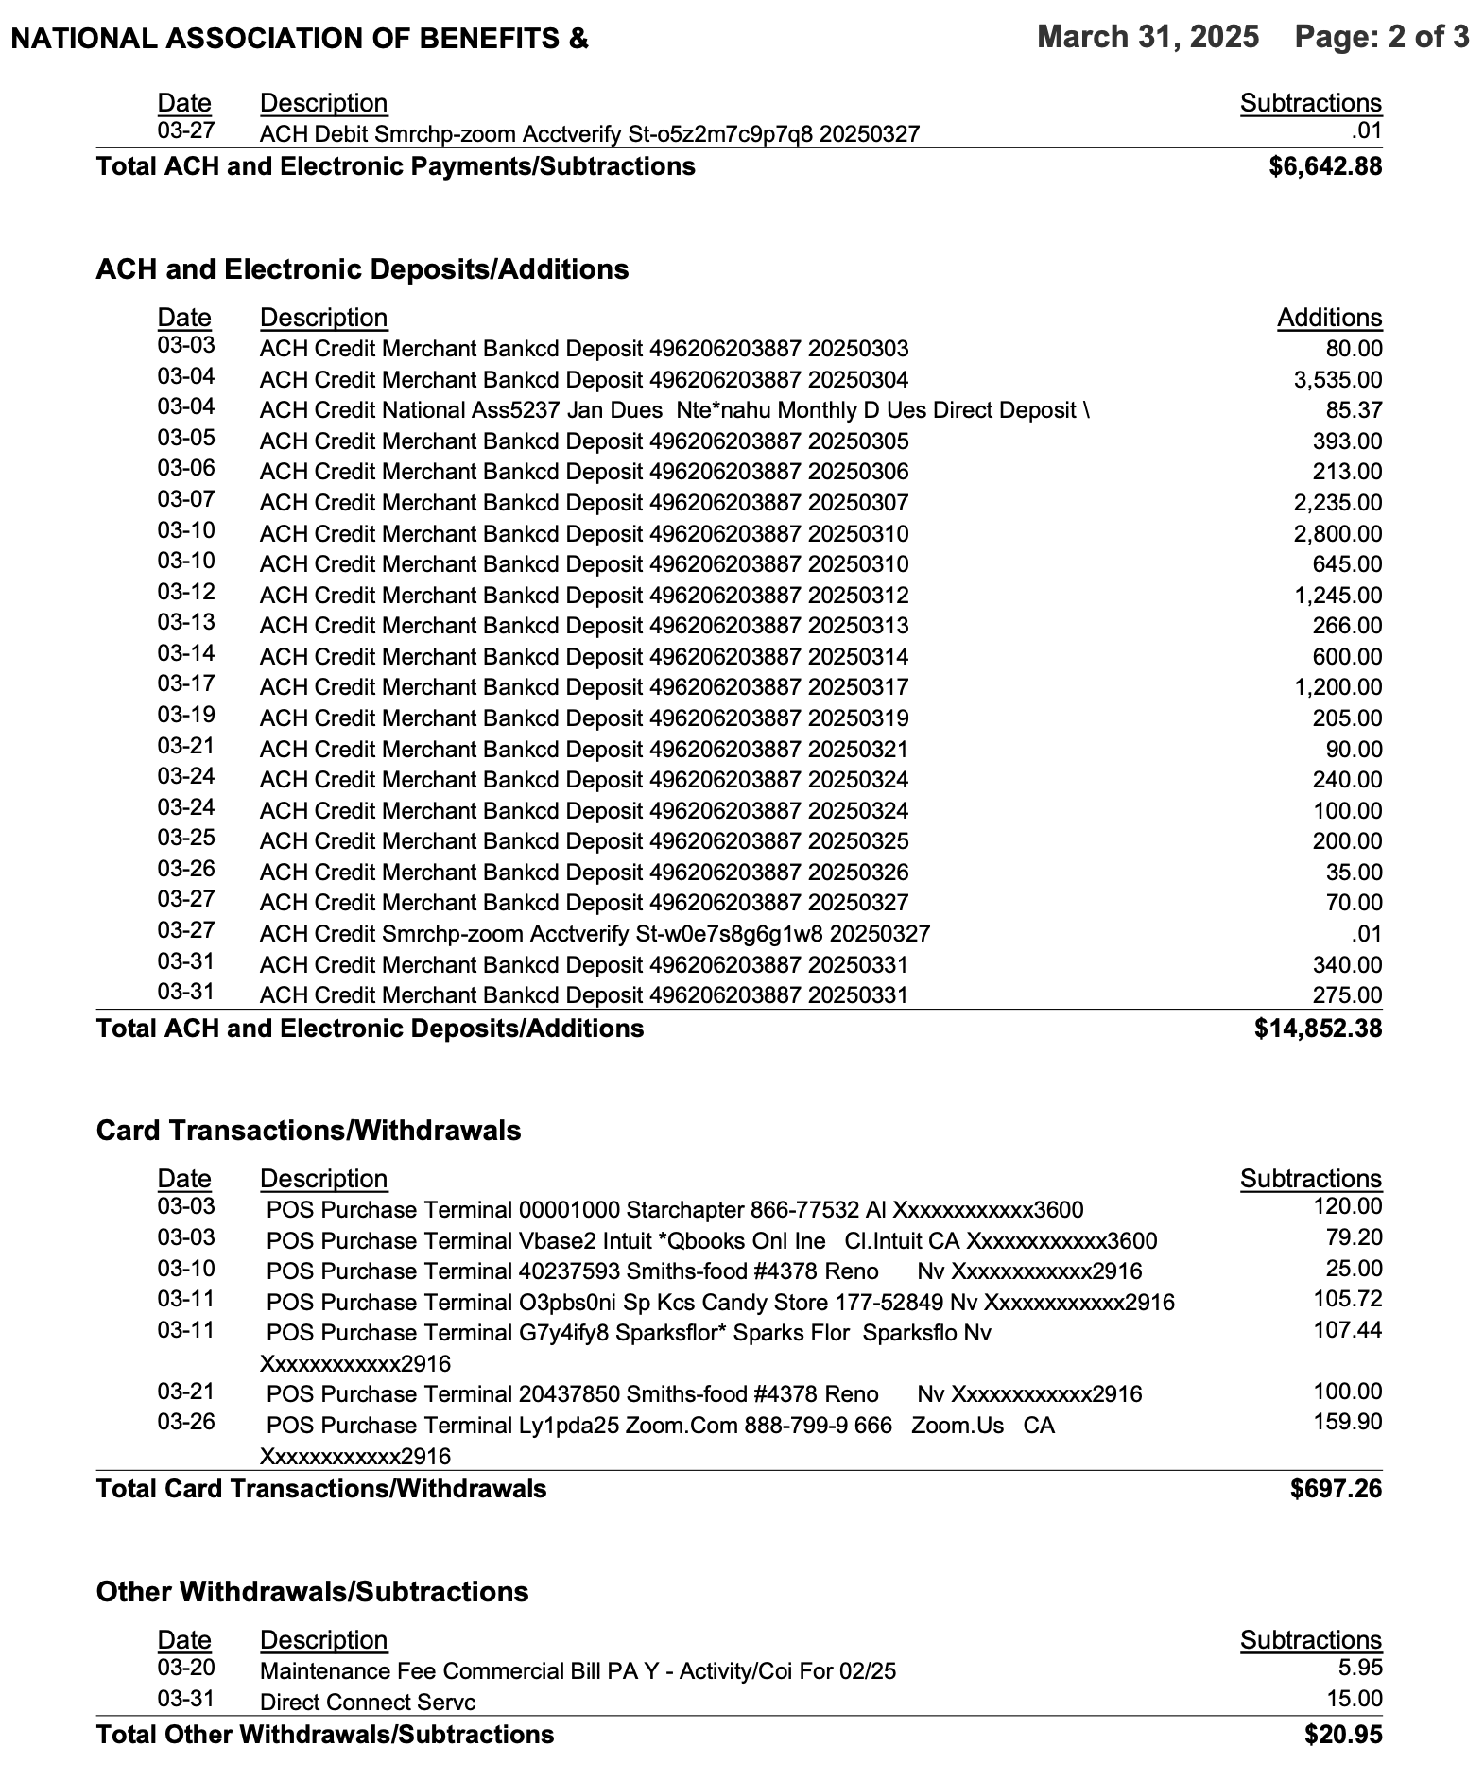

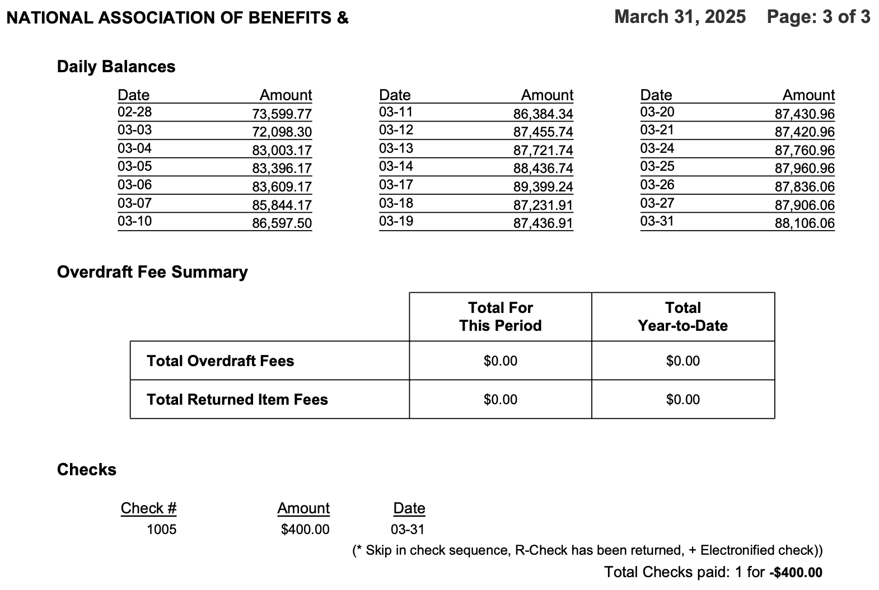

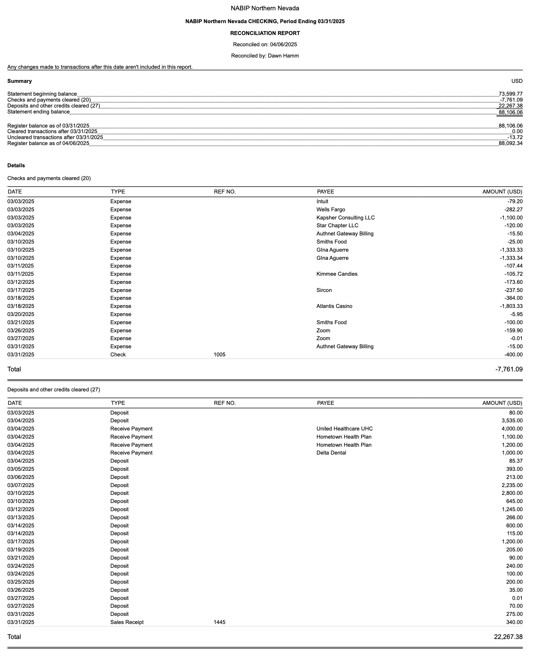
Reconciliation of Checking and Savings Accounts

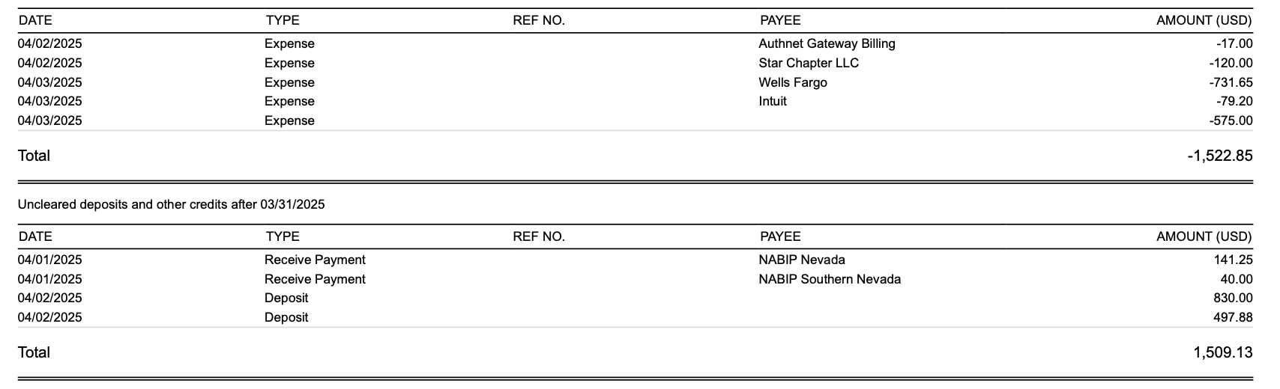
Profit and Loss by Month YTD Through March
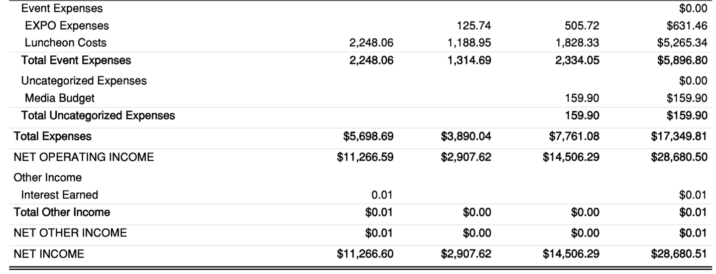
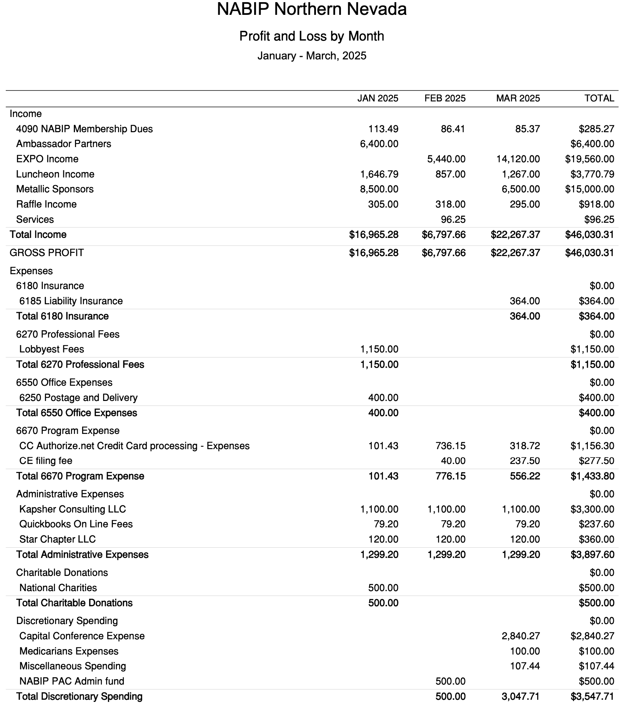

Budget vs. Actual January – March 2025
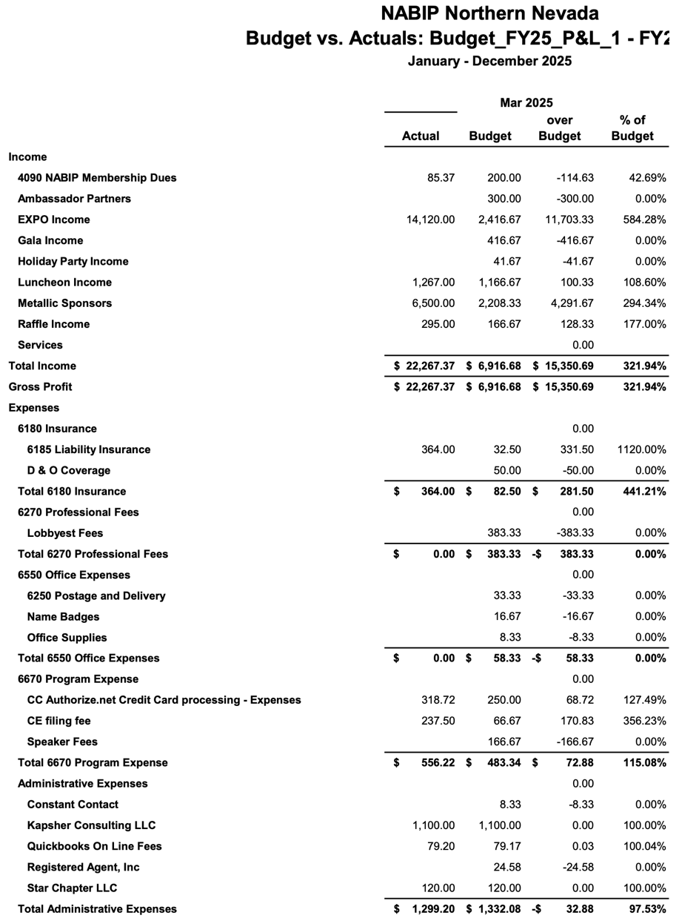

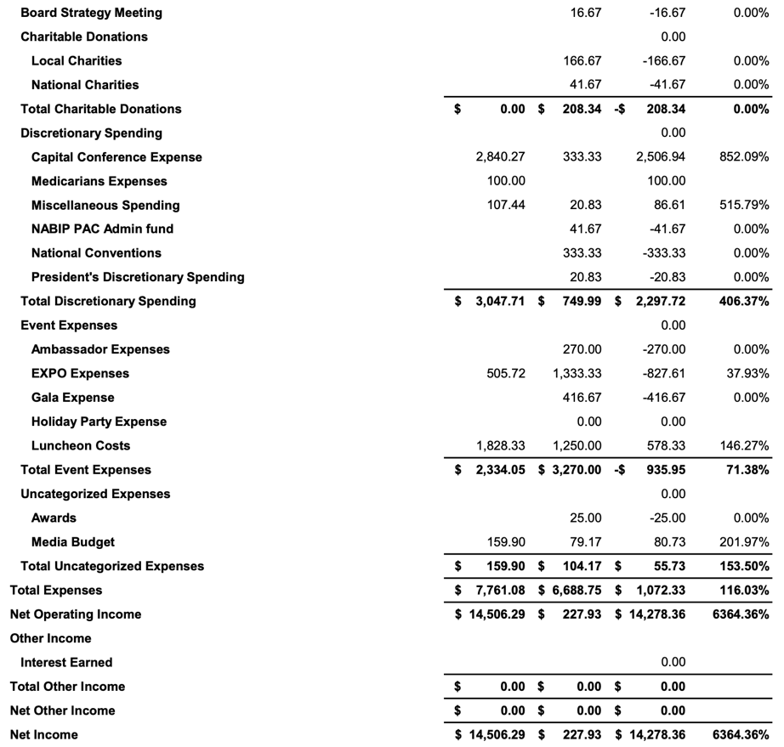

Legislative Report
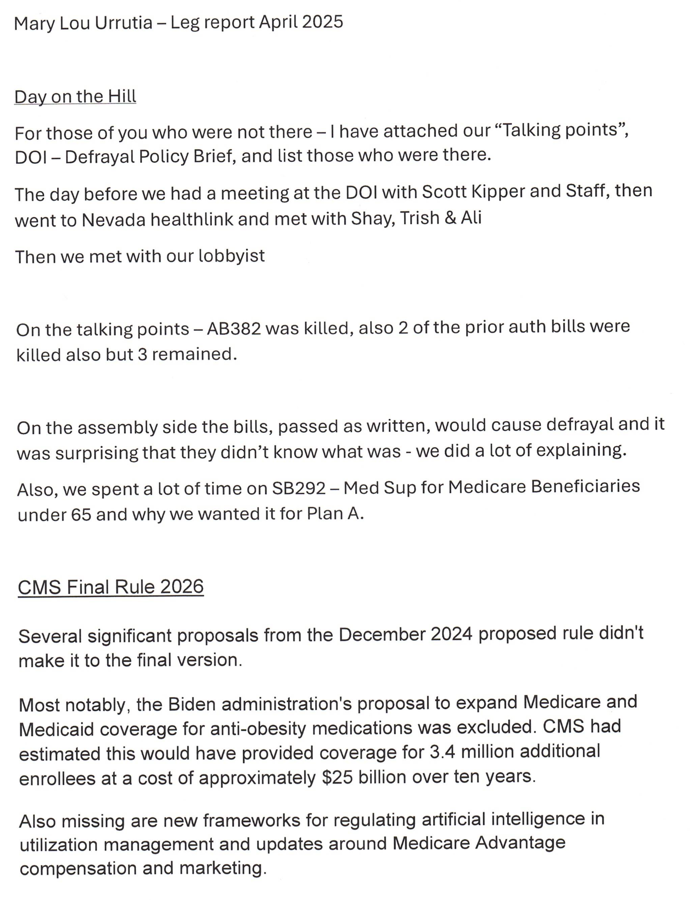
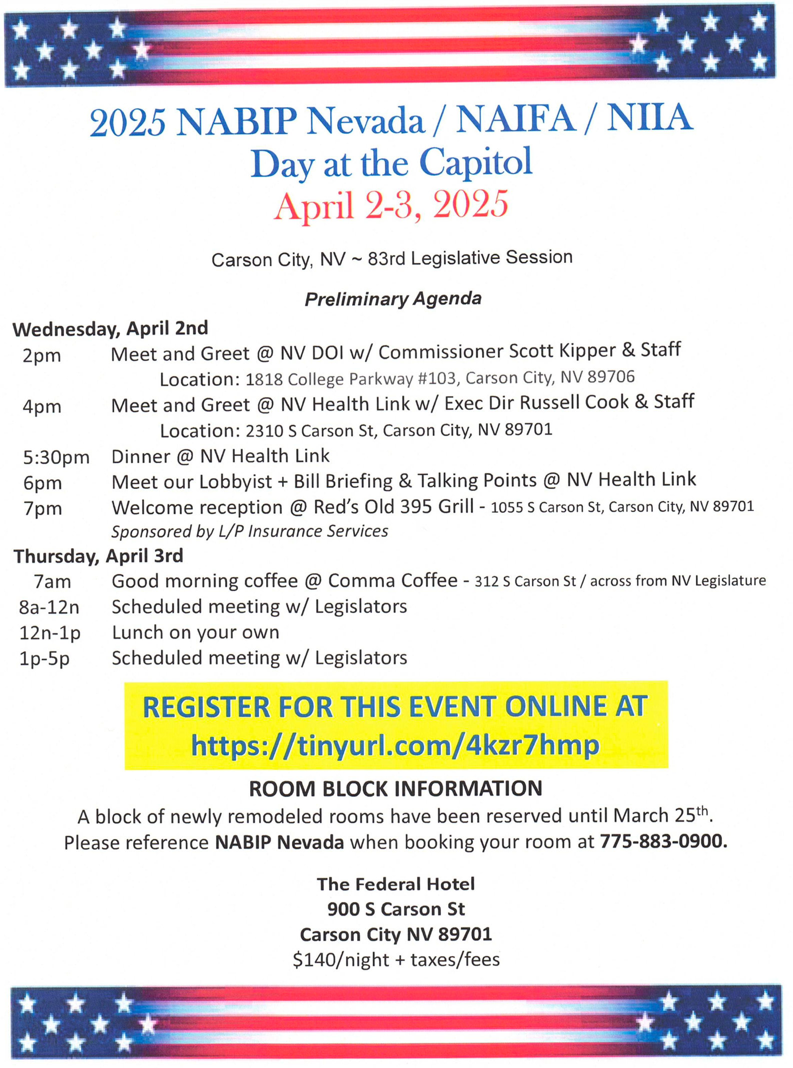
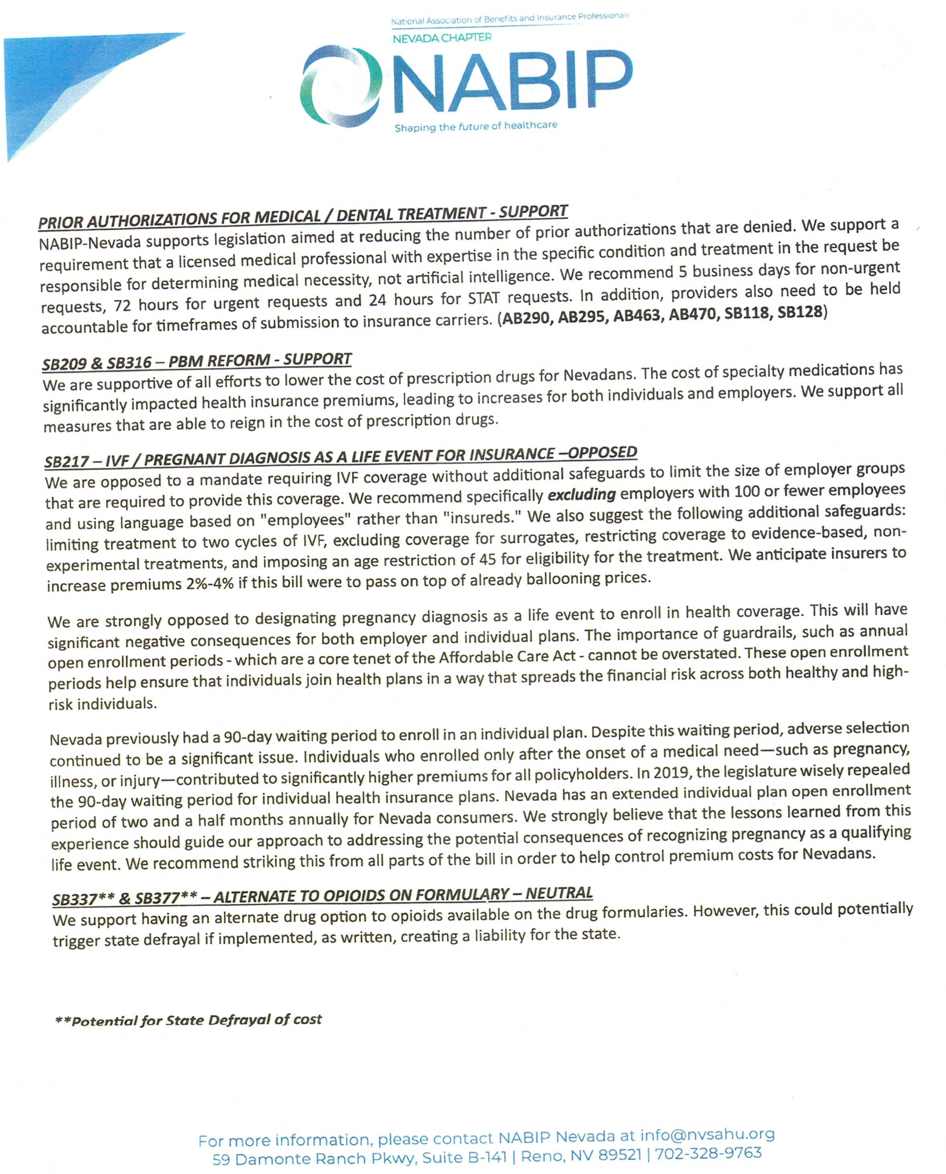

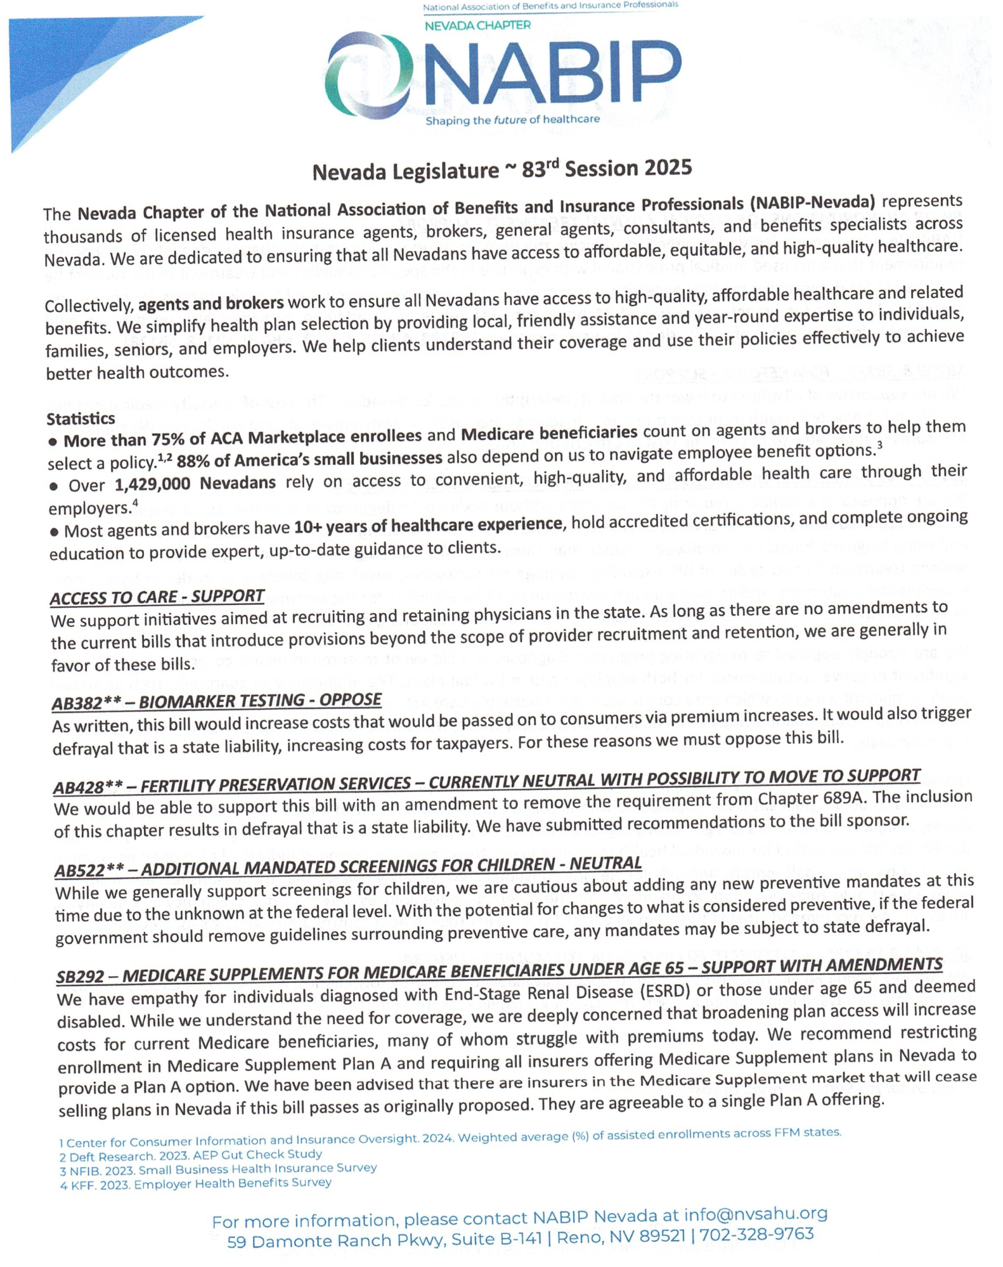
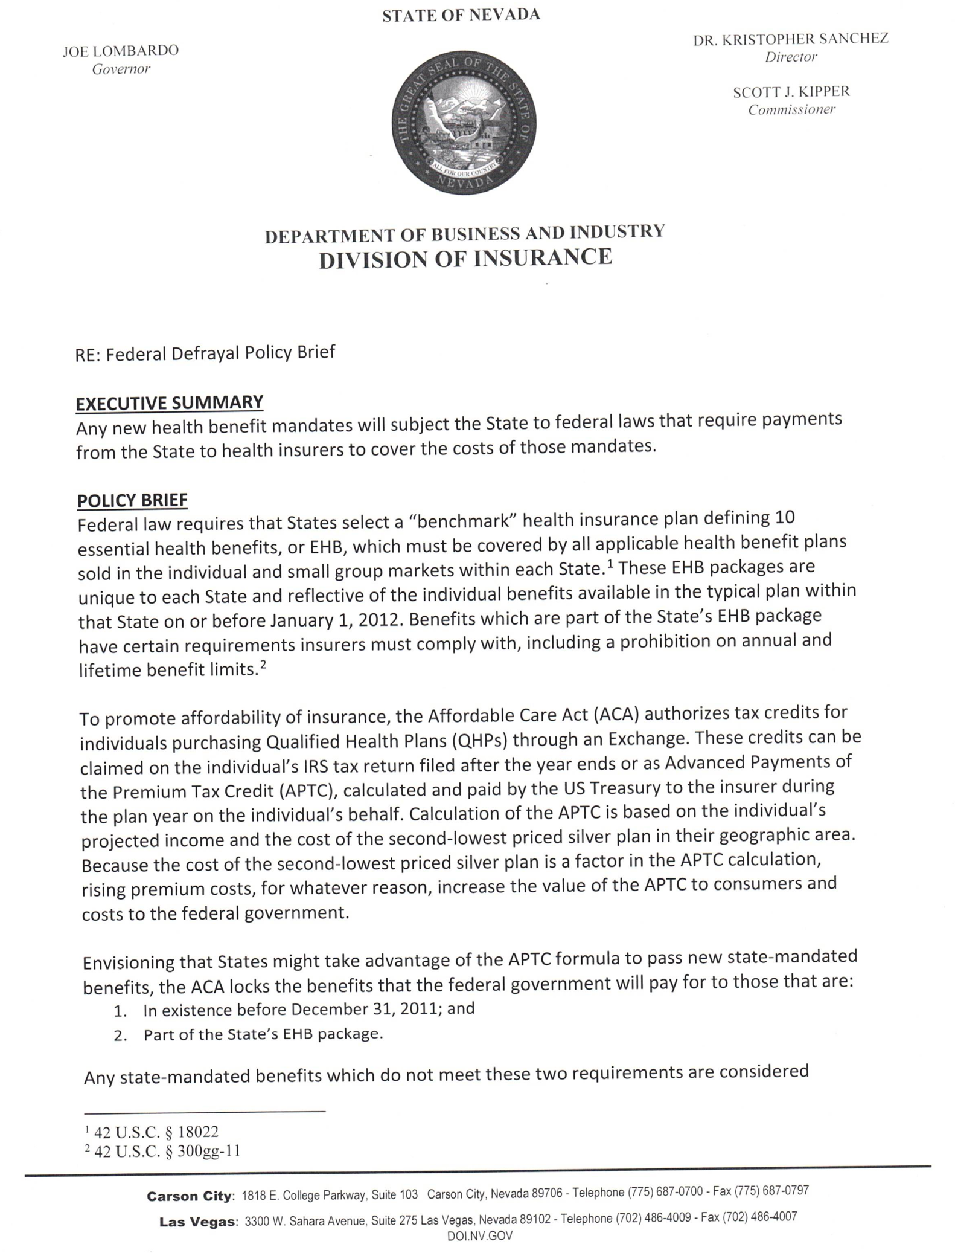
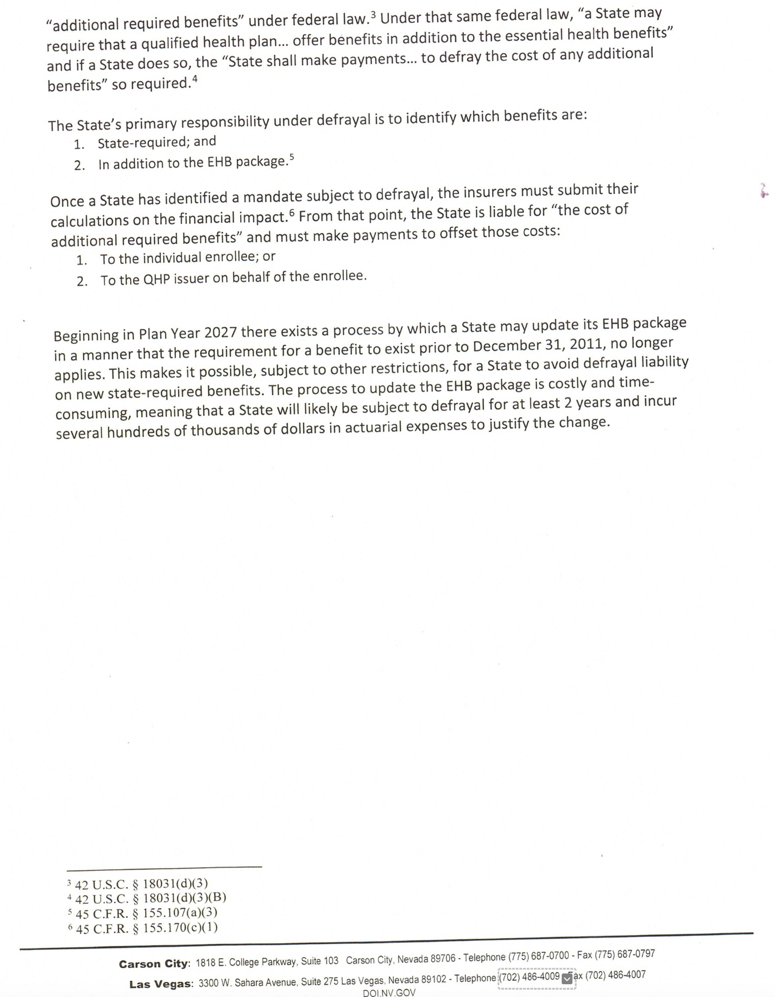
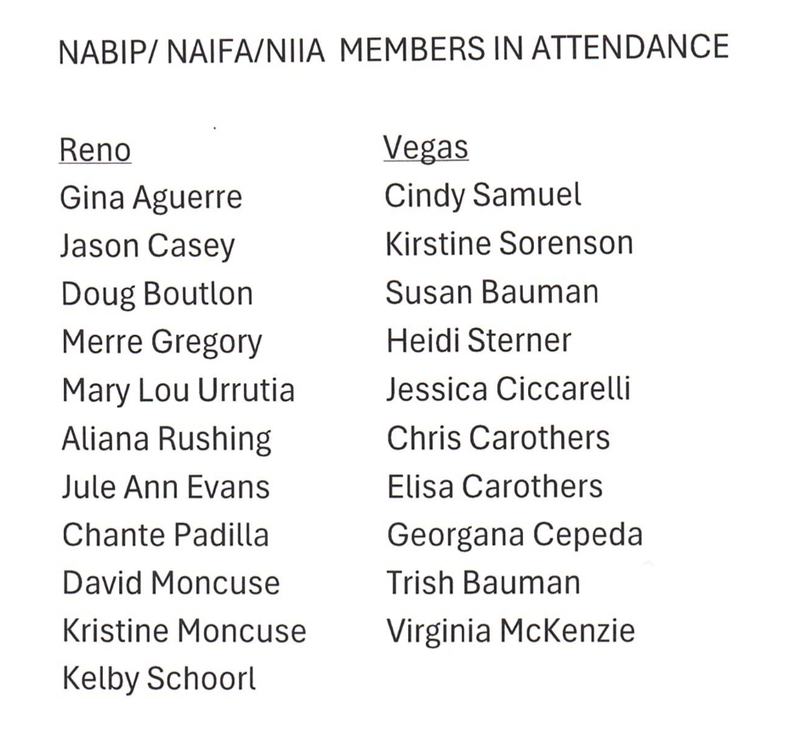
Chapter Members at Day at the Captial

NABIP–PAC Report
