National Association of Benefits and Insurance Professionals - Northern Nevada

Board of Directors Meeting Minutes
August 6, 2024 11:06 AM – 12:12 PM
4600 Kietzke Lane, Building G-160, Reno, NV
Via Zoom – Meeting ID = us02web.zoom.us/j/84698950624

Attendance Report: Don Goldmann, Joy Gardner, Molly Moreno, Gina Espinal-Aguerre and Mary Lou Urrutia

Virtual Attendance by Phone: Julie Ann Evans, Ross Pendergraft, Jay Eldridge, Ken LaRovere, Merre Gregory, Ashley Kapostins, and Dave Sherrill.

Absent: Mika Clauson and Georgana Cepeda

Guest: None

- Meeting was called to order by President Molly Moreno at 11:06 AM.

- Roll call of attendees was taken by sight for those attending in person by Secretary, Don Goldmann, and by verbal confirmation for those who phoned into the meeting. Quorum confirmed. Connectivity confirmed.

- Review of the July 2024 board minutes by Secretary, Don Goldmann.

  - A motion to approve the July 2024 board minutes was made by Don Goldmann and seconded by Julie Ann Evans. Unanimously approved.

- Report of the President by Molly Moreno:

  - Review of the state Board of Directors’ monthly August meeting was presented and the President lead a discussion about the state meeting.

  - Review of the state strategic planning session that was attended after the monthly meeting with Northern Nevada chapter officers Molly Moreno, Don Goldmann, Joy Gardner, Julie Ann Evans and chapter members Jason Casey and Aliana Rushing in attendance.

- Report of the Secretary by Don Goldmann:

  - With the July minutes having been approved, there was nothing else to report.

- Report of the Vice President of Finance by Joy Gardner: A number of financial documents have been placed into the Addendum of these minutes.

  - Don Goldmann moved to approve the July financial report that had been tabled during last month’s Board of Directors’ meeting. The motion was seconded by Molly Moreno. Unanimously approved.

  - New checks with the chapter’s new name will be ordered through Costco and the cost of it has been budgeted in the Office Supplies line item.

  - Review of partnerships for 2024, with all paid, includes Diamond Anthem $8,500, Gold Aetna $4,000, Gold United Healthcare $4,000, Silver Hometown Health $2,500, Silver Word & Brown $2,500, Silver Alignment $2,500 and Bronze Prominence $1,000.

  - Current bank checking account balance, as of 7/31/2024, was $73,908.17 and the savings account balance was at $200.38.

  - The July membership luncheon financials were:

    - Attendance: 41 attendees with 7 sponsors, 3 speakers for the panel and 1 paid walk-in.

    - Income: $1,235 plus $630 sponsorship for a total of $1,865.

    - Cost: $1,789.16

    - Raffle Income: $260

  - All changes to the new name of “NABIP Northern Nevada” have been completed, except for the new logo and the name change in QuickBooks, which Executive Director, Dave Sherril will assist in helping to get changed.

  - The 2024 budget update with changed formatting has been attached to the Addendum of these minutes.

  - A motion to approve the August financial report was made by Gina Espinal-Aguerre and seconded by Mary Lou Urrutia. Unanimously approved.

- Report of the Vice President: Absent with no written report submitted.

- Committee Reports:

  - Vice President of Legislative Affairs by Mary Lou Urrutia: A written report has been included in the Addendum of these minutes.

    - Mary Lou Urrutia attended the Region 8 Legislative Committee, which was held on July 25, 2024.

    - Mary Lou Urrutia led an extensive discussion of the items reported in her monthly report, which has been attached to the Addendum of these meeting minutes.

  - Vice President of Awards report by Ross Pendergraft:

    - The chapter is one of only three chapters throughout the country to earn the Platinum Certification.

    - All board members were reminded to complete their NABIP Leadership Training and when watching the training videos on the NABIP website, be certain to sign into the website in order to assure the chapter of earning Pacesetter award points.

    - It was announced that the New Member Orientation will continue this new board year and that the information continues to be found each month in the chapter’s newsletter, which is posted on the chapter’s website.

    - The NABIP Region 8 Leadership Training meeting will be held virtually on ZOOM this year on August 19th and everyone should watch for an email invitation from Keith Wallace.

  - Vice President of Membership report by Gina Espinal-Aguerre:

    - Current membership is 99 with 11 lost in 2024, but 12 gained.

    - Outreach to lost members is occurring with larger agencies losing and gaining members as agents transfer into, and out of, new jobs.

    - Lost independent agents report that they don’t see value and the chapter needs to do a better joy of selling its value proposition.

  - Vice President of Communications/Media report by Mika Clauson: absent with no written report submitted.

  - Vice President of Professional Development report by Julie Ann Evans: Written report submitted and entered into these minutes.

    - Monthly luncheons:

      - August 14, 2024 - Medicare Summit

      - September 11, 2024 – “Non-Standard Plans for Small Groups”, presented by Jon Hager, Asset Solutions Group.

        - CE Material submitted on 7/5/2024 and approved on 7/8/24.
        - Course offering was created on 7/31/2024.
        - All necessary information was sent to Kapsher on 7/31/24 to create and advertise the event.

      - October 9, 2024 - “Member Incentive Level Funded Health Plans”, presented by Michael Patton.

        - This is a CE approved event.
        - Course offering was created on 7/13/24.
        - All necessary information was sent to Kapsher on 7/31/24 to create and advertise the event.

    - NABIP-NV Free CE Program:

      - The 10/4/24 class is managed through NABIP NN.

        - CE material submitted on 7/3/24 and approved on 7/8/24.
        - Course offering was created on 7/13/24.

    - NABIP Southern Nevada’s Medicare CEs on September 16th and 23rd.

      - NABIP SN will hold two Medicare/Inflation Reduction Act CEs which they have graciously agreed to make available to all in NV, as they will be presented virtually.

        - These classes are being managed through NABIP NNs Sircon account.
        - September 16th - “CMS Final Rule for Medicare Advantage / PDP”, which will be presented by Danielle Roberts.

          - CE material was submitted on July 26th and approved on July 31st.
          - The course offering was created on July 31st.
          - NABIP NN should see an invoice from Sircon for $40 for the filing fee.

        - September 23rd - “2025 Inflation Reduction Act: Upcoming Changes and How They Affect You and Your Clients”, presented by Amanda Brewton.

          - CE material was submitted on July 29th and approved on July 31st.
          - The course offering was created on July 31st.
          - NABIP NN should see an invoice from Sircon for $40 for the filing fee.

    - CEs and Awards Documents:

      - An e-mail was sent to Ross Pendergraft and Don Goldmann on 07/18/24 with the necessary information and documents to provide proof of approved CEs for awards purposes.

      - There was a total of 15 CEs accounted for - 10 for NABIP NN, 4 for NABIP NV and 1 for NABIP SN.

  - Director of Programs report by Ken LaRovere:

    - Commented on the completeness of Julie Ann Evans report and had nothing to add.

    - Led a discussion about the relative value of holding a December charity Christmas event or an “I Survived The 4th Quarter” party and the general position of the majority of the board was to continue with the annual holiday event.

  - NABIP-PAC Chairperson report by Ross Pendergraft: A written report is included in the Addendum for these minutes.

    - Ross Pendergraft will make certain that NABIP-PAC forms for making contributions will be available at the August Annual Medicare Summit.

  - Medicare Chairperson report by Jay Eldridge: A written report was submitted by Merre Gregory and Jay Eldridge and has been included in the Addendum for these minutes.

    - Jay Eldridge and Merre Gregory led a discussion of the primary points of their joint report, which is included in the Addendum of these minutes.

    - The Medicare Summit is ready.

      - All printed material is finished.

      - Venue set up will occur on the 13th and set-up work will start at 3 PM.

      - Each board member was asked to bring a raffle prize of about a $25 value.

      - Each board member was asked to send a trivia question about themselves to Jay for use in a trivia/win-raffle-tickets contest.

      - Sponsorship and vendor booth purchases have been light, but it is believed that the event will at least break even financially.

  - By-Laws and P&P Committee report by Don Goldmann: Nothing to report

- A motion was made by Don Goldmann and seconded by Julie Ann Evans to accept all reports in toto. Unanimously approved.

- Old Business –

  - New vendor signage will be sent out for printing by Jay Eldridge and the use of the new signs is targeted to start next year.

- New Business –

  - NYEP is asking for volunteers to work at their Sunday, September 22nd annual charity support event known as their “Fall Harvest Festival at Bartley Ranch”.

    - A list of possible volunteer positions and an announcement of the event will be sent to the entire membership.

    - Molly Moreno will check to see if we can get some NABIP promotional material distributed at the event.

  - December 11th was selected for the holiday charity event.

- A motion to adjourn was made by Don Goldmann and seconded by Molly Moreno. Unanimously approved.

- President Molly Moreno adjourned the meeting at 12:12 PM.

Submitted by Don Goldmann, NABIP-NN Secretary
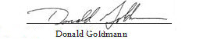

Next Monthly Board Meeting: September 3rd, 11:00 AM – 12:30 PM, 4600 Kietzke Lane, Offices of Gina Espinal-Aguerre, Reno, NV

Addendum

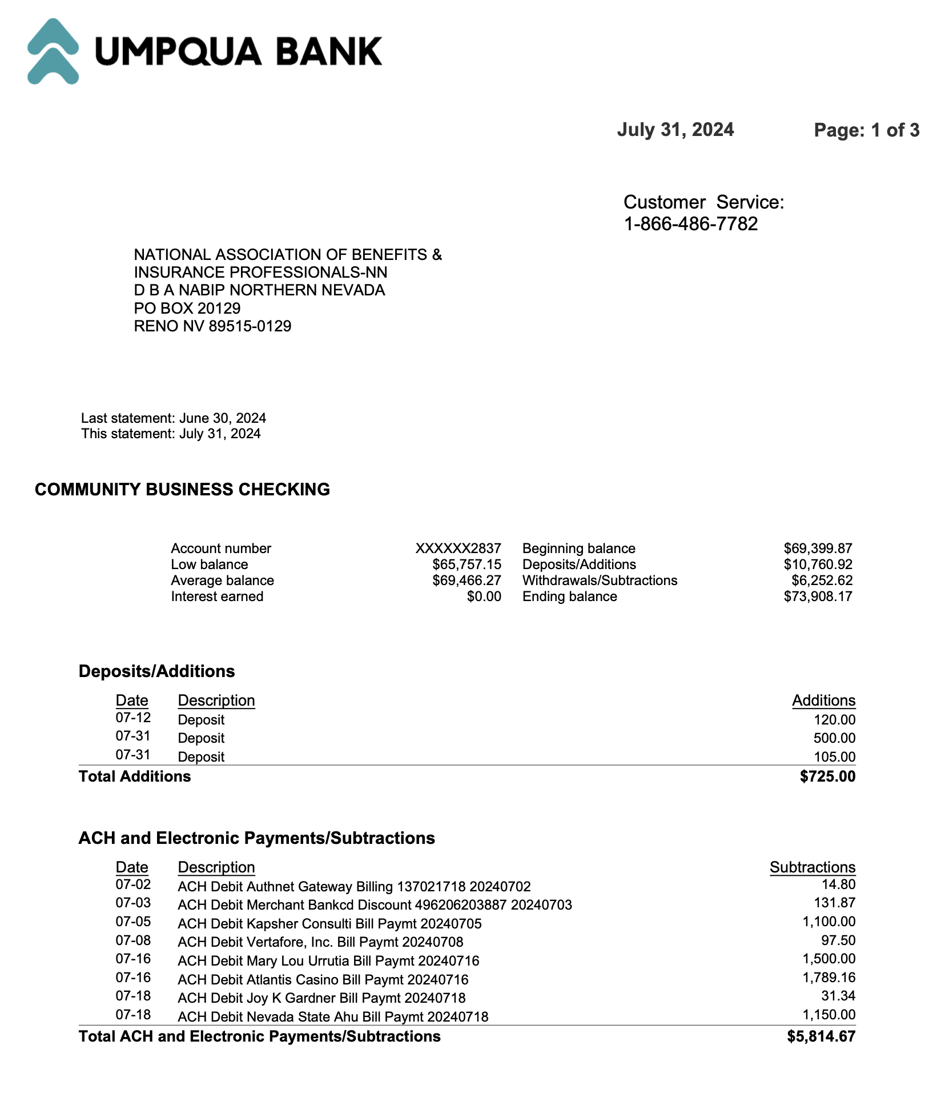
Umpqua June 2024 Statement

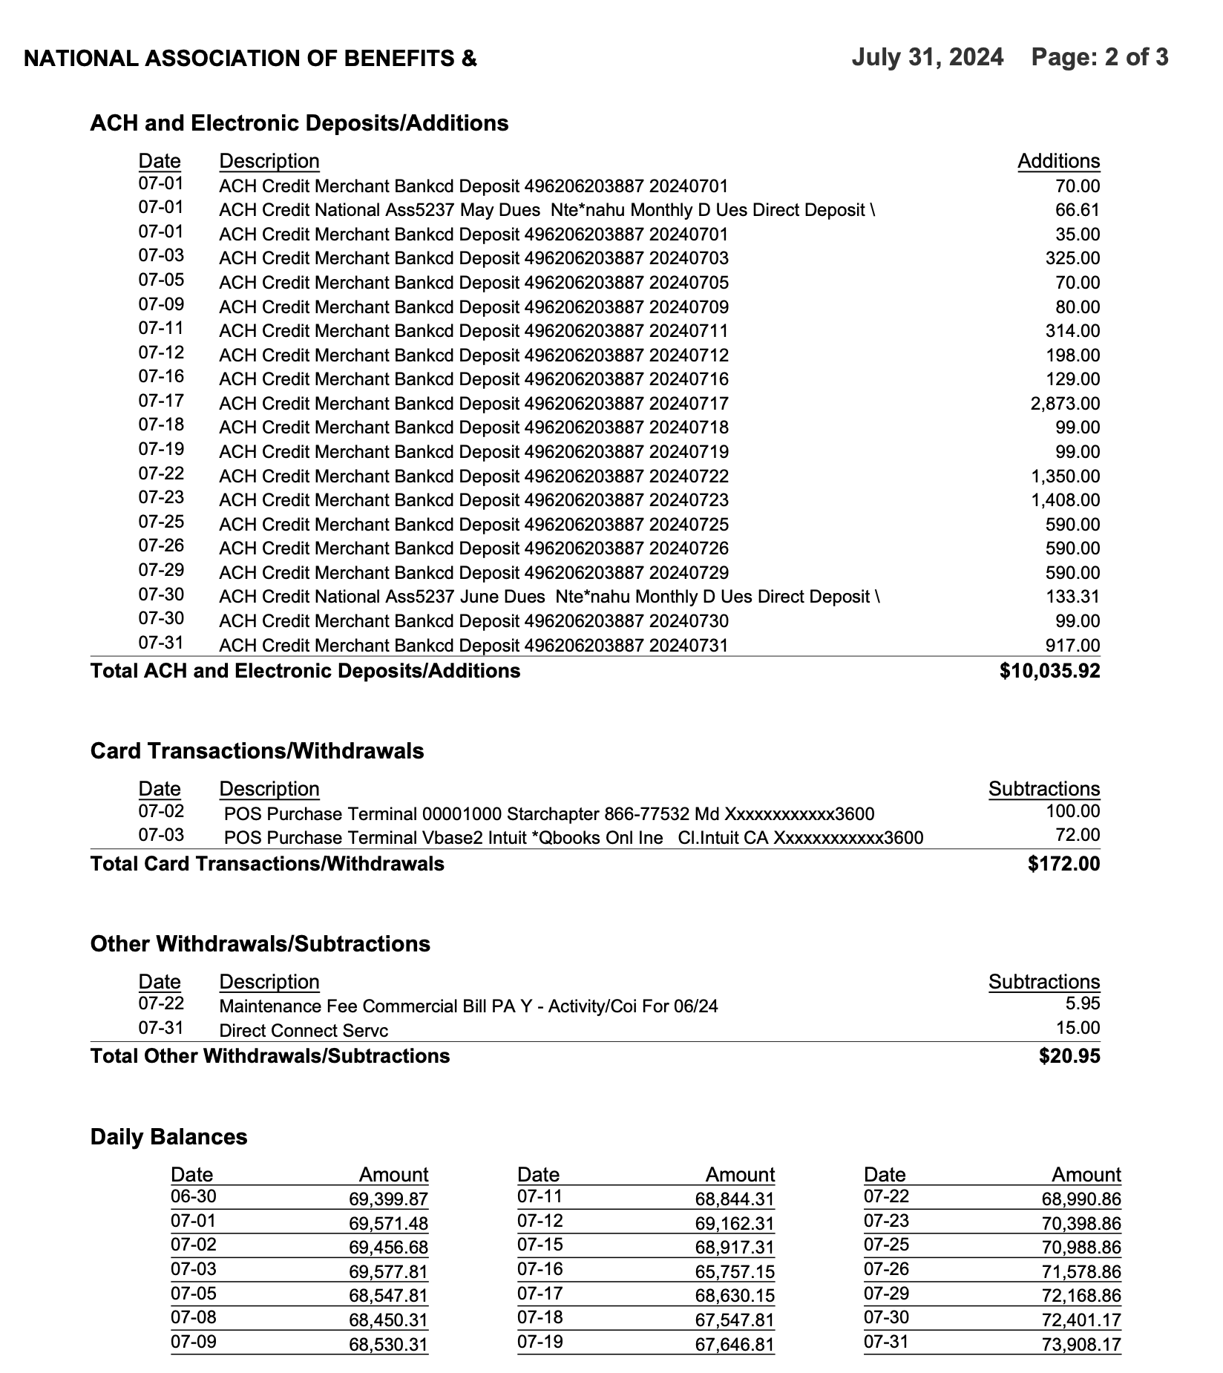
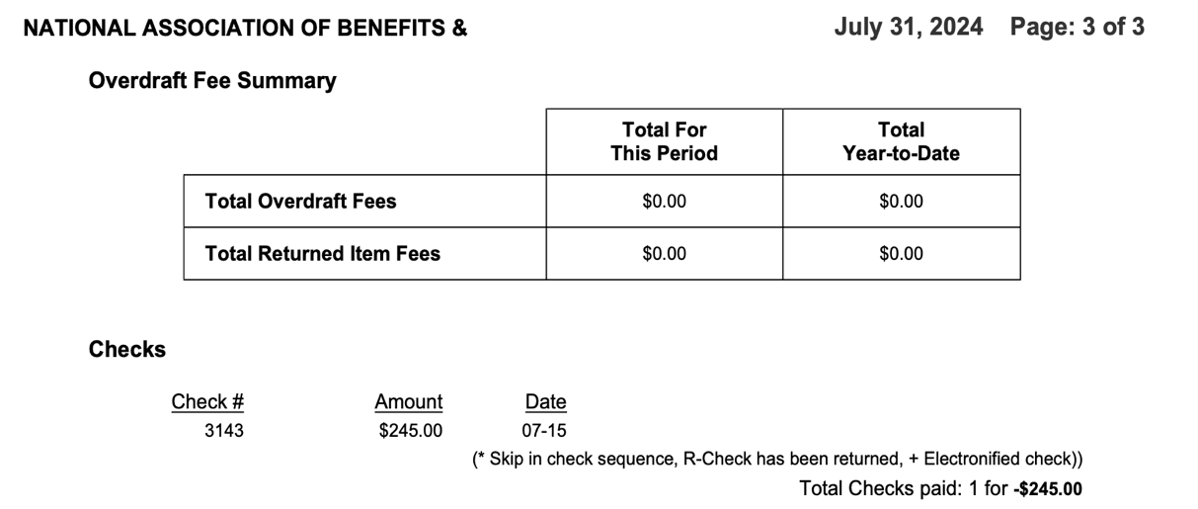

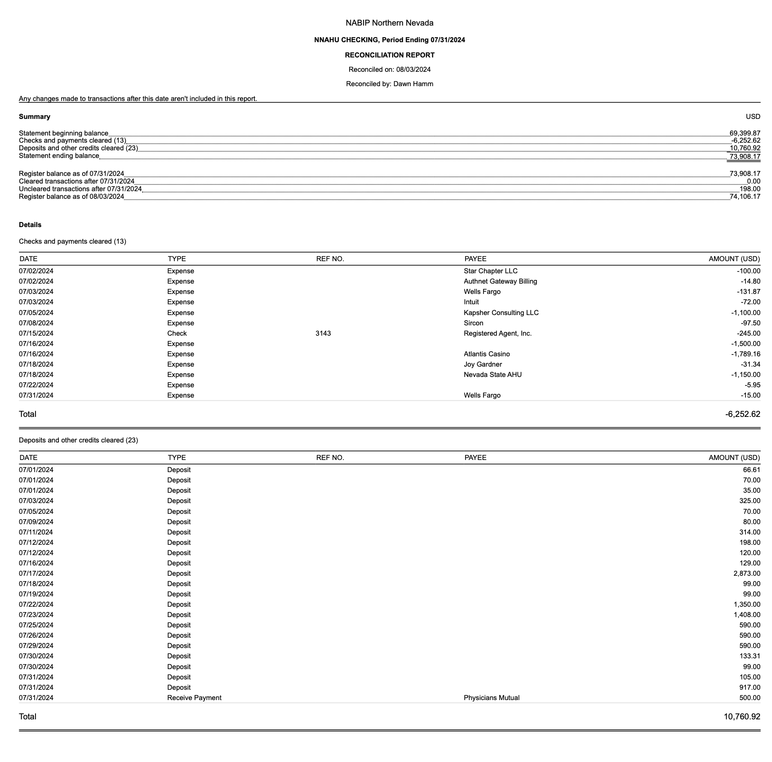
Reconciliation

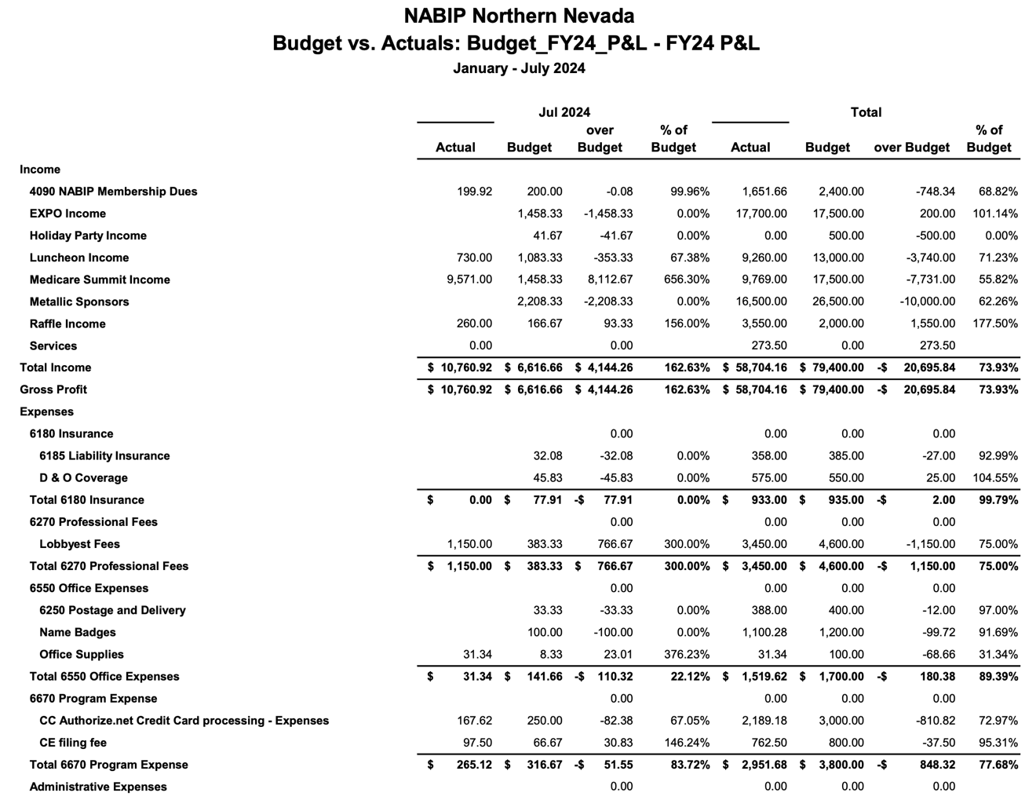
Budget vs. Actuals YTD

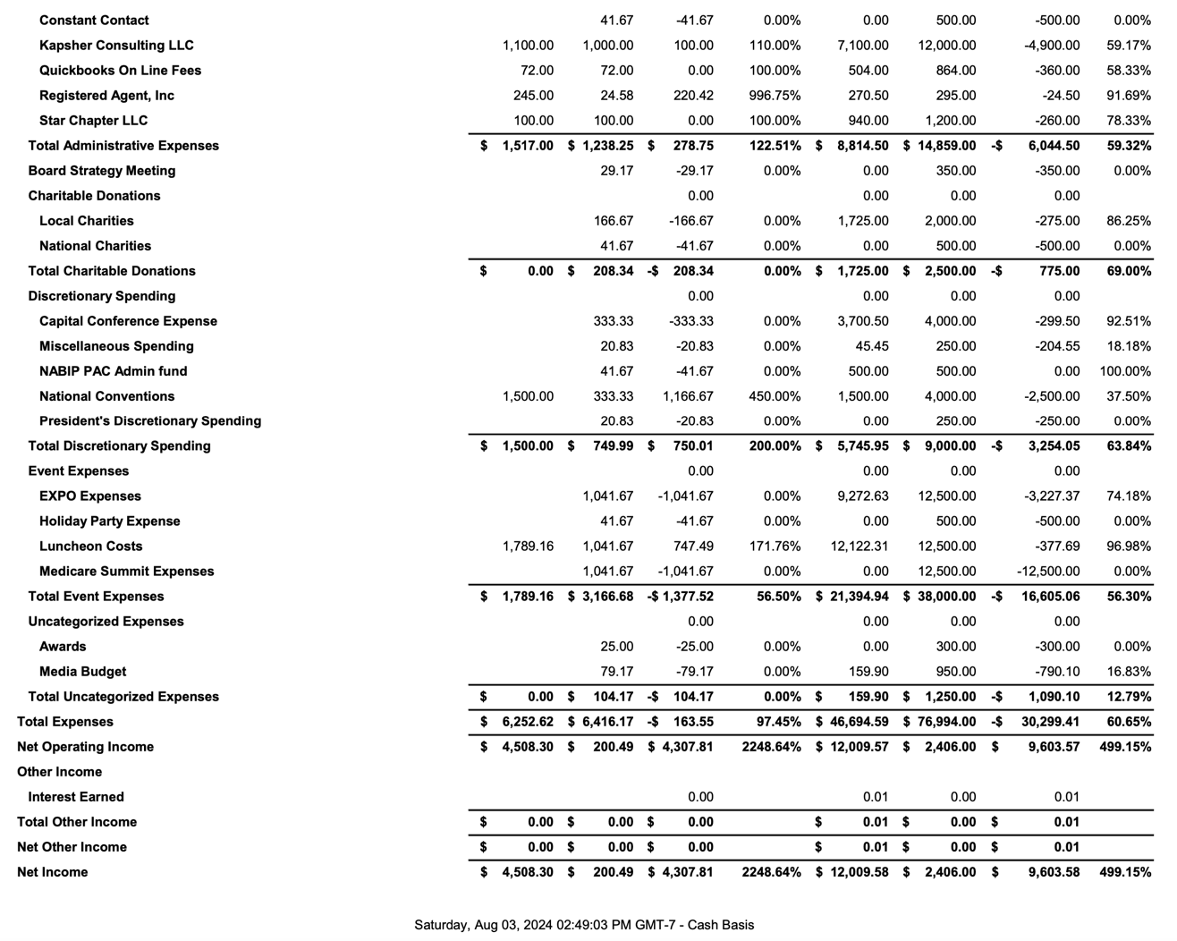

Profit and Loss Year to Date June 2024
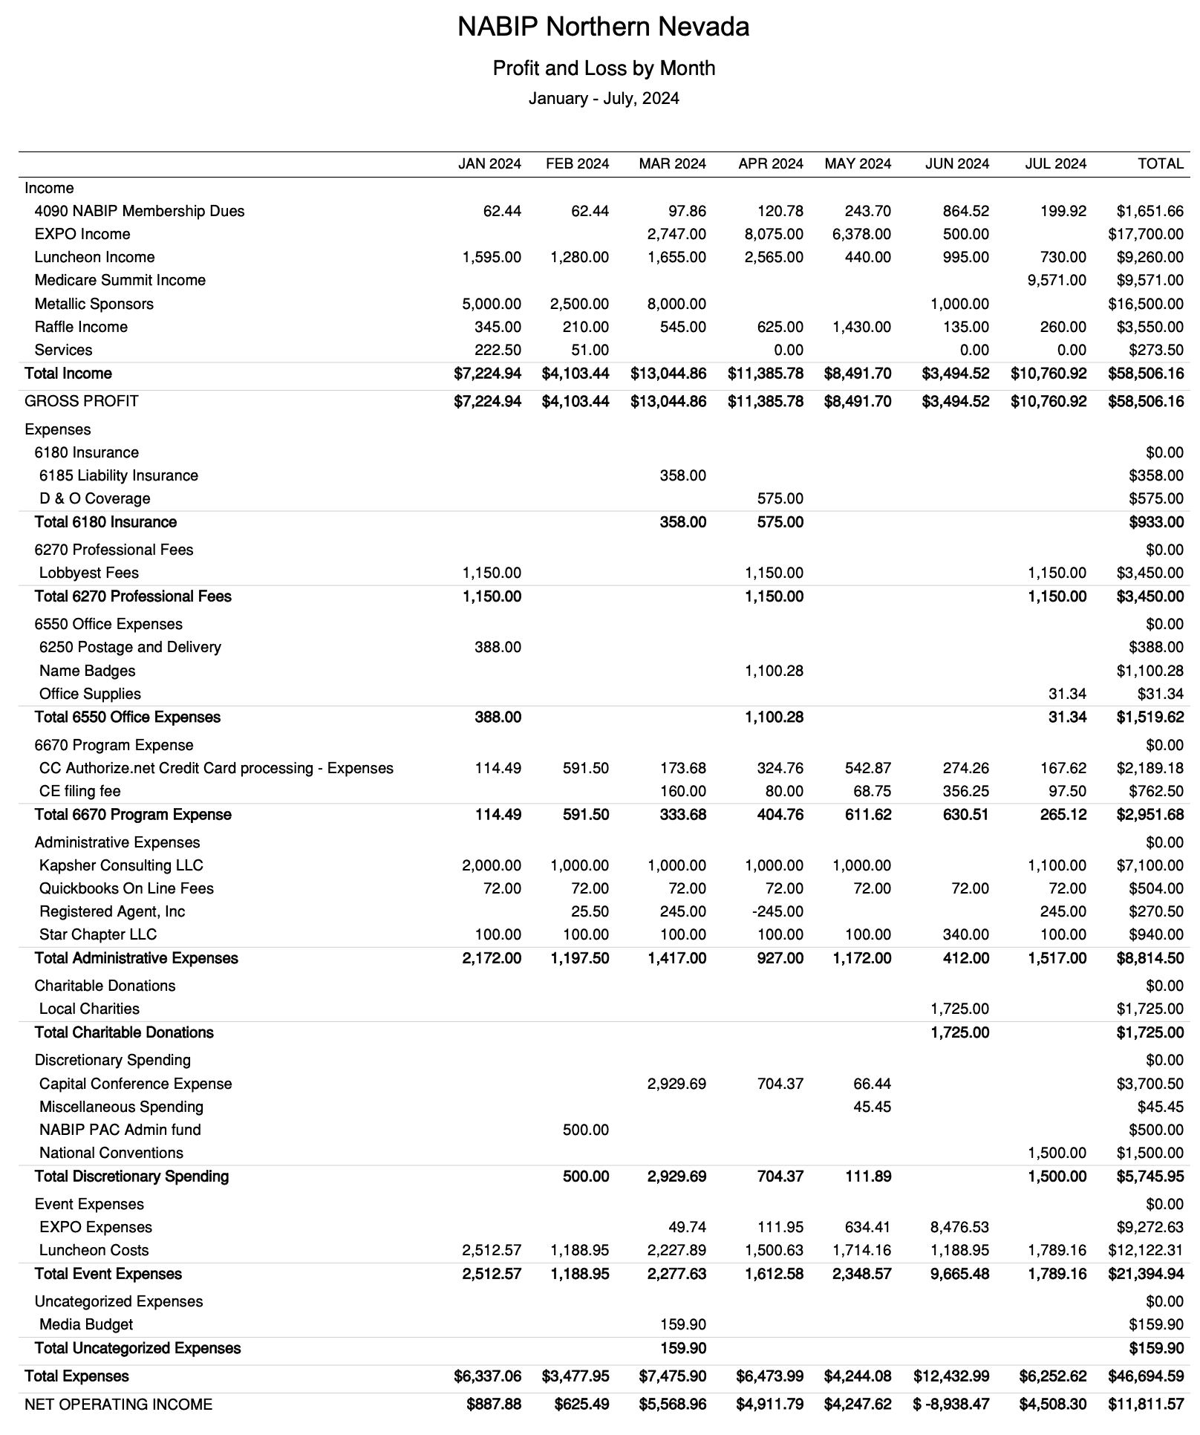

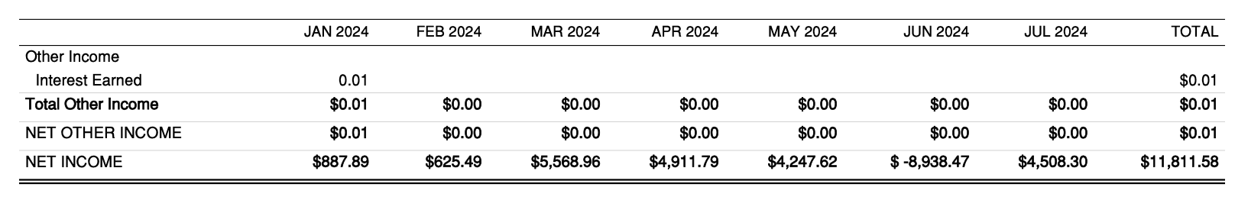

Legislative Report

NABIP-PAC Report
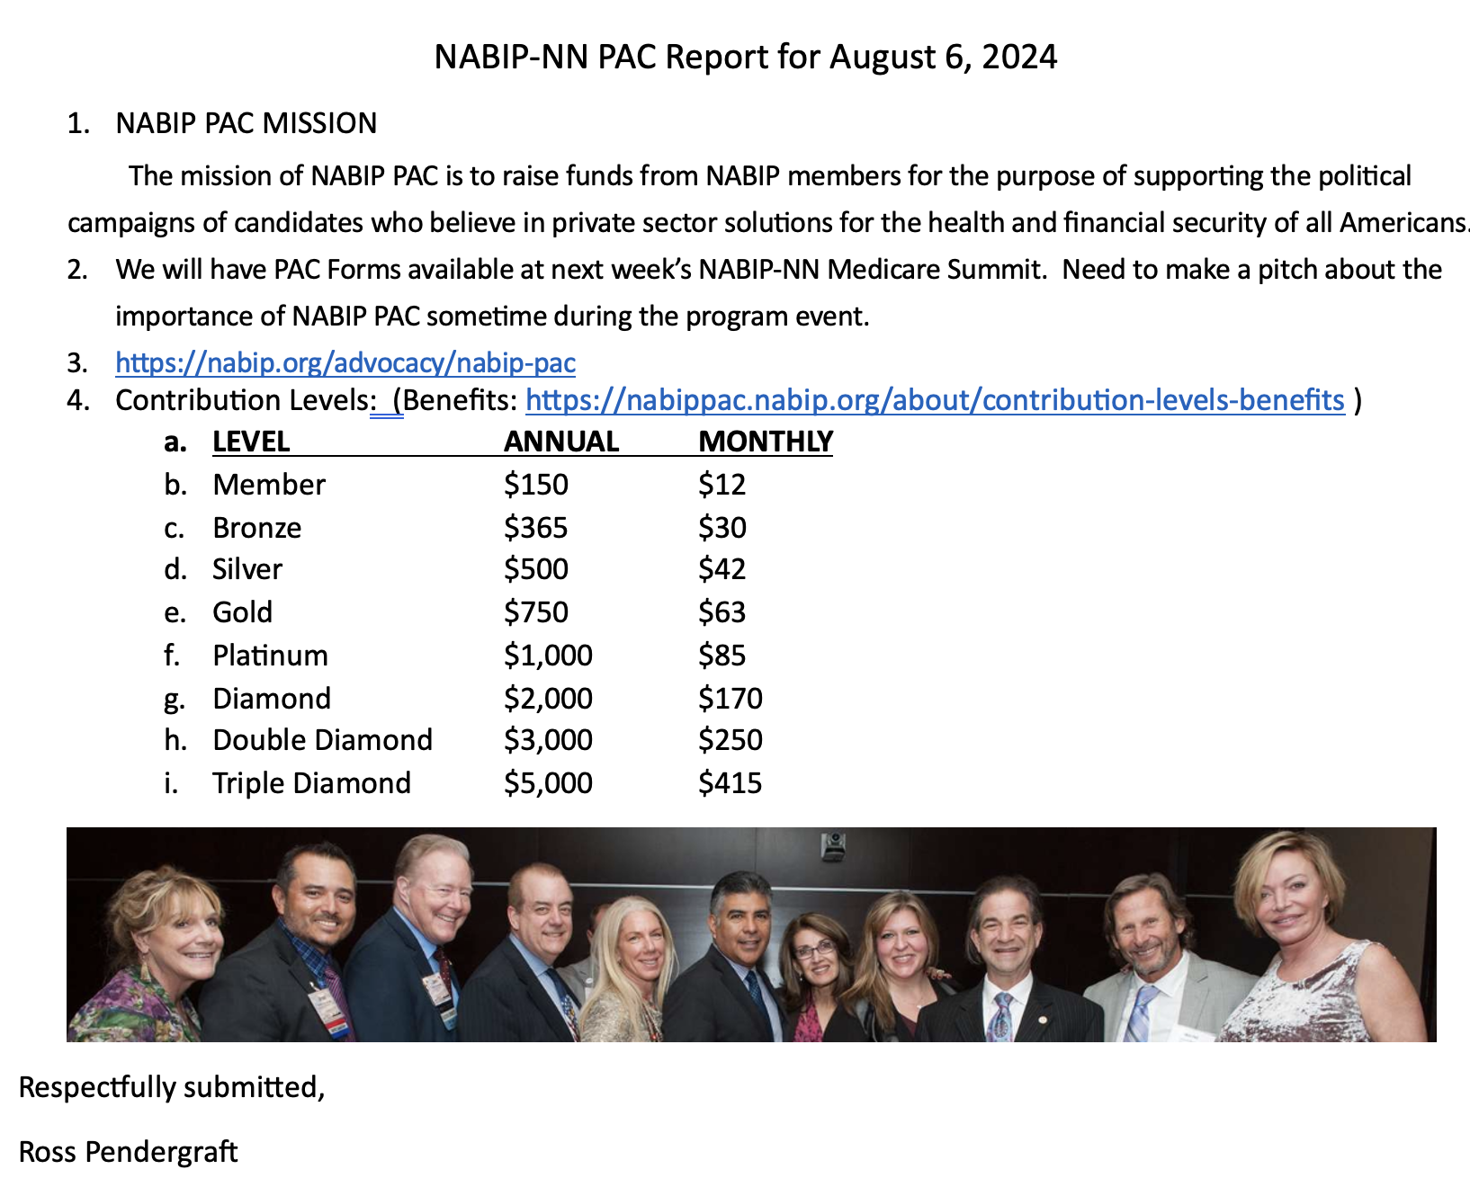

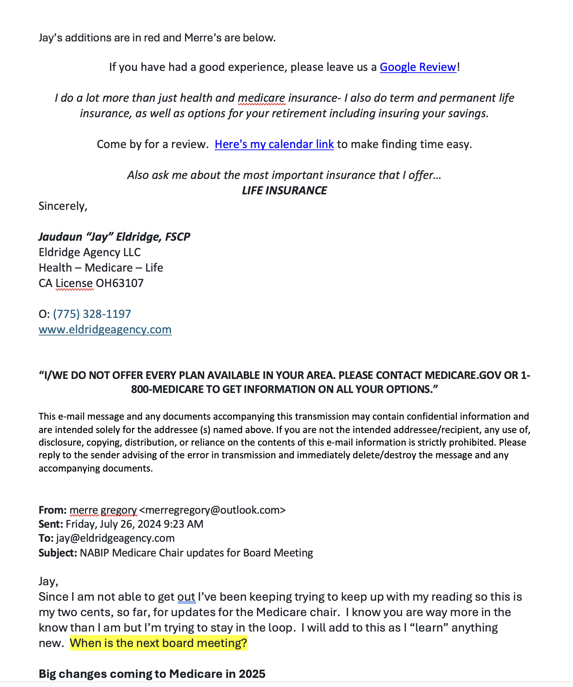
Medicare Report – Pg 1

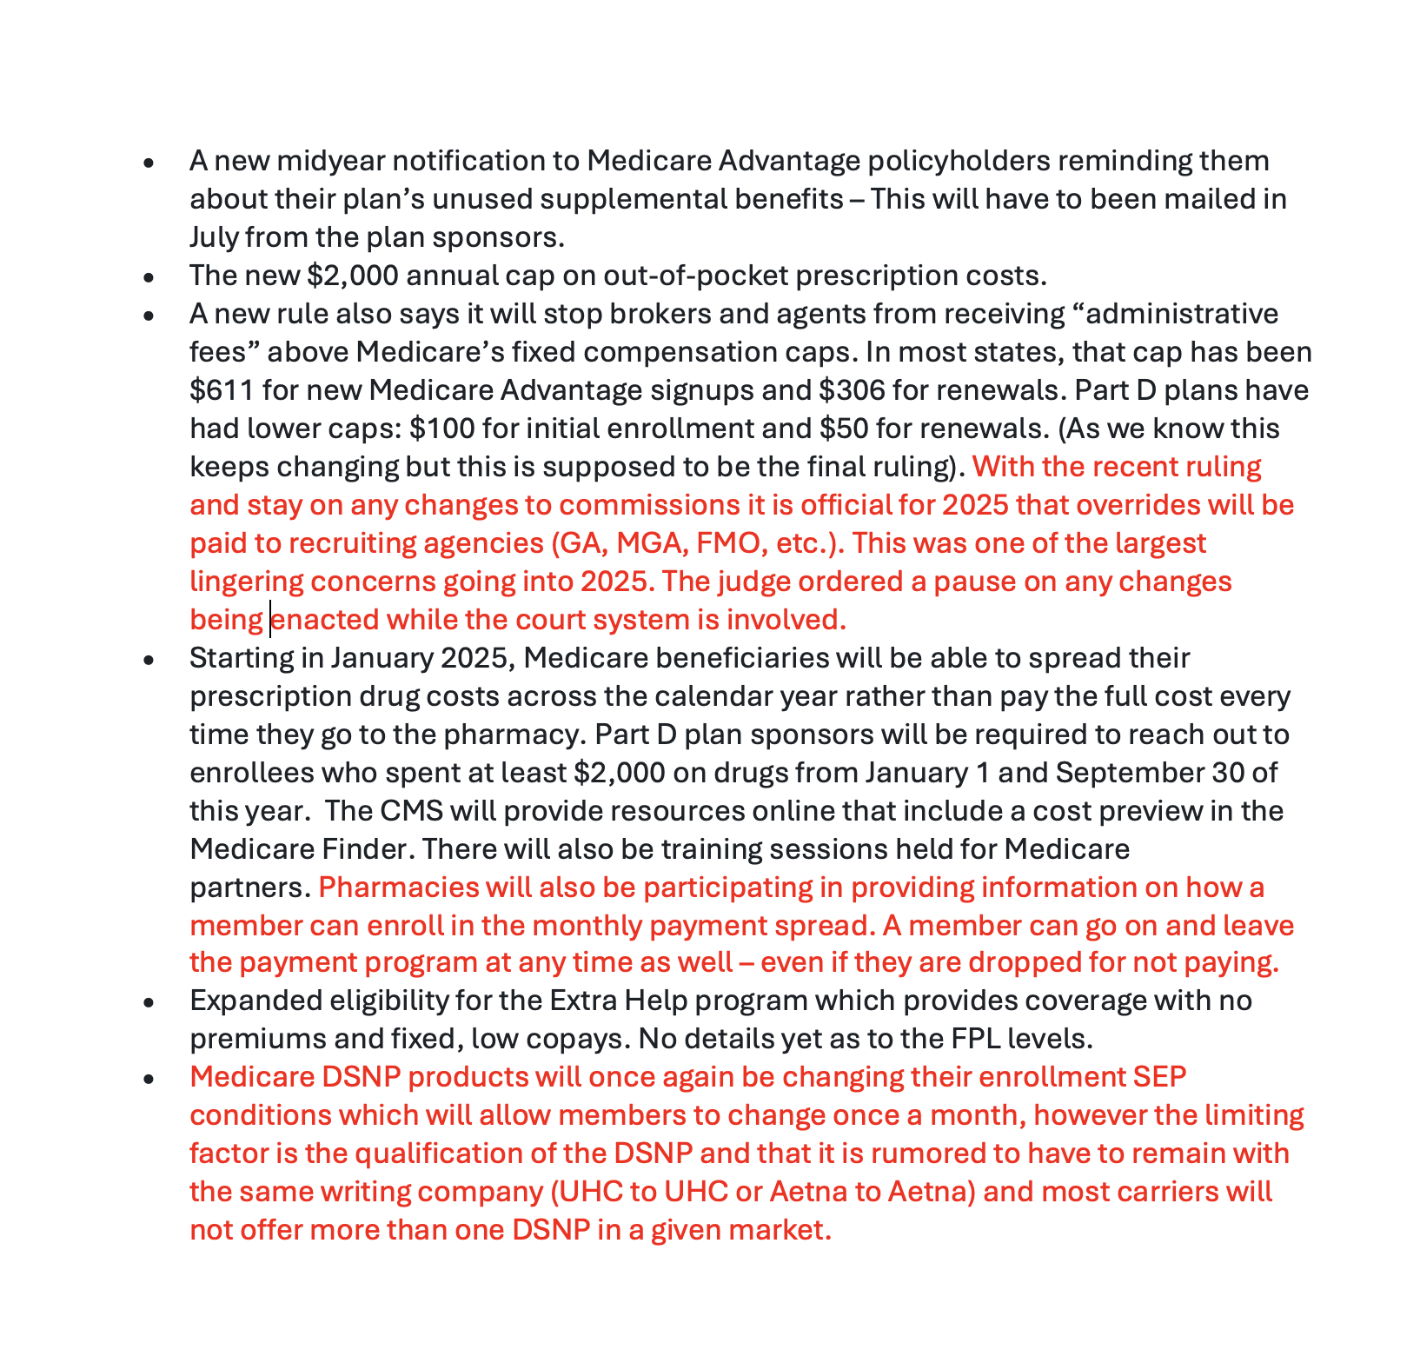
Medicare Report – Pg 2

