National Association of Benefits and Insurance Professionals - Northern Nevada

Board of Directors Meeting Minutes
December 3, 2024 11:02 AM – 12:10 AM
4600 Kietzke Lane, Building A-105, Reno, NV
Via Zoom – Meeting ID = us02web.zoom.us/j/84698950624

Attendance Report: Gina Espinal-Aguerre, Don Goldmann, Georgana Cepeda, Mary Lou Urrutia, Joy Gardner and Molly Moreno

Virtual Attendance by Phone and Computer: Julie Ann Evans, Ross Pendergraft, Jay Eldridge, Aliana Rushing, Merre Gregory, Ashley Kapostins, and Dave Sherrill.

Absent: Mika Clauson

Guest: None

- Meeting was called to order by President Molly Moreno at 11:02 AM.

- Roll call of attendees was taken by sight for those attending in person and on Zoom by Secretary, Don Goldmann, and by verbal confirmation for those who phoned into the meeting. Quorum confirmed. Connectivity confirmed.

- Motion, by Don Goldmann, to approve the November financial reports carried over from the November board meeting was seconded by Molly Moreno. Unanimously approved.

- Review of the November 2024 board minutes by Secretary, Don Goldmann.

  - A motion to approve the November 2024 board minutes was made by Don Goldmann and seconded by molly m. Unanimously approved.

- Report of the President by Molly Moreno:

  - Discussed who wanted to attend the 2025 Cap Conference with Mary Lou Urrutia, Gina Espinal-Aguerre, Georgana Cepeda and Molly Moreno announcing a desire to possibly attend.

  - It was observed that there is not yet an annual budget for 2025 and therefore, budgeted amounts for reimbursement of attendees’ expenses would have to be discussed and voted upon quickly.

  - Secretary Don Goldmann will hold an email vote, per the By-Laws, on a proposed 2025 annual budget after working with Vice President of Finance, Joy Gardner to develop that budget.

  - Vice President of Awards, Ross Pendergraft, reminded the board that for the Pacesetter Award, it was most important that Mary Lou Urrutia and Georgana Cepeda attend.

- Report of the Secretary by Don Goldmann:

  - With the minutes from last month approved, there was nothing else to report.

- Report of the Vice President of Finance by Joy Gardner: A number of financial documents have been placed into the Addendum of these minutes.

  - The Metallic Sponsorships have been revamped to reflect the value and what the chapter is giving to the Sponsors, especially with only 1 major event (EXPO and Medicare Summit together).

    - It is believed the sponsorship flyers have been sent out by Kapsher.

    - Anthem has already agreed to be the Diamond Sponsor and they have been invoiced.

  - StarChapter is raising the monthly cost from $100 to $125 beginning 10/31/24 and the chapter was billed in November for $125.

  - The chapter Christmas Party is set for Sierra Gold on South Meadows Pkwy on December 18th from 4:30 PM to 7:30 PM.

    - Jay Eldridge and Gina Espinal-Aguerre donated $250 each to pay for the food served at the Christmas Party in place of the usual donation from another sponsor.

    - The total $500 donation will cover the cost of the food and one drink ticket for each attendee.

    - Mika Clauson has purchased $500 worth of toys to be given to Ashley’s Toy Closet Charity with that money having been allotted in the chapter’s 2024 budget.

  - Prominence Health Plans owes the chapter $375 from 2020 and, while it has been verified that the funds have not yet been received since 2020 and a request for payment has been made, as of 12/2/24, payment has not yet been received.

  - Both the chapter’s checking and savings accounts balance.

  - Alaina Rushing is congratulated for good hard work at getting the Agency Sponsorship flyer ready and has placed a copy of the flyer within her Program Report.

  - Review of partnerships for 2024, with all paid, includes Diamond Anthem $8,500, Gold Aetna $4,000, Gold United Healthcare $4,000, Silver Hometown Health $2,500, Silver Word & Brown $2,500, Silver Alignment $2,500 and Bronze Prominence $1,000.

  - Current bank checking account balance, as of 11/30/2024, was $61,112.52 and the savings account’s balance was $200.39 with both accounts balancing.

  - In as much as there was no November membership luncheon meeting, there are no financials for that event.

  - It was requested by Aliana Rushing that the annual 2025 budget proposal include $2,000 for speaker fees for lunch program presenters.

  - It was announced that the Atlantis will not be increasing the meal costs for the chapter’s event meals.

  - It was announced that 25 persons have already registered for the chapter Christmas Party.

  - A motion to approve the December financial report was made by Julie Ann Evans and seconded by Gina Espinal-Aguerre. Unanimously approved.

- Report of the Vice President by Georgana Cepeda:

  - The Expo/Medicare event committee will hold a meeting, starting at 8 AM, on 12/19/24 at the Comic & Coffee shop with any person welcome to attend.

  - Speakers, sponsorship and vendor packets will go out by January.

- Committee Reports:

  - Vice President of Legislative Affairs by Mary Lou Urrutia: A written report has been included in the Addendum of these minutes.

    - A short verbal discussion, based on the written report, was held with NABIP showcased as to what they are focused on this year with the state of Vermont taking center stage, because of their universal coverage program.

  - Vice President of Awards report by Ross Pendergraft: Written report was submitted and has been entered into these minutes.

    - All the 2025 NABIP Awards now posted.

    - Last year, we earned 3295 points out of 4815.

    - Areas to focus on complete in 2025

      - Duly Noted: Identified Julie Ann Evans as Education Foundation Champion

      - Duly Noted: Education Foundation Provided update at Board Meeting on 11-5-2024 Meeting

      - Annual Summary Report of Chapter Activities

      - New Officer Leadership Training

      - Conduct a Member Needs Survey

      - Active Membership Campaign Ongoing 3-6 months

      - Establish or continued New Agent Outreach Program

      - Conduct an overview of NABIP Website at Chapter Meeting

    - Reminding everyone to complete their NABIP Leadership Training. This will help with your position. Be sure to sign-in before watching the video: https://videos.nabip.org/

    - The New Member Orientation will continue every 4th Thursday at 9:00am PST on Zoom. Need to make sure we keep blasting this out in our newsletter each month as has been done each month this year.

      - Zoom meeting ID 826 3420 3381, Passcode “Membership”
      - http://welcometonabip.org

  - Vice President of Membership report by Gina Espinal-Aguerre:

    - Membership is steady at 98.

    - March 31 is the date when the national organization will determine our chapter size for awards.

  - Vice President of Communications/Media report by Mika Clauson: Absent with no report.

  - Vice President of Professional Development report by Julie Ann Evans: Written report submitted and entered into these minutes. See report and remember we were dark and therefore, there are notes about the south for the purpose of charging them sircon

    - There was no November Membership luncheon and hence, there is nothing to report about non-event.

    - NABIP SN’s November 12, 2024 Luncheon:

      - This was a CE approved event and managed through NABIP NNs Sircon account.

      - There was a total of 7 CEs processed on November 12th. There is a fee of $1.25 per CE, so NABIP NN should receive an invoice from Sircon for $8.75.

      - This information was shared with the President, VP of Professional Development and Treasurer of the NABIP SN board, as well as with Joy Gardner, NABIP NN Treasurer, so she can invoice them.

    - NABIP NV Free CE Series:

      - Paul Roberts with Word & Brown has agreed to offer 3 Ethics CE classes in 2025. These classes will be held on January 30th, February 13th and March 13th.

      - The course material for all 3 classes was submitted on November 23rd and are currently still pending review.

      - These classes are being managed through NABIP NNs Sircon account. There is a filing fee of $40 per course, so NABIP NN should see an invoice from Sircon for $120.00.

    - NABIP NV Monthly Professional Development Meeting:

      - On the 4th Friday of each month there is a virtual meeting held for those who are involved with planning luncheons, events, CE classes, etc. for both local chapters and the state chapter.

      - All are welcome to attend the meeting.

  - Director of Programs report: Written report submitted and has been entered into these minutes.

    - January Luncheon still Jim Wadhams.

    - February Luncheon - Dr Marty Thermography confirmed.

    - March Luncheon - Kris Bashford confirmed.

    - April Luncheon - Medicaid (will be a deep dive on programs available to aged and disabled that DO NOT qualify for Medicaid).

    - Included in the Addendum to these minutes is a flyer for the new agency partnership package which will soon be mailed to brokers and agencies.

      - The proposed Gala has not been included in the cost/benefit analysis of the program since we do not know what pricing on that will look like yet.

      - Appreciation was expressed to Secretary, Don Goldmann, for his tremendous help in getting a draft version of the flyer created.

  - NABIP-PAC Chairperson report by Ross Pendergraft: A written report is included in the Addendum for these minutes.

  - Medicare Chairperson report by Jay Eldridge and Merre Gregory: Written report submitted and entered into the Addendum of these minutes.

  - By-Laws and P&P Committee report by Don Goldmann:

    - Due to fourth quarter open enrollment activities, no meeting was held.

- A motion was made by Don Goldmann and seconded by Julie Ann Evans to accept all reports in toto. Unanimously approved.

- Old Business – None

- New Business – None

- A motion to adjourn was made by Molly Moreno and seconded by Don Goldmann. Unanimously approved.

- President Molly Moreno adjourned the meeting at 12:10 PM.

Submitted by Don Goldmann, NABIP-NN Secretary
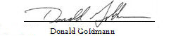

Next Monthly Board Meeting: January 7th, 11:00 AM – 12:30 PM, 4600 Kietzke Lane, Offices of Gina Espinal-Aguerre, Reno, NV

Addendum

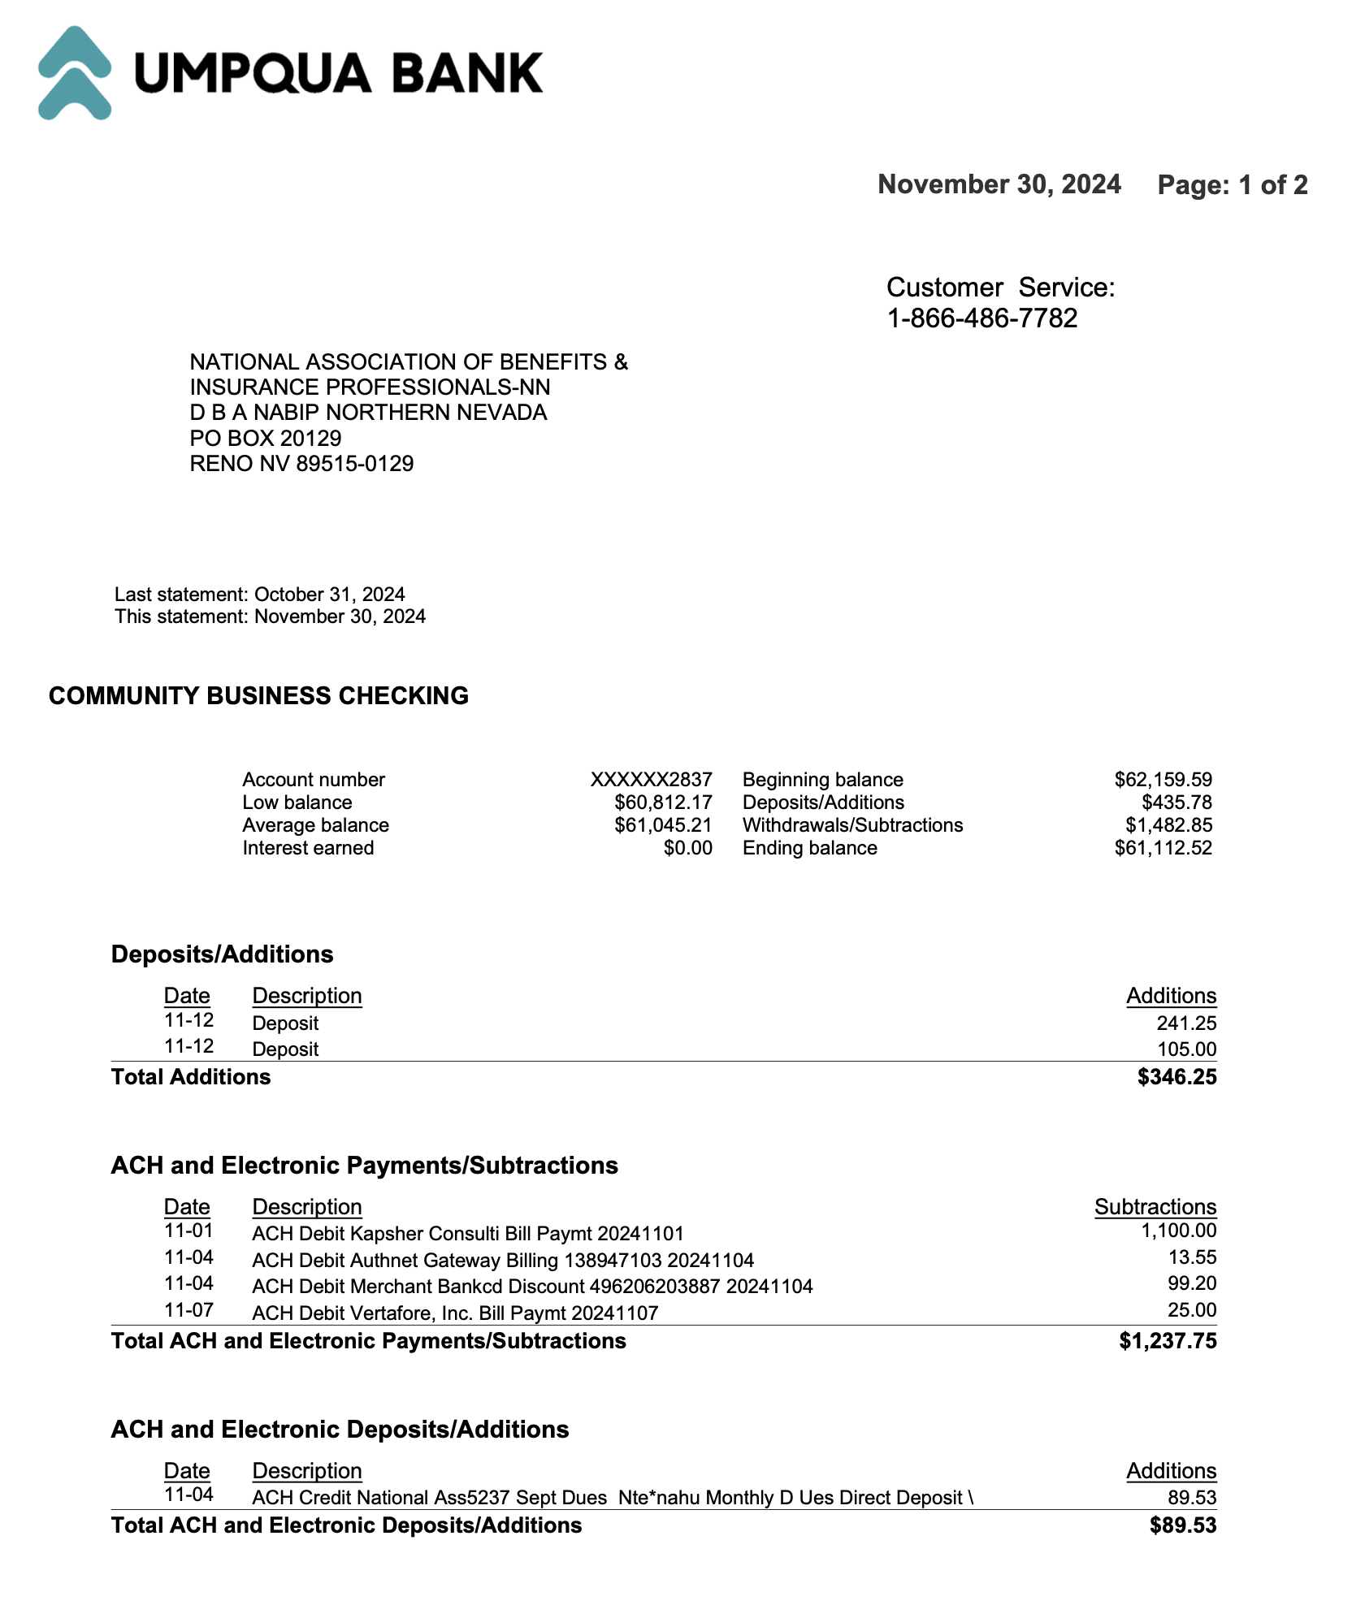
Umpqua November 2024 Statement

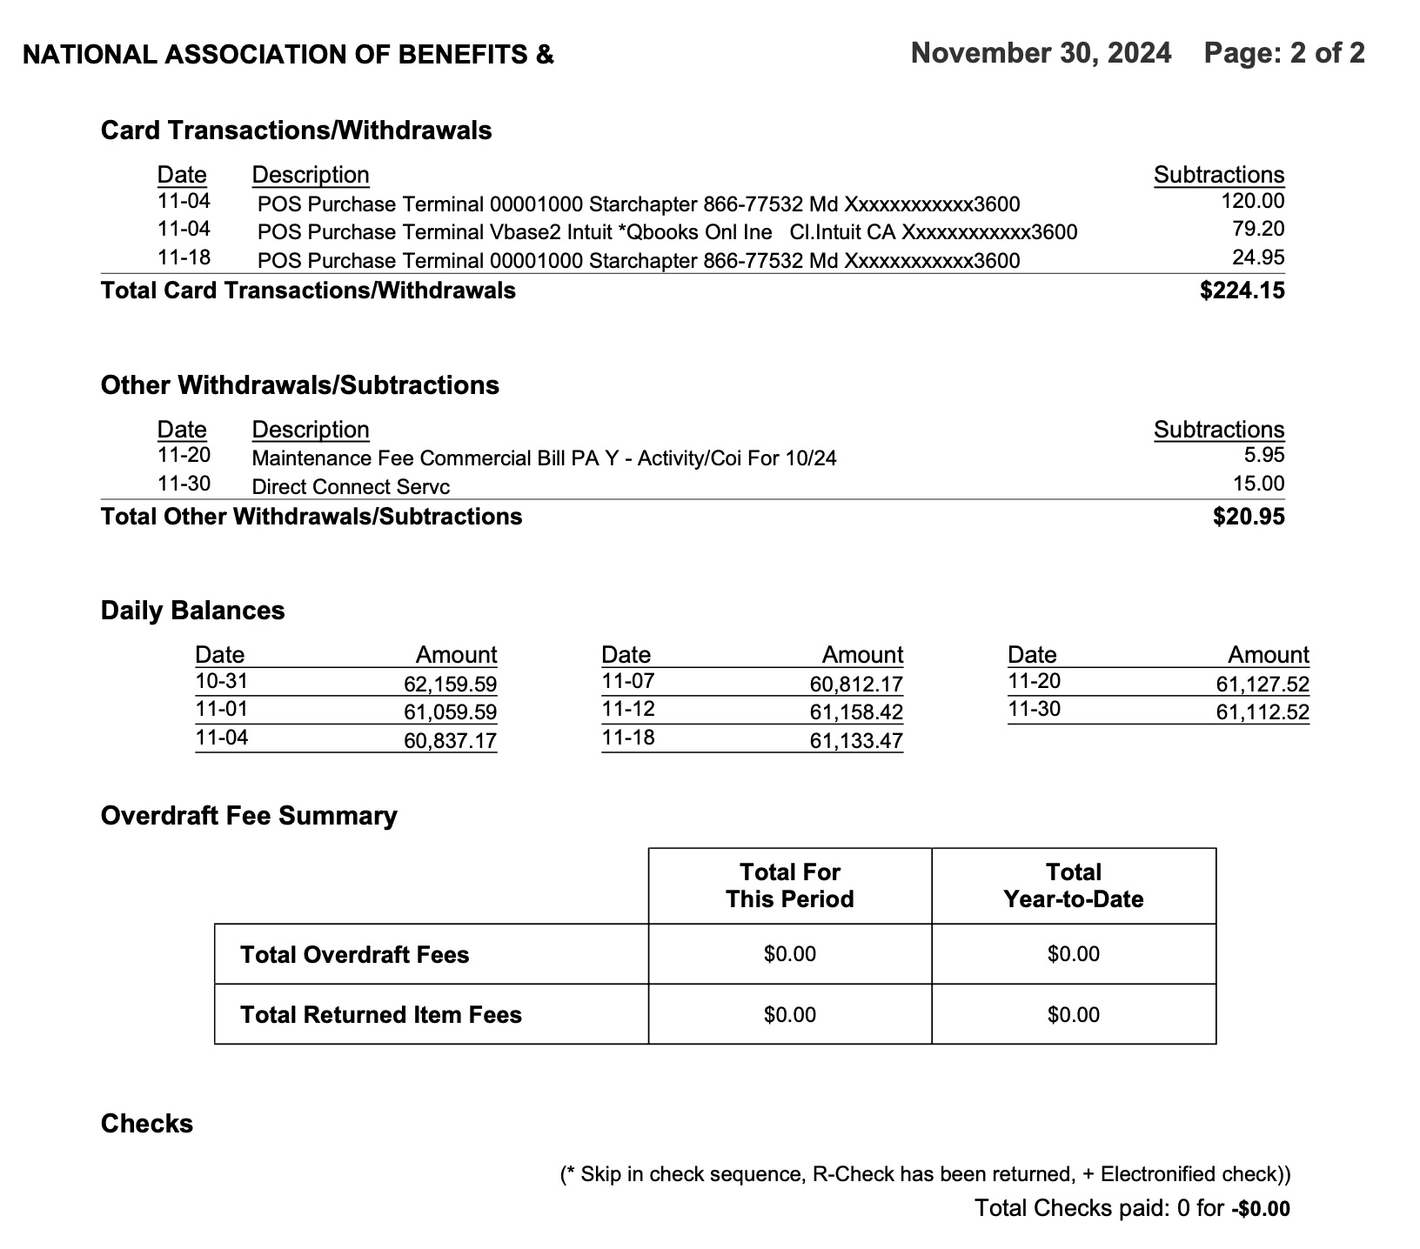

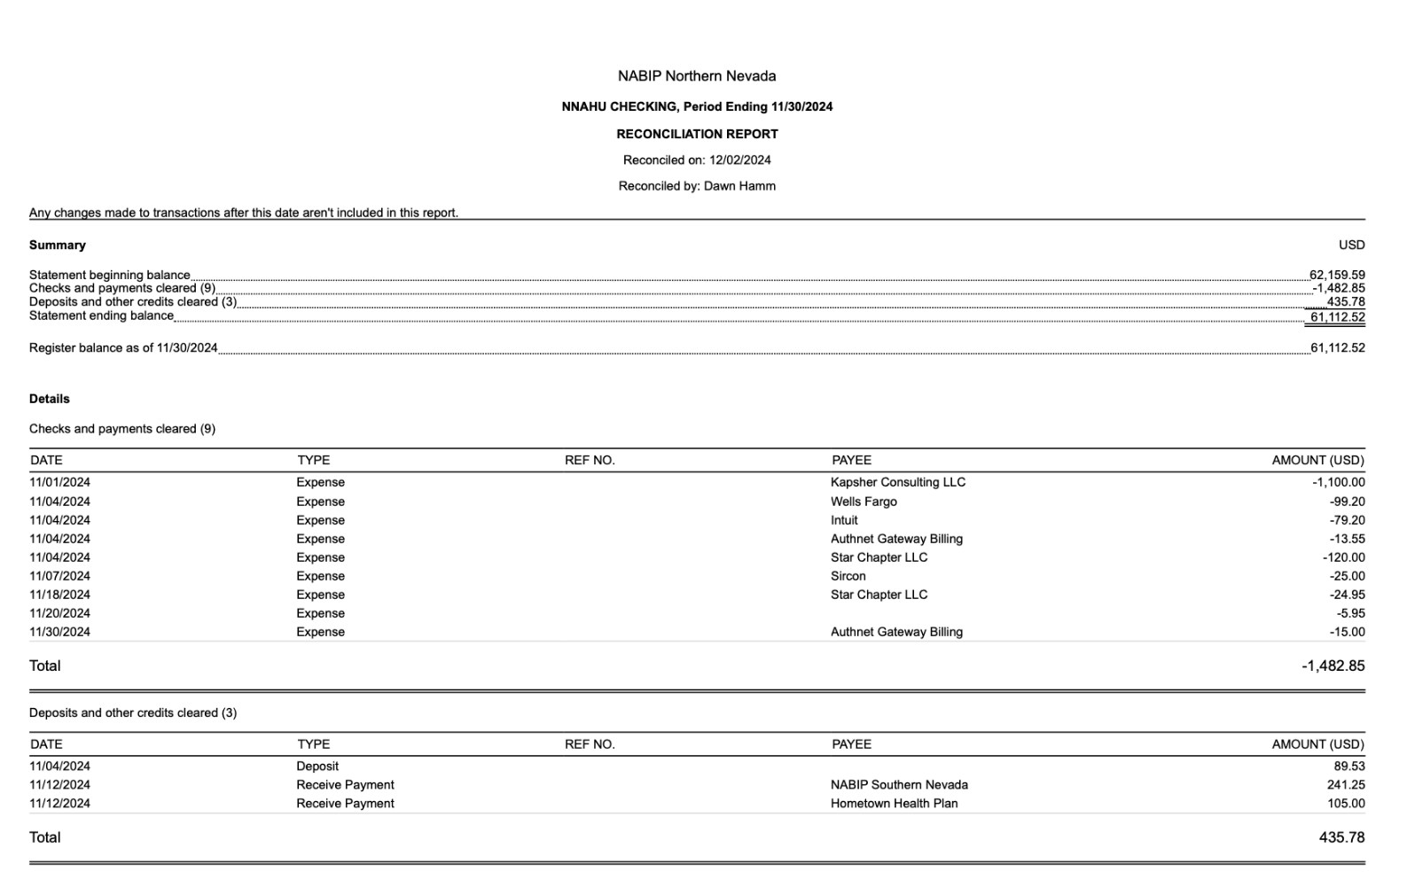
Reconciliation of Checking and Savings Accounts

Profit and Loss by Month YTD Through November
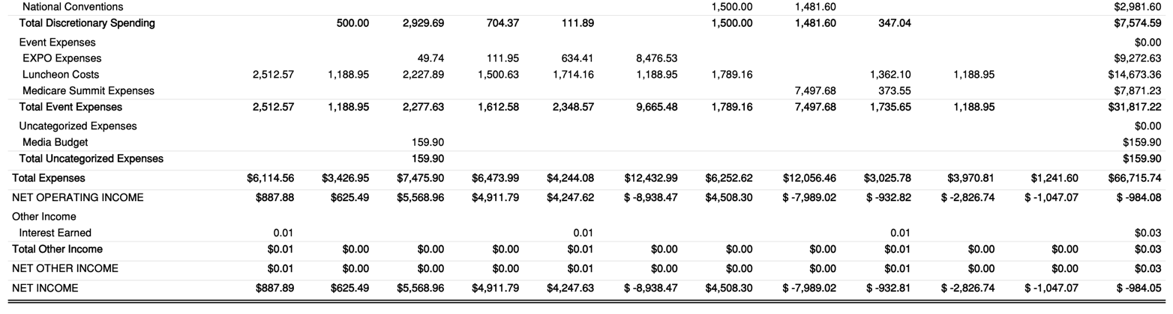
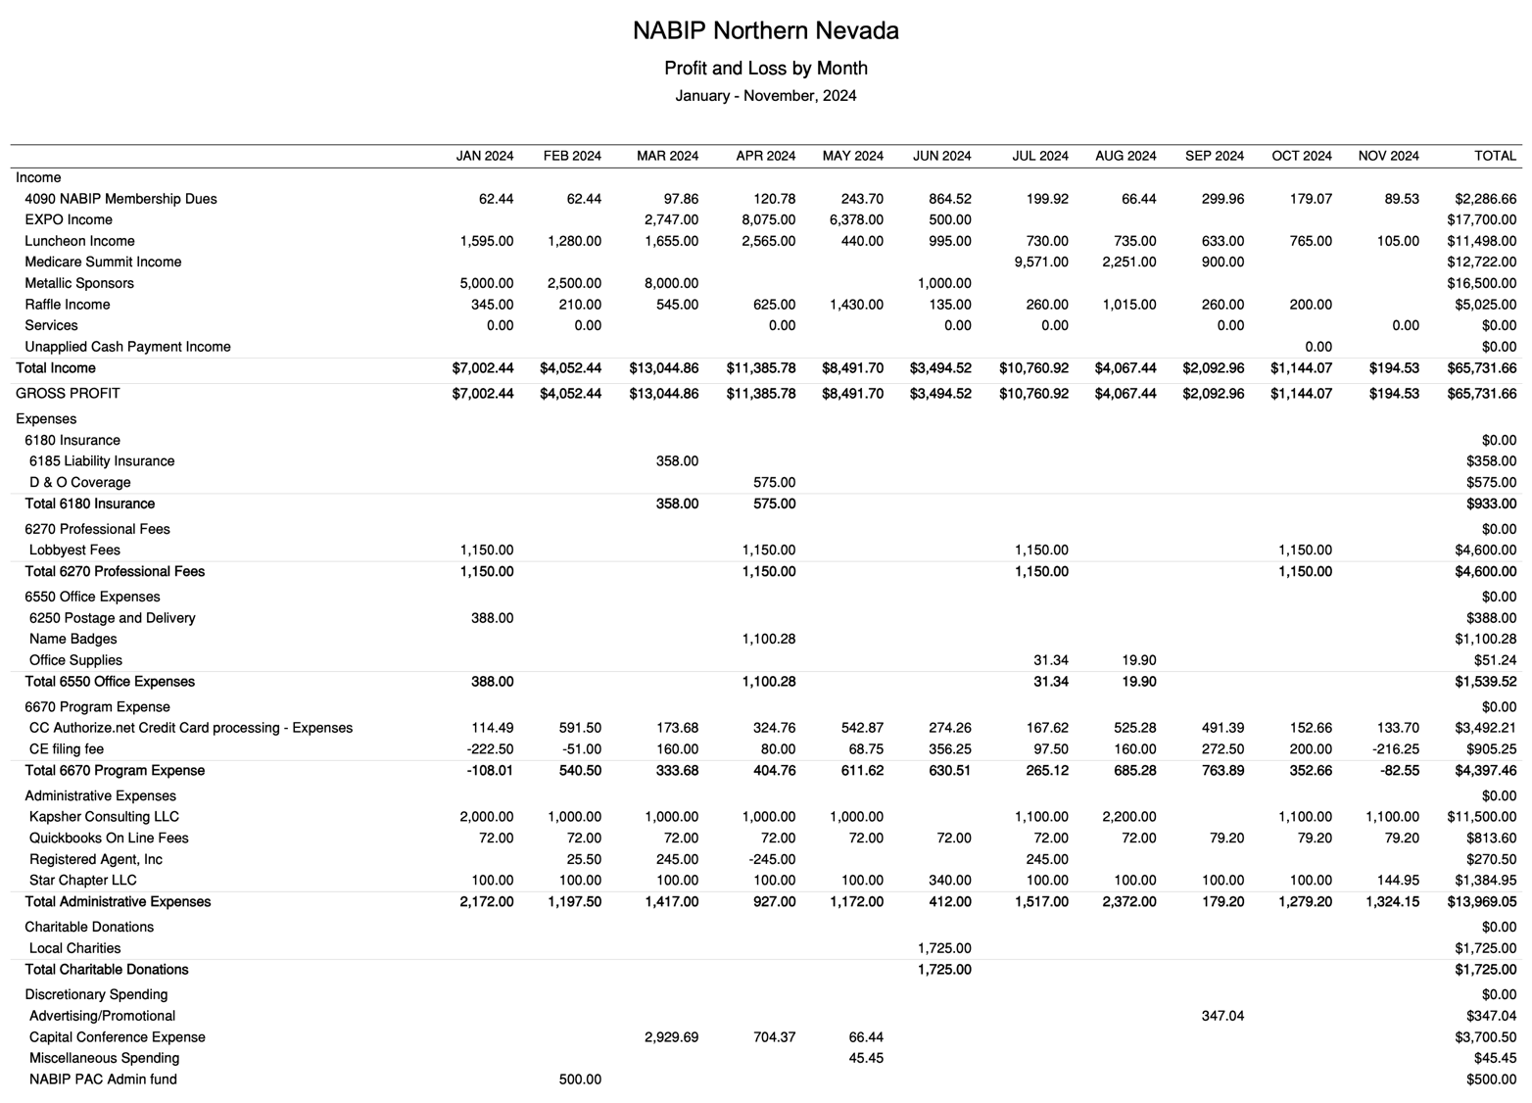

Budget vs. Actual January – December 2024

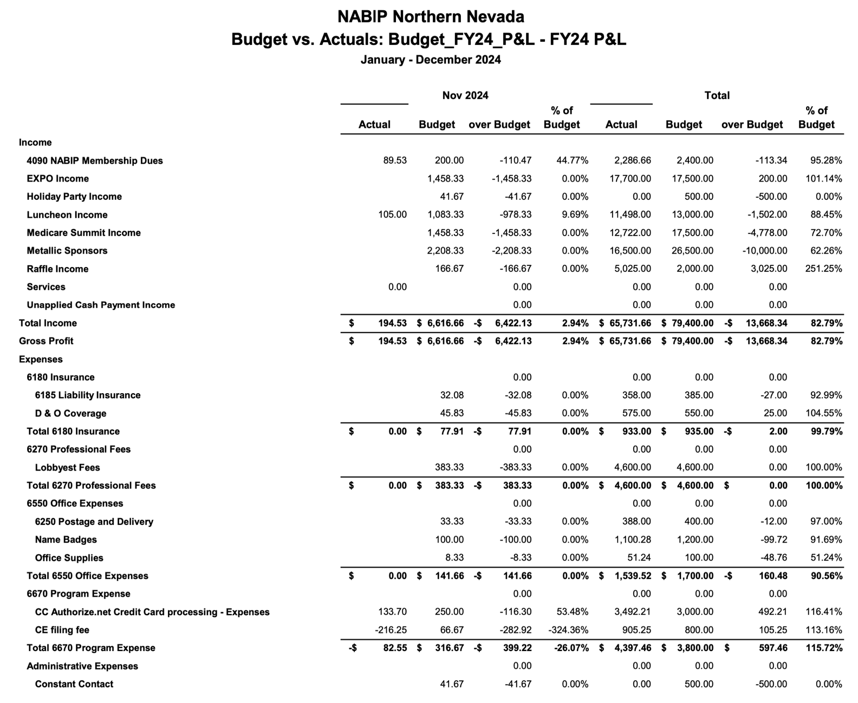

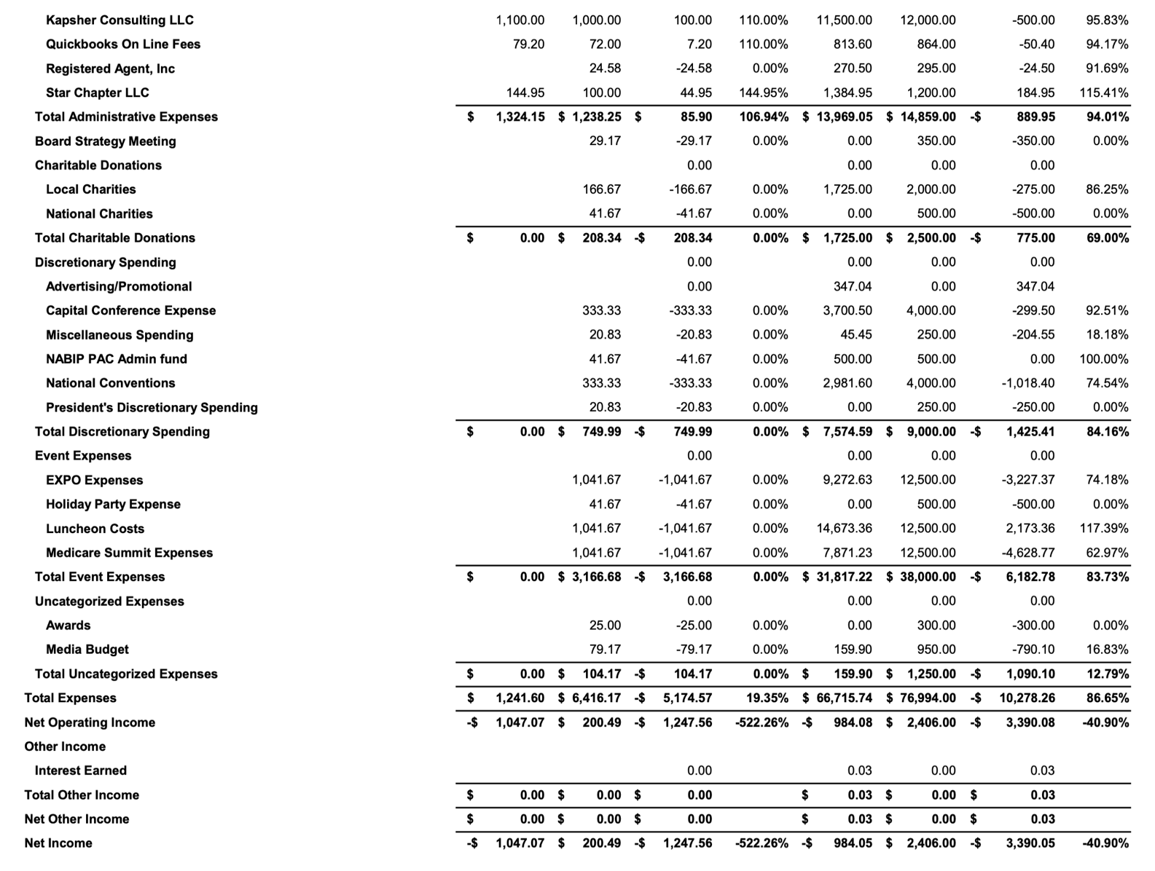
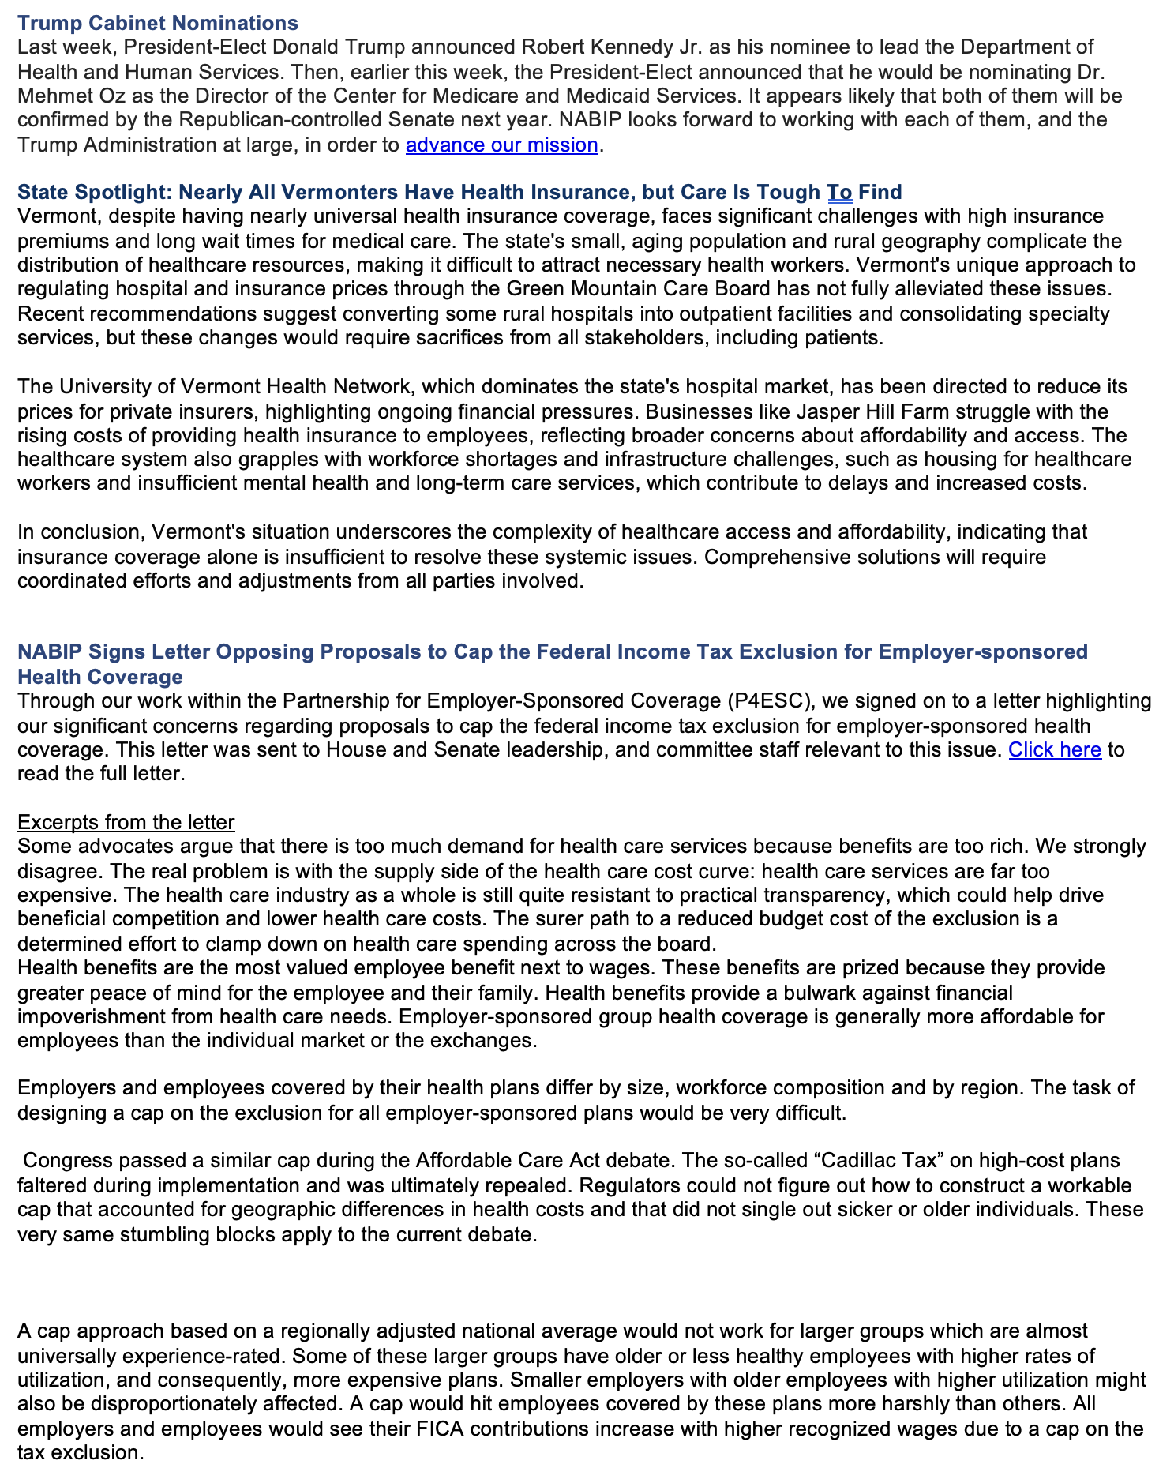
Legislative Report
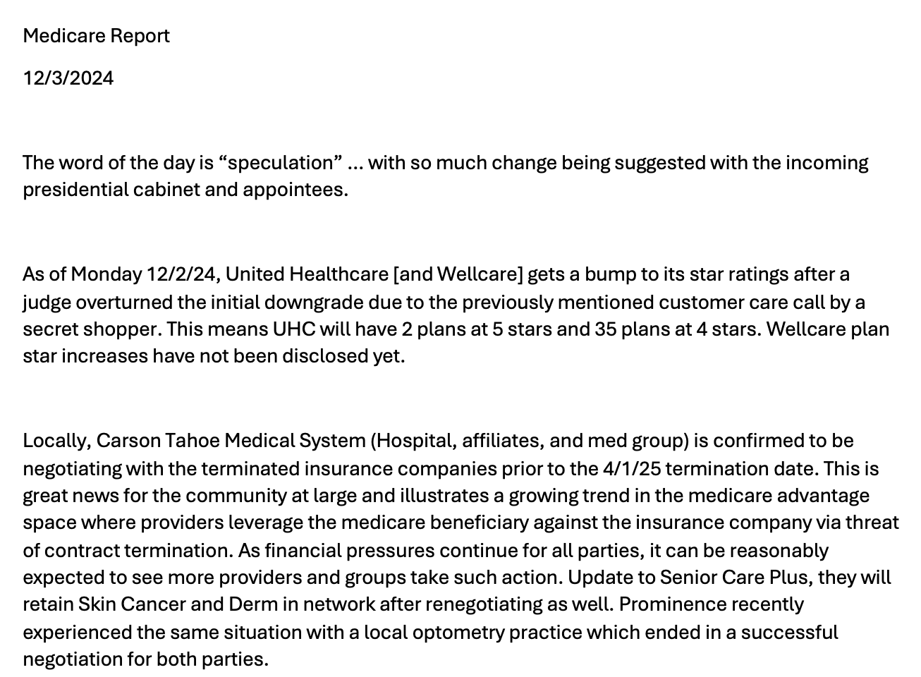
Medicare Report

NABIP–PAC Report

