National Association of Benefits and Insurance Professionals - Northern Nevada

Board of Directors Meeting Minutes
February 4, 2025 11:02 AM – 12:20 PM
4600 Kietzke Lane, Building A-105, Reno, NV
Via Zoom – Meeting ID = us02web.zoom.us/j/84698950624

Attendance Report: Gina Espinal-Aguerre, Don Goldmann, Mary Lou Urrutia, Joy Gardner, Jay Eldridge and Aliana Rushing

Virtual Attendance by Phone and Computer: Julie Ann Evans, Ross Pendergraft and Merre Gregory.

Absent: Molly Moreno, Mika Clauson, Georgana Cepeda, Ashley Kapostins, and Dave Sherrill.

Guest: None

- Meeting was called to order by Acting President Aliana Rushing at 11:02 AM.

- Roll call of attendees was taken by sight for those attending in person and on Zoom by Secretary, Don Goldmann. Quorum confirmed. Connectivity confirmed.

- Review of the January 2025 board minutes by Secretary, Don Goldmann.

  - Discussion occurred about the absence of a Medicare report from the addendum and clarification about one not being given was accepted.

  - A motion to approve the January 2025 board minutes was made by Don Goldmann and seconded by Julie Ann Evans. Unanimously approved.

- Report of the President by Molly Moreno: Absent with no written report.

  - In the absence of the President, Aliana Rushing provided an update about the progress of the May Expo and Medicare event.

- Report of the Secretary by Don Goldmann:

  - Per the approval by email from Molly Moreno, Don Goldmann made a motion to nominate himself as the Chairperson of the 2025 Nominations Committee and Joy Gardner seconded the motion.

  - After a review of the chapter’s By-Laws, it was determined that the Immediate Past President was not required to be on the committee and that committee appointment of the Chairperson was solely the authority of the President.

  - As Chairperson of the Committee, Don Goldmann requested that Joy Gardner and Julie Ann Evans serve on the Committee and they agreed to do so. Jay Eldridge also offered to participate when his schedule permitted.

- Report of the Vice President of Finance by Joy Gardner: A number of financial documents have been placed into the Addendum of these minutes.

  - The Ambassador Program has been a huge success with $3,600 budgeted to be raised, while the current income actually raised is $6,400 from having 5 individual and 3 Platinum Partners sold year to date.

  - Prominence Health Plans owes the chapter $375 from 2020 and, while it has been verified that the funds have not yet been received since 2020 and a request for payment has been made, as of 2/1/25, payment has not yet been received.

  - Both the chapter’s checking and savings accounts balance.

  - Review of partnerships for 2025 shows that Anthem has renewed at the Diamond level for $8,500, which has been received. Other sponsors, who have been invoiced include United Healthcare, Hometown Health and Word & Brown. Aetna and Prominence is still considering their renewal for 2025. Alignment is probably not going to participate this year, but Molly Moreno is working on it.

  - Current bank checking account balance, as of 1/1/2025, was $70,692.15 and the savings account’s balance was $200.39, but no statement has been received for the month yet.

  - The January, 1/16/2025, luncheon financials were:

    - Attendance: 50 attendees with 18 NABIP members, 11 Ambassadors, 4 sponsors, 2 speakers, 15 NAIFA members and 6 paid walk-ins (5 NABIP and 1 NAIFA) and no shows of 8 (4 NABIP and 2 NAIFA) members.

    - Income: $751 plus $490 Ambassadors and $525 from sponsorship with an additional NAIFA income of $710.79 for a total of $2,466.79 in income.

    - Cost: $2,020.10

    - Raffle Income: $305.00

  - A motion to approve the February financial report was made by Gina Espinal-Aguerre and seconded by Mary Lou Urrutia. Unanimously approved.

- Report of the Vice President by Georgana Cepeda: Absent with a written report updating the activities that committee members are doing, which has been entered into these minutes.

  - Marylou will be researching party favor options.

  - Julie Ann will be reaching out to Julie Rowlands to confirm her as a guest speaker.

  - Speaker Gifts: Need to confirm who is working on this.

  - Speaker Guide: Need to confirm who is working on this.

  - Vendor Outreach: Please continue reaching out to your vendors via calls and emails.

  - Molly: to connect with ROTC.

- Committee Reports:

  - Vice President of Legislative Affairs by Mary Lou Urrutia: A written report has been included in the Addendum of these minutes.

  - Vice President of Awards report by Ross Pendergraft: Written report was submitted and has been entered into these minutes.

    - The deadline for Awards submission is April 5th and Ross will be reviewing all outstanding items that are still needed.

    - Last year, we earned 3295 points out of 4815.

    - Areas to focus on in order to complete 2025 submission.

      - Annual Summary Report of Chapter Activities

      - New Officer Leadership Training (75 pts)

      - Conduct a Member Needs Survey (50 pts)

      - Active Membership Campaign Ongoing 3-6 months

      - Establish or continued New Agent Outreach Program

      - Conduct an overview of NABIP Website at Chapter Meeting

      - 5 Letters to the Editors and 5 Press Releases need to be completed.

    - Reminding everyone to complete their NABIP Leadership Training. This will help with your position. Be sure to sign-in before watching the video: https://videos.nabip.org/

    - The New Member Orientation will continue every 4th Thursday at 9:00 AM PST on Zoom. Need to make sure we keep blasting this out in our newsletter each month as has been done each month this year.

      - Zoom meeting ID 826 3420 3381, Passcode “Membership”
      - http://welcometonabip.org

  - Vice President of Membership report by Gina Espinal-Aguerre:

    - Membership is 98.

    - NABIP national has authorized the chapter to offer, to any person signing up to become a new NABIP - NN member the day of the Annual Expo and Medicare event, a $50 discount on their annual dues.

  - Vice President of Communications/Media report by Mika Clauson: Absent with a written report that has been included in these minutes.

    - Six press releases were completed and have been submitted for awards and the Media Award.

    - Mika will make a presentation about the NABIP website and how to use it at the luncheon membership event on February 12th.

  - Vice President of Professional Development report by Julie Ann Evans: Written report submitted and entered into these minutes.

    - NABIP NN’s March 12th Luncheon:

      - Kris Bashford, Physicians Mutual, will be presenting a CE class titled: “Understanding the Medicare Supplement Birthday Rule: A Guide for Insurance Professionals”.

      - The CE material was submitted on January 15th and approved on January 22nd.

      - The course offering was completed on February 3^{rd.}

    - NABIP NN - Survey:

      - The results of the survey from the 2024 Expo were sent to Ross Pendergraft, VP of Awards, on January 8th.

      - Included was a PDF of the actual survey response cards, a copy of my submitted June 4th Professional Development notes for the BOD meeting in which I mentioned the survey having taken place, and a copy of the Excel file created to capture the information from the response cards.

    - NABIP NV Free CE Series:

      - NABIP NV has 3 Ethics CE classes approved, presented by Paul Roberts with Word & Brown, and managed through NABIP NNs Sircon account.

      - The first class was held on January 30th. The next two classes are scheduled for February 13th and March 13th.

      - The January 30th class had 45 participants, and the CEs were processed on February 3rd.

      - There is a $1.25 fee per completed CE course, so NABIP NN should see an invoice from Sircon for $56.25.

    - NABIP NV Monthly Professional Development Meeting:

      - On the 4th Friday of each month there is a virtual meeting held for those who are involved with planning luncheons, events, CE classes, etc. for both local chapters and the state chapter.

      - The February meeting will be held on February 20th at 2 PM to accommodate those traveling to Capital Conference.

      - All are welcome to attend the meeting.

    - NABIP Educational Foundation report:

      - Reminder about making the chapter donation to the Foundation.

  - Director of Programs report: Written report submitted and has been entered into these minutes.

    - As reported in last month’s minutes and repeated here, the February luncheon will be presented by Doctor Martin Stivers with a program on Thermography and Mika Clauson doing a NAPIB website educational presentation.

    - March luncheon will be Kris Bashford.

    - April luncheon is not yet confirmed, but Aliana has reached out to a representative in Medicaid a few times, and is having one of her coworkers contact her on the chapter’s behalf, but, if that option is not open, someone from the welfare department may be able to present while including the updated Medicaid eligibility information.

    - June luncheon has confirmation that Sam Shad will do a marketing presentation about “all aspects of advertising, including radio TV Digital, Social media, Podcasting, Websites, Billboards, YouTube, AI political advertising and advertising aimed at the Legislature.”

    - July luncheon would be a good date for a post legislative update at this point, but it’s unclear if it would crowd the luncheon topics since, we will not have had a group topic for the year.

    - August luncheon has Paul Roberts confirmed to do a compliance update heading into open enrollment.

    - The September luncheon has been cancelled and will be replaced with the evening Gala, to be held September 5th.

    - The October luncheon is still currently open, but it will be a Health Link focused meeting.

  - NABIP-PAC Chairperson report by Ross Pendergraft: A written report is included in the Addendum for these minutes.

  - Medicare Chairperson report by Merre Gregory: Written report submitted and entered into the Addendum of these minutes.

  - By-Laws and P&P Committee report by Don Goldmann:

    - No meeting was held.

- A motion was made by Joy Gardner, and seconded by Julie Ann Evans, to accept all reports in toto. Unanimously approved.

- Old Business – None

- New Business –

  - Research should be done to determine how many years the Northern Nevada Chapter has existed in order to determine the desirability of using a 40-year anniversary theme for the September Gala and Aliana Rushing will take lead on the project.

- A motion to adjourn was made by Jay Eldridge, and seconded by Joy Gardner. Unanimously approved.

- Acting President, Aliana Rushing adjourned the meeting at 12:20 PM.

Submitted by Don Goldmann, NABIP-NN Secretary
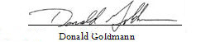

Next Monthly Board Meeting: March 4th, 11:00 AM – 12:30 PM, 4600 Kietzke Lane, Offices of Gina Espinal-Aguerre, Reno, NV

Addendum

Umpqua January 2025 Statement

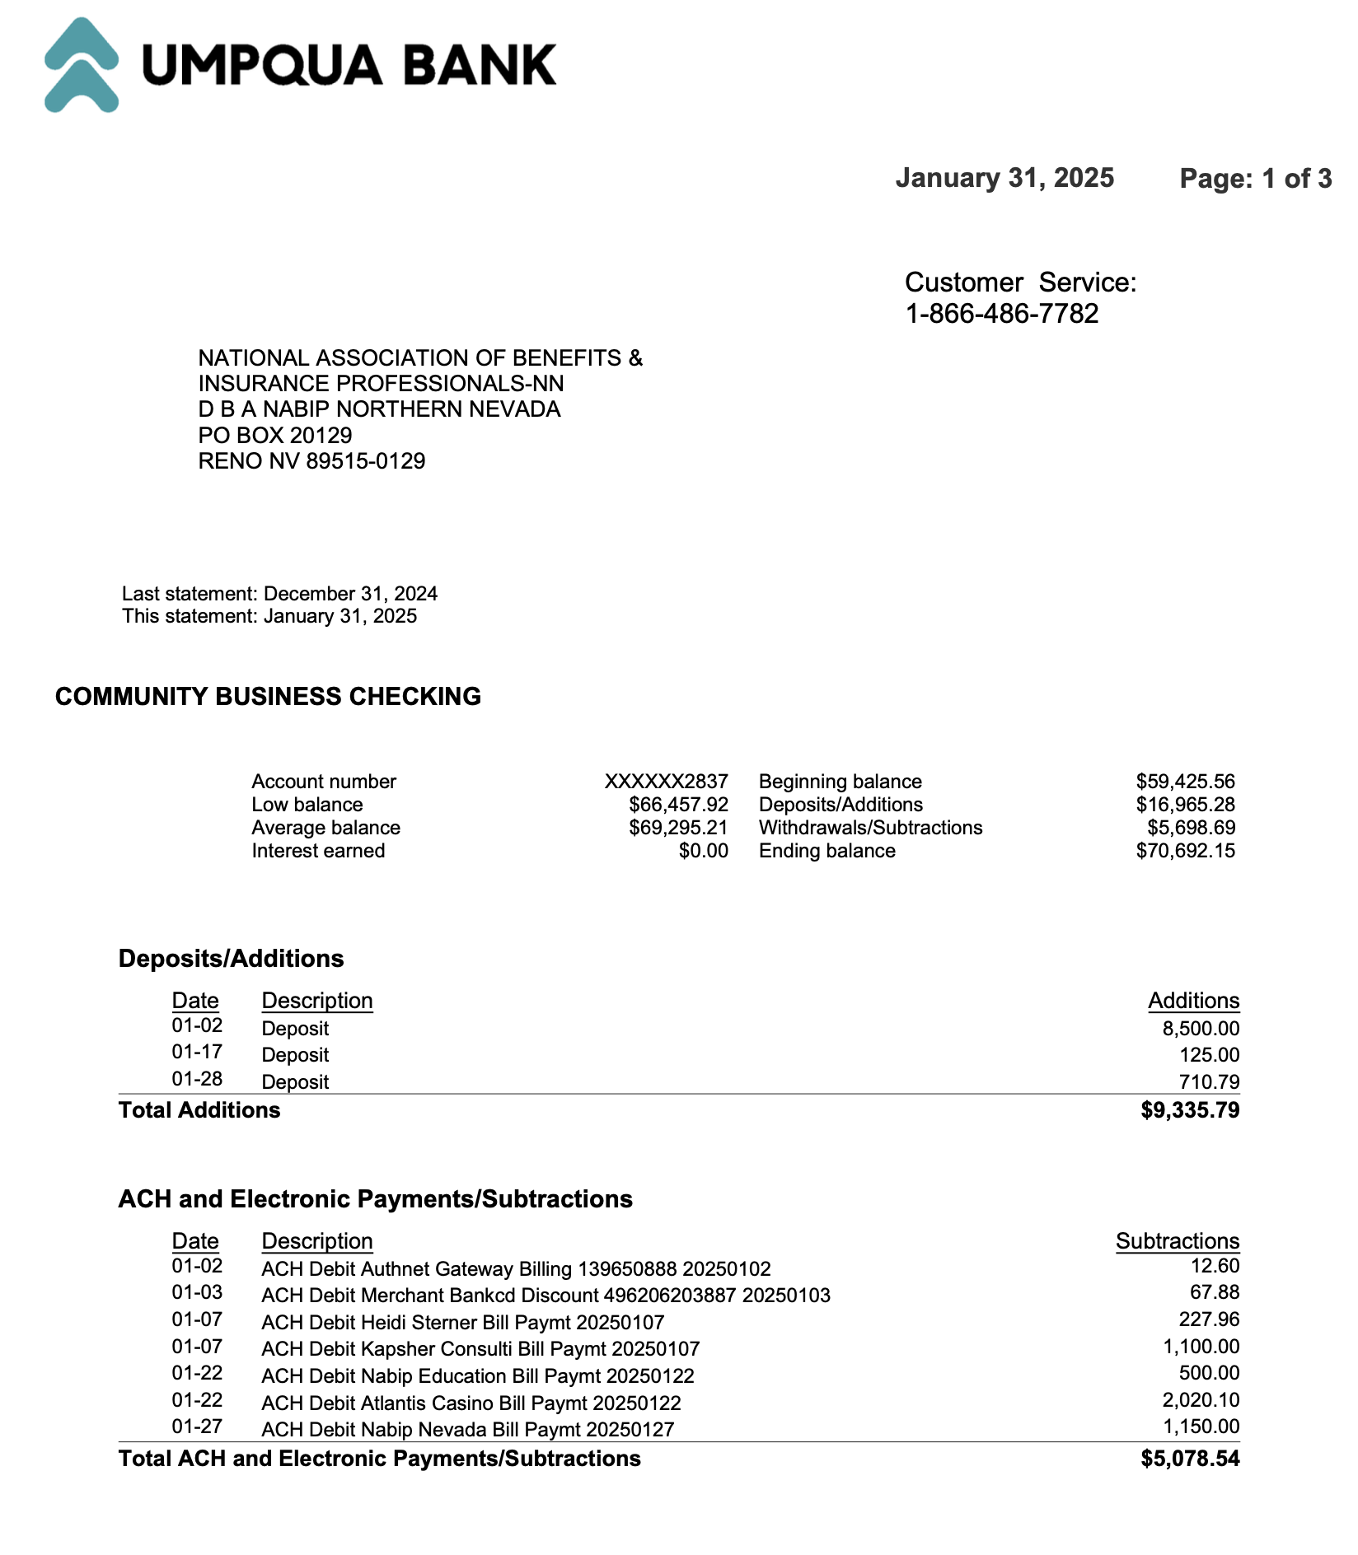
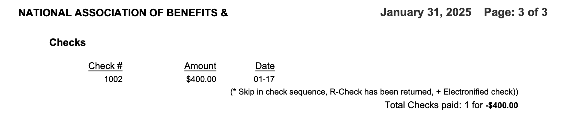
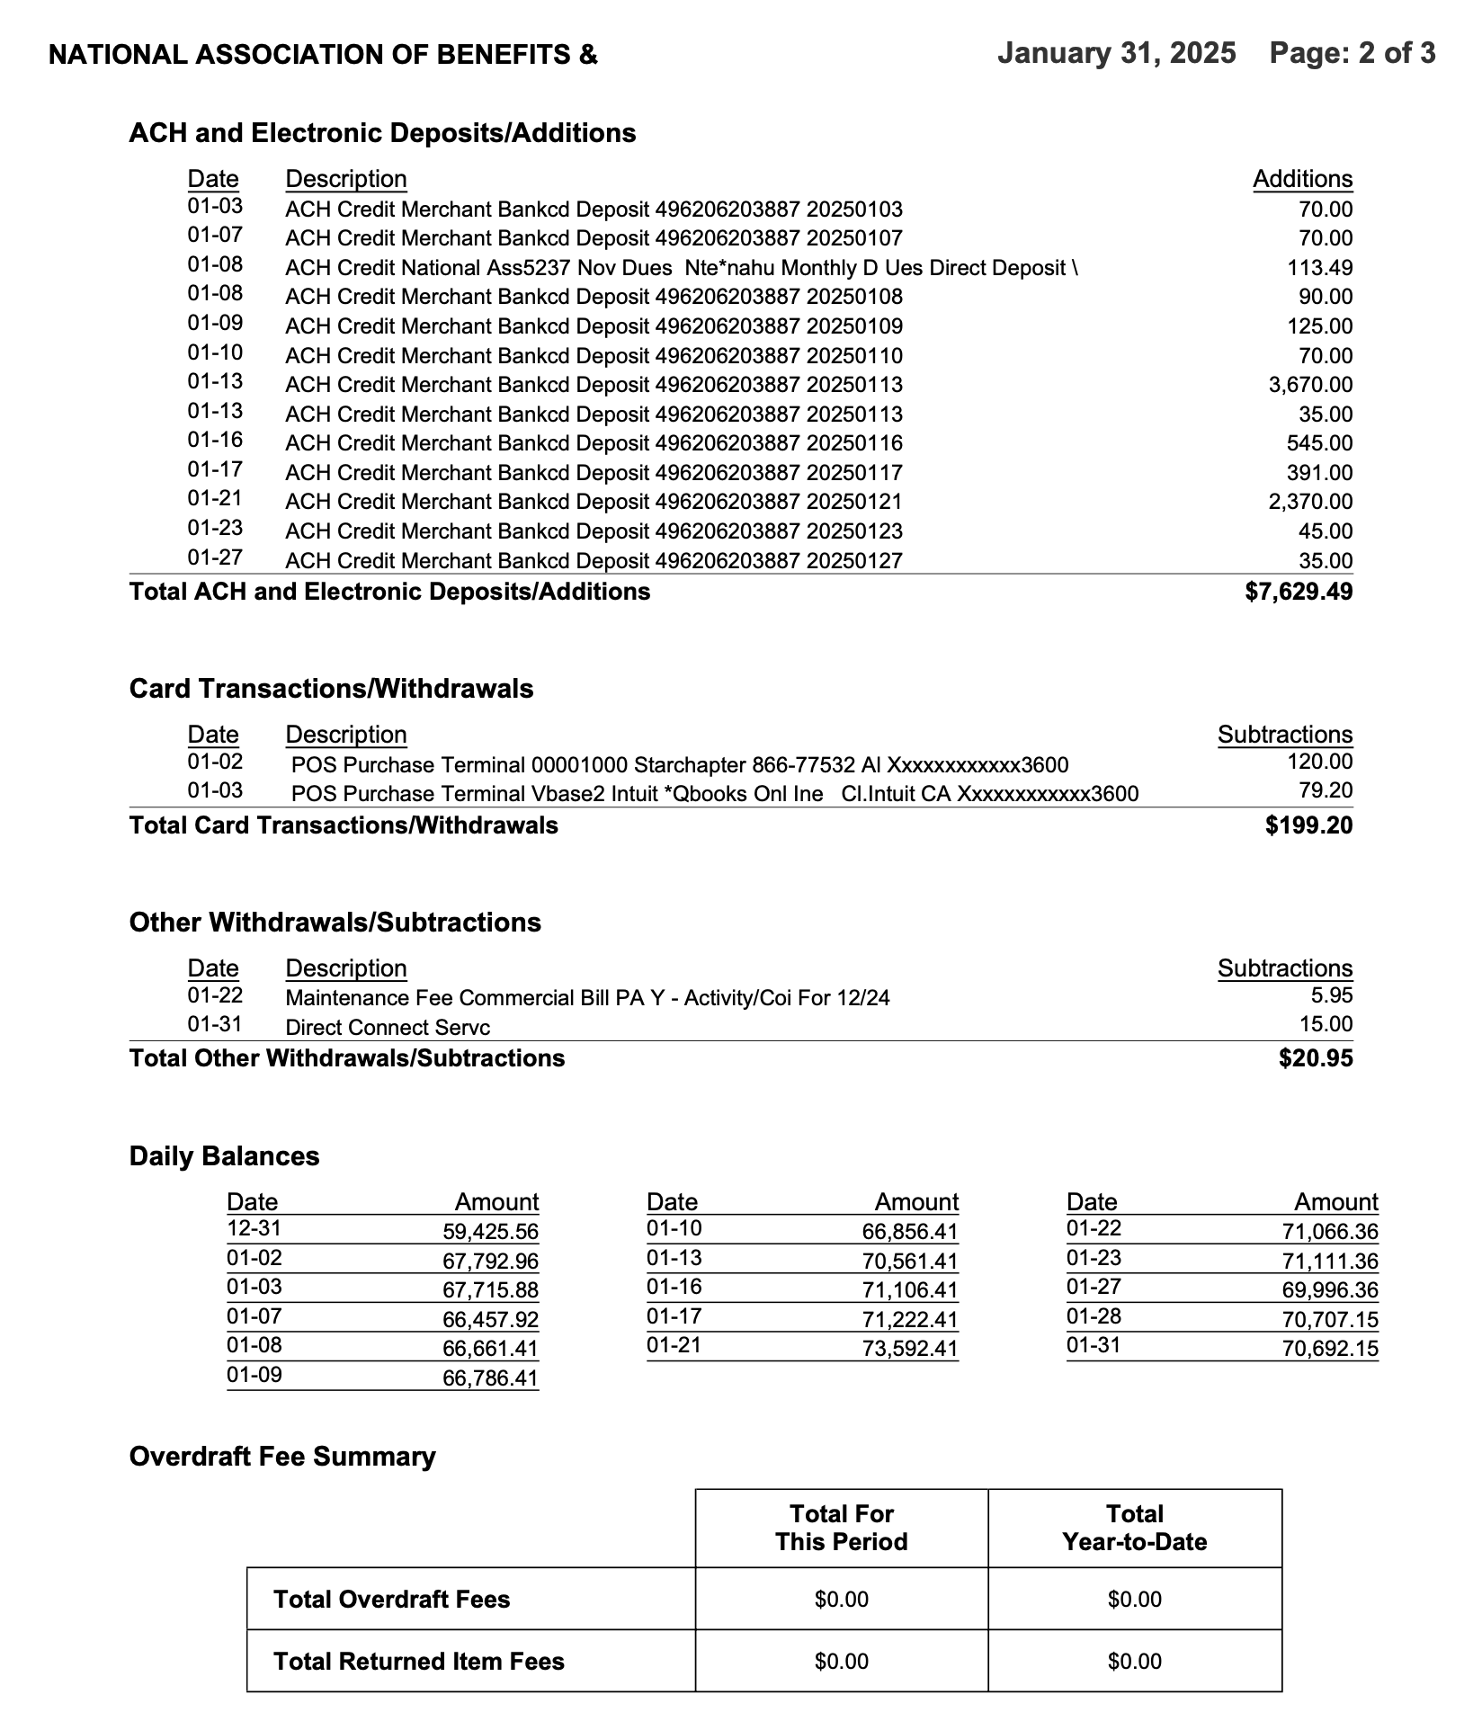

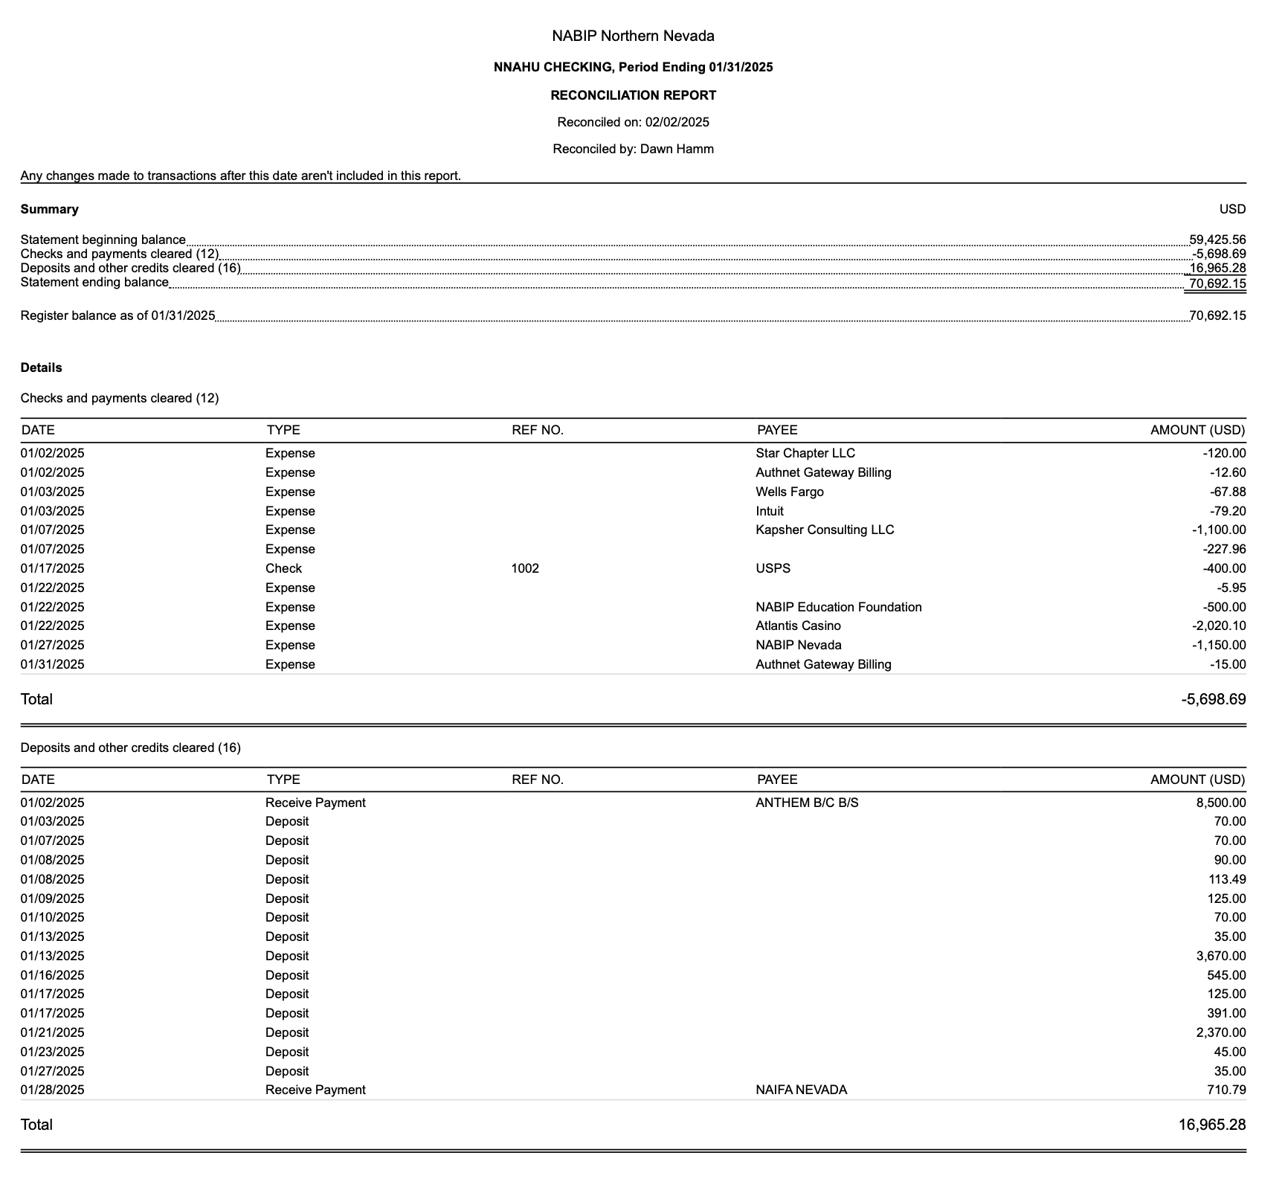
Reconciliation of Checking and Savings Accounts

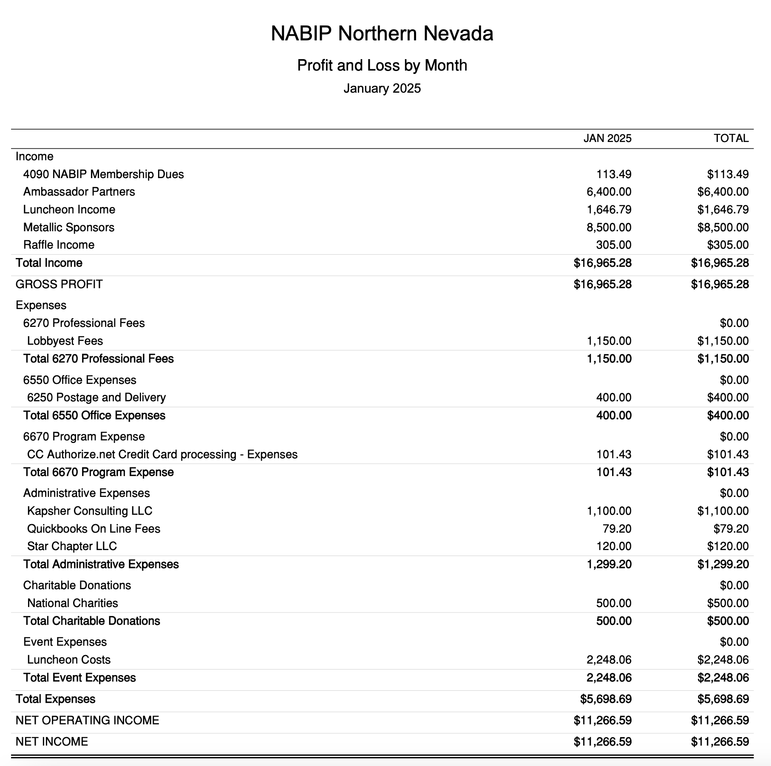
Profit and Loss by Month YTD Through January

Budget vs. Actual January – December 2025
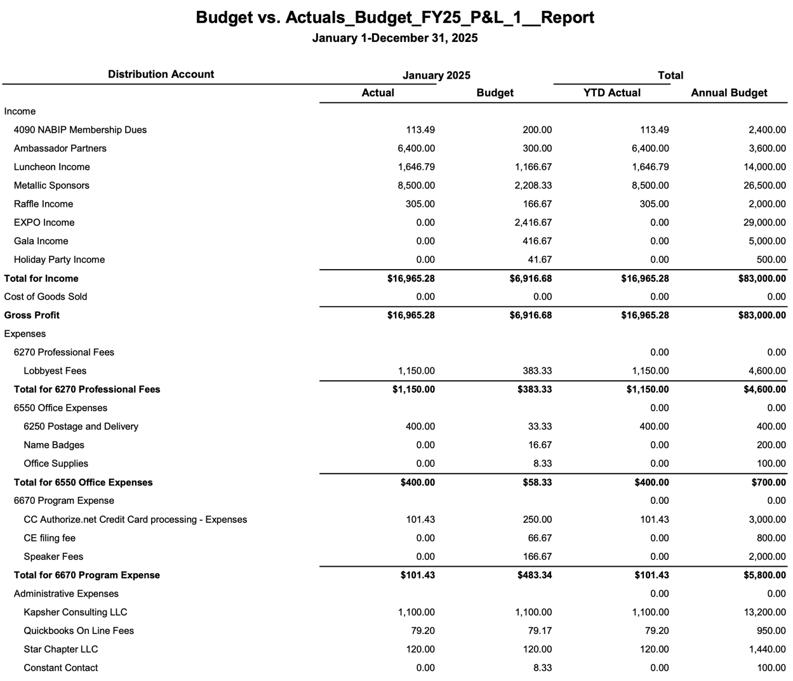
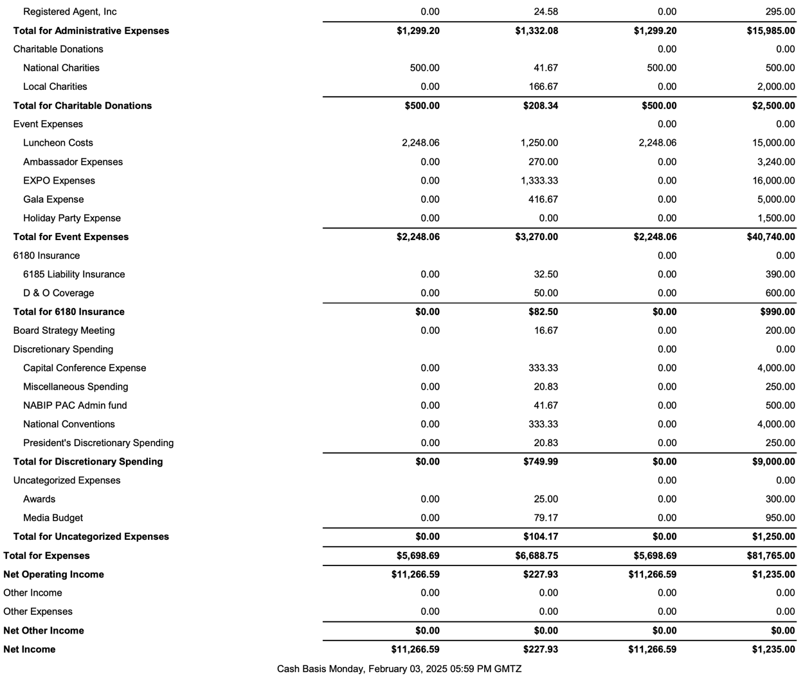
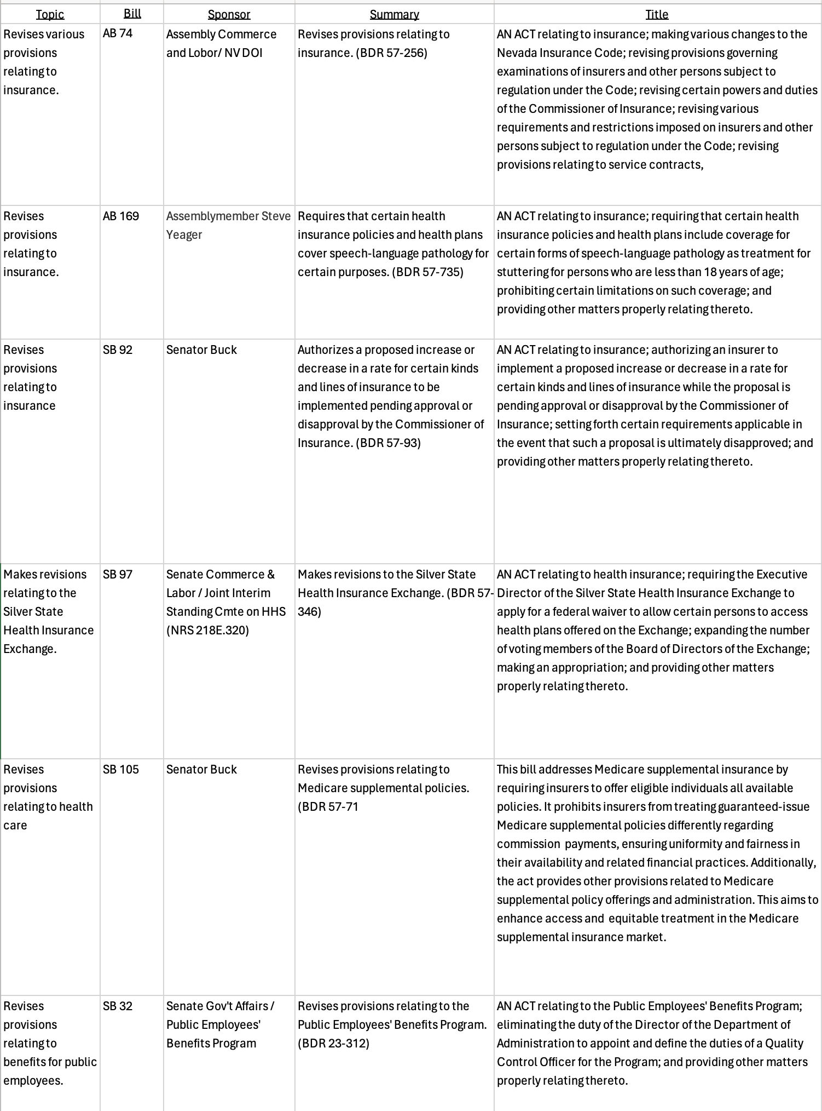
Legislative Report
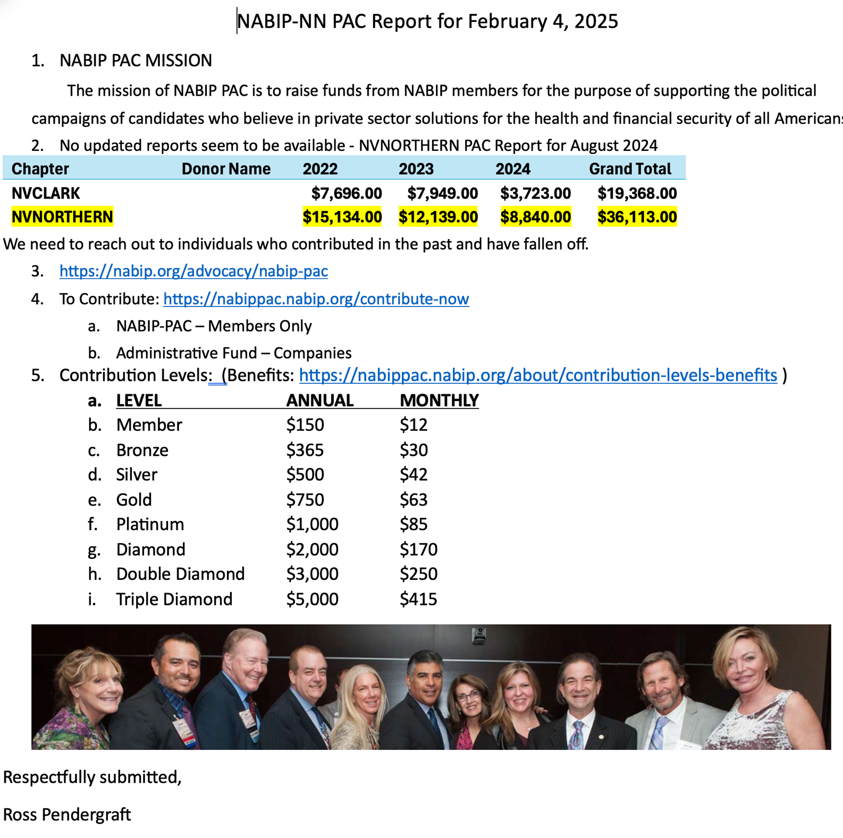
NABIP–PAC Report

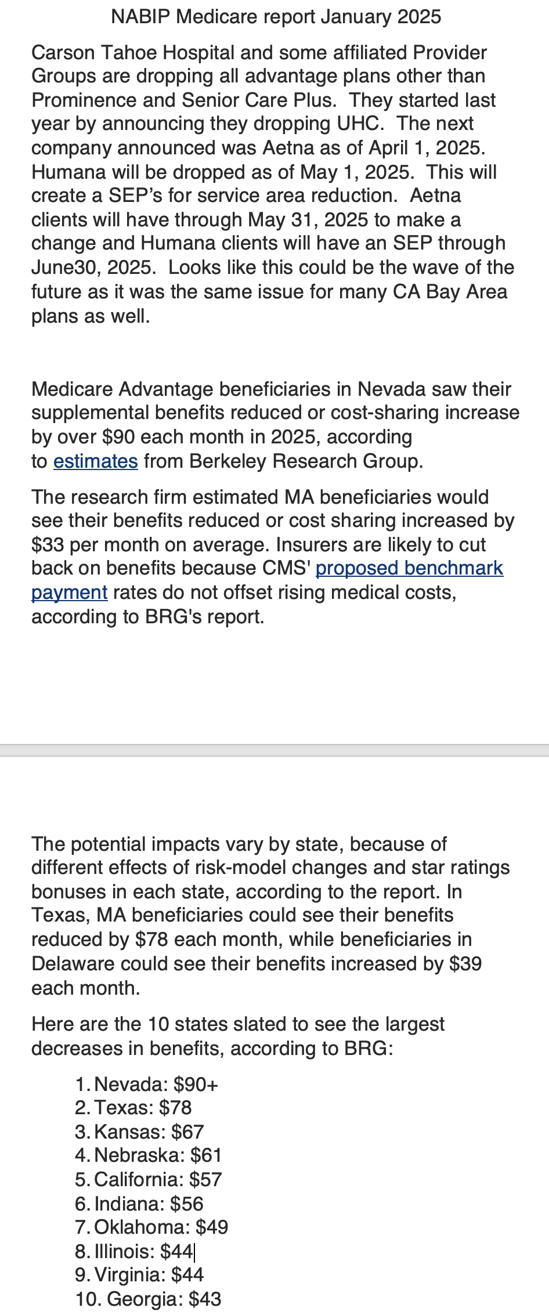
Medicare Report

