National Association of Benefits and Insurance Professionals - Northern Nevada

Draft Board of Directors Meeting Minutes
June 3, 2025, 11:03 AM – 12:06 PM
4600 Kietzke Lane, Building A-105, Reno, NV
Via Zoom – Meeting ID = us02web.zoom.us/j/84698950624

- Attendance Report: Don Goldmann, Joy Gardner, Mary Lou Urrutia and Gina Espinal-Aguerre

- Virtual Attendance by Phone and Computer: Julie Ann Evans, Molly Moreno, Ross Pendergraft, Dave Sherrill, Ashley Kapostins, Merre Gregory, Georgana Cepeda and Jay Eldridge

- Absent: Aliana Rushing and Mika Clauson

- Guest: None

- Meeting was called to order by President Molly Moreno at 11:03 AM.

- Roll call of attendees was taken by sight for those attending in person and on Zoom by Secretary, Don Goldmann. Quorum confirmed. Connectivity confirmed.

- Review of the May 2025 board minutes by Secretary, Don Goldmann.

  - A motion to approve the May 2025 board minutes was made by Joy Gardner and seconded by Don Goldmann. Unanimously approved.

- Report of the President by Molly Moreno:

  - Congratulated the Exposition committee for a great exposition and Medicare summit.

  - Is looking forward to a successful transition to Aliana Rushing as President.

- Report of the Secretary by Don Goldmann:

  - With the May minutes approved, there was nothing else to report.

- Report of the Vice President of Finance by Joy Gardner: A number of financial documents that were not available in time for the May board meeting and those documents related to the June financial report, have been added to the Addendum of these minutes.

  - There are only 4 persons registered for lunch in June and phone call must be prioritized.
  - Review of partnerships for 2025 show that Anthem is paid up for the Diamond level for $8,500, United Healthcare and Hometown Health are paid up at the Gold level for $4,000 and Aetna and Word & Brown are paid up for the Silver level of $2,500.
  - Prominence Health Plans owes the chapter $375 from 2020. It has been verified that the chapter has not received the funds and requested payment. It has not been received as of 6/1/25.
  - Current bank checking account balance, as of 5/31/25, was $96,768.51 and the savings account’s balance was $200.40.

  - Both the chapter’s checking and savings accounts balance.

  - The May 21, 2025, Exposition and Medicare Summit financials were:

    - Attendance: 130 attendees composed of 64 attendees, 12 Ambassadors, 6 speakers. 47 vendors, 1 charity honoree with four walk-ins and 10 no shows (4 paid, 1 Ambassador, 3 vendors and 2 charity honorees).

    - Income: $7,993.50 from attendees plus $1,400 Ambassadors, $5,350 Partnerships and $19,110 from vendors for a total of $33,793.50 in income.

    - Cost: $12,133.76 for food and $4,556.92 for other expenses.

    - Raffle Income: $1,472.00

  - A separate financial statement detailing the Exposition and Medicare Summit numbers has been included in the Addendum of these minutes.

  - A motion was made by Don Goldmann to approve the May financial report, that was tabled at the May board, and it was seconded by Gina Espinal-Aguerre. Unanimously approved.

  - A motion was made by Julie Ann Evans and seconded by Don Goldmann to approve the June financial report with suggested mathematical corrections offered by Julie Ann Evans and accepted by Joy Gardner. Unanimously approved.

- Report of the Vice President by Georgana Cepeda:

  - The Exposition and Medicare Summit, referred to as the Symposium, was a huge success.

  - Appreciation was expressed to everyone who helped with the event to make the event outstanding.

  - The next Symposium planning meeting for next year’s event will be held on June 11, 2025, and will include a postmortem of the 2025 activities.

  - A summary of the surveys taken at the Symposium from those who attended was completed and has been added to the Addendum of these minutes.

- Committee Reports:

  - Vice President of Legislative Affairs report by Mary Lou Urrutia: Written report was submitted with a brief discussion about the list of Nevada State legislative proposals and the list has been entered into the Addendum of these minutes.

  - Vice President of Awards report by Ross Pendergraft: Written report was submitted and has been entered into these minutes.

    - The deadline for Awards submission was April 5th and that deadline was met for submitting Pacesetter, Media and Website awards with 96 members for the size of a small chapter.

    - NABIP-NN’s Monthly Membership Report for March 2025 reported our chapter with 96 members.

      - This placed us in the “Small” (51 to 100 members) size category for Pacesetter.

      - This placed us in the “Small” (under 250) size category for Media relations.

      - For Pacesetter, we were the ONLY Chapter to apply in this size category.

      - For Media Relations, we were the ONLY Chapter to apply in this size category.

      - For the Website Award, 9 Local Chapters applied, and the top 50% (5 Chapters) will win.

      - Pacesetter Submissions:

        - In the Tiny size category, there were 3 Chapters.
        - In the Medium size category, there were 5 Chapters.
        - In the Large size category, there was only 1 Chapter

    - The following officers completed their virtual training:

GEORGANA | CEPEDA | VIce President
Mary Lou | Urrutia | Legislative Chair
Mika | Clauson | Media
Donald | Goldmann | Secretary
Ross | Pendergraft | Awards & PAC
Joy | Gardner | Treasurer/Treasurer

    - Strategic Planning for the new 2025-26 Board Year will be crucial for us, and we will use the Pacesetter’s responsibility document to help organize things.
      - Our goal should be to keep on track of activities throughout the year instead of waiting until the last minute.
      - It is desirable to begin next year’s training before the Strategic Planning meeting.
    - The New Member Orientation will continue every 4th Thursday at 9:00 AM PST on Zoom. Need to make sure we keep blasting this out in our newsletter each month as has been done each month this year.

      - Zoom meeting ID 826 3420 3381, Passcode “Membership”
      - http://welcometonabip.org

  - Vice President of Membership report by Gina Espinal-Aguerre: Written report submitted and entered into these minutes.

    - Membership is at 98 members with 2 new applications received at the Exposition and possibly not yet reported in the numbers.

    - There were only 5 independent brokers, who were non-members, at the event and signing two of them was good.

      - Of the remaining 3, Peter Breen, just can’t do it now, Karina Salas is now part of Art of Medicare which is signed up as an Agency in Southern Nevada and Triense Gloyd gave no information.

      - Everyone said the event was a great time, and Gina spoke individually with the agencies that attended including:

        - Alex Sampson/Amy from Health Benefits Association, who supports the chapter, but never joined and needs to be involved.

        - Health Plan Advisors are growing, and Ron and Susan were spoken to, but, while they prefer not to be involved, they agree it's a great organization and they will think about it

        - Jeremy from The Medicare Store was pinned down, but stated that if they had an Agency membership, it would probably be in Southern Nevada.

    - A new member will be coming to our board next year with Breeze Yerves, from A & H, agreeing to help with membership.

      - This will help with outreach to new (or just independent) agents, bringing back some of our past outreach projects.

  - Vice President of Communications/Media report by Mika Clauson: Absent with no report.

  - Vice President of Professional Development report by Julie Ann Evans: Written report submitted and entered into these minutes.

    - NABIP NN - Monthly Luncheons:

      - The July 9th luncheon:

        - This will be a CE approved event.
        - The course material was submitted on May 16th and approved on May 19th.
        - The course offering was created on May 20th.
        - There is a $40.00 filing fee, so we should see an invoice from Sircon for $40.00.

    - NABIP NN - Symposium - May 21st:

      - This all-day event offered participants a total of 4 CEs (6 filed).

        - Aliana Rushing - there were a total of 68 CEs processed on 05/22/25.

          - There is a $1.25 fee per CE, so we should see an invoice from Sircon for $85.00.

        - Calvin Bagley - there were a total of 42 CEs processed on 05/22/25.

          - There is a $1.25 fee per CE, so we should see an invoice from Sircon for $52.50.

        - Paul Roberts - there were a total of 23 CEs processed on 05/22/25.

          - There is a $1.25 fee per CE, so we should see an invoice from Sircon for $28.75.

        - Stephanie Berger - there were a total of 59 CEs processed on 05/22/25.

          - There is a $1.25 fee per CE, so we should see an invoice from Sircon for $73.75.

        - Serena Farrell - there were a total of 39 CEs processed on 05/22/25.

          - There is a $1.25 fee per CE, so we should see an invoice from Sircon for $48.75.

        - Lynn DeMaria - there were a total of 12 CEs processed on 05/22/25.

          - There is a $1.25 fee per CE, so we should see an invoice from Sircon for $15.00.

      - Total cost to provide CEs at this event is: $543.75 ($240 in filing fees plus $303.75 in CE completion fees).

      - This all-day event will offer a total of 4 CEs (6 filed) all of which have been approved and the course offerings created.

    - NABIP NV - Free CE Series:

      - The May 16TH CE class was managed through NABIP-NN’s Sircon account.

        - There were 19 CE completions processed on MAY 16TH.
        - There is a $1.25 fee per CE completion, so the chapter should see an invoice from Sircon for $23.75.
        - The total CE cost is $63.75 ($40.00 filing fee, plus $23.75 completion fee).

    - NABIP NV - 4-Hour Medicare CE:

      - Chris Carothers, Carothers Insurance, is planning to do a 4-hour in-person CE class in both Southern and Northern Nevada and the class is being managed through NABIP NNs Sircon account.

      - The class dates are still pending, but he is looking at August.

      - The course material was submitted on June 2nd.

      - There is a $40.00 filing fee so NABIP NN should see an invoice from Sircon for $40.00.

    - NABIP-NV Monthly Professional Development Meeting:

      - Typically, on the 4th Friday of each month, there is a virtual meeting held for those who are involved with planning luncheons, events, CE classes, etc. for both local chapters and the state chapter.

      - The next meeting will be held on June 27th at 2:00 PM and all are welcome to attend the meeting.

  - Director of Programs report: Absent with a written report submitted and entered into the Addendum of these minutes.

  - NABIP-PAC Chairperson report by Ross Pendergraft: A written report is included in the Addendum for these minutes.

  - Medicare Chairperson report by Merre Gregory: A written report was submitted with a brief discussion about the report being run by Merre Gregory and Jay Eldridge.

    - The full report has been added to the addendum of these minutes.

  - By-Laws and P&P Committee report by Don Goldmann:
    - The By-Laws require the publication of the chapter’s Annual Membership meeting minutes and to do that, the information about the starting times, ending times, who made the motion to adjourn and who seconded it, must be sent to the Secretary in order to complete the minutes.

      - Molly Moreno will take the lead in discovering that information and reporting it.

- A motion was made by Julie Ann Evans, and seconded by Molly Moreno, to accept all reports in toto. Unanimously approved.

- Old Business – None

- New Business -

  - A “shout out” was given to Ashley Kapostins and Dave Sherrill for their good work on the chapter’s Exposition and Medicare Summit.

  - Jay Eldridge will work with Kapsher to either post on the chapter website, or email out to the attendees, the Power Point presentations from the speakers at the Exposition.

- A motion to adjourn was made by Joy Gardner and Molly Moreno seconded the motion. Unanimously approved.

- President, Molly Moreno adjourned the meeting at 12:06 PM.

- Submitted by Don Goldmann, NABIP-NN Secretary
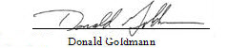

Next Monthly Board Meeting: June 24th, 11:00 AM – 12:30 PM, with Strategic Planning Meeting immediately following, at 4600 Kietzke Lane, Main Conference Room, Reno, NV
Addendum

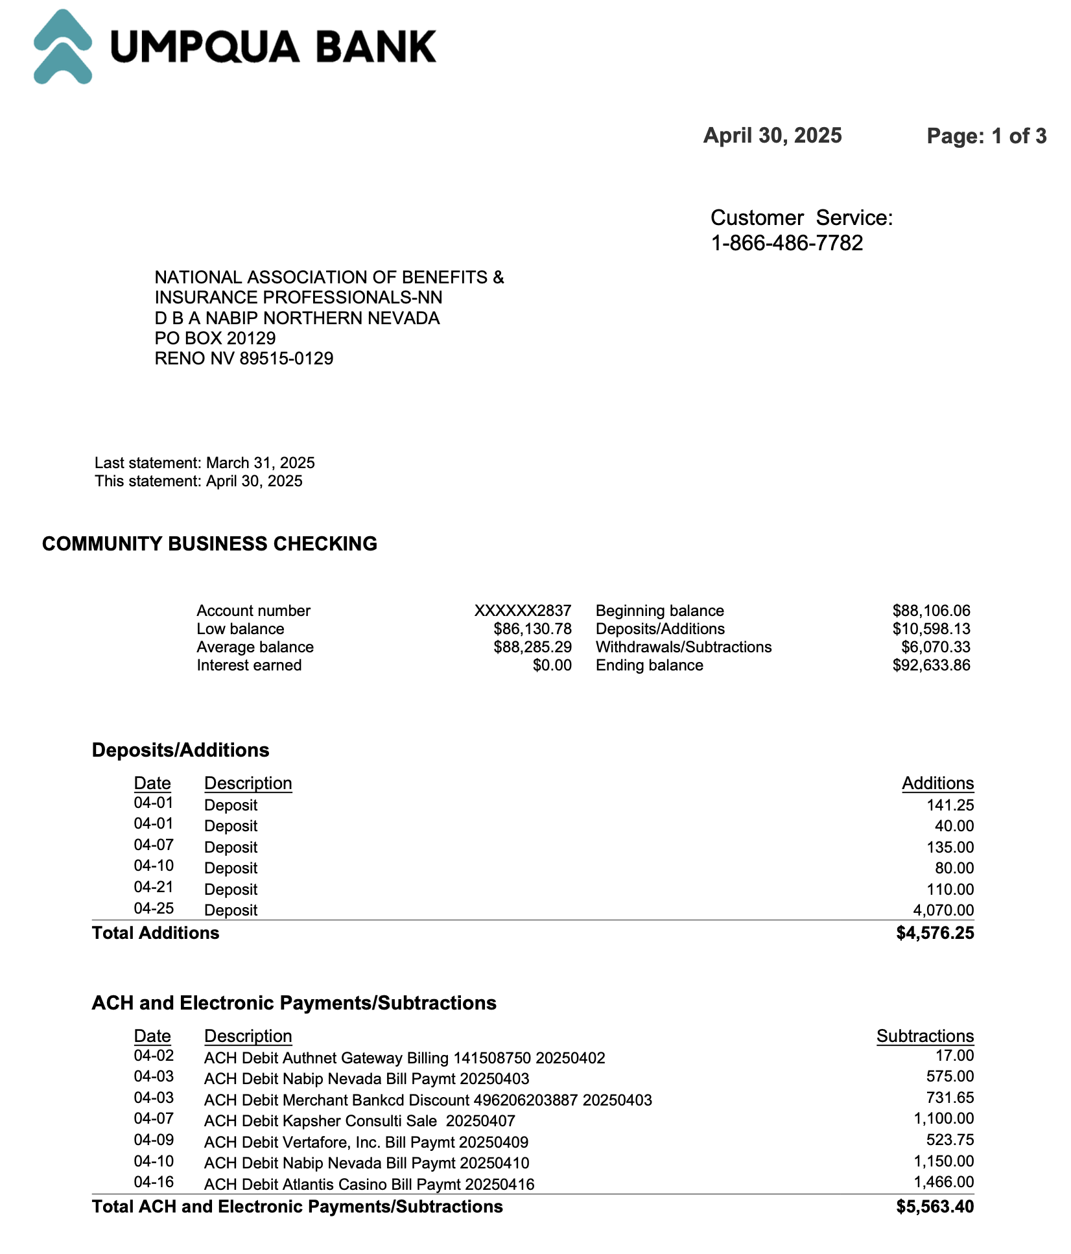
Umpqua April 2025 Statement

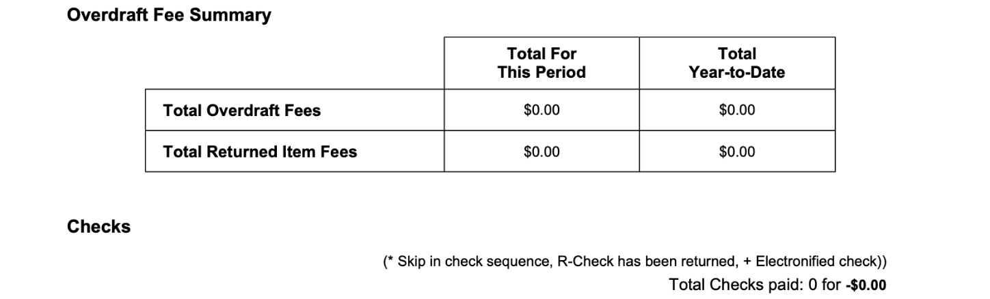
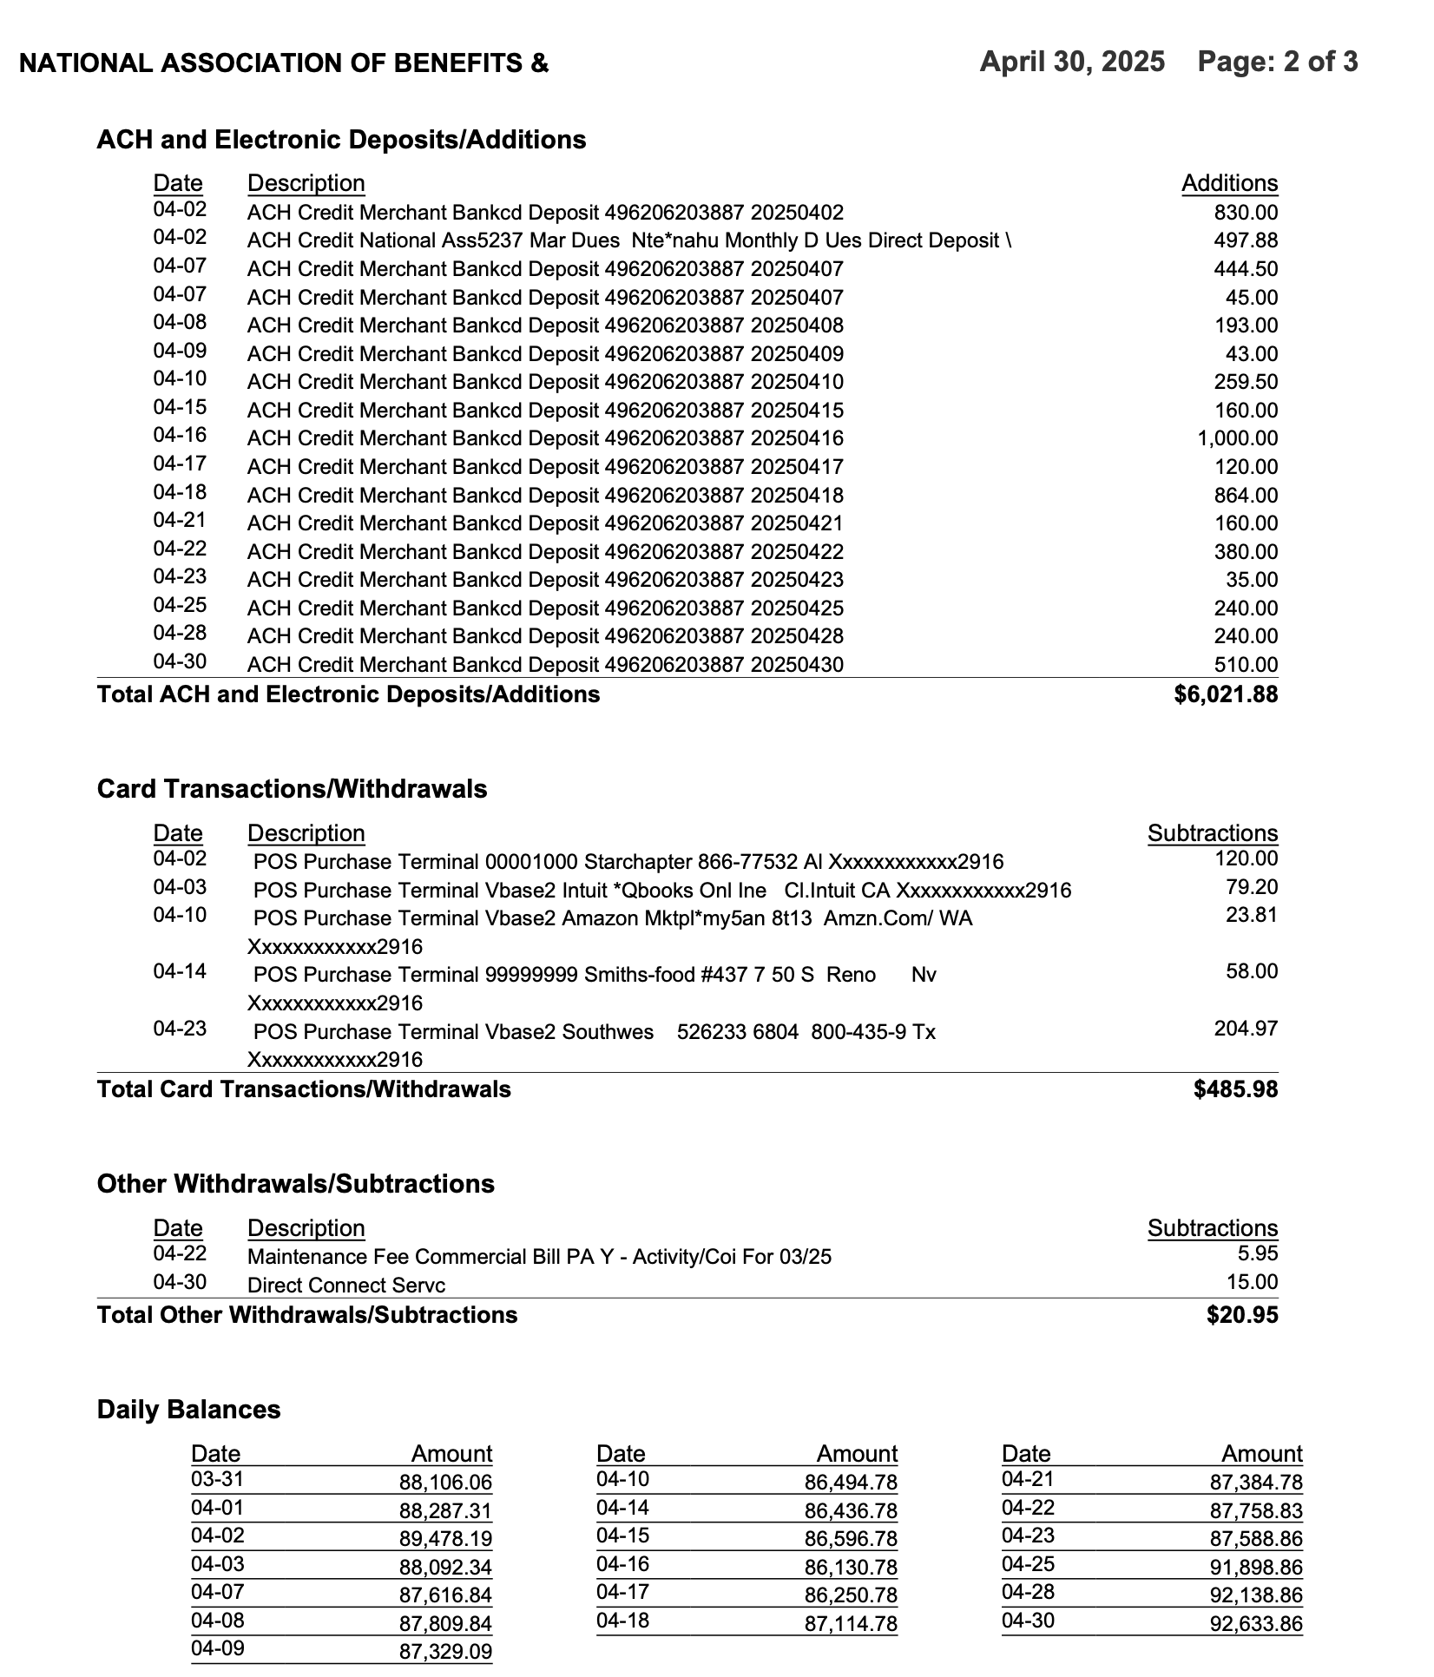

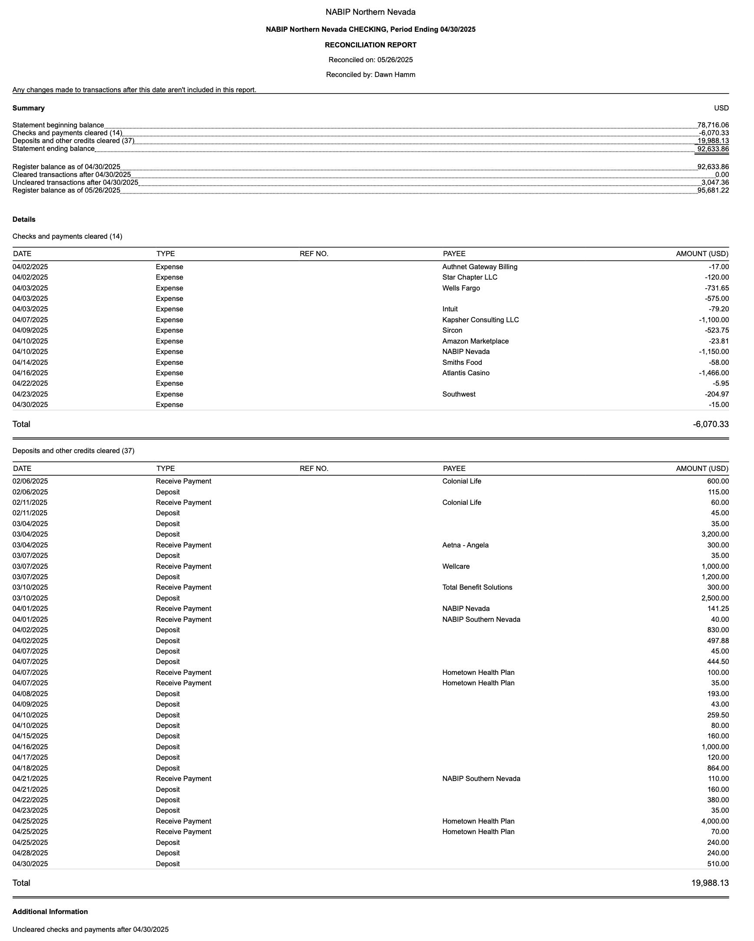
Reconciliation of Checking and Savings Accounts

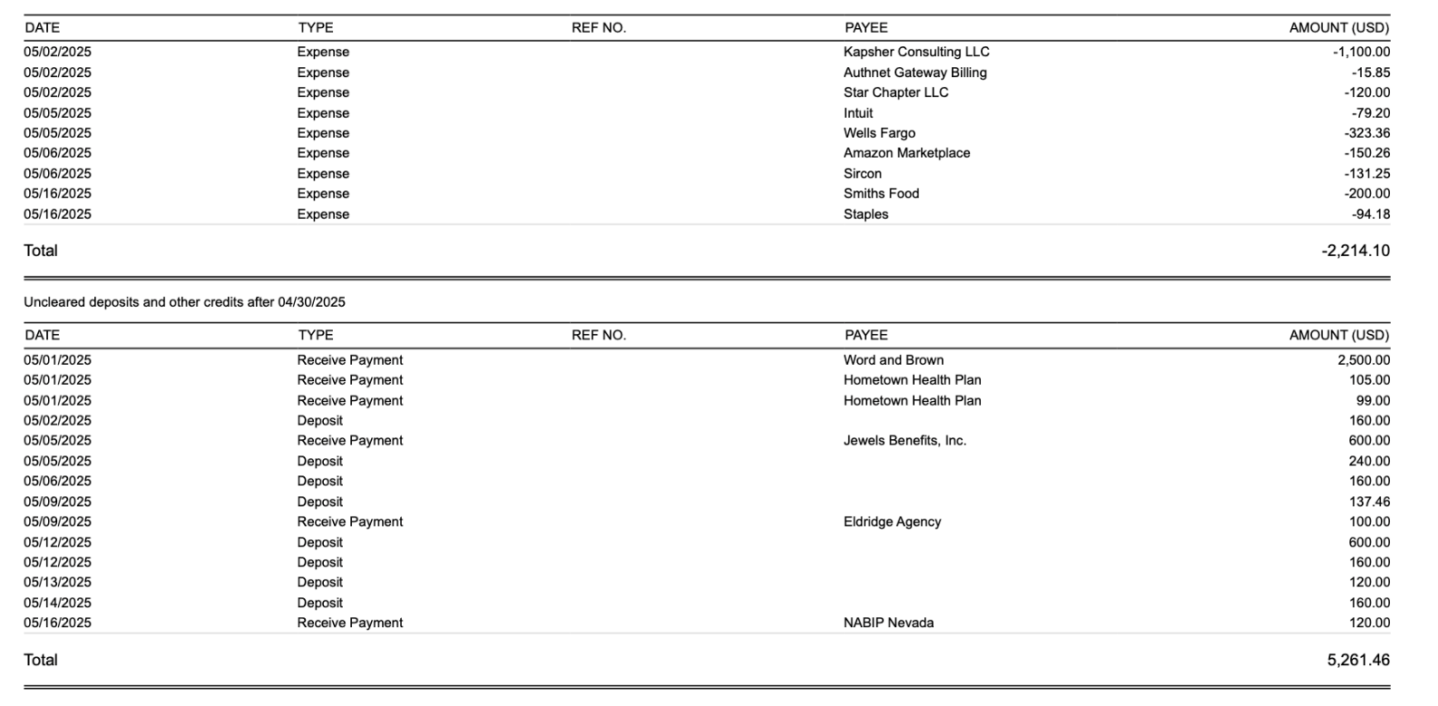

Profit and Loss by Month YTD Through April
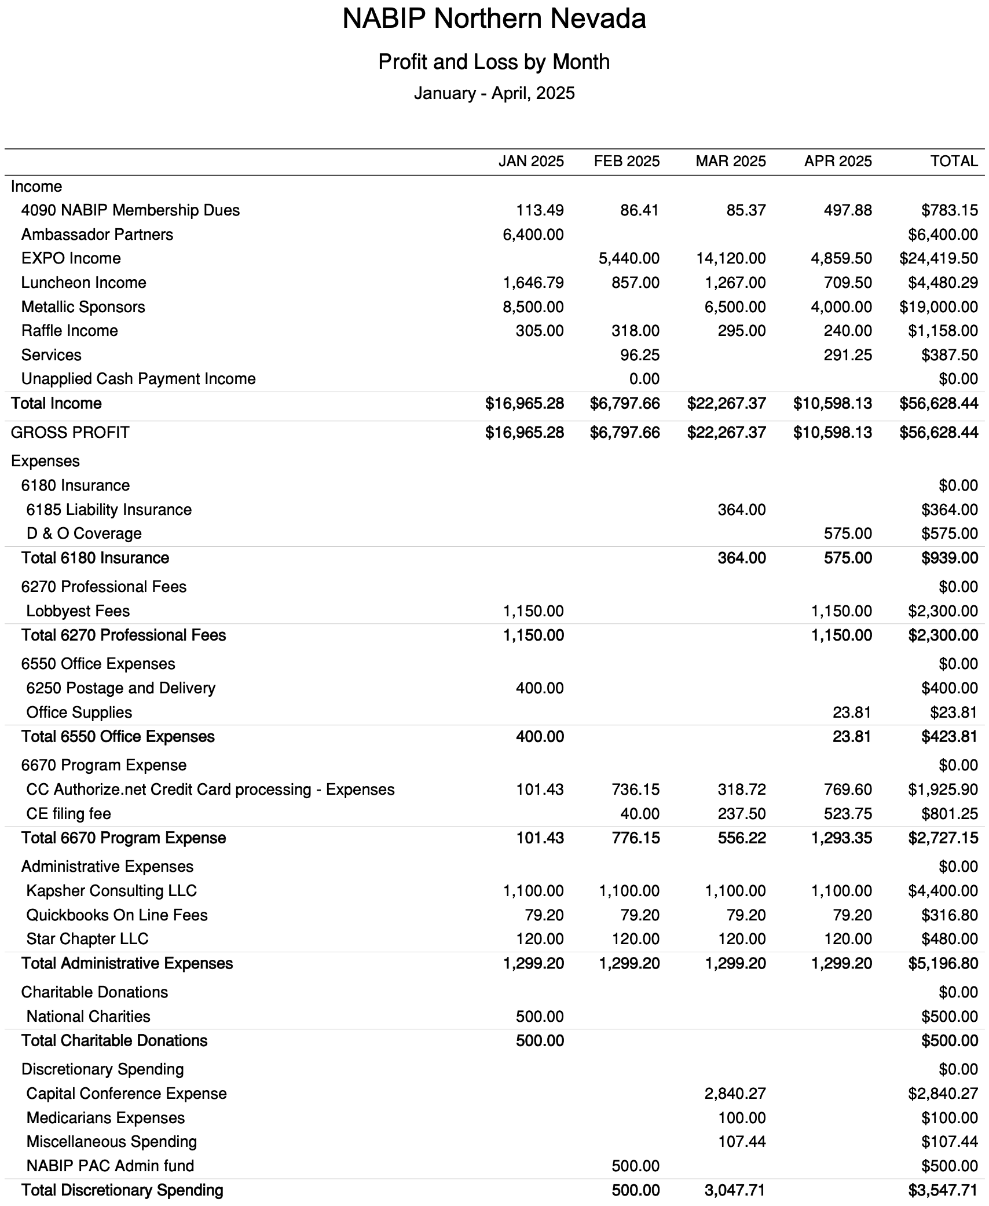
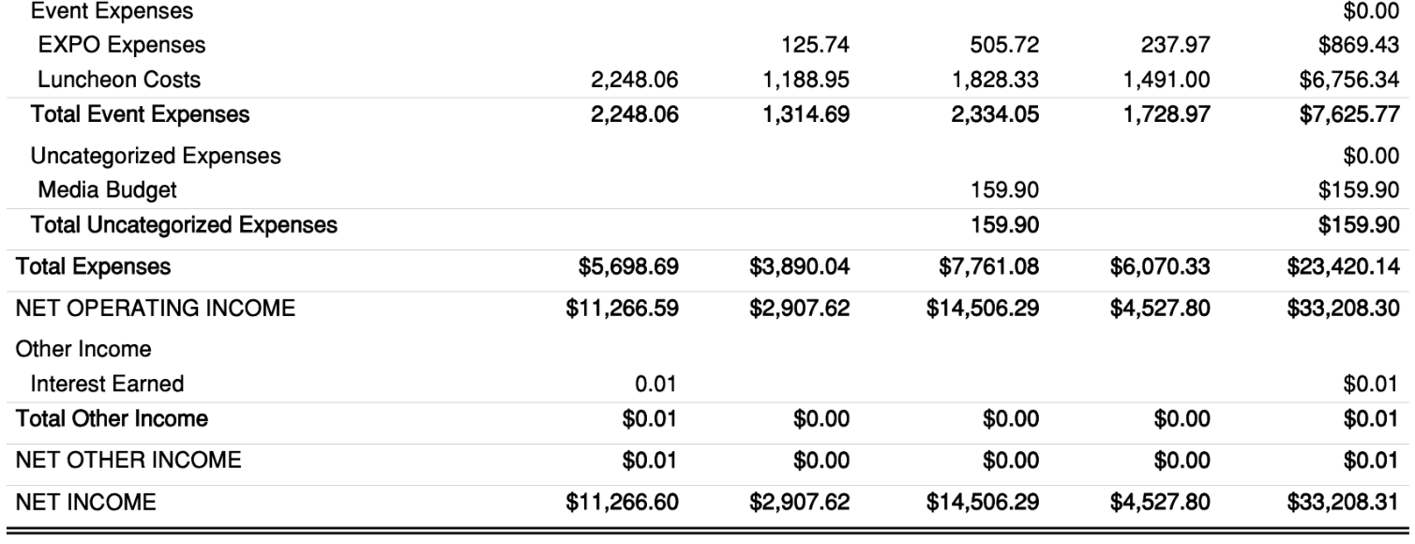

Budget vs. Actual January – April 2025
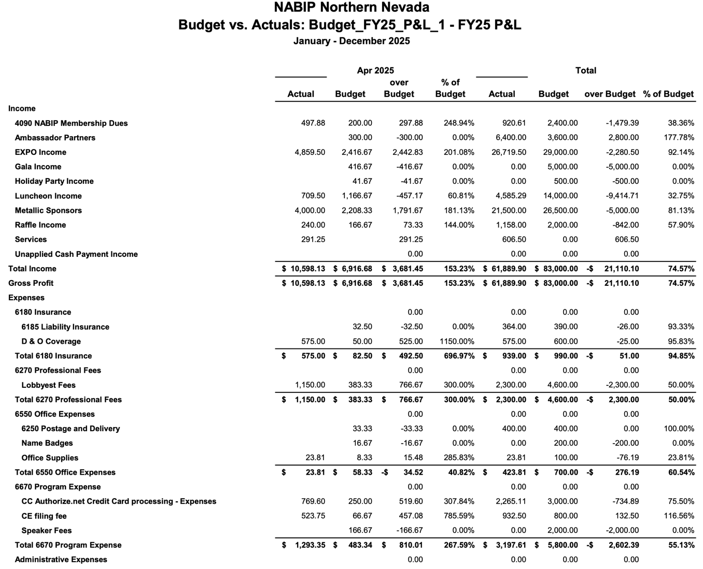

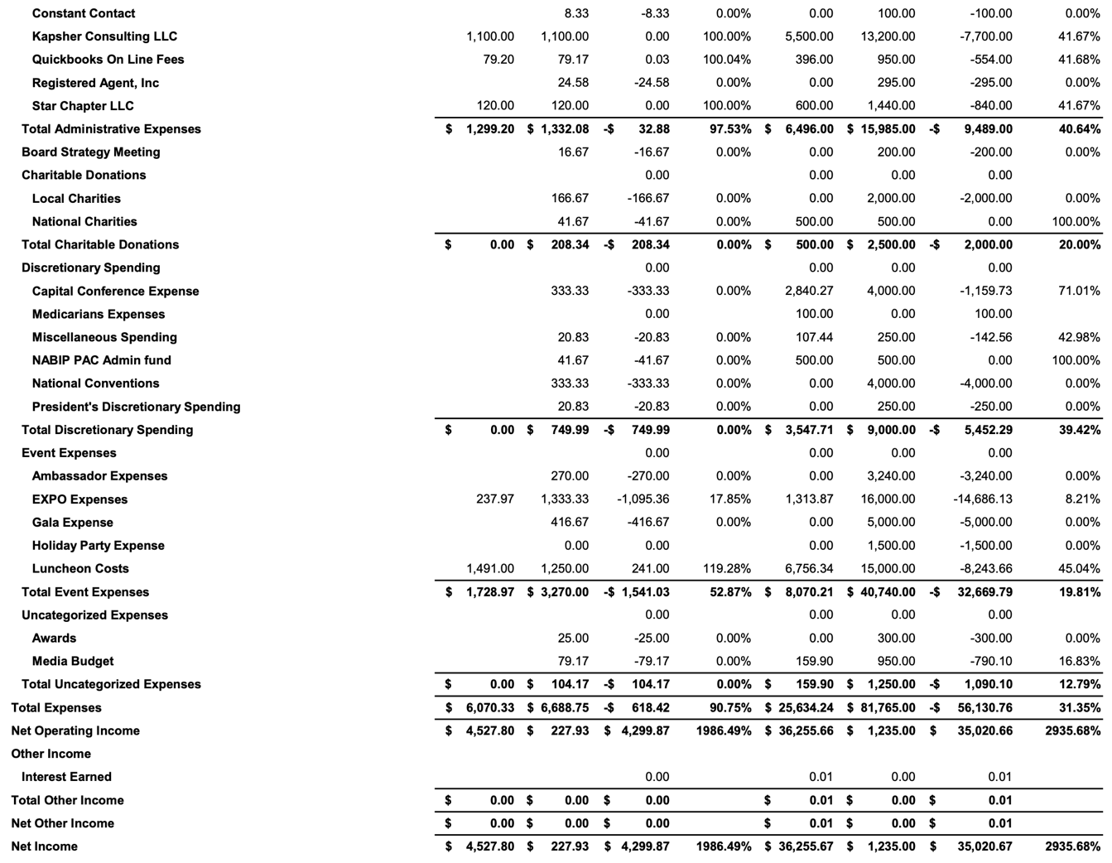

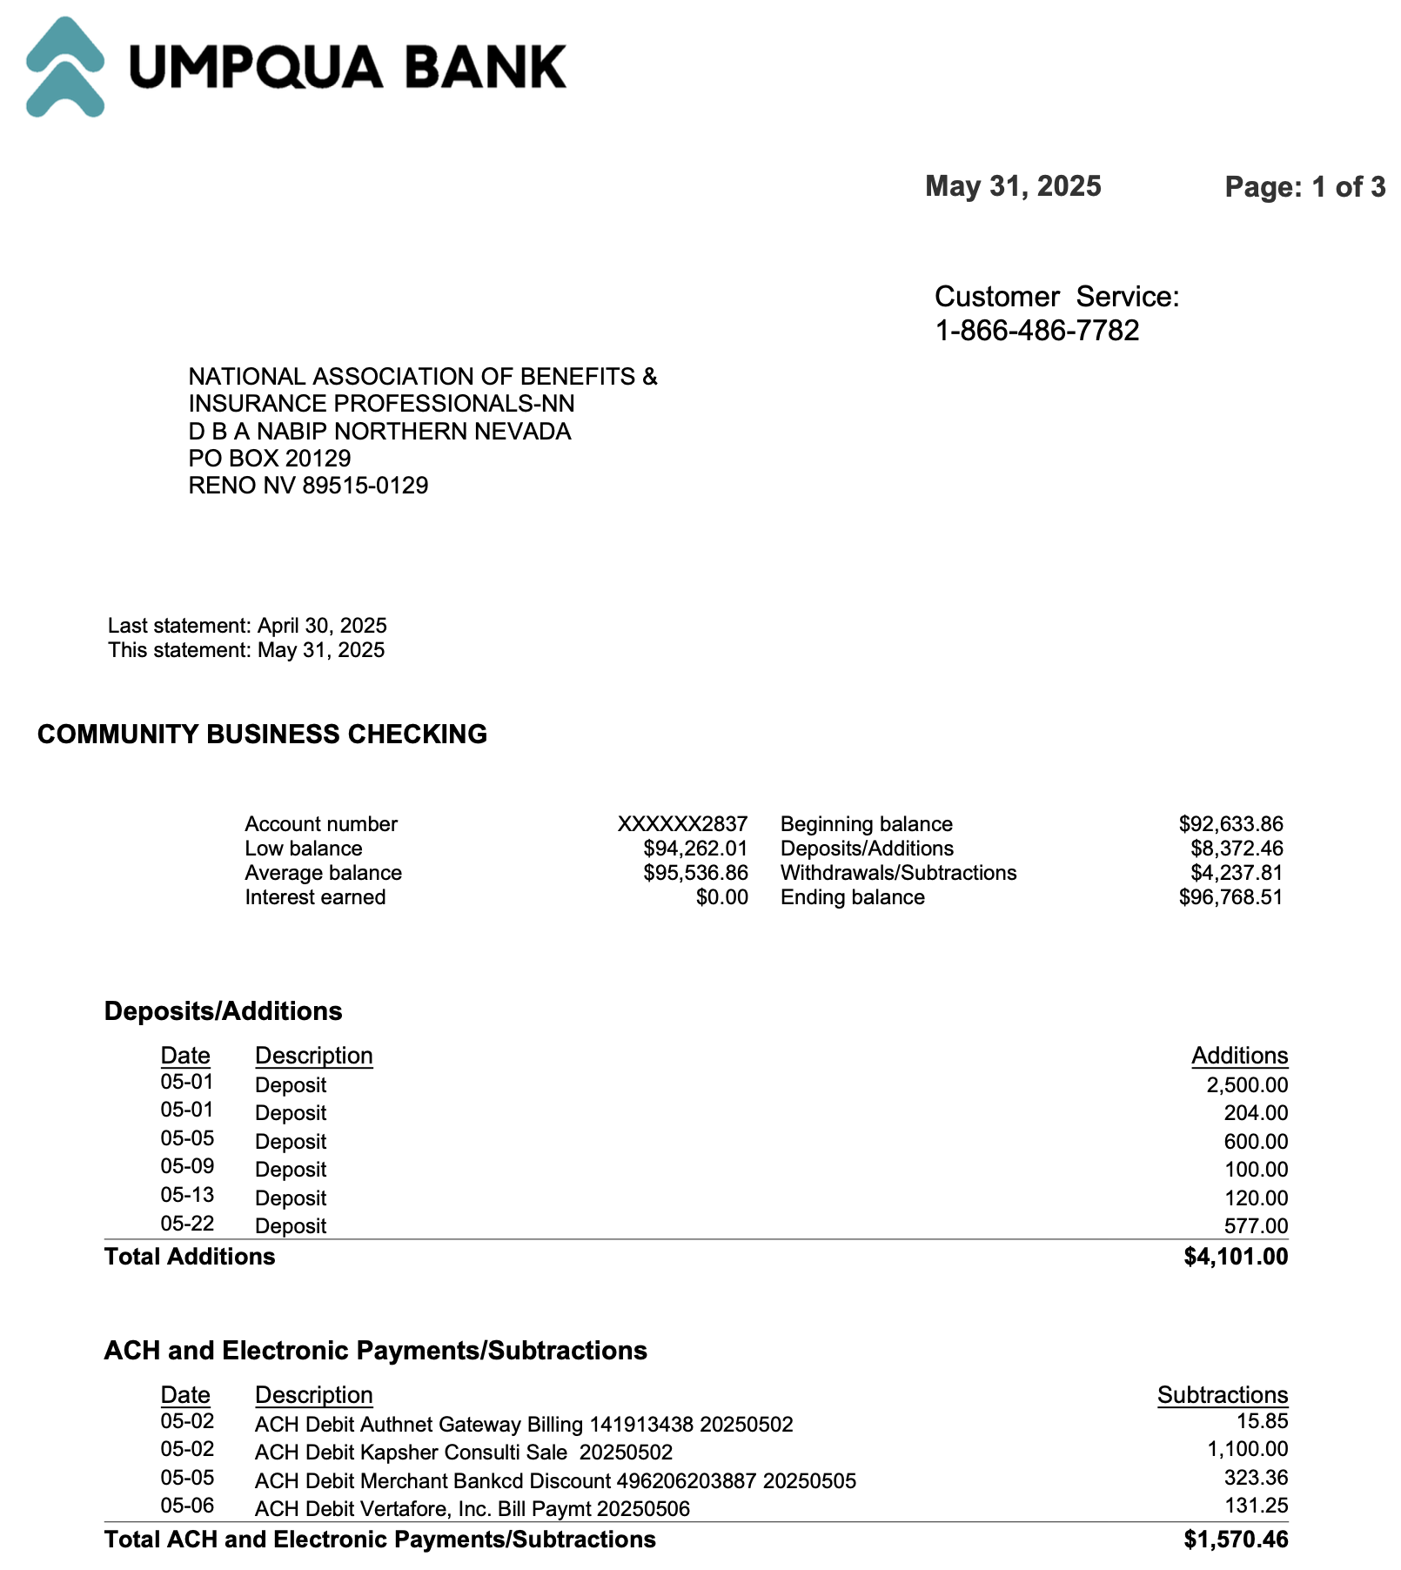
Umpqua May 2025 Statement

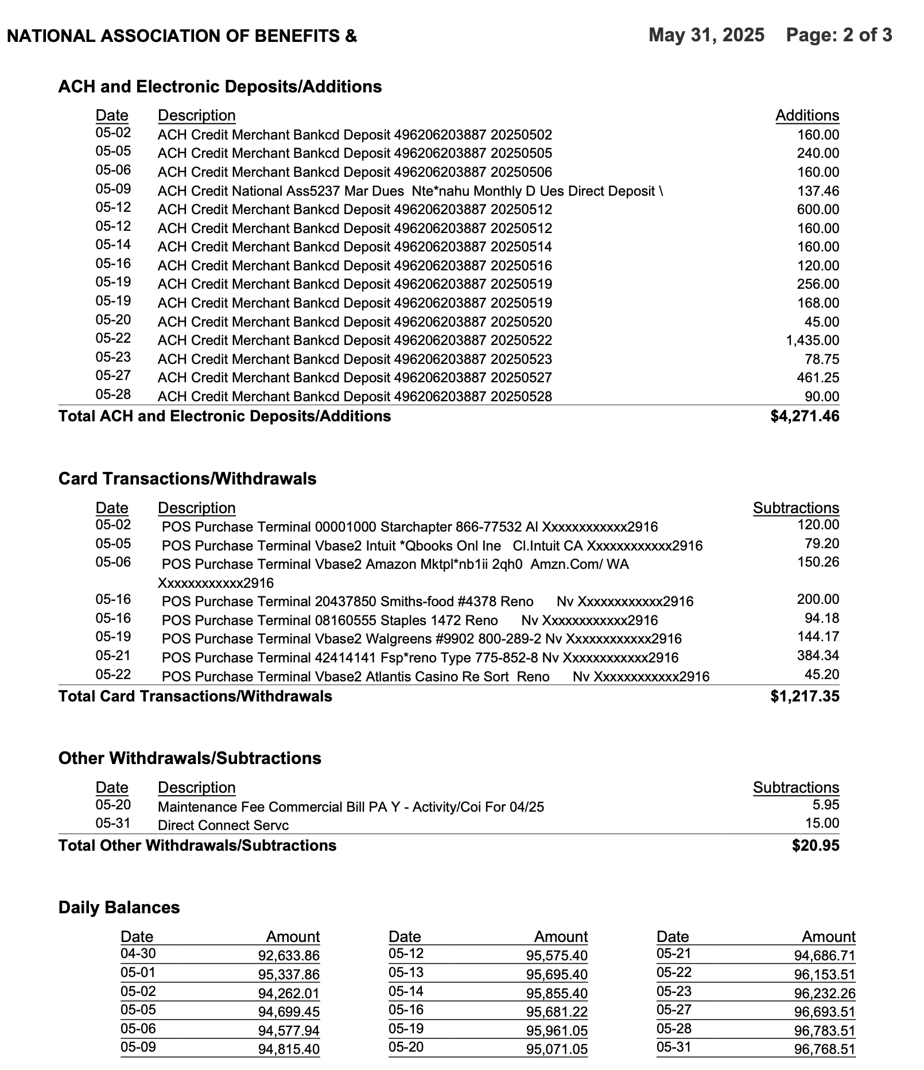

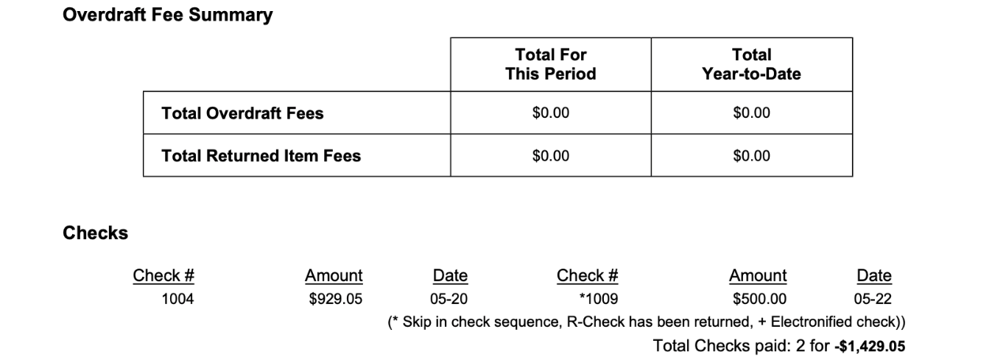
Reconciliation of Checking and Savings Accounts
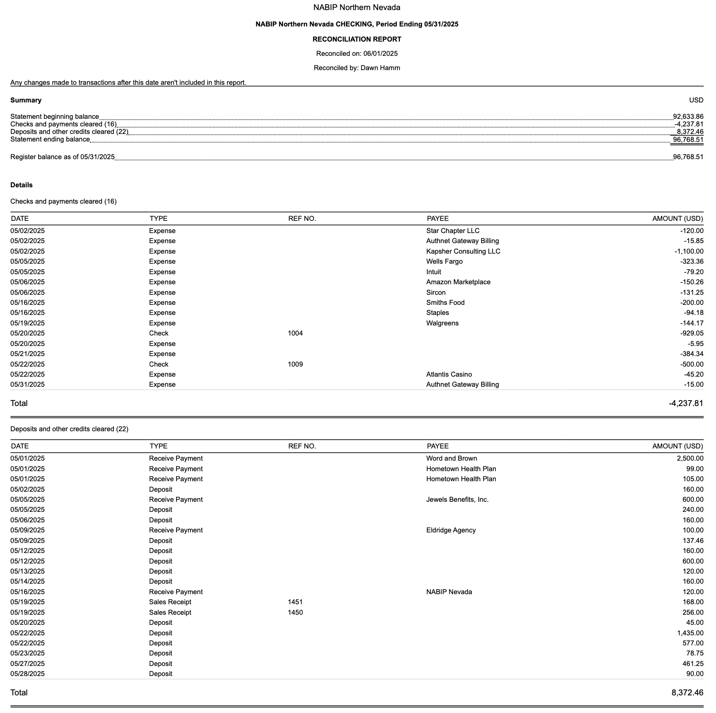

Profit and Loss by Month YTD Through May

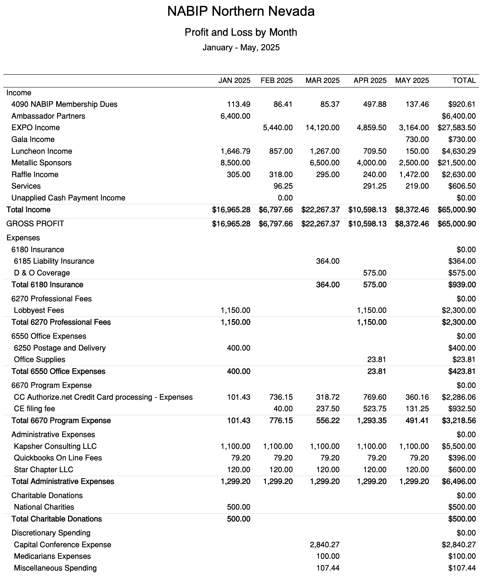
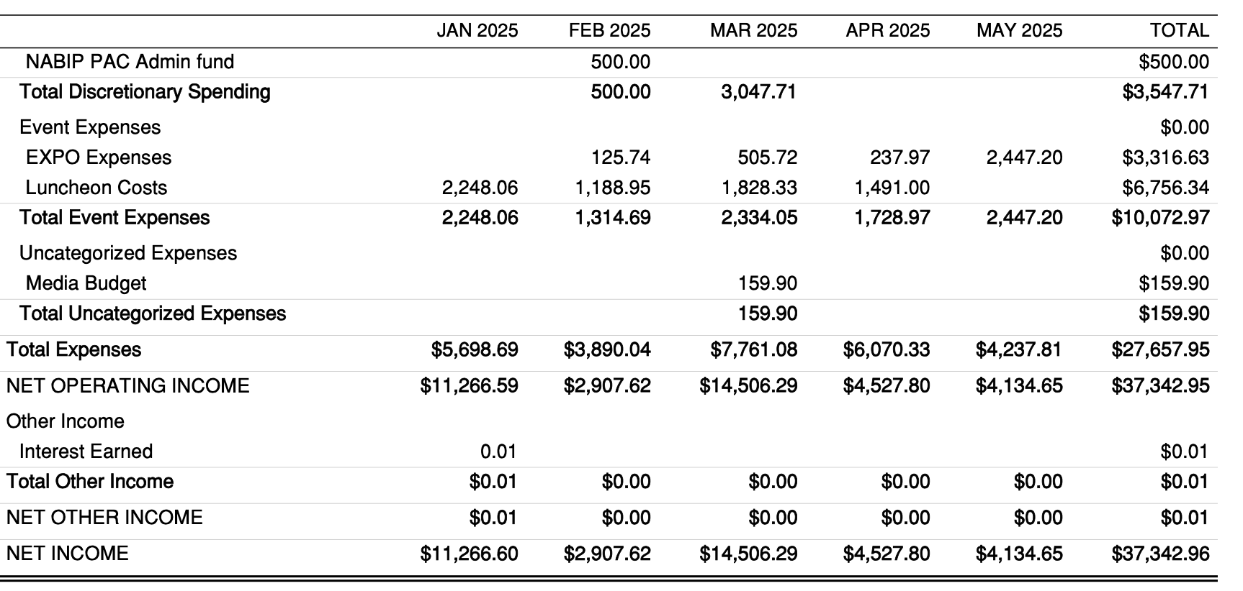
Budget vs. Actual January – May 2025
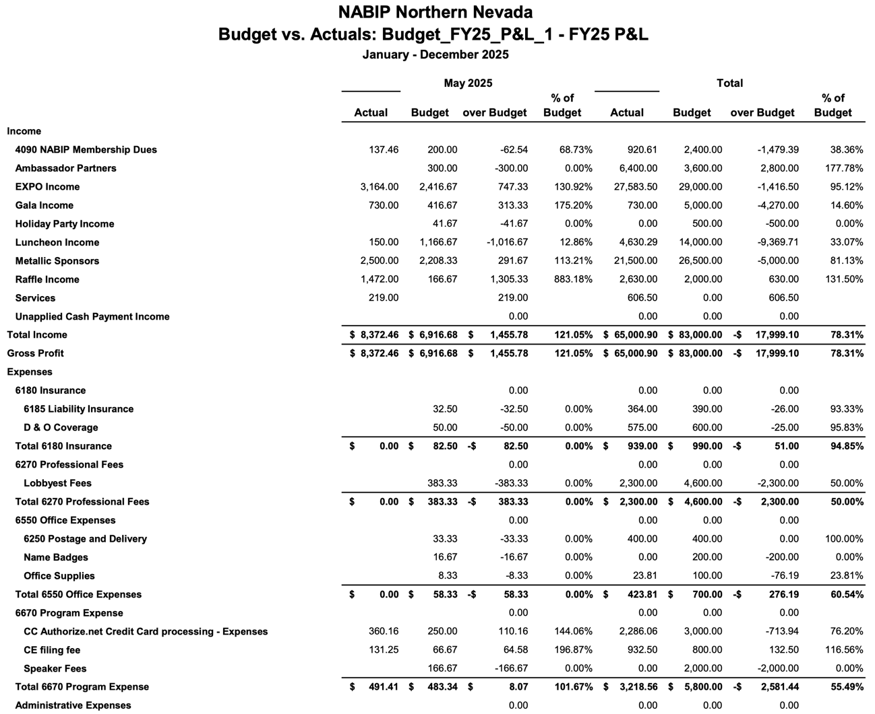

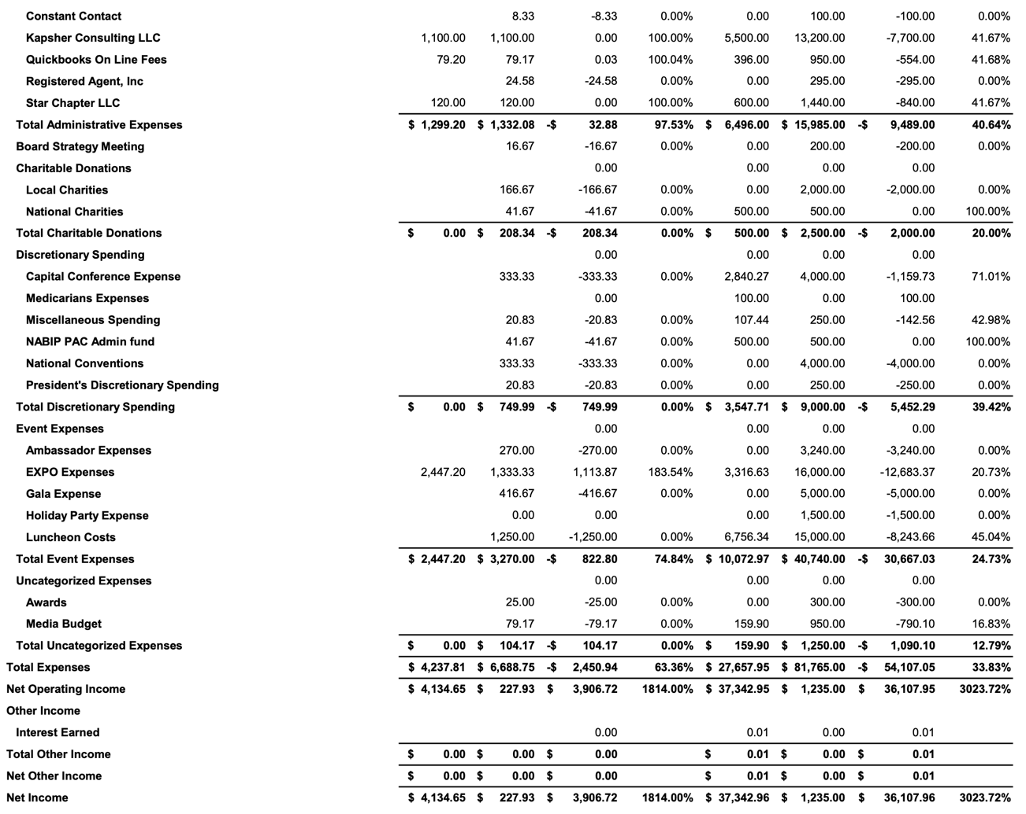
2025 Symposium Financial Breakdown

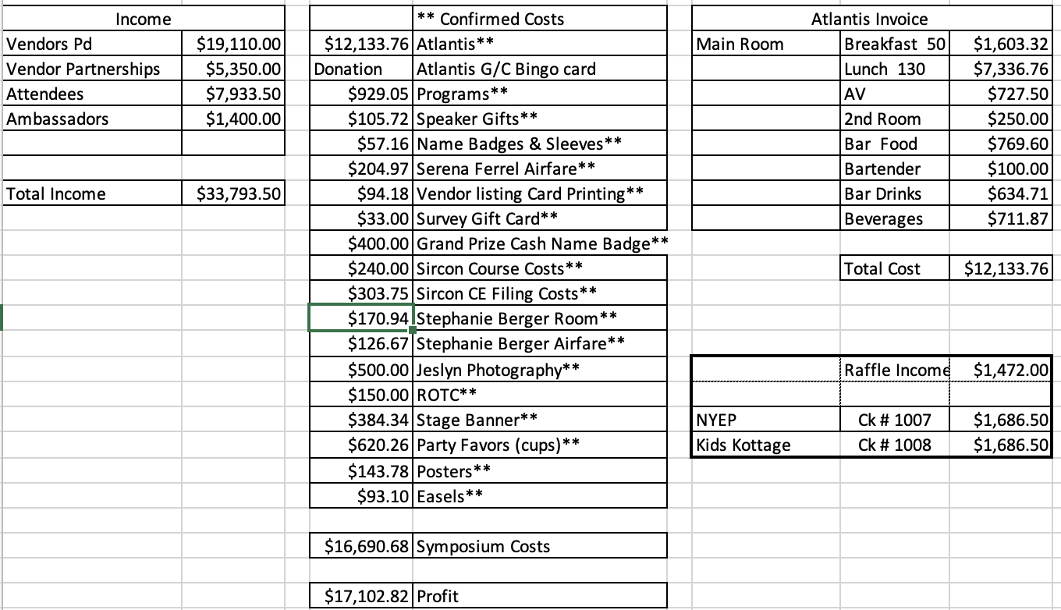
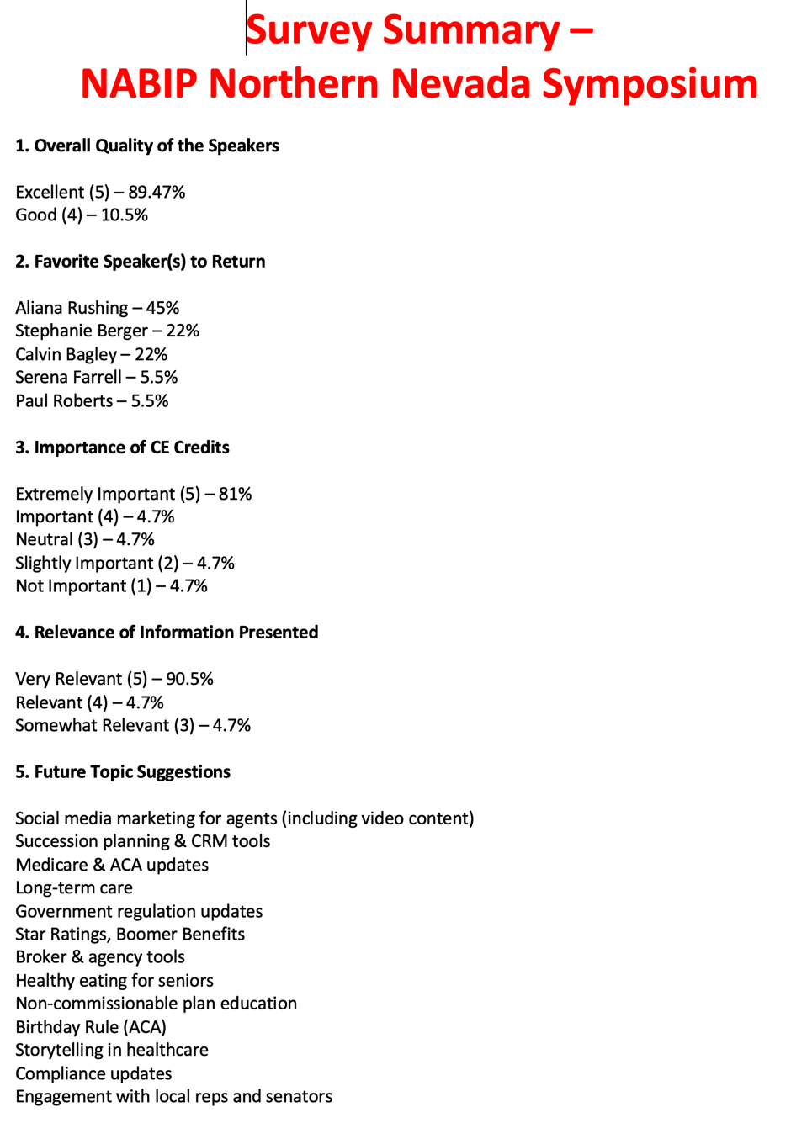
Survey Results for 2025 Exposition

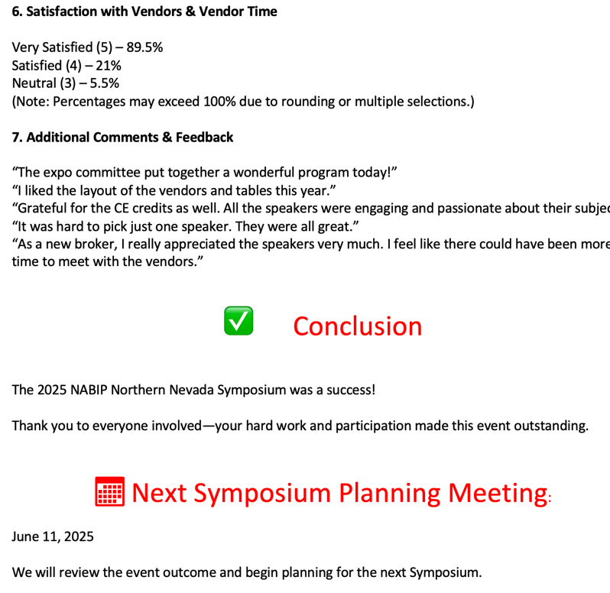

Legislative Report
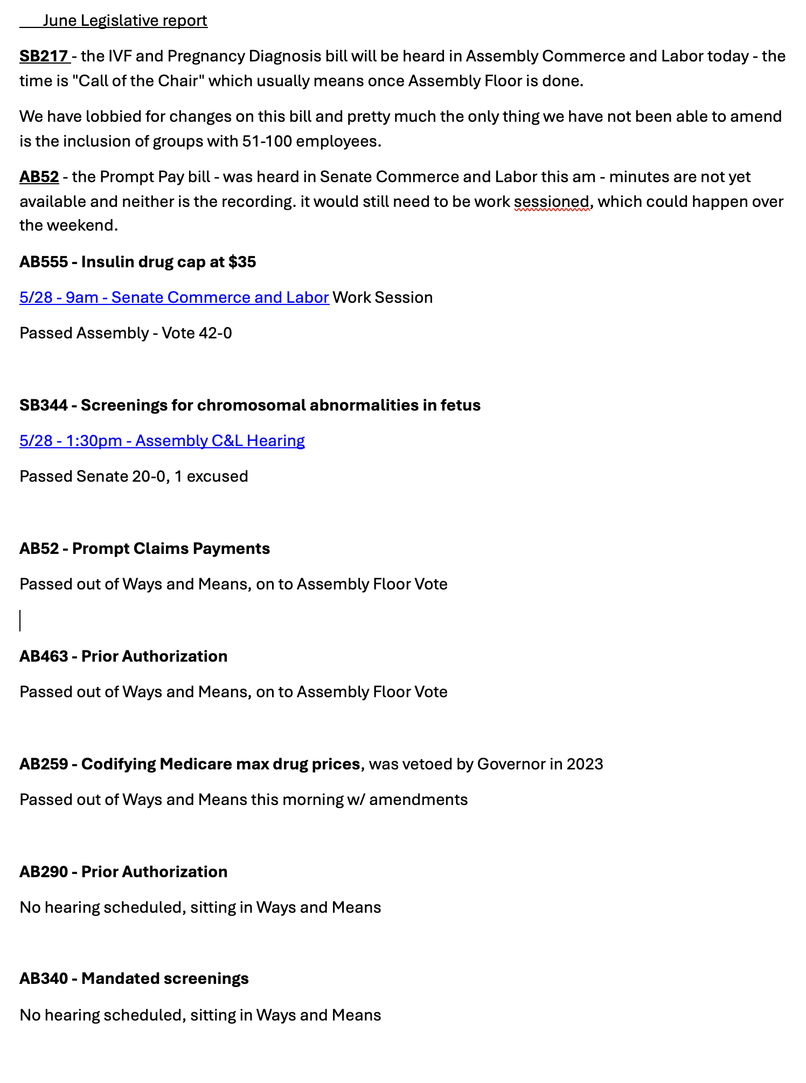
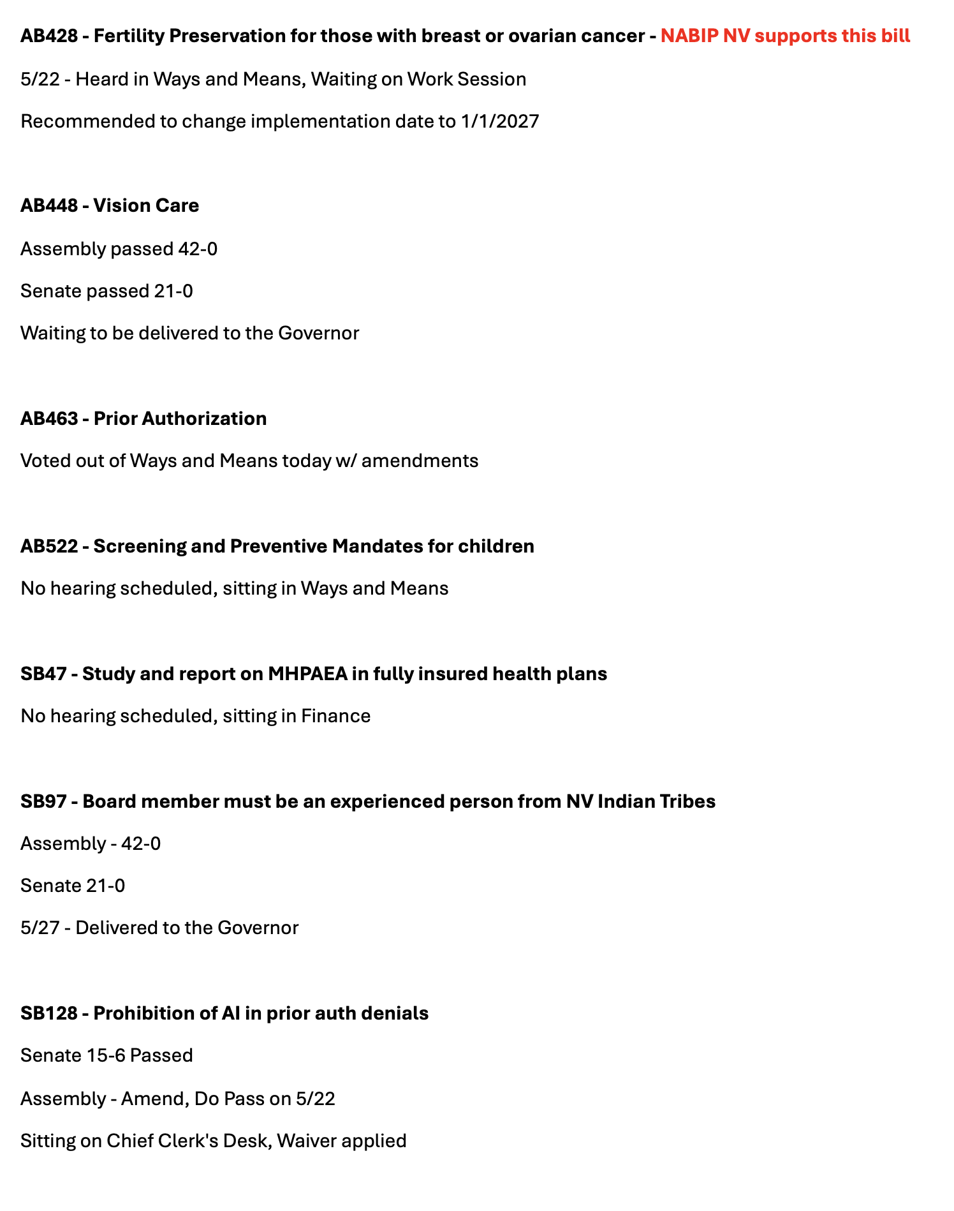
Page 2

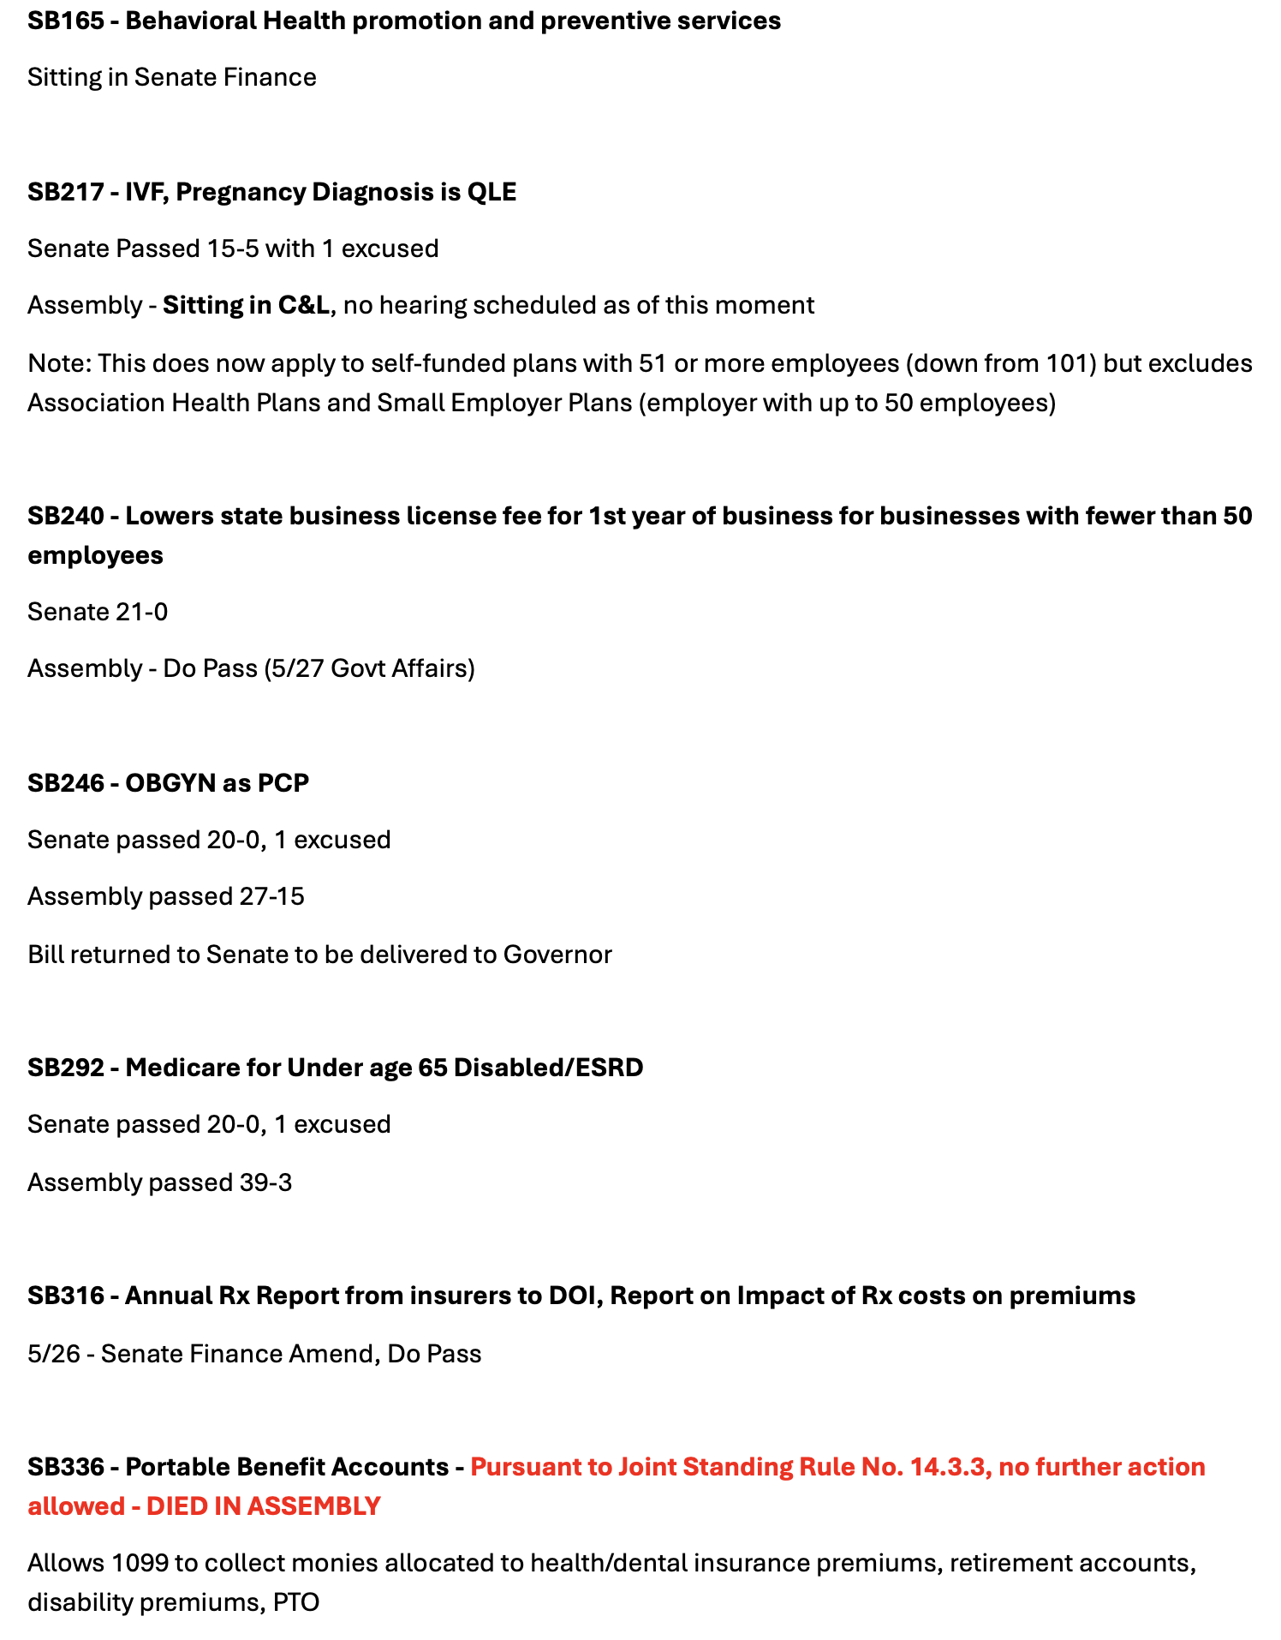
Page 3

Page 4

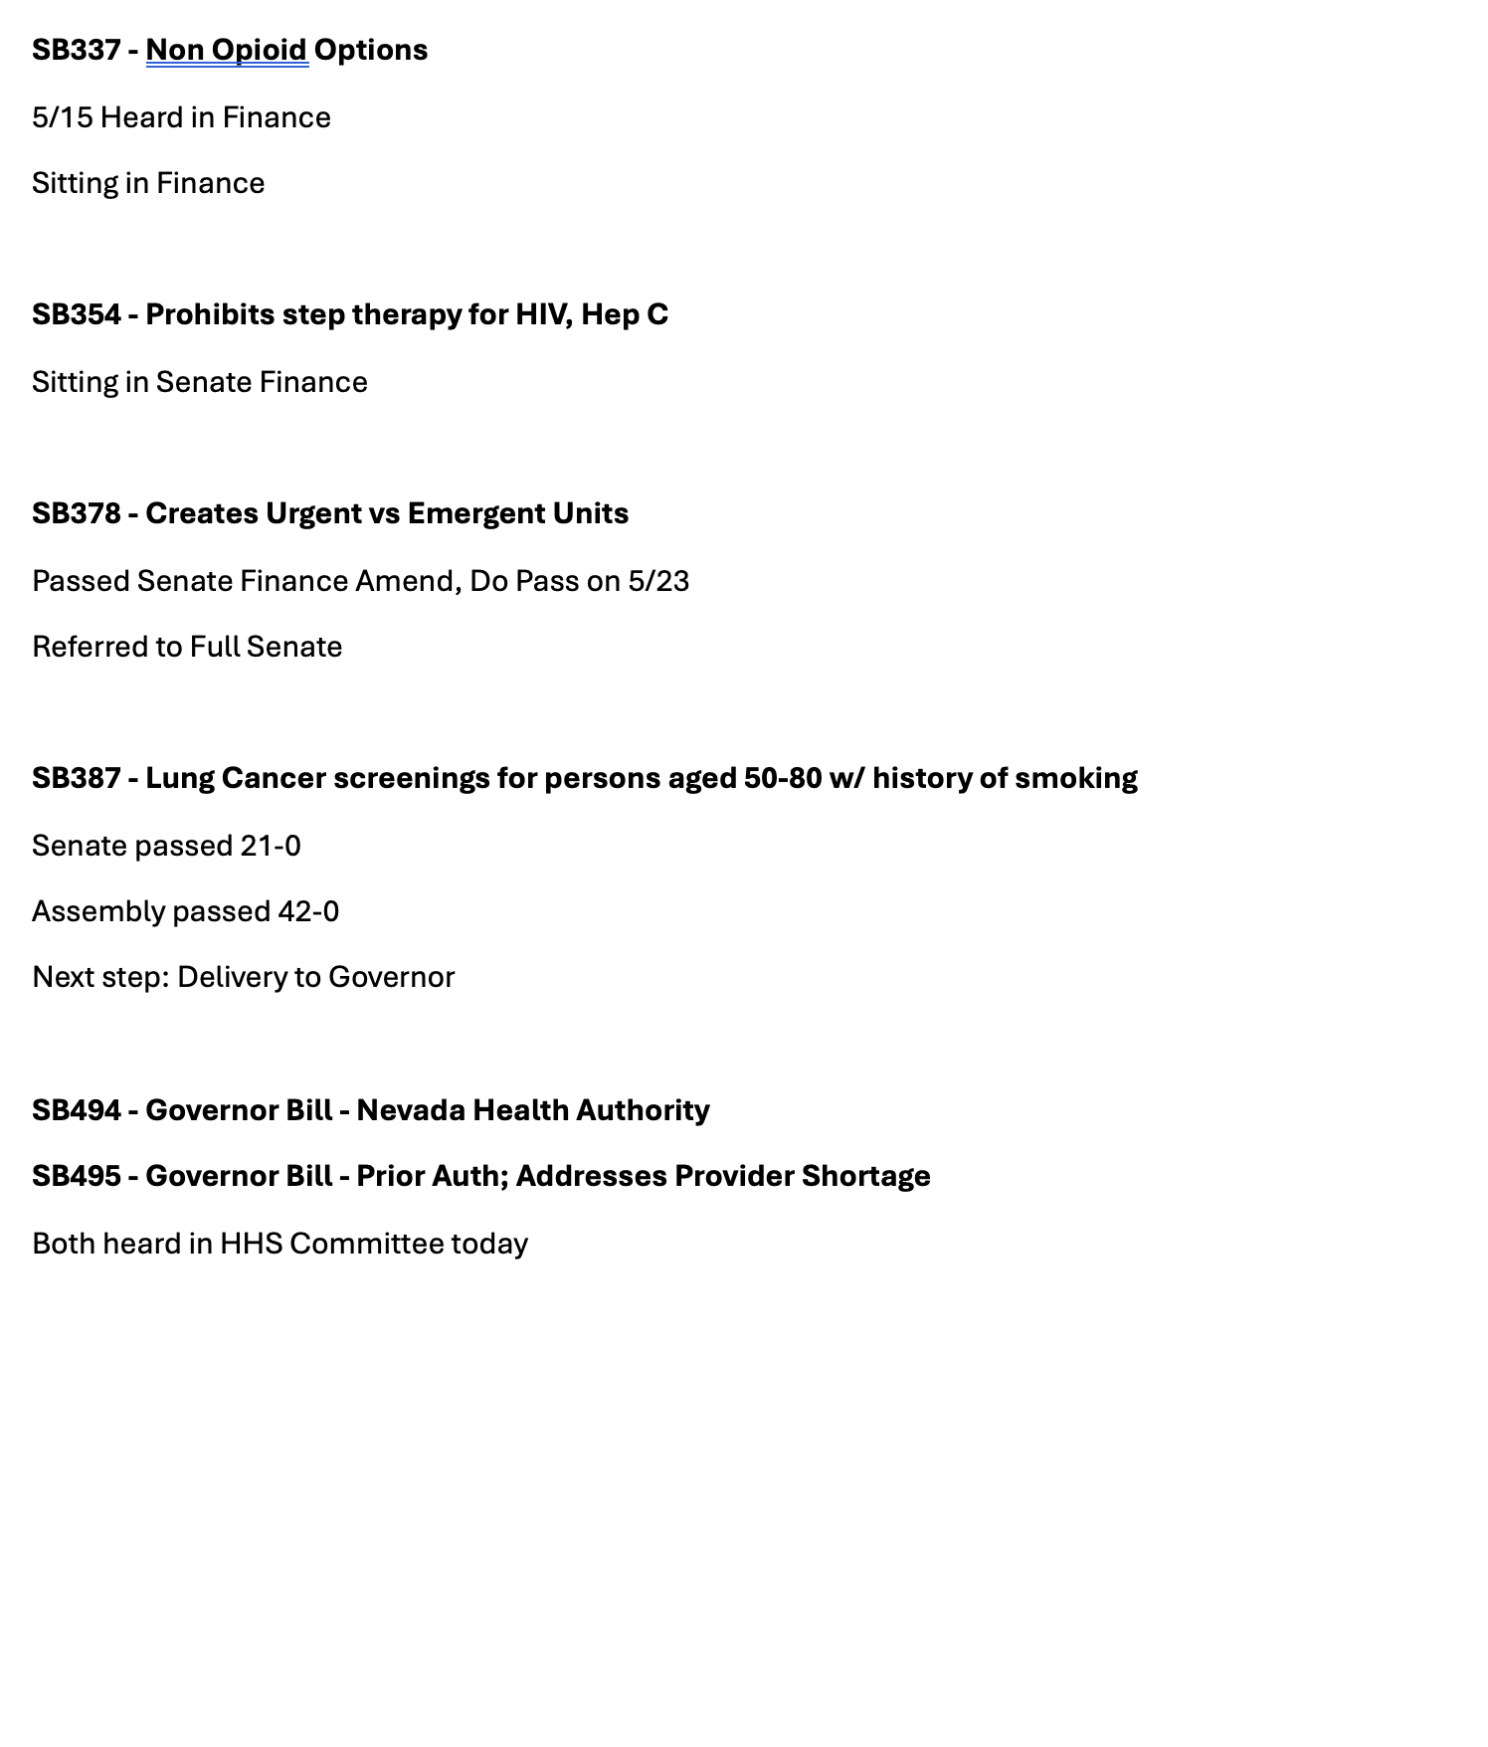
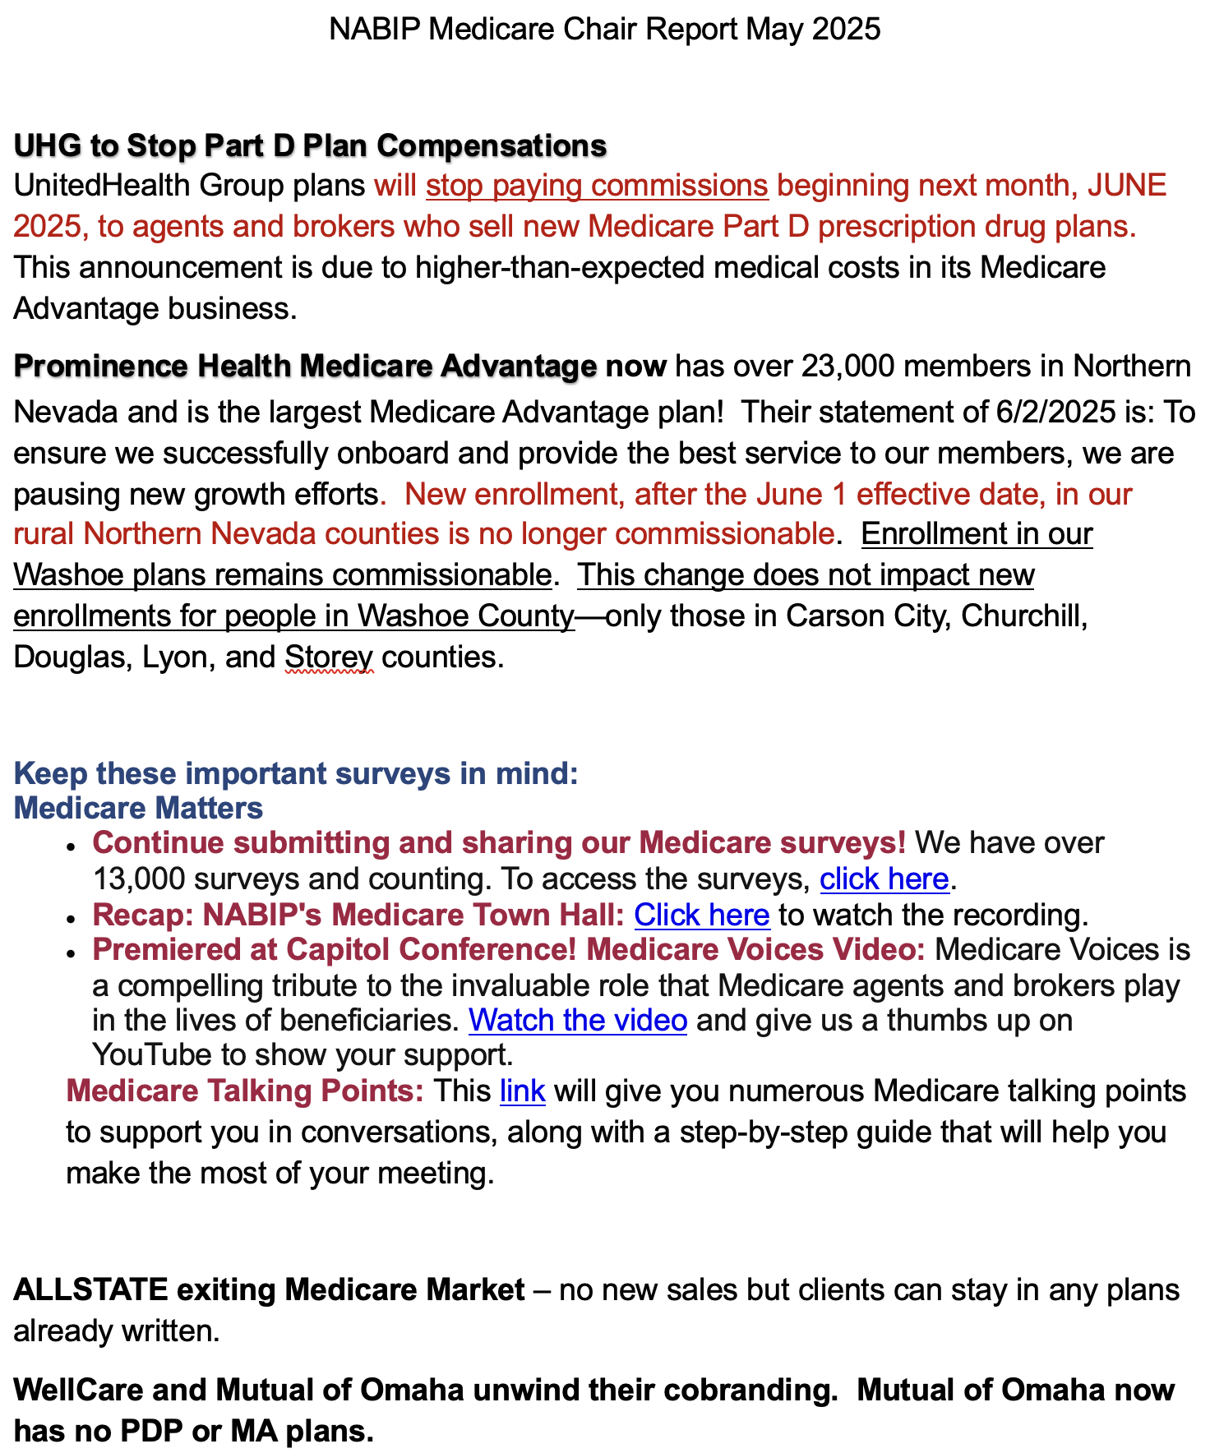
Medicare Pg 1

Pg 2
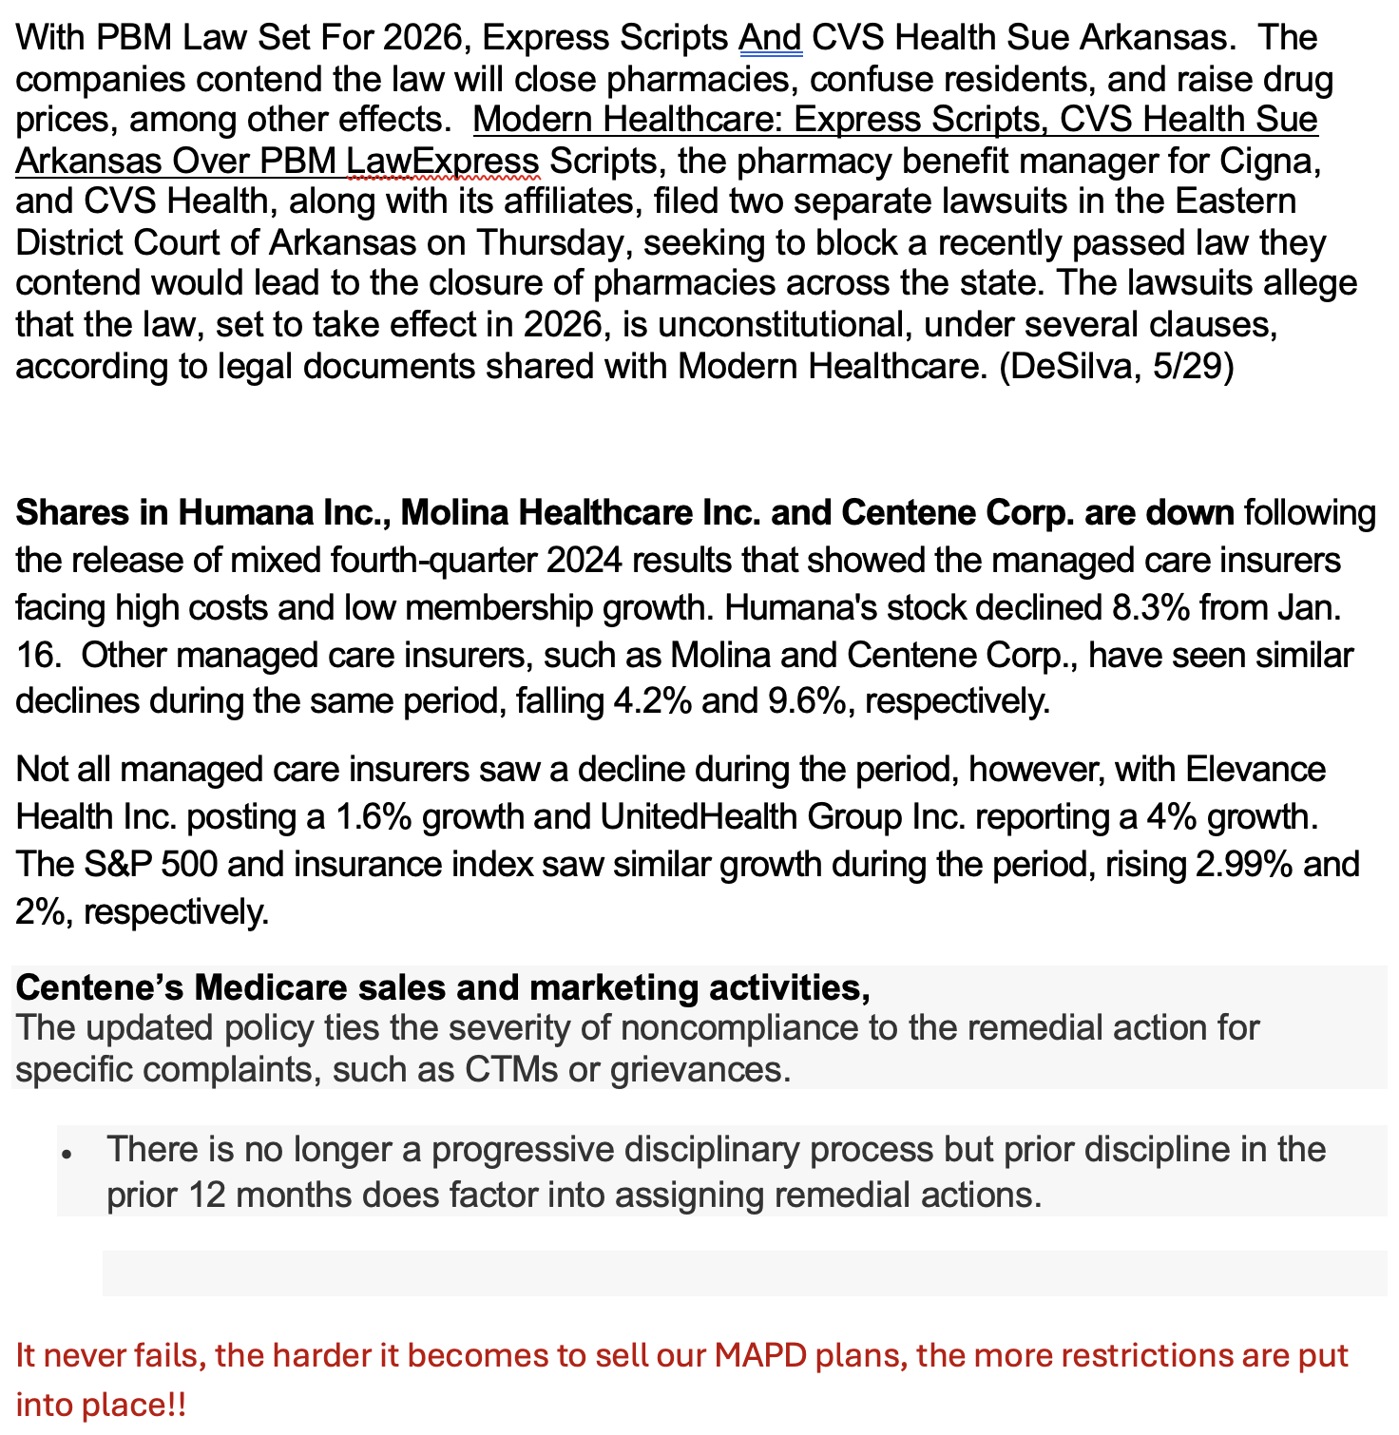

Programs Report -
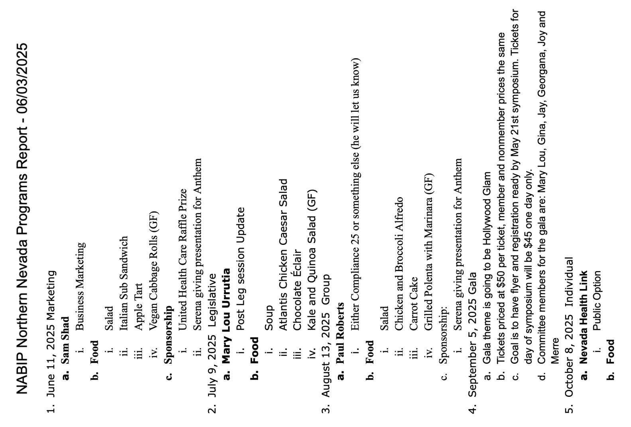

NABIP–PAC Report

