National Association of Benefits and Insurance Professionals - Northern Nevada

DRAFT - Board of Directors Meeting Minutes
June 4, 2024 11:05 AM – 12:49 PM
4600 Kietzke Lane, Building G-160, Reno, NV
Via Zoom – Meeting ID = us02web.zoom.us/j/84698950624

Attendance Report: Joy Gardner, Don Goldmann and Jay Eldridge

Virtual Attendance by Phone: Julie Ann Evans, Mika Clauson, Mary Lou Urrutia, Ross Pendergraft, Ashley Kapostins and Dave Sherrill

Absent: Merre Gregory, Molly Moreno, Gina Espinal-Aguerre and Ken LaRovere

Guest: None

- Meeting was called to order by President Jay Eldridge at 11:05 AM.

- Roll call of attendees was taken by sight for those attending in person by Secretary, Don Goldmann, and by verbal confirmation for those who phoned into the meeting. Quorum confirmed. Connectivity confirmed.

- Review of the May 2024 board minutes by Secretary, Don Goldmann.

  - A motion to approve the May 2024 board minutes was made by Joy Gardner and seconded by Julie Ann Evans. Unanimously approved.

- Report of the President by Jay Eldridge:

  - The Exposition was a big success and congratulations is given to the committee.

  - The President’s book has been transferred to Molly Moreno for her use as she starts her term as President on July 1st.

  - Jay expressed his appreciation to his fellow board members for their support of him during his year as President, for the great experience he was able to share with them and expressed the hope that he has left the chapter in a better place for going forward.

- Report of the Secretary by Don Goldmann:

  - With the May minutes having been approved, there was nothing else to report.

- Report of the Vice President of Finance by Joy Gardner: There are financial records placed into the Addendum of these minutes.

  - Exposition income was $26,078.70 versus expenses of $9,746.33 for a total profit of $16,332.37.

  - Raffle income was $1,430 and two checks of $862.50 each were given to the annual charities of NYEP and the Kids Kottage.

  - Review of partnerships for 2024, with all invoiced, includes Diamond Anthem $8,500 (Paid), Gold Aetna $4,000 (Paid), Gold United Healthcare $4,000 (Paid), Silver Hometown Health $2,500 (Paid), Silver Word & Brown $2,500 (Paid), Silver Alignment $2,500 (PAID) and Bronze Prominence $1,000 with Mary Granger of Prominence personally working on it and will deliver it when available.

  - Current bank checking account balance as of 5/31/2024 was $78,338.34 and the savings account was at $200.37.

  - The April Exposition of 5/22/2024 financials are reported below.

    - Attendance: 108 attendees, 8 no shows (7 paid and 1 vendor) and 6 walk-ins.

    - Income: $17,28.70 plus $8,250 sponsorship for a total of $26,078.70 with $500 from Ambetter included in the calculation, but not yet collected.

    - Cost: $7,784.04 with the Atlantis costing $1,812.29 and other costs equaling $9,746.33

    - Raffle Income: $1,430

  - The 2024 budget update has been attached to the Addendum of these minutes.

  - Julie Ann Evans moved to approve the Financial Report and it was seconded by Don Goldmann. Unanimously approved.

- Report of the Vice President by Molly Moreno:

  - It was announced that the annual strategic planning meeting will be held immediately after the July monthly board meeting for about an hour and a half with lunch being served.

    - A Strategic Planning Meeting committee of Molly Moreno, Ross Pendergraft and Don Goldmann will teleconference next week to discuss the agenda and training in Media Relations during the strategic planning meeting.

- Committee Reports:

  - Vice President of Legislative Affairs by Mary Lou Urrutia: A written report has been included in the Addendum of these minutes.

    - Discussion was held about the new federal regulation approving Dreamers (DACA) to be eligible for coverage in the state exchange.

    - Discussion was held about NABIP’s stance on COBRA qualifying as credible coverage for Medicare.

    - Discussion was held about the rules that are used with Medicare concerning Observation Status during hospital visits.

    - Nothing has yet been planned for the Nevada “Day on the Hill” event.

  - Vice President of Awards report by Ross Pendergraft: A written report was submitted and has been included in these minutes.

    - The NABIP national office awarded a Platinum Certificate to the chapter.

    - Four awards were submitted for consideration at the Annual Convention and those submissions were for the Pacesetter, Media Relations, Website and a Presidential Citation.

    - Media training should be coordinated with the Annual Strategic Planning meeting.

    - Everyone needs to be more diligent about making sure the board uses the Pacesetter criteria and Awards will follow up at each board meeting with announcements for the meeting minutes.

  - Vice President of Membership report by Gina Espinal-Aguerre: absent, but sent a report via text.

    - The chapter began May with 105 Members.

    - Two new members were recruited during the Exposition through a membership drive using an “Exposition New Member Promotion” Flyer, which has been added to the Addendum of these minutes.

  - Vice President of Communications/Media report by Mika Clauson:

    - A topic for the July monthly membership luncheon is still needed.

    - For the Media Relations award submission, the chapter will likely be “dinged” for not having enough media releases and needs to do better next year.

    - The Executive Director team is converting the chapter website over to the new domain while Star Chapter is still handling the old domain and the move to the new one should be moving forward soon with a cost of $140 to Star Chapter to make the change.

  - Vice President of Professional Development report by Julie Ann Evans: Written report submitted and entered into these minutes.

    - Monthly luncheons:

      - June 12, 2024 - Dental Tourism, presented by Mark Popejoy.

        - Material submitted to Kapsher to create/advertise the event on 05/20/24.

      - July 10, 2024 – TBD

      - August 14, 2024 - Medicare Summit

      - September 11, 2024 – TBD

      - October 9, 2024 - Member Incentive Level Funded Health Plans, presented by Michael Patton.

        - CE material submitted on 05/21/24.

        - Course approved on 05/22/24.

    - Quarterly Medicare Luncheon – August 14, 2024:

      - The committee plans to offer several CEs at this event.

        - One CE has already been approved.

        - The material for another CE has been submitted.

        - Expecting the material for two additional CEs that will need to be submitted.

      - The deadline to submit for CEs for this event is June 13, 2024.

    - Annual Expo – May 22, 2024:

      - There was a total of four approved CEs for this event.

        - Three of the CEs were managed by NABIP-NN.

        - One was managed by Kelley Carr with One America.

      - All CE completions were processed on May 25, 2024.

        - David Smith had a total of 66 CEs processed.

        - William Hepscher had a total of 63 CEs processed.

        - Paul Roberts had a total of 51 CEs processed.

      - Sircon charges $40 per course and there is a CE completion fee of $1.25 per course per person getting CE credit.

        - Total cost of filing was $120.

        - Total cost for CE completions was $225.

        - Total cost for all was $345.

      - Vender Bingo cards were given to attendees, who were asked to write ideas for future luncheon topics and recommend presenters.

        - There was a separate raffle prize for those who participated.

        - The information gained from the cards has been compiled and will be shared with the PD Committee at the next PD meeting.

      - The NABIP Mentor Program was not promoted as planned at the event, but it will be in future events.

      - Speaker Thank You Notes:

        - An email was sent on May 24, 2024 to each of the speakers to thank them for presenting and included were pictures taken of them presenting.

        - An email was also sent to Congressman Amodei and Insurance Commissioner Scott Kipper on May 28, 2024 to thank them for providing a welcome video for the event.

    - NABIP-NV Free CE Program:

      - The May 17, 2024 class was managed through NABIP-NN.

      - There was a total of nine participants.

      - NABIP-NN should see an invoice from Sircon for $51.25

    - Chapter training for PD was completed online by Julie Ann on May 14, 2024.

  - Director of Programs report by Ken LaRovere: Absent and no written report.

  - NABIP-PAC Chairperson report by Ross Pendergraft: A written report is included in the Addendum for these minutes.

    - Due to the chapter’s annual donation to NABIP-PAC having been given during Capital Conference, a mock check will be delivered in Chicago at the Annual National Convention.

  - Medicare Chairperson report by Jay Eldridge in place of Merre Gregory, who was absent:

    - No new news reported regarding the IRA or Final Rule.

    - The Medicare Summit Committee has been on fire getting CEs submitted and marketing is being created with “Save the Date” announcements hitting inboxes this week.

      - The theme is Twilight Zone - watch for the “Save The Date”!

  - By-Laws and P&P Committee report by Don Goldmann: Written minutes of the Annual Membership Meeting have been added to the Addendum of these minutes.

    - The annual membership meeting minutes were distributed and after discussion, Don Goldmann made a motion to approve the minutes as written and that motion was seconded by Joy Gardner. Unanimously approved.

- A motion was made by Julie Ann Evans and seconded by Don Goldmann to accept all reports in toto. Unanimously approved.

- Old Business –

  - Works continues on vendor signage with follow up being done by Jay Eldridge.

- New Business –

  - Discussions, led by Mika Clauson, were held concerning giving credit from the podium at monthly, quarterly and annual meeting, to persons and companies that provide prizes in order to help promote raffle ticket sales for the chapter’s charities.

  - Some complaints were received from Exposition vendors, who did not feel that they received adequate exposure for their sponsorships, and in particular, Protect Health, as the beverage sponsor, felt slighted and in compensation, will be given free advertising, a free booth and two complementary meals at next year’s expo.
  - Topics gained from the Exposition Bingo cards listed in the PD report and will be shared at the next PD meeting, which PD will inform everyone of later this week.

  - Molly Moreno will be doing a post-mortem on the Exposition on Friday morning in a virtual teleconference.

  - There is a possible volunteer, named Georgana Cepeda, to serve as the chapter Vice President starting July 1st and Gina will, or has been, in contact with her.

  - NABIP-NN.org is now active and pointing to the old website.

- A motion to adjourn was made by Jay Eldridge and seconded by Don Goldmann. Unanimously approved.

- President Jay Eldridge adjourned the meeting at 12:49 PM.

Submitted by Don Goldmann, NABIP-NN Secretary
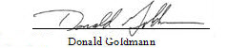

Next Monthly Board Meeting: July 2nd, 11:00 AM – 12:30 PM, 4600 Kietzke Lane, Building G-160, Reno, NV

Addendum

Umpqua April 2024 Statement
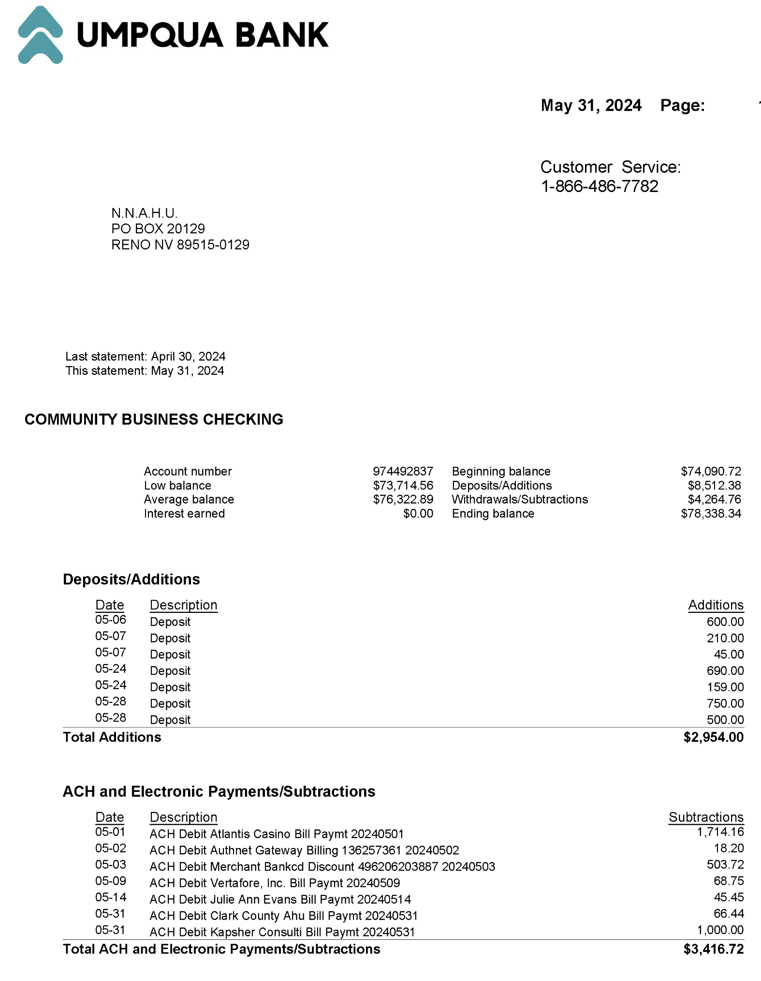

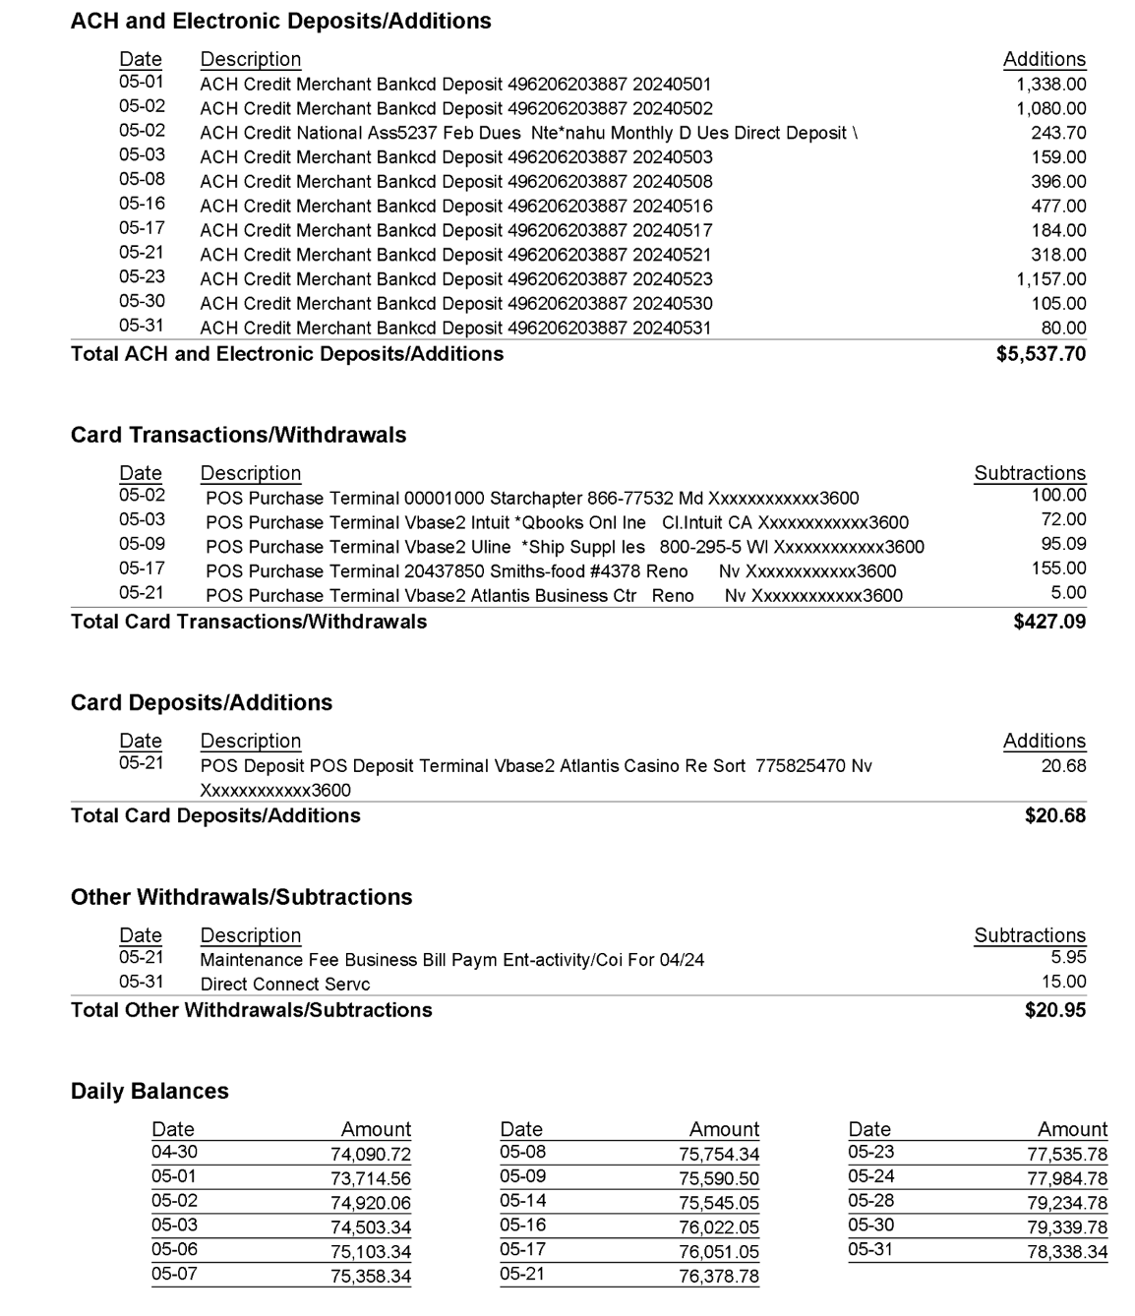

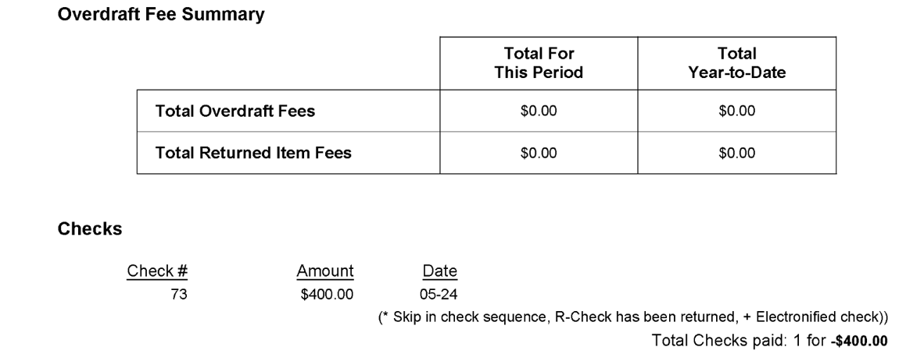

Reconciliation
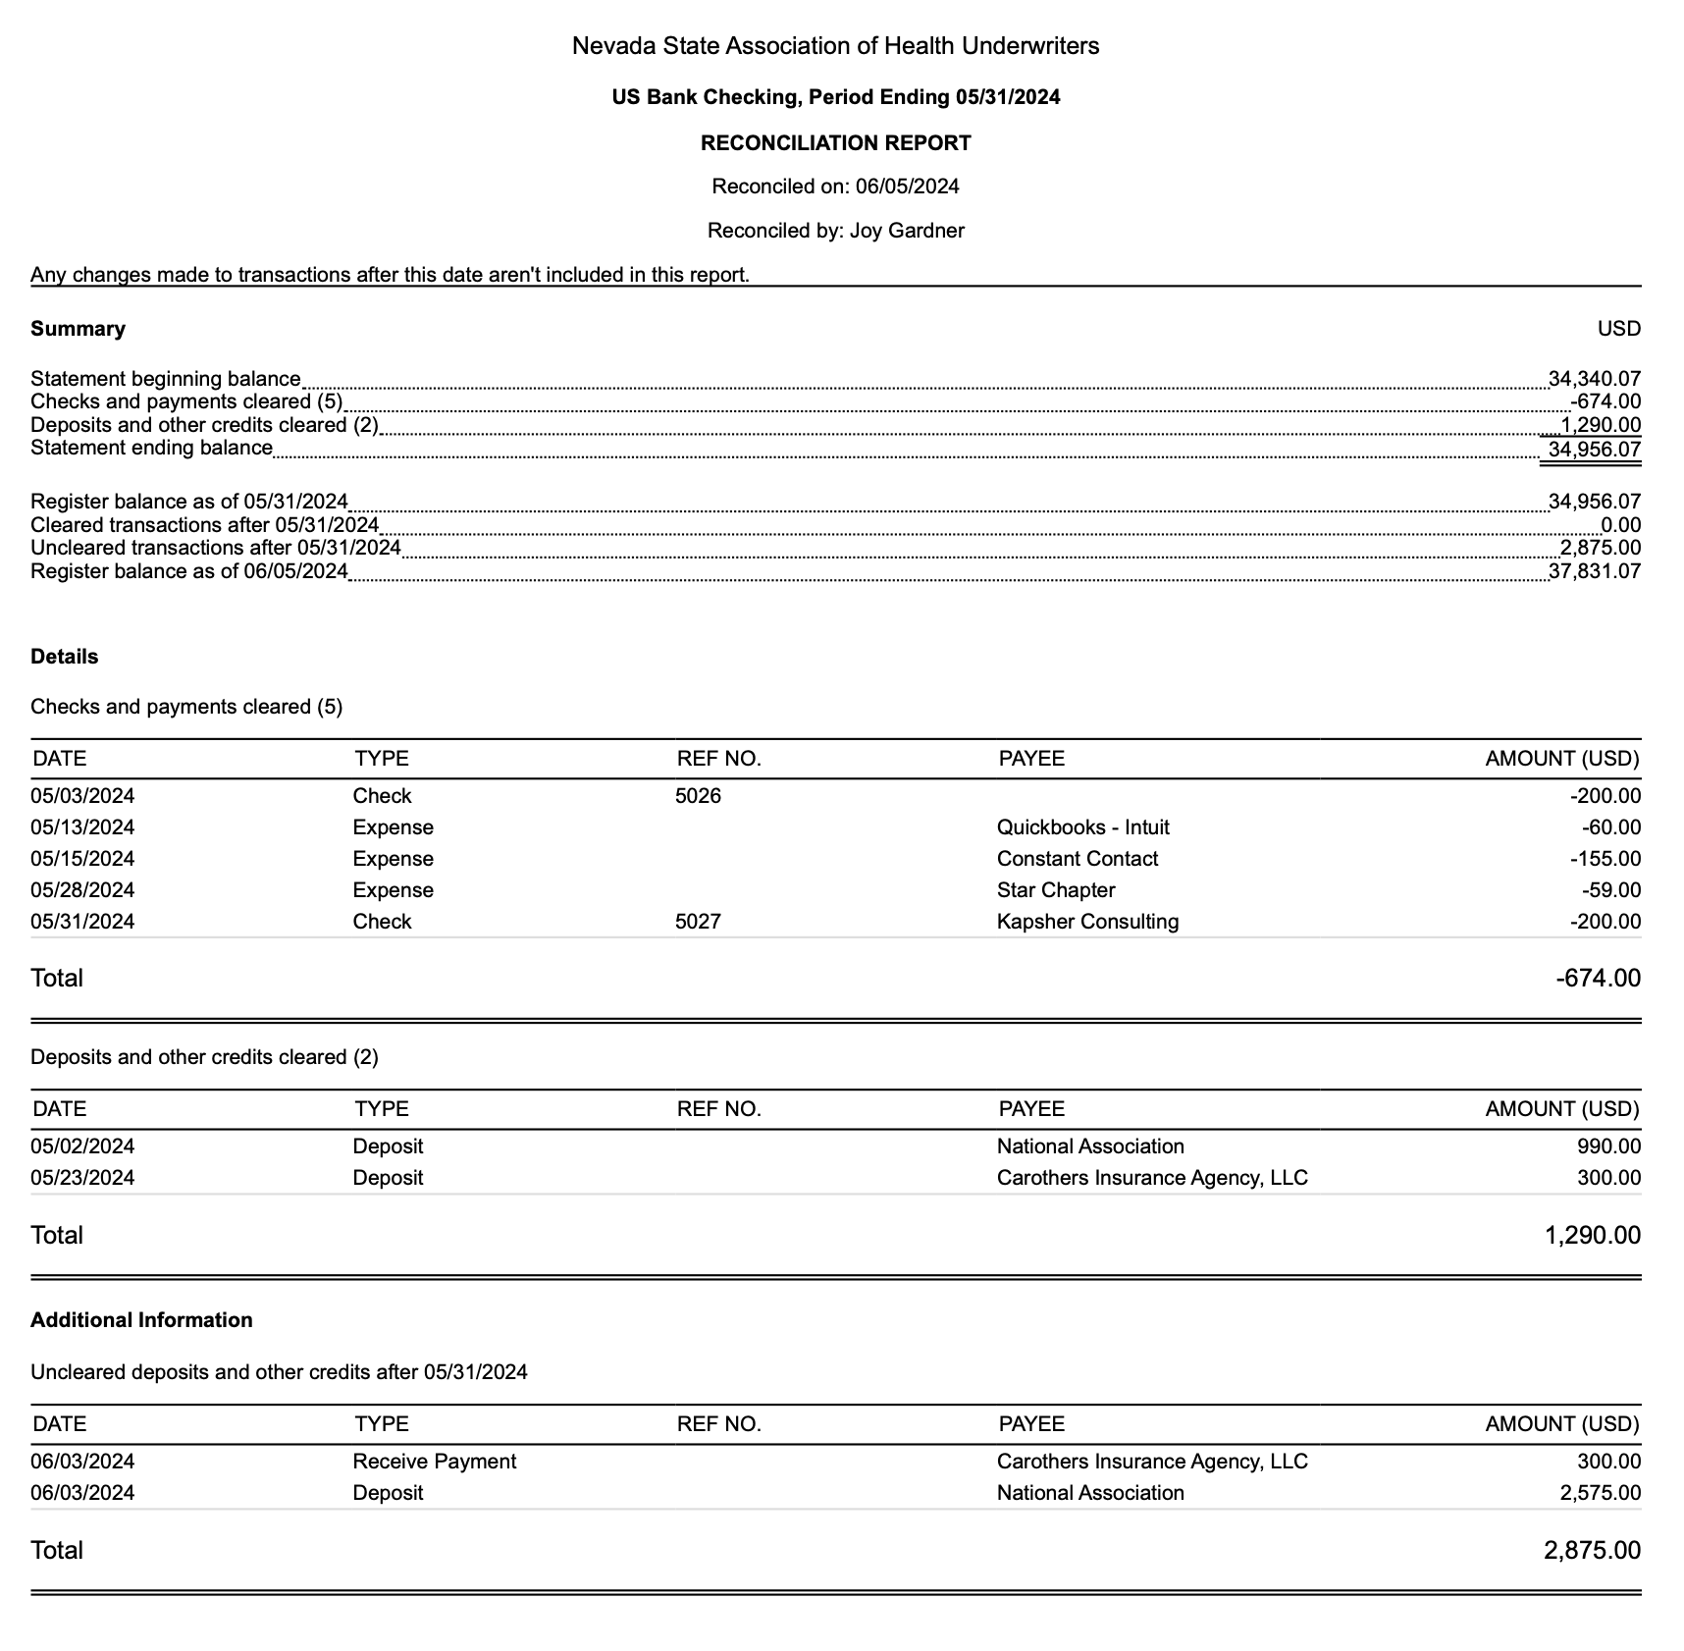
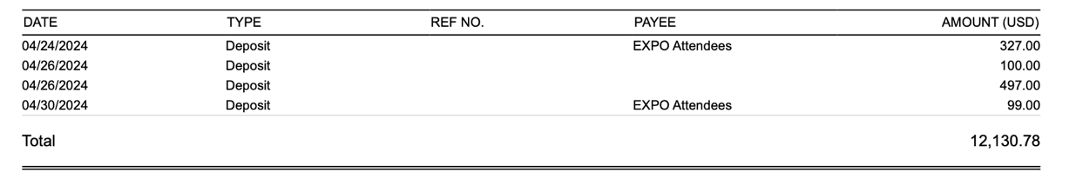
Budget vs. Actuals YTD
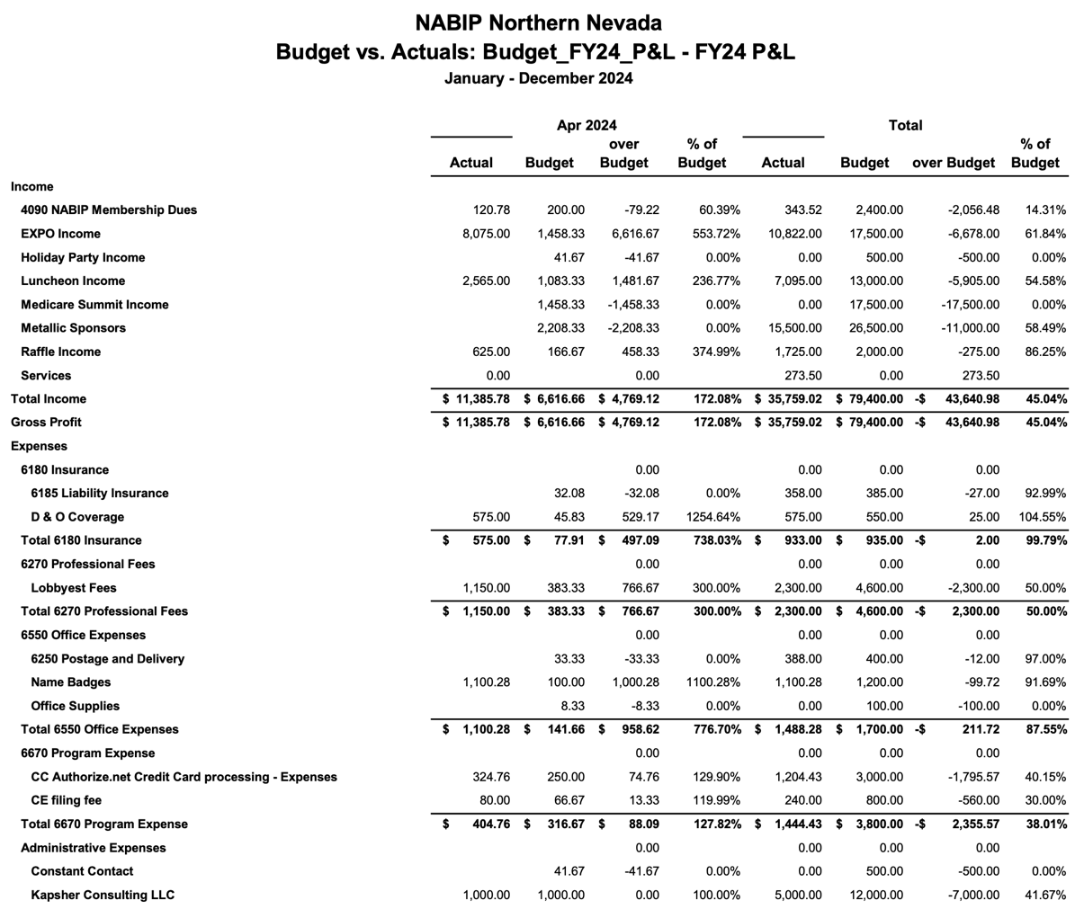

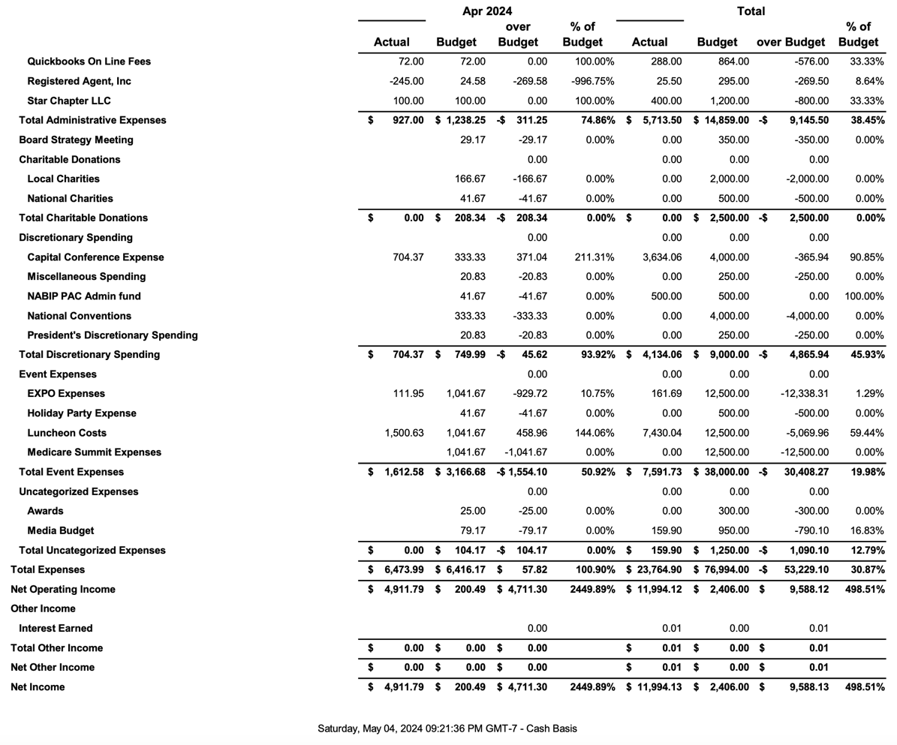
Profit and Loss Year to Date April 2024
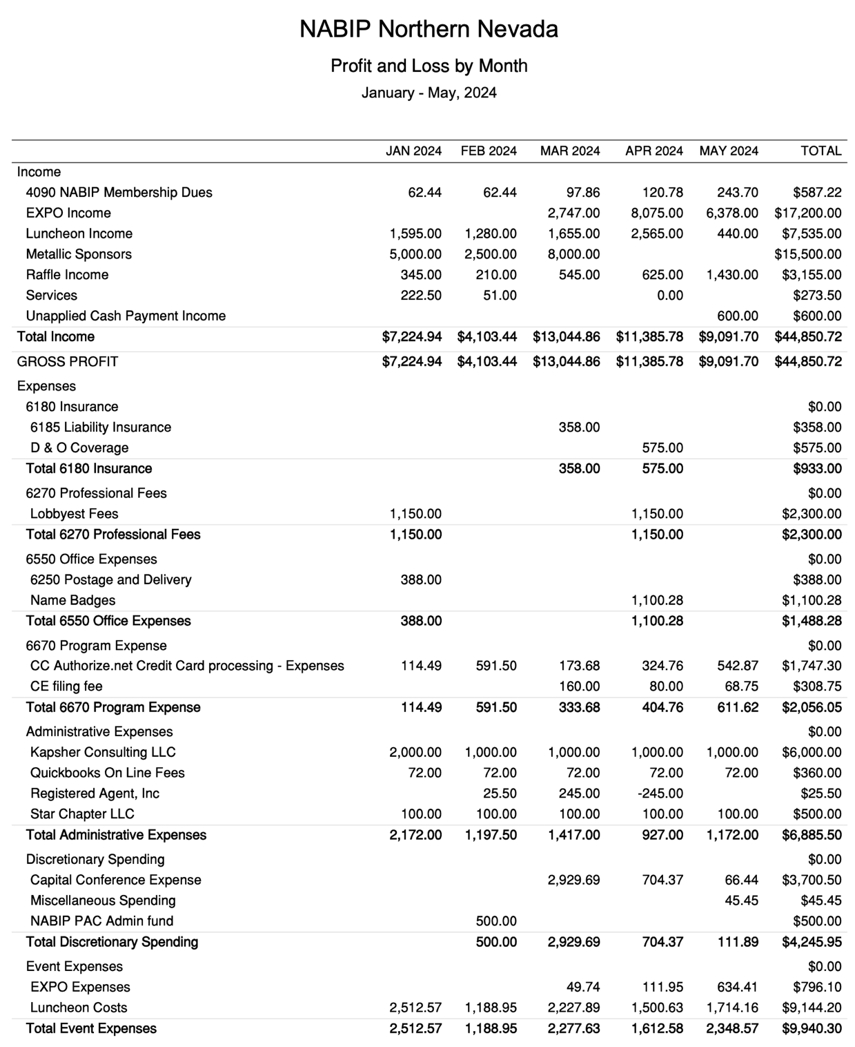

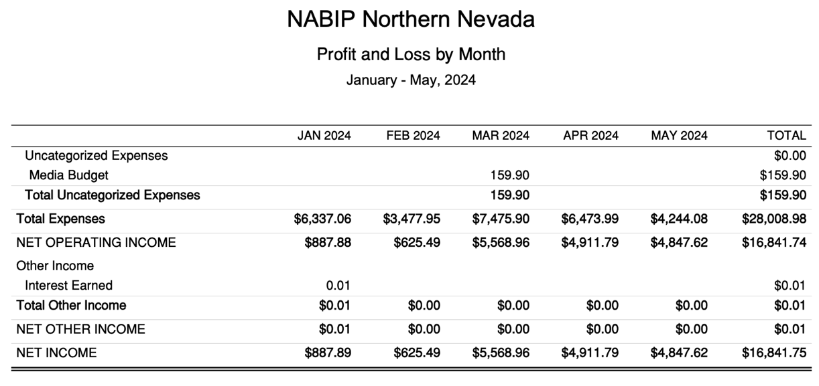

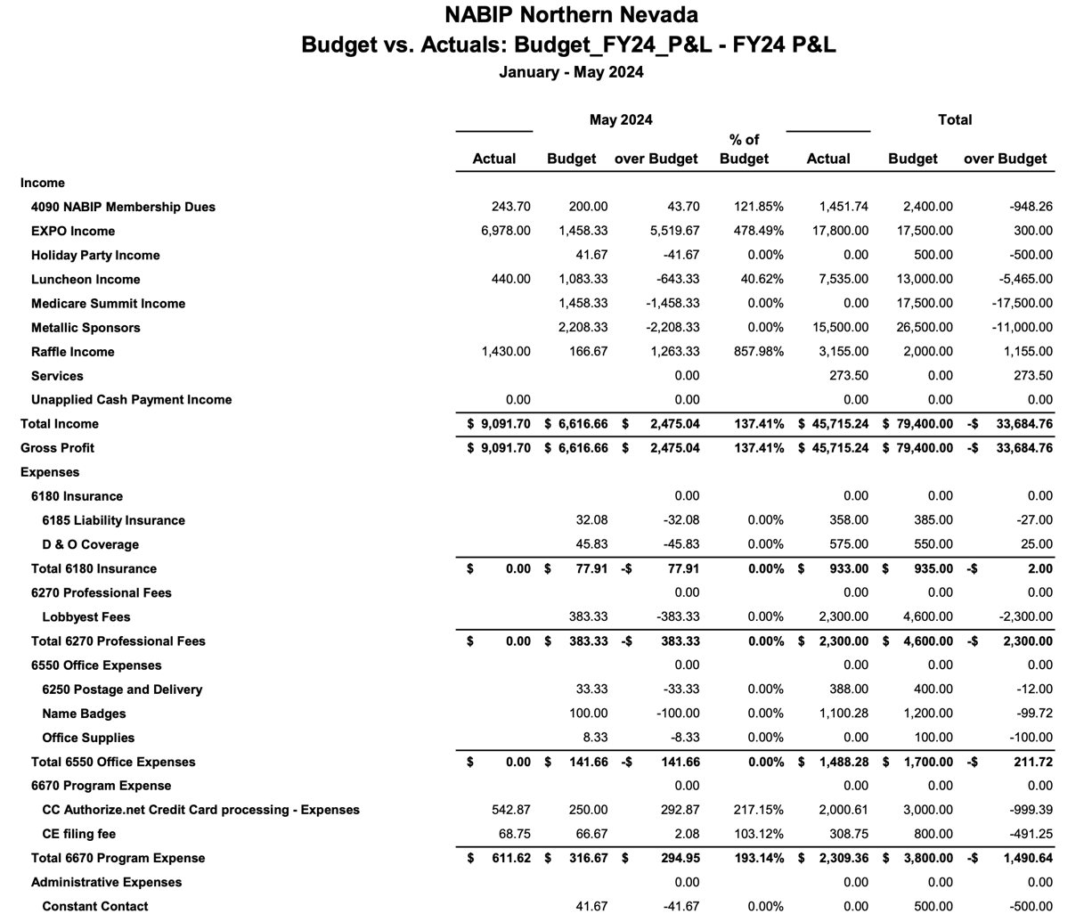
NABIP-NN Budget vs. Actual May 31, 2024

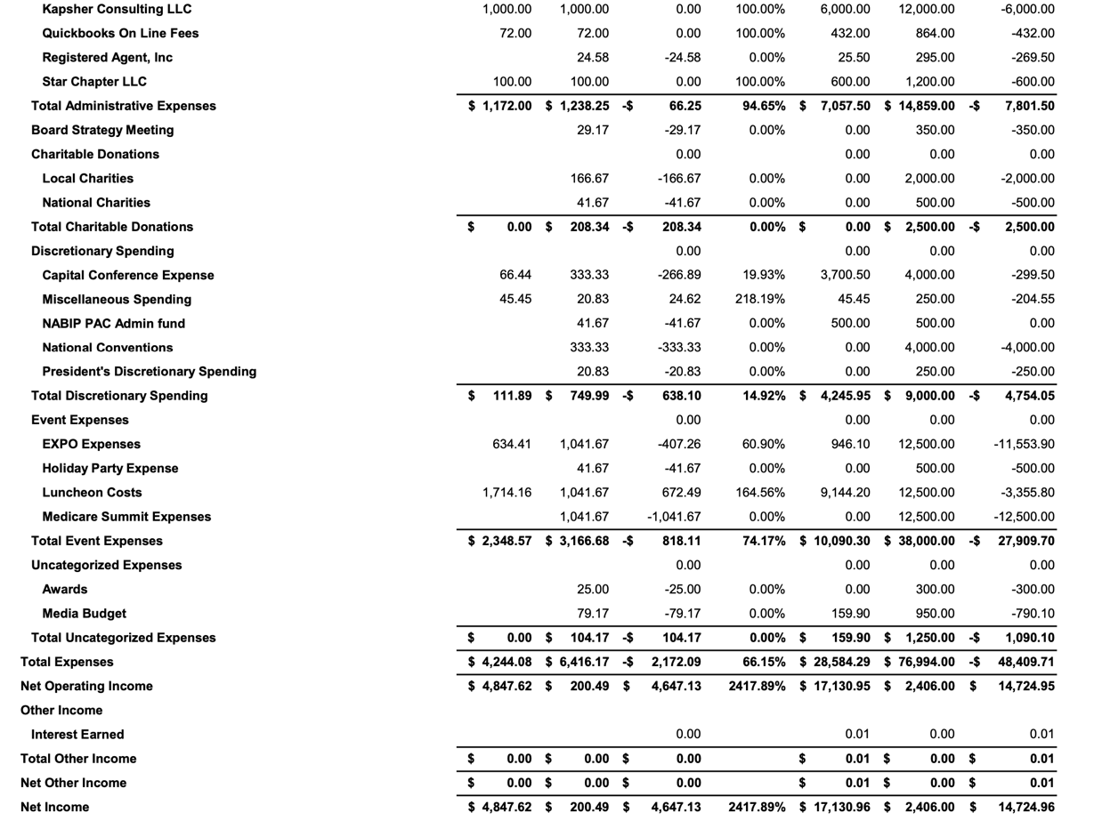

2024 vs 2023 Exposition Financial Breakdown

2024
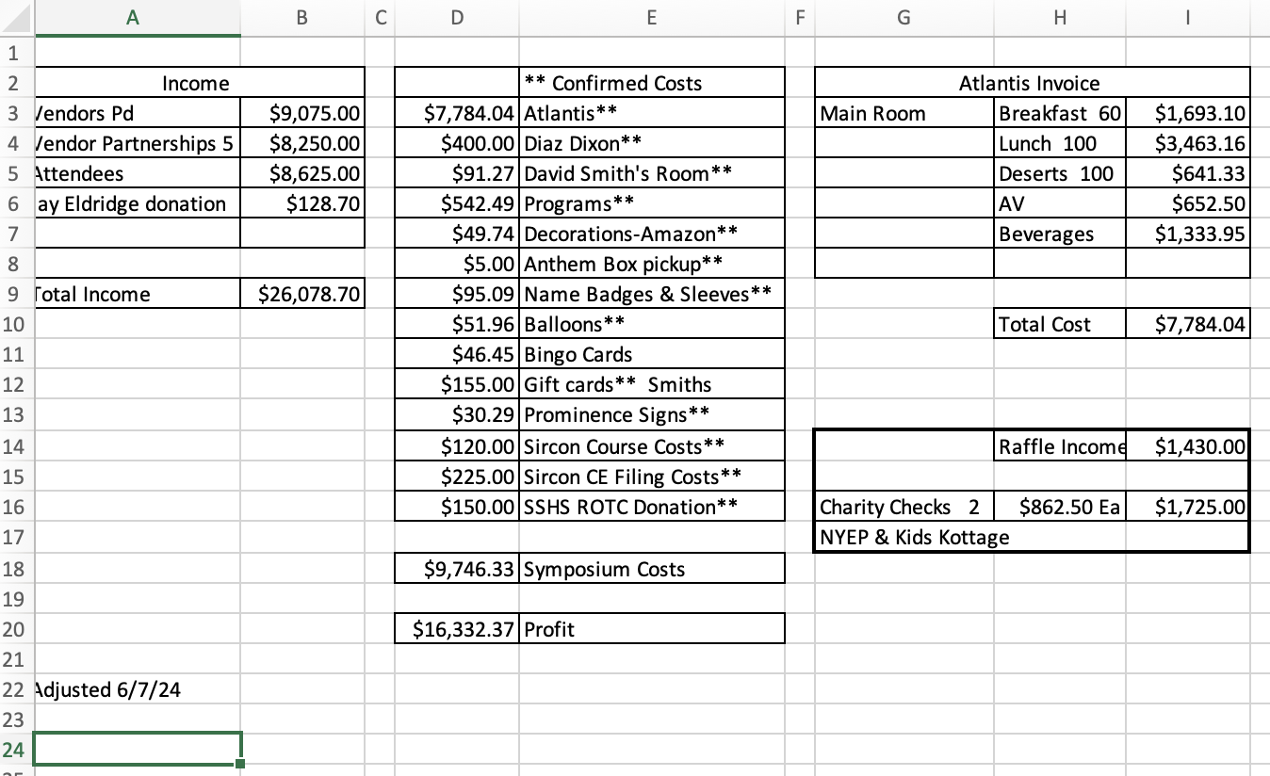

2023
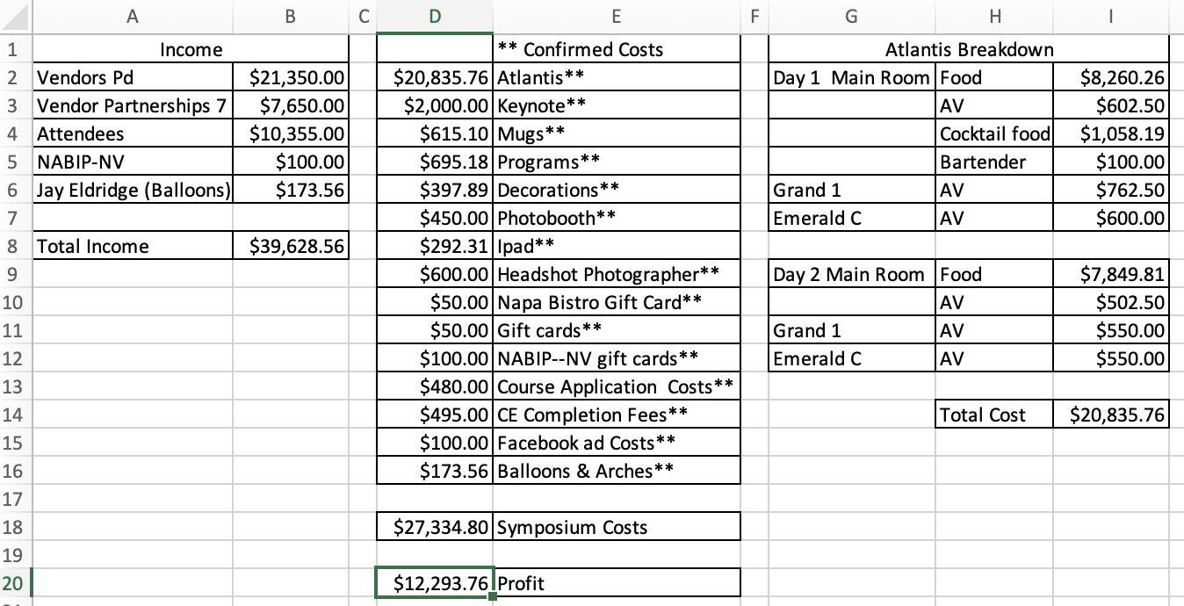

Legislative Report
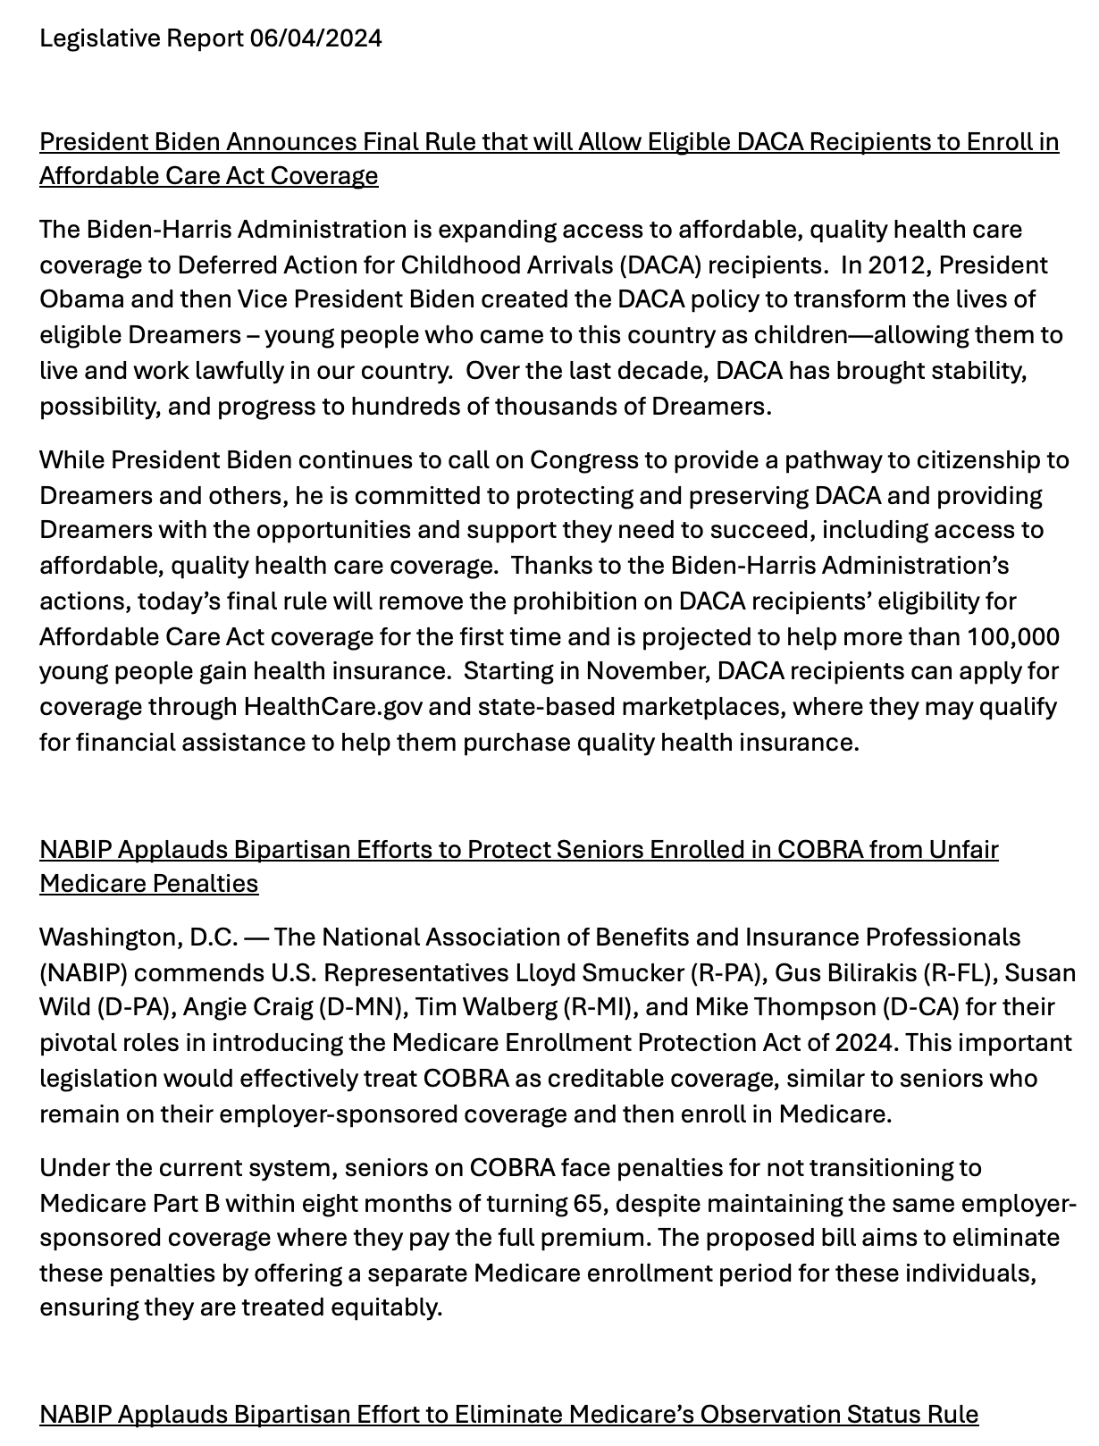

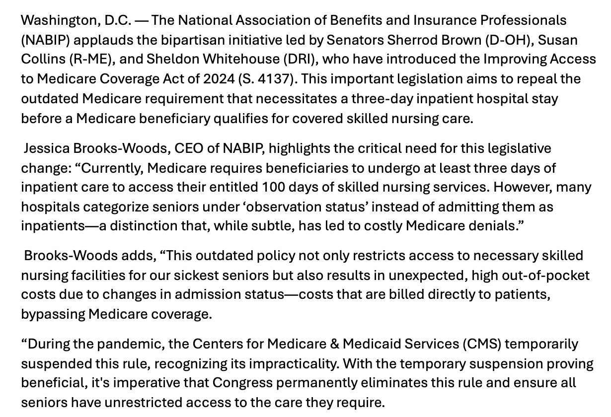

Exposition New Member Promotion Flyer

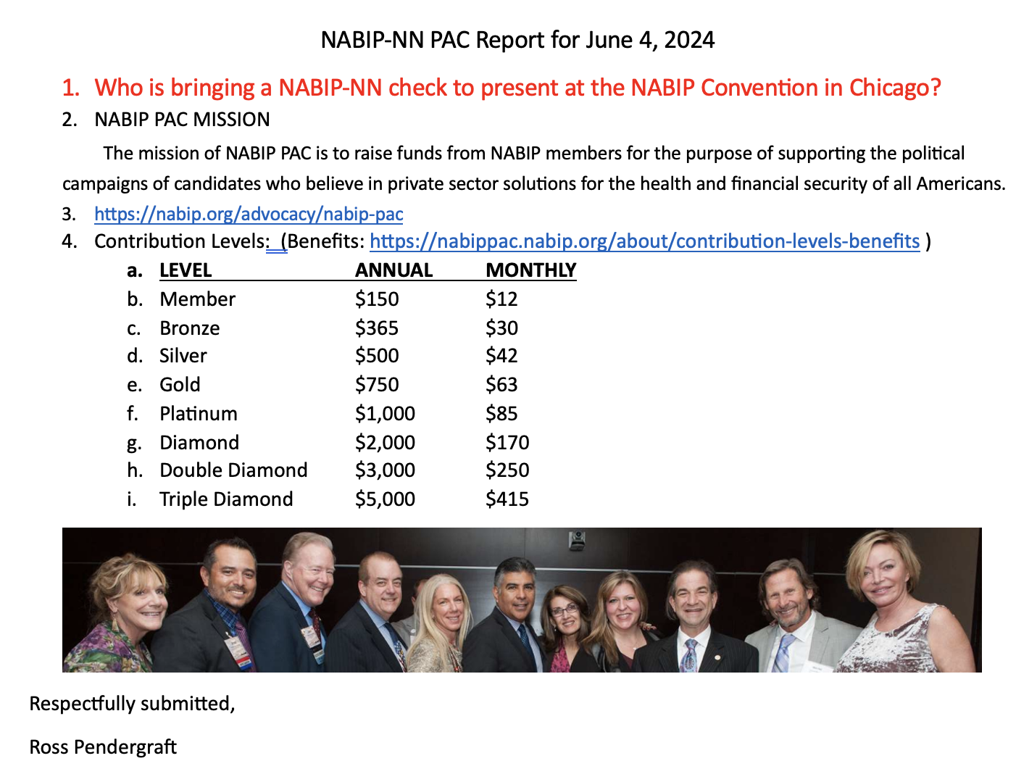
NABIP-PAC Report

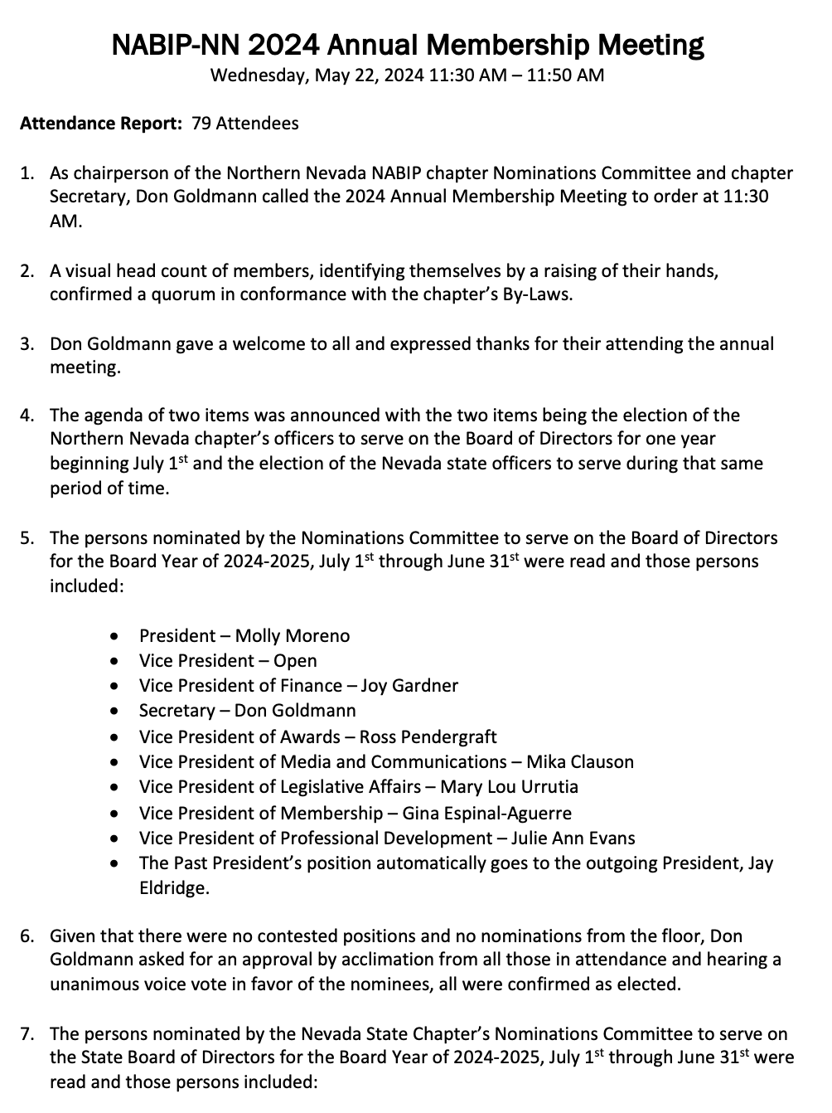
Annual Membership Meeting Minutes

