National Association of Benefits and Insurance Professionals
Northern Nevada Chapter

Board of Directors Meeting Minutes
October 7th, 2025 11:04 AM - 12:15 PM
4600 Kietzke Lane, Building G-160, Reno, NV
Via Zoom – Meeting ID = us02web.zoom.us/j/84698950624

Attendance Report: Aliana Rushing, Joy Gardner, Don Goldmann, Merre Gregory, Chanté Padilla, Breezé Yerves, Doug Boulton

Virtual Attendance: Dave Sherrill, Ross Pendergraft, Julie Ann Evans, Ashley Kapostins, Gina Espinal-Aguerre,

Absent: Molly Moreno, Adrienne Saintil, Merre Gregory, Mary Lou Urrutia, Georgana Cepeda, Gina Espinal-Aguerre and Jay Eldridge

Guests: none

- Meeting called to order by President Aliana Rushing at 11:04 AM.

- Roll Call of attendees was taken by sight for those attending in person and on Zoom by Secretary, Chanté Padilla. Quorum confirmed. Connectivity confirmed.

- Review of the September 2025 board minutes by Secretary, Chanté Padilla.

  - A motion to approve the board minutes was made byDon Goldmann and seconded by Julie Ann Evans. Unanimously approved.

- President’s report by Aliana Rushing. Written report submitted and entered into the addendum. Written report submitted and entered into the addendum with brief discussion.

  - 2026 Charity Proposal - “Spread the Word Nevada”.

    - $25 sponsors 8-10 books for children.

    - Joy wants to verify monies will be used in the Northern Nevada region.

  - November BOD meeting virtual only. Zoom, quick Tuesday Nov 4th @ 11am.

  - Starting January, BOD meetings will move to the morning of NABIP luncheon at 9:30 am. Filled by NABIP luncheon.

  - Dec. BOD meeting moved to Tuesday, Dec. 9th @ 11am as well May the 2nd Wednesday of the month to 9:30 and the Sept. meeting also.

  - Brief discussion regarding the Renewing Annual Sponsorships.

    - Automatically sending updated invoices.

    - Need to correct Luncheon meetings Gold attendee tickets to: 3 silver 1 bronze 0 luncheon meetings.

    - Need to correct Luncheon meetings that say must be a non member to member.

    - Need to correct Symposion and add EXPO title.

    - Change complimentary annual symposium & medicare registrations to 3 under GOLD.

    - Change speaker introduction to allow speakers to introduce themselves to Luncheons NOT Symposium.

    - Need to be better on advertisements and allow carriers to advertise themselves.
    - Correct -Special Social Events change to 3 under GOLD.

    - Aliana will send all additional updates and corrections to Ashley to update.

    - Brief discussion for Individual Family plans panel with a customer service related panel POST AEP would be nice to have BOD members who assist with Individual Family plans to assist with this.

    - Brief discussion of Ambassador Program.

    - Fees need to add GALA and increase total fee to reflect GALA cost.

      - Add $100 to Premier

      - Add $100 to Elite

      - Add $50 to Individual

    - Remove the handout of special ribbons

    - Change 9 luncheons to 8 luncheons.

- Secretary report by Chanté Padilla.

  - With the approval of the last board meeting minutes, the leadership minutes and the strategic planning minutes, there was nothing else to report.
- VP of Finance’s report by Joy Gardner. Financial statements submitted and added into the addendum. BOD had brief discussions.

  - Motion to approve July Financial reports made by Julie Ann Evans and seconded by Don Goldmann. Unanimously approved.

  - Brief discussion on the Gala.

  - Confirmed money was made for the Gala.

  - Doug suggest selling booths at the Gala next year.

  - Cost for 2026 - Ticket cost $60 / Table cost $50 (6 per seat).

  - Joy briefly discussion the NEED to prioritize calling vendors re: renewing sponsorships immediately.

  - Umpqua Bank is changing its name to Columbia Bank.

  - Past due accounts: Prominence past due since 2020. Joy will connect this month about this.

- Committee Reports

  - Vice President’s report by Georgana Capeda. Written report submitted and entered into the addendum with brief discussion.

    - Aliana updates EXPO committee vendor packet finalized. Goal is to send out Vendor packet out.

  - Director of Program’s report by Aliana Rushing. Written report submitted and entered into the addendum with brief discussion.

    - The Gala Event officially will be annual.

    - Aliana will email Joy and Julie Ann to finalize the Christmas party that will be December 17th.

    - Imperial and Molina have yet to respond back to Julie Ann.

    - 2 Part Ethics class by Doug Boulan one for Local one for State allowing for 2 CE’s.

    - Aliana confirms HTH, Anthem and Care Source will attend and participate in the IFP panel.

  - VP of Professional Development’s report by Julie Ann Evans - written report submitted and entered into these minutes.

    - NABIP SN - September Virtual CE Class:

      - NABIP SN offered a virtual CE class on September 11th where they had Serena Farrell, Anthem BCBS, present the same CE class she did for NABIP NN at our Expo on May 21st

      - There was a total of 12 CEs processed on September 11th

      - There is a $1.25 fee per CE completion, so we should see an invoice from Sircon for $15.00

      - As NABIP NN already covered the $40.00 filing fee, the total cost to be billed to NABIP SN is $15.00 and this was communicated to NABIP SN, as well as to Joy Gardner, VP of Finance for NABIP NN

    - NABIP NV - September CE Class:

      - The September 12th CE class was managed through NABIP NNs Sircon account

      - There was a total of 13 CEs processed on September 12th

      - There is a $1.25 fee per CE completion, so we should see an invoice from Sircon for $16.25

      - The total CE cost is $56.25 ($40.00 filing fee, plus $16.25 completion fee)

    - NABIP SN - November Monthly Luncheon:

      - NABIP SN will have a CE approved event on November 4th. The course title is “OBBBA Budget Bill: Navigating the New Benefits Landscape”, presented by Paul Roberts, Word & Brown
      - This CE class is being managed through NABIP NNs Sircon account. The material was submitted on September 25th and approved on September 30th

      - The course offering was created on September 30th

      - There is a $40.00 filing fee, so NABIP NN should receive an invoice from Sircon for $40.00 and this was communicated to NABIP SN, as well as to Joy Gardner, VP of Finance for NABIP NN

    - NABIP NV - January CE Class:

      - This CE class is being managed through NABIP NNs Sircon account. The course title is ”365 Selling: Medicare Election Periods Beyond AEP”, presented by Aliana Rushing, Senior Insurance Agency

      - The course material was submitted on September 25th and approved on September 30th

      - The course offering was created on September 30th

      - There is a $40.00 filing fee, so we should see an invoice from Sircon for $40.00

    - I attended the Region 8 PD meeting on September 26th which was held virtually.

    - NABIP NV - Monthly Professional Development Meeting:

      - Typically, on the 4th Friday of each month there is a virtual meeting held for those who are involved with planning luncheons, events, CE classes, etc. for both local chapters and the state chapter

      - The next meeting will be held on October 24th at 2:00 PM, and all are welcome to attend the meeting

  - Vice President of Media and Communication’s report by Donald Goldmann - Written report submitted and entered into these minutes with brief discussion.

    - Don Goldmann will work with Ashley and Dave to get sponsor advertisements in the newsletter.

    - Shout out to Ashley helping Julie Ann and Don as they did a last minute request for donations to help out the Nevada Charity and it was successfully added to the newsletter.

  - Vice President of Membership’s report by Gina Espinal-Aguerre. Written report submitted and entered into the addendum with brief discussion.

    - We are 102 members.

    - Working on lapse memberships.

      - A&H was able to get caught up on payments.

  - Vice President of Awards’ report by Ross Pendergraft. Brief discussion and written report submitted and entered into the addendum.

    - NABIP website has updated all awards.

    - No changes to Media website

    - PaceSetter made a couple of changes to awards.

    - NABIP Vision Training no longer gives points.

    - DEI was also removed.

    - Ross mentions the goal to have NN chapter Service Awards distinguished service award. Need to get together to figure out how to get a couple BOD members qualified for this.

    - DSA award eligibility:

      - Who does non profit work?

      - Who serves on local and state, regional or national levels?

      - Who is doing outstanding work in the community.

    - Ross will send out qualifications for DSA award.

    - Ross mentions we need to make sure our FB is getting updated. Our last Facebook post was August 14, 2023. We need to develop a plan to post on these social media sites.

    - Dave mentions there have been recent updates on the FaceBook page.

    - Aliana will take pictures from the NABIP Luncheon tomorrow.

    - The New Member Orientation will continue every 4th Thursday at 9:00am PST on Zoom. Need to make sure we keep blasting this out in our newsletter each month

    - Zoom meeting ID 826 3420 3381, Passcode “Membership”

    - http://welcometonabip.org

  - Vice President of Legislative Affairs’ report by Mary Lou Urrutia. Written report submitted and entered into the addendum.

  - Employer Benefits Chair’s report by Breeze Yerves. No report, brief discussion.

    - She is working on getting the Nevada Health Link questions back for the panelist.

    - Goal to obtain Anthem, Home Town Health Prominence and UHC.

  - Medicare Chair’s and VP of Medicare Chair’s report by Merre Gregory Lou and Doug Boulton. Written report submitted and entered into the addendum with brief discussion.

    - Under 65 MedSups have taken effect in Nevada effective 10-01-2025.

    - Most commissions structures will be similar to guarantee issue rates.

    - Fed regulations directly prohibits Insurance Agents from charging any fees as plans are commissionable.

  - LPRT Chair’s report by Joy Gardner. No report.

  - Incoming DEIB Chair’s report by Adrienne Saintil. No report, absent.

  - Incoming NABIP Foundation chair’s report by George Beach. No report brief discussion.

    - George Beach has resigned.

  - Incoming Director of NABIP PAC’s report by Jay Eldrige. No report.

    - Brief Discussion that he completed leadership training.

  - Immediate Past President’s report by Molly Moreno. No report, absent.

- A motion was by Julie Ann Evans and seconded by Joy Gardner to accept all reports in toto. Unanimously approved.

- Old Business - None

- New Business:

  - Ross mentions Keiser opening up in Northern Nevada under Home Town Health.

  - Aliana proposes to review the proposed budget for 2026 to be approved in November.

  - Aliana wants to confirm how to consolidate some of the Administration Fees with the goal of using less admins to save money.

    - Don Goldmann motions to approve 2026 budget seconded by Julie Ann Evans. Unanimously approved.

  - Aliana motions to appoint Merre Gregory and Doug Boulton both as the Medicare Chair. Seconded by Don Goldmann. Unanimously approved.

  - Aliana motions to appoint Julie Ann Evans as the 2026 NABIP Foundation Chair by Aliana seconded by Don Goldmann Unanimously approved.

- A motion to adjourn meeting by Aliana Rushing, seconded by Julie Ann Evans. Unanimously approved.

- President Aliana Rushing adjourned the meeting at 12:12 pm.

- Submitted by Chanté Padilla NABIP NN Secretary.
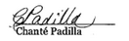

Next Monthly Board Meeting: VIRTUAL, November 4th, 2025, 11:00 AM - 11:30 PM. https://us06web.zoom.us/j/85852438497?pwd=GhSaLjW8LD03ZBoa4fAgz12XNh7cGe.1

Meeting ID: 858 5243 8497
Passcode: 881981

Addendum

Report from the President - Aliana Rushing
PG 1 of 1
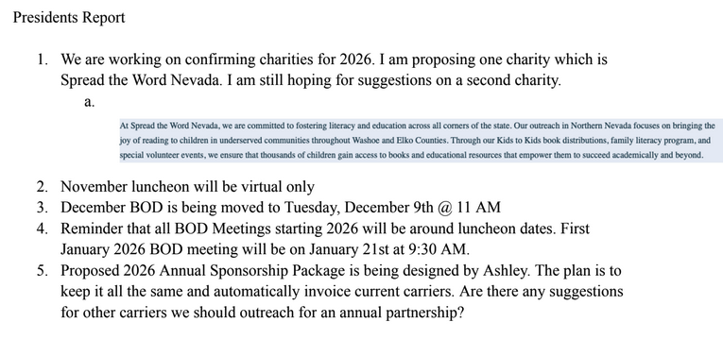

Treasurer’s Report from VP of Finance - Joy Gardner
Pg 1 of 1
NABIP-NORTHERN NEVADA Treasurer’s Report
Month end 9/30/2025

Partnerships 2025: All Paid
Diamond-$8,500 Anthem
Gold-$4,000 Hometown Health, United Healthcare
Silver-$2,500 Aetna, Word & Brown
Bronze-

Umpqua Bank Balance: 9/30/25
Checking $66,280.69
Savings $ 200.42
See attached bank statement

Budget vs Actual: Attached

GALA: 9/5/2025
Attendance: 40 (23 attendees, 13 Ambassadors, 2 Annual Sponsors, 2 Gala Sponsors)
No Shows: 7 (7 attendees)
Walk Ins: 0
Income: $1,723.00 + $50.00 (Ambassadors) + $600. (Sponsors) + $3000 (Gala Sponsors) = $5,373.00
Cost: $4,452.75
Raffle Income: $00

Additional Information:
We need to begin solicitation for our Annual Partners. The scope of carrier participation needs to broaden so we can have participation include more of the individual and Medicare carriers. A letter coming from our President Aliana would start the ball rolling. Then those board members who know specific carrier reps can work on getting the partnership sold and solidified. I know Aliana is working on a revised flyer to reflect what we are offering for each sponsorship level.

The name change from Umpqua Bank to Columbia Bank has been completed and we do not need to do anything. All is as it was before the name change.

Prominence Health Plans owe us $375 from 2020. I verified we have not received the funds and requested payment. Have not received it as of 9/30/2025. I need to follow up on this one this month.

Both the Checking and Savings accounts balance.

Respectfully submitted: Joy K Gardner

Columbia September 2025 Statement
Pg 1 of 2
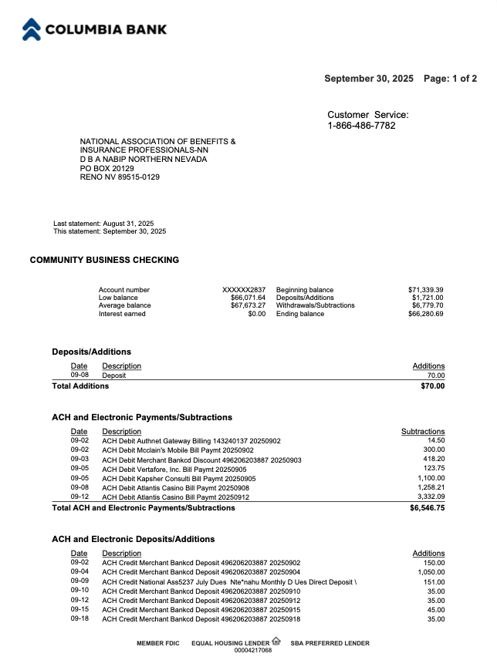

Columbia September 2025 Statement
Pg 2 of 2

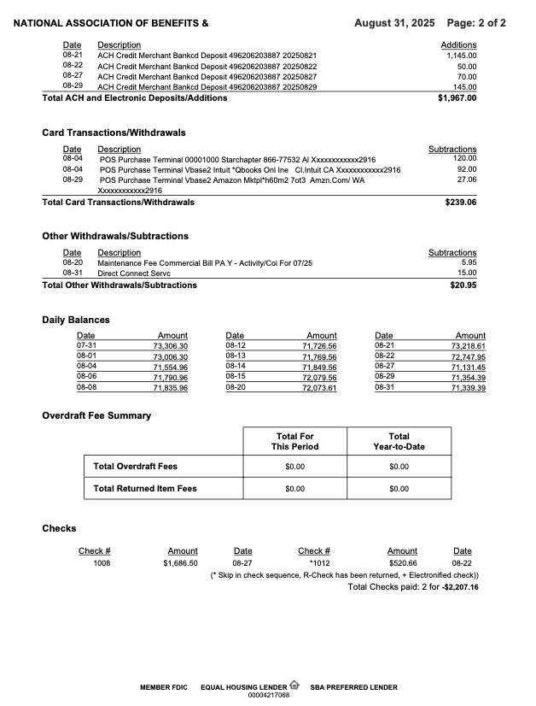

Reconciliation of Check and Savings Accounts
PG 1 of 1
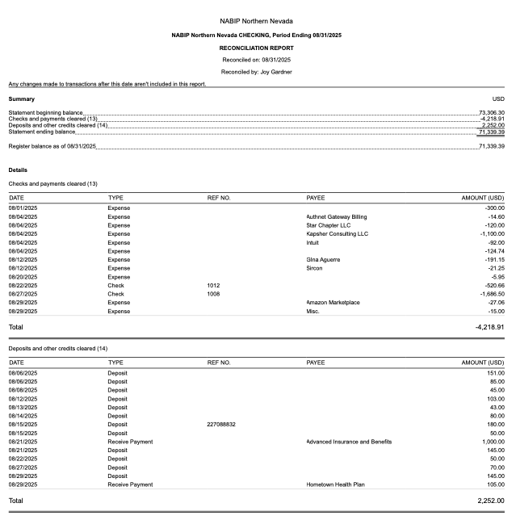

NABIP NN Budget vs Actual January 2025- September 2025 Profit and Loss
Pg 1 of 2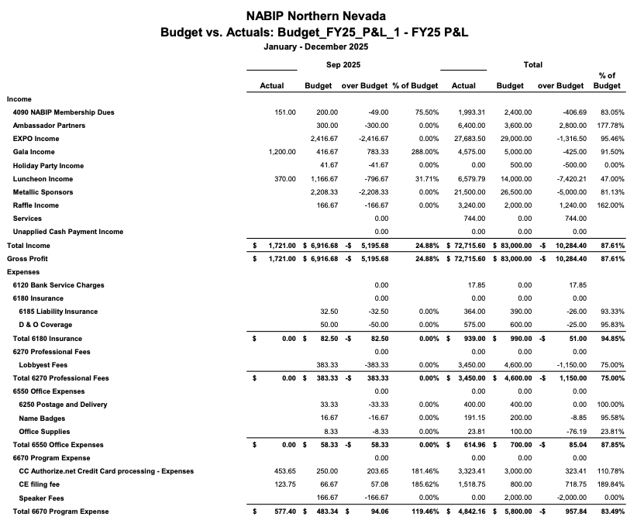

NABIP NN Budget vs Actual January 2025- August 2025 Profit and Loss
Pg 2 of 2

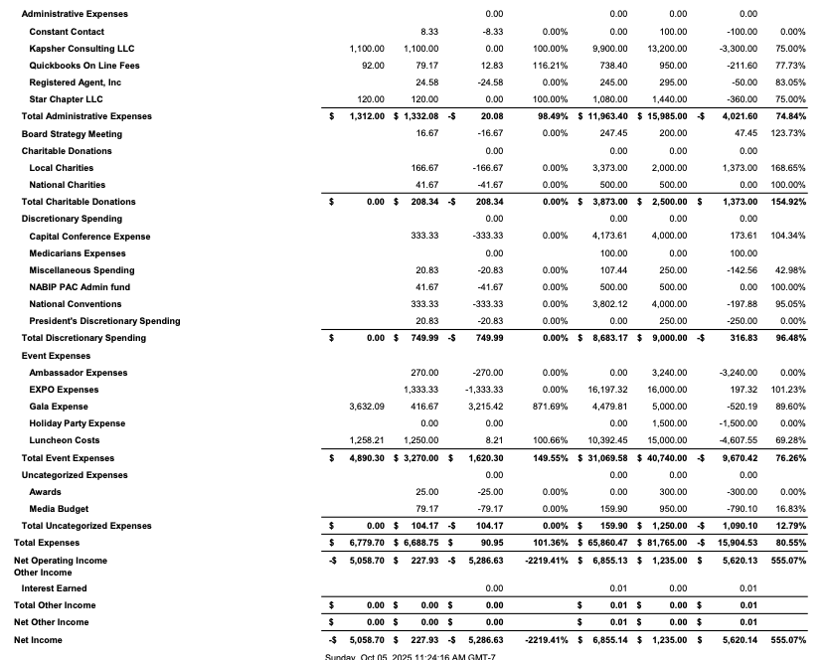

NABIP NN Profit and Loss by Month. January 2025- August 2025
Pg 1 of 4

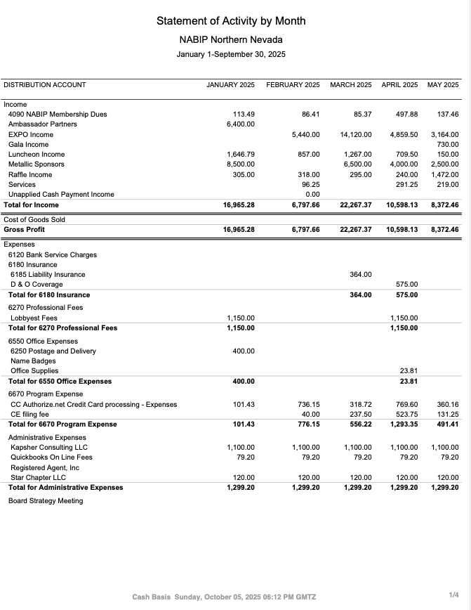

NABIP NN Profit and Loss by Month. January 2025- August 2025
Pg 2 of 4
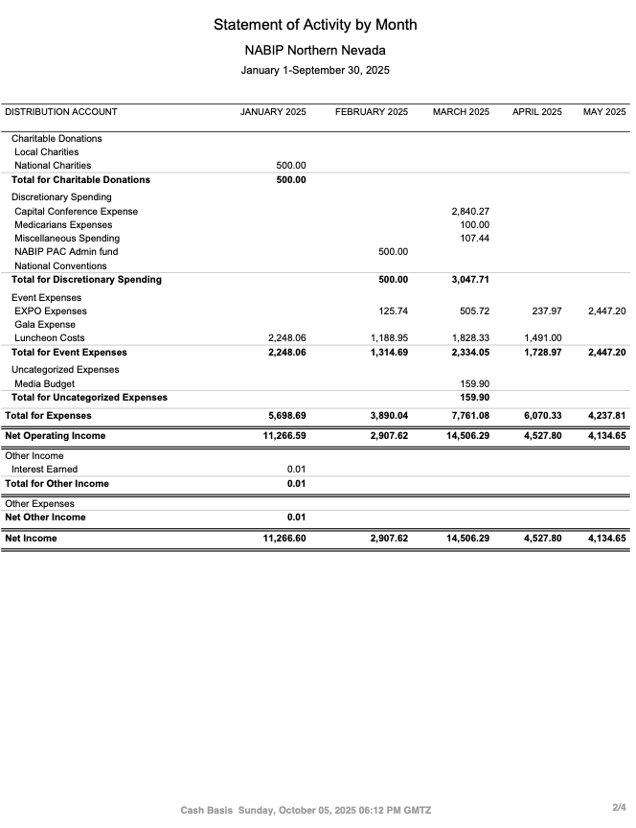

NABIP NN Profit and Loss by Month. January 2025- August 2025
Pg 3 of 4
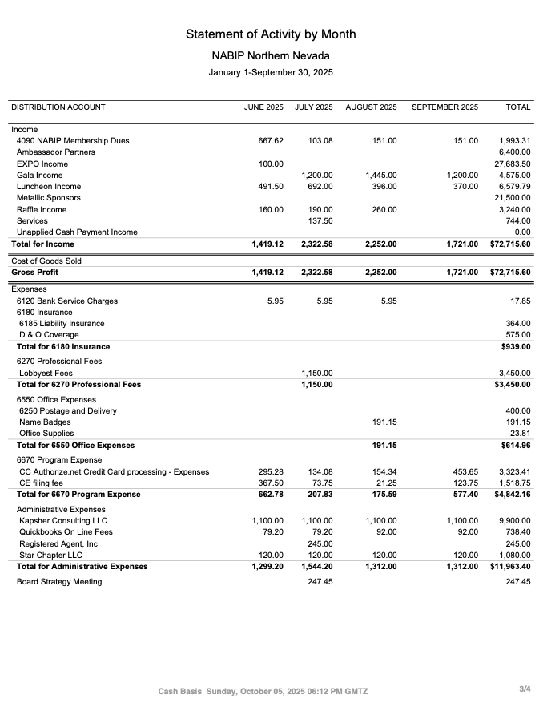

NABIP NN Profit and Loss by Month. January 2025- August 2025
Pg 4 of 4
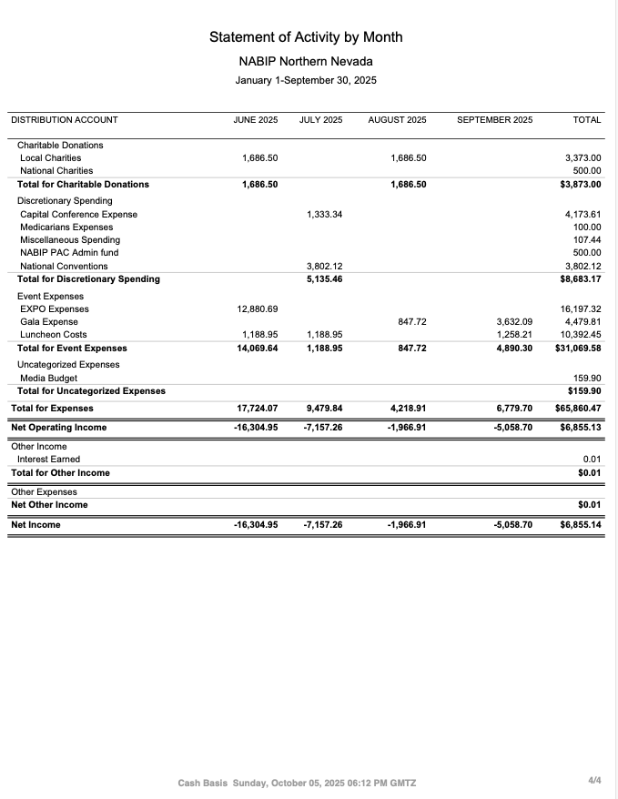

NABIP NN Proposed 2026 Annual Budget
Pg 1 of 2

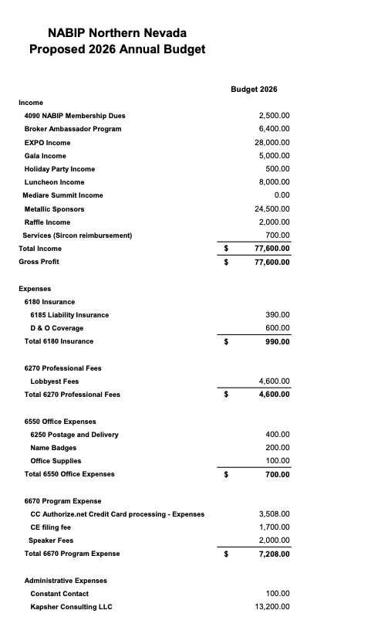

NABIP NN Proposed 2026 Annual Budget
Pg 2 of 2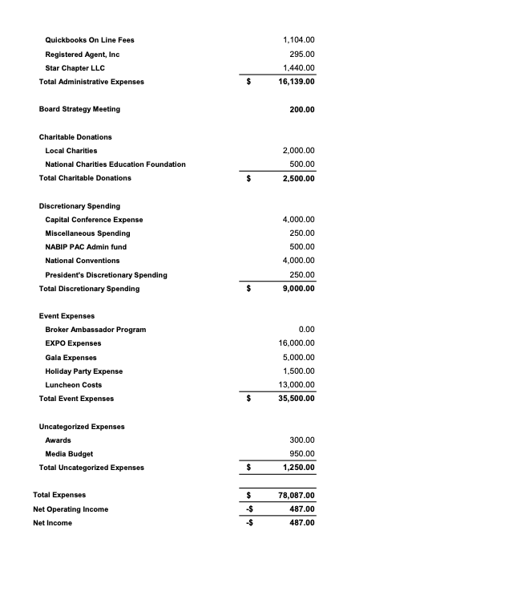

Report from the VP - Georgana Cepeda
PG 1 of 2

National Association of Benefits and Insurance Professionals
Northern Nevada Chapter – Board of Directors Meeting
2026 EXPO REPORT
Expo Date: April 29, 2026
Theme: Country
Theme/Slogans:
- Saddlin Up for Success
Follow-Up: Gravi and Kaiser Speakers.
The committee reviewed the vendor packet, noting only minor adjustments, such as centering in the sponsorship guide. The plan is to send vendor packets soon to begin securing 2026 budget commitments.
They emphasized the importance of including a fillable form in the vendor packet and outlined the process for distributing packets to vendors. A pre-written outreach script will also be developed to ensure consistent vendor communication and engagement.
Speaker Updates:
It was noted the need to update speaker information and to send out bios and topics early.
The vendor list will also be reviewed and updated so everyone remains aligned on vendor communication.
Keynote Speaker:
- Merre Gregory Stalker shared an email regarding the proposed keynote speaker, who is willing to present for $2,000.
- The group discussed the need for an invoice and to ensure payment timing aligns with the correct budget year.
- They agreed to schedule a meeting with the keynote speaker to discuss her motivational talk and gather input on the event theme.
- Final details with the keynote speaker will be revisited in January, allowing the committee to stay focused and organized.

Report from the VP - Georgana Cepeda
PG 2 of 2
Kaiser Update:
- The group discussed the challenge of securing Kaiser’s commitment for the Hometown Merge session.
- NABIP-NN shared updates from CJ, confirming that Kaiser is not yet ready to commit at this stage.

Report from the Director of Programs - Aliana Rushing
PG 1 of 1
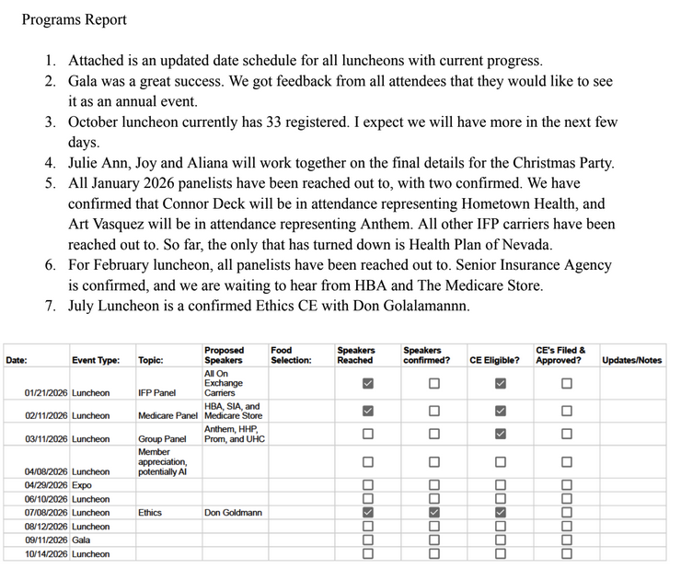

Report from the VP of Membership - Gina Espinal-Aguerre
PG 1 of 1

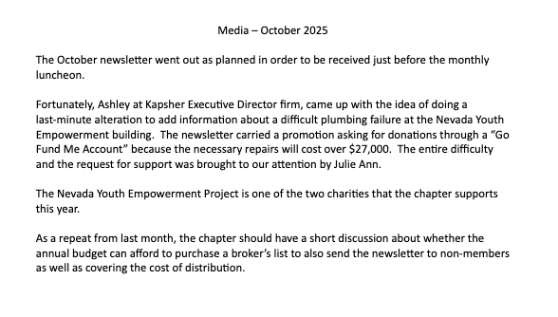

Report from the VP of Awards - Ross Pendergraft
PG 1 of 3

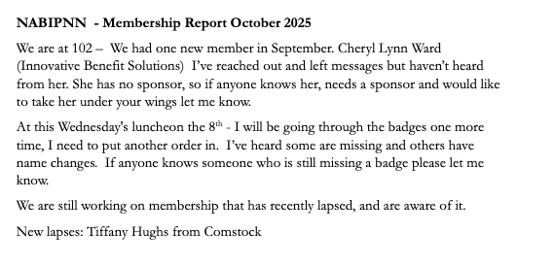

Report from the VP of Awards - Ross Pendergraft
PG 2 of 3
NABIP-NN Awards Report for October 7, 2025

- The updated 2026 NABIP Awards have been posted on the website.
- There are a few changes to the NABIP Pacesetter Award (See attached)
  - Eliminated NABIPvision Chapter Leadership Training
  - No longer to receive points for promoting DEI&B Training
  - No longer to receive points for completing training for DEI&B
- No apparent changes to Media, Website, and Presidential Citation.
- I would like to see the Reno Chapter make an effort to apply for the Distinguished Service Award (DSA) for at least one of our members.
- Our last Facebook post was August 14, 2023. Also, not seeing anything posted recently on X or LinkedIn. We need to develop a plan to post on these social media sites.
- Even though this has been eliminated from Pacesetter Awards, I still strongly recommend you complete the NABIP Leadership Training. This will help with your position. Be sure to sign-in before watching the video: https://videos.nabip.org/
- The New Member Orientation will continue every 4th Thursday at 9:00am PST on Zoom. Need to make sure we keep blasting this out in our newsletter each month
  - Zoom meeting ID 826 3420 3381, Passcode “Membership”
  - http://welcometonabip.org

Respectfully submitted,
Ross Pendergraft
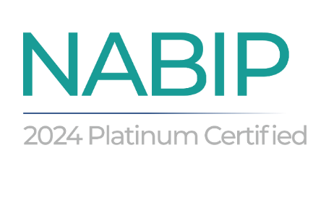

Report from the VP of Awards - Ross Pendergraft
PG 3 of 3

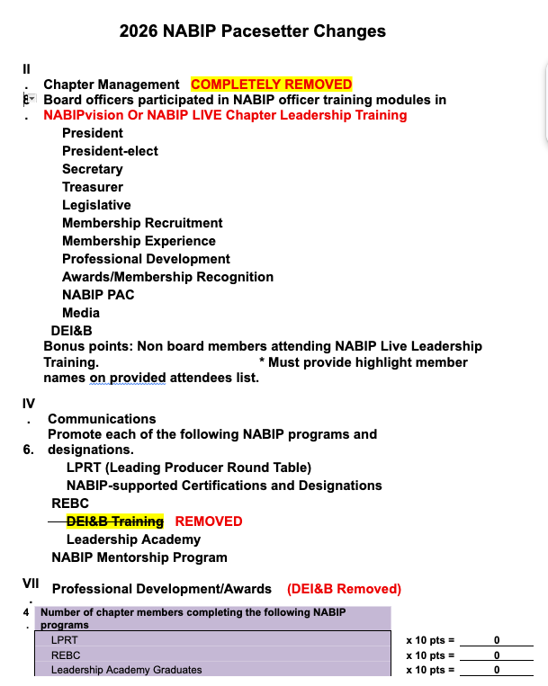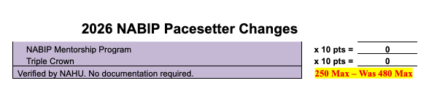

Report from the Vice President of Legislative Affairs - Mary Lou Urrutia
PG 1 of 3

Legislative Report – October 2025
Newsflash – there is a Government Shut down happening! They are at an impasse!
Will the ACA enhanced premium Tax Credits be extended? Hiedi Sterner is hitting Rep Amodei hard with examples of clients on NVHLK with premiums rising steeply and some even doubling with the carrier increases and no enhanced credits.
If you want to share client situations, please email examples to - Heidi Sterner - heidijsterner@gmail.com and see will forward to the Amodei's office.

CMS Launches Landmark $50 Billion Rural Health Transformation Program
New Federal Program Aims to Transform Rural Health Care Nationwide
Today, the Centers for Medicare & Medicaid Services (CMS) unveiled details on how states can apply to receive funding from the $50 billion Rural Health Transformation Program created under the Working Families Tax Cuts Act to strengthen health care across rural America. This unprecedented investment is designed to empower states to transform the existing rural health care infrastructure and build sustainable health care systems that expand access, enhance quality of care, and improve outcomes for patients.
“Rural communities are the bedrock of America. They have waited too long for Washington to act. Now, at last, we are acting with the largest investment ever made to improve health care for rural Americans,” said U.S. Health and Human Services Secretary Robert F. Kennedy, Jr. “This $50 billion program is about delivering dignity and dependable care to rural communities, making sure every American has access to affordable, high-quality treatment.”
“This program is a historic investment that will catalyze needed change in rural health systems and improve lives for generations to come,” said CMS Administrator Dr. Mehmet Oz. “For too long, when it comes to health care access and infrastructure, we've left behind the backbone of America. That stops now with this program that will spark real change for rural health care. ”
The Rural Health Transformation Program invites all 50 states to apply for funding to address each state’s specific rural health challenges. The Program enables states to reimagine care delivery and develop innovative, enduring, state-driven solutions to tackle the root causes of poor health outcomes specific to rural America.

If possible, listen to the NABIP Town Hall that was done 9/25/25 - there is great info about the changes that are happening this AEP and what is part of the cause the carriers are doing. It also stresses the importance of the Agent/ Client surveys for Medicare and ACA. If we don’t show our representatives our worth the carriers are not going to pay us and use the federal funds they receive to take care of their pockets/ expenses. I think the town hall link should be put in our Newsletter for everyone to access easily and they can send the survey links out to clients. I am not tech savvy enough to attach the link – below is the Title and it is available on the NABIP Nation site.
NABIP Medicare Agent & Broker Town Hall: Preparing for AEP - September 25, 2025 | By: NABIP Medicare

Report from the Vice President of Legislative Affairs - Mary Lou Urrutia
PG 2 of 3

3 items are happening to carriers that we work closely with in our area and these companies are going to be spending money they do not want to, and it will affect us.
As of late September 2025, a jury awarded Saint Mary's Health Network over $510 million in a lawsuit against Universal Health Services (UHS) and its affiliates, including Pinnacle Medical Group, for conspiring to poach doctors and employees. The lawsuit did not involve Prominence Health Plan.

The articles states that the lawsuit did not involve Prominence Health Plan, yet their parent company UHS is going to be in the decision making of tightening the belt to cover losses.

Missouri’s biggest individual insurer must rebate almost $90 million to policyholders because it spent too little on care and too much on administration.
Ambetter from Home State Health, a subsidiary of Clayton-based Centene Corporation, is mailing checks totaling $87.5 million to customers in Missouri because it violated the Medical Loss Ratio requirements of the Affordable Care Act. Letters dated Sept. 10 notifying policyholders of the rebates — equal to more than one month’s premium for each — began arriving in mailboxes over the weekend.
One of Ambetter’s competitors, United Healthcare, is also making rebates to Missouri customers. In a Sept. 5 news release, United Healthcare stated that it will rebate $192.2 million nationally for group market plans offered in 31 states and $167.1 million for individual insurance market plans offered in 19 states.
Missourians in both United Healthcare markets will be eligible for rebates, but the material supplied by the company did not show the amounts.
The rebates from Ambetter are among the largest for individual insurance companies operating in the Missouri marketplace since the Affordable Care Act began requiring them in 2012. Over 12 years, insurers have rebated $587.1 million to Missouri policyholders, with the most being $192.7 million in 2019.

How do these large corporations not realize they are spending too little on care and too much on administration?

A California resident with multiple sclerosis and her mother are suing Anthem Blue Cross Life and Health Insurance Company over the company's refusal to cover an autologous hematopoietic stem cell transplantation treatment.
The patient, Callie McKay, and her mother, Bethany McKay, contend that Anthem Blue's own medical policy statement shows that the company believes a stem cell transplant may be medically necessary for patients with the kind of aggressive, progressive, multiple sclerosis that Callie McKay has. Studies have suggested that the transplants could stop or even reverse the effects of multiple sclerosis for some patients.
Anthem Blue, a unit of Elevance Health, has repeatedly blocked Callie McKay from getting the transplant by taking steps such as denying her coverage for the kind of medication, such as natalizumab, that she must take before she can be considered a candidate for a stem cell transplant, according to a complaint the McKays filed earlier this month in a state court in Los Angeles County, California.

Report from the Vice President of Legislative Affairs - Mary Lou Urrutia
PG 3 of 3

Attorneys for Anthem have not yet appeared in court, and representatives for Elevance were not immediately available to comment on the case.
Multiple sclerosis is a condition in which an individual's immune system attacks the myelin layer that normally covers and protects the nerves.
Callie McKay's age was not available.
The cost of typical stem cell autologous stem cell transplants, which involve the use of cells from a patient's own body, runs from $15,000 to $75,000, according to DVC Stem.

What it means: The McKay case involves an individual health insurance policy, not an employer-sponsored health plan.

But the case could end up having an impact on how the California courts see all suits for insurance coverage for stem cell transplant suits, because review of the Law.com lawsuit complaint database and the federal government's GovInfo federal court opinion database suggests that recent court cases involving patients' suing commercial health insurers or employer health plans over coverage for stem cell transplants in connection with multiple sclerosis have been uncommon.

The McKay case could also have a direct effect on stem cell transplant benefits at fully insured group health plans in California.

Granted I don’t know the full story, the drug that was needed to be considered a candidate for a stem cell transplant was denied, not the transplant.

Report from the Medicare Chair- Merre Gregory
Pg 1 of 5
October NABIP Medicare Chair report
Aetna, Elevance, Cigna Cut Some Medicare Advantage commissions mid year:
- Elevance will eliminate commission payments beginning Nov. 1 for new enrollees in some Anthem Blue Cross Blue Shield plans in 15 states. They will still pay commissions to brokers for renewing existing members.
- Aetna will eliminate commissions for some plans in nine states and Washington, D.C, NV will have none.
- Beginning Nov. 4, Cigna will no longer pay commissions for new enrollees in some PPO plans in 25 states and Washington, D.C., NV will have two, Cigna Saver RX – renamed to HealthSpring Extra RX $52.60 and Cigna Assurance RX- renamed to HealthSpring Assurance RX $95.60
- Humana will have two commissionable pdp plans in NV Humana Premier RX $148.70 and Humana Value RX $43.70
Anthem commission update:
- D-SNP and C-SNP commissions
  - Renewals: 2026 fair market value (FMV) commission applies.
  - New Enrollments: 2026 FMV commission applies.
  - New Enrollment Exception: Anthem Full Dual Advantage (HMO D-SNP) H4346-025-000 will be non-commissionable for new sales effective 1/1/2026.
- HMO non-SNP commissions
  - Renewals: 2026 FMV renewal commission applies on your renewing members on non-SNP HMO plans.
  - New non-SNP HMO enrollments: 2025 FMV commission applies.
  - New Enrollment Exception: Anthem Medicare Advantage (HMO-POS) H4346-017-000 will be non-commissionable for new sales effective 1/1/2026.
PROMINENCE; will not be paying commissions on any county other than Washoe.
AETNA: will not be paying commissions on any county other than Washoe.
Centene said it would eliminate broker commissions for all of its Medicare Part D plans. They will eliminate payments for renewals and new members. Elevance is exiting Medicare Part D in 2026.

Report from the Medicare Chair- Merre Gregory
Pg 2 of 5

ATRIO: Will have upcoming Service Area Reduction (SAR) that will take effect January 1, 2026 (with marketing beginning October 1, 2025). ATRIO Health Plans will discontinue offering Medicare Advantage plans in the Nevada service areas for Plan Year 2026. All counties.
• Current Members: Members will receive CMS-approved notices outlining their 2026 plan options and SEP eligibility. While they may make changes during AEP, the SEP for plan/contract non-renewals or service area reductions is available Dec 8 – Feb 28. Please note: agents cannot use this SEP prior to 12/08.
- Commissions: Renewal commissions for Nevada members remain payable through 12/31/2025 according to contract terms.
In the state of Nevada, a new regulation for individuals under the age of 65 will take effect October 1, 2025.
- As part of this new regulation, a six-month open enrollment period will be available from October 1, 2025, through April 1, 2026, for individuals under age 65, currently eligible for Medicare due to disability or end-stage renal disease (ESRD).
- Plans A, F, G, high-deductible G and N will be made available. Compensation will be paid as open enrollment.

Per a statement from NABIP: We have received several questions regarding whether licensed agents may charge beneficiaries a fee when enrolling them in non-commissionable Medicare Advantage (MA) or Prescription Drug Plans (PDP).
- We want to make this absolutely clear: federal regulations prohibit agents from directly charging any fee to beneficiaries for marketing, consulting, or enrollment services involving MA or PDP plans, even if the plan does not pay a commission.
- Federal Regulation: 42 CFR § 423.2274(c)(8) requires Part D sponsors to “ensure beneficiaries are not charged marketing consulting fees when considering enrollment in Part D Plans.” The same prohibition applies under Medicare Advantage regulations. Federal law preempts state law in this area. Even if a state permits Certified Insurance Consultants or Registered Investment Advisors to charge fees for other products, they may not do so for MA or PDP plans.
- All compensation must come directly from plan sponsors and must comply with CMS regulations. Charging beneficiaries directly for these services places the agent at risk of regulatory enforcement and plan contract termination.
Report from the Medicare Chair- Merre Gregory
Pg 3 of 5

States with Active Medigap Birthday Rules

These states have enacted birthday rules, enabling Medigap policyholders to change
plans without medical underwriting during designated windows:
- State Birthday Rule Details
California 30-day window starting on the policyholder's birthday to switch to a plan
with equal or lesser benefits from any carrier.
Idaho 63-day window beginning on the policyholder's birthday to switch to a plan
with equal or lesser benefits; switching carriers is allowed.
Illinois 45-day window post-birthday for enrollees aged 65–75 to switch to a plan
with equal or lesser benefits within the same carrier or its affiliates.
Kentucky 60-day window post-birthday to switch to a plan with the same benefits from
any carrier.
Louisiana 63-day window post-birthday to switch to a plan with equal or lesser
benefits within the same carrier or its affiliates.
Maryland 30-day window post-birthday to switch to a plan with equal or lesser
benefits from any carrier.
Nevada 60-day window starting on the first day of the birth month to switch to a plan
with equal or lesser benefits; switching carriers is allowed.
Oklahoma 60-day window post-birthday to switch to a plan with equal or lesser
benefits from any carrier.
Oregon 30-day window before and after the birthday to switch to a plan with equal
or lesser benefits from any carrier.

Report from the Medicare Chair- Merre Gregory
Pg 4 of 5

- States Considering Medigap Birthday Rules in 2025
Several states have introduced legislation in 2025 to establish Medigap birthday rules:
State Proposed Rule Details
Nebraska 30-day annual open enrollment period starting on the policyholder's
birthday, allowing guaranteed issue access to any Medigap plan without medical underwriting.
Utah 60-day annual window post-birthday to switch to a plan with equal or
lesser benefits within the same carrier.
Virginia Proposals include allowing enrollees to switch to the same plan type from
a different carrier or to any plan with equal or lesser benefits.
Indiana Proposal to allow switching to the same plan type from a different carrier
during a birthday window.
Iowa 30-day birthday rule starting in 2026, permitting switches to plans with
equal or lesser benefits.
Rhode Island 30-day birthday rule allowing individuals with continuous prior Medicare
Advantage coverage to enroll in Medigap plans.
New Mexico 60-day window post-birthday for enrollees aged 65 and older to switch to
any Medigap plan.
Wyoming Proposal under review to allow an annual enrollment period around the
policyholder's birthday to switch plans without medical underwriting.
- States with Other Guaranteed Issue Rules
Some states offer alternative guaranteed issue rights not tied to birthdays:
• Missouri: An "anniversary rule" permits enrollees to switch to the same plan type
from a different carrier within 30 days before or after their policy anniversary.

Report from the Medicare Chair- Merre Gregory
Pg 5 of 5

• Connecticut, New York, Vermont: Year-round open enrollment for Medigap
plans, allowing changes without medical underwriting at any time

CMS has finalized a rule requiring Medicare Advantage plans to submit provider directory data for inclusion in the Medicare Plan Finder. The change, aimed at improving transparency and beneficiary decision-making, takes effect January 1, 2026.
- Under the rule, MA plans must make provider directory information available to CMS in a standardized format for online publication, update the data within 30 days of becoming aware of changes, and attest at least once a year to the accuracy of the information.
- CMS said the move is designed to allow beneficiaries to more easily compare provider networks across plans without having to navigate multiple websites. The agency expects to publish an operational guide in the coming months with technical specifications for plans to follow, along with a testing period before the data appears publicly online.

CMS delays Medicare Advantage Supplemental benefit notice requirements
- As of September 8, 2025, the Centers for Medicare and Medicaid Services (CMS) is delaying enforcement of Medicare Advantage (MA) mid-year Notice of Supplemental Benefits notification requirements for contract year 2026 and beyond. The enforcement pause will remain in effect until further notice.
- This requirement would have required MA organizations to send annual notifications to enrollees about unused supplemental benefits between June 30 and July 31, beginning in 2026

